Unit 1 · be, there is / are, this / that — Quick quiz
15 minutes · Destination A1 · Grade 3

Name: ______________________________ Class: ________ Date: ______________
Part 1 · Words (6 points)
A Look and write the words.
  1 ___________ |   2 ___________ |   3 ___________
  4 ___________ | 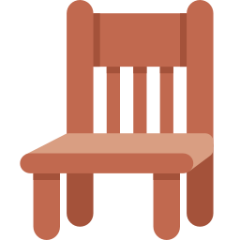  5 ___________ |   6 ___________

Part 2 · Grammar (8 points)
B Choose the correct word.
1 She (am / is / are) nine.
2 There (are / is) three windows.
3 (Is / Are) there a clock?
4 (Those / That) are the doors. (far away)
C Complete the sentences.
am · Are · These · those · is

1 I ________ ten years old.
2 There ________ a board.
3 ________ there any chairs? — Yes, there are.
4 ________ are my books. (near)
Part 3 · Reading and writing (6 points)
D Read and answer.
My room
There is a bed in my room. There are two chairs and a lamp. There isn't a computer.

1 Is there a bed?

2 How many chairs are there?

3 Is there a computer?

E Put the words in the right order.
1 There / is / lamp. / a

2 books? / any / there / Are

3 bags. / are / Those / my

Score: ________ / 20

