Unit 3 · My home — Lesson plans
3 lessons × 45 minutes · Destination A1 · Grade 3

Adapted for Grade 3 (age 8–9, CEFR A1): the topic follows a unit of Destination A1 (grammar and vocabulary practice); all exercises, pictures and texts are new.
Unit at a glance
In the book | Destination A1, Unit 3 — Vocabulary: My home
Topic | Rooms and furniture; where things are
Vocabulary | living room, bedroom, kitchen, bathroom, garden, door, window, sofa, lamp, chair
Grammar | • There is / there are + a room or a thing; Is there …? Are there …?  • Where is the lamp? It's on / in / next to / under the …  • I sleep in the bedroom. We cook in the kitchen.

Vocabulary
 | English | O'zbekcha
 | living room | mehmonxona
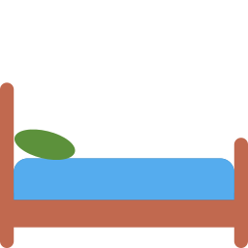 | bedroom | yotoqxona
 | kitchen | oshxona
 | bathroom | hammom
 | garden | bog'
 | door | eshik
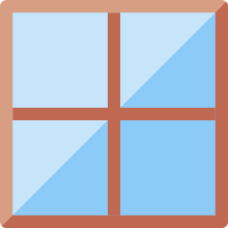 | window | deraza
 | sofa | divan
 | lamp | chiroq
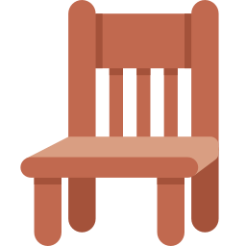 | chair | stul

Extra words used in the lessons
 | English | O'zbekcha
 | table | stol
 | fridge | muzlatgich
 | carpet | gilam
 | cupboard | shkaf
 | flat | kvartira
 | house | uy

Lesson 1: Rooms in my home
Focus | Vocabulary — rooms and what we do in them
Aims (by the end of the lesson pupils can…) | • name five rooms and the garden  • say what we do in each room: I sleep in the bedroom.
Key language | • living room, bedroom, kitchen, bathroom, garden  • I sleep / cook / wash / watch TV in the …
Materials | • Flashcards (games/flashcards.pdf)  • Word card (grammar-card.pdf)  • Worksheet A exercises A, B
Time | 45 minutes

Min | Stage | What happens | Interaction
3 | Greeting & organisation | Ask 'Do you live in a flat or a house?' and write the answers on the board. | T-Ss
5 | Warm-up | Floor plan: draw a simple plan of a flat on the board and name the rooms with the class. | T-Ss
10 | Presentation | Present the room flashcards, one at a time, and attach an action: bedroom = sleep, kitchen = cook, bathroom = wash. Choral repetition. Stick the cards on the plan. | T-Ss
12 | Controlled practice | Worksheet A exercises A (label), B (match sentences to rooms) and C (complete the words). | S / Ss-Ss
10 | Freer practice / production | Where am I? One pupil mimes (sleeping, cooking); the class asks 'Are you in the bedroom?' | Ss-Ss / G
5 | Wrap-up & homework | Teacher says an action; pupils say the room. Homework. | T-Ss

Homework: Draw a plan of your home and label four rooms (Worksheet A exercise F).
Check learning: Point at cards for 5 pupils; note gaps.
Teacher tips (o'qituvchi uchun)
- 'in the kitchen' (artikl bilan), lekin 'at home' (artiklsiz) — alohida eslatib qo'ying.
- 'living room' — mehmonxona; ko'p o'zbek oilalarida 'zal' deyiladi. Ikkalasi ham bir xil xona.
- Support: use the picture card. Extension: add 'balcony' and 'hall'.

Lesson 2: Furniture and where it is
Focus | Furniture words and prepositions: in, on, next to, under, behind
Aims (by the end of the lesson pupils can…) | • name furniture (sofa, lamp, chair, window, door)  • say where it is: The lamp is on the table.
Key language | • The lamp is on the table. · The chair is next to the window.  • in · on · under · next to · behind
Materials | • Furniture flashcards  • Preposition pictures from the Round-Up pack (or a ball and a box)  • Worksheet A D–E; B exercises A–B
Time | 45 minutes

Min | Stage | What happens | Interaction
3 | Greeting & organisation | Hold a lamp or its picture: 'Where is the lamp? It's on the table.' | T-Ss
5 | Warm-up | Where's the ball? Hide a ball and ask 'Is it under the chair?' until pupils find it. | T-Ss
10 | Presentation | Present furniture words with the flashcards. Revise prepositions with real objects. | T-Ss
12 | Controlled practice | Worksheet A exercises D (word search) and E (odd one out); Worksheet B exercises A (circle) and B (fill in). | S / Ss-Ss
10 | Freer practice / production | Describe and draw: pairs describe a room ('There is a sofa next to the window.') while the partner draws. | Ss-Ss / G
5 | Wrap-up & homework | Check the drawings against the descriptions. Homework. | T-Ss

Homework: Write four sentences about furniture in your bedroom.
Check learning: Check correct prepositions in the describe-and-draw task.
Teacher tips (o'qituvchi uchun)
- 'in / on / under' — rasm yoki haqiqiy buyum bilan; o'zbekcha '-da, ustida, tagida'.
- 'There is / are' oldingi bo'limda — takrorlab o'ting.
- Support: preposition pictures. Extension: add 'between'.

Lesson 3: My dream home
Focus | Describe a home: There is / are, has got, adjectives
Aims (by the end of the lesson pupils can…) | • describe their home or dream home in 4–5 sentences  • ask and answer about each other's homes
Key language | • There is a big garden. · There are two bedrooms. · My room isn't big.  • Is there a …? Yes, there is.
Materials | • Paper and crayons  • Worksheet B exercises C–E
Time | 45 minutes

Min | Stage | What happens | Interaction
3 | Greeting & organisation | Show a picture of a big house: 'Is this your home? No, it's my dream home.' | T-Ss
5 | Warm-up | Yes or no? Pupils ask about a hidden picture of a home: 'Is there a garden?' | T-Ss
10 | Presentation | Model a description on the board using the frames from Worksheet B exercise E, then read the sample text (Worksheet B exercise D). | T-Ss
12 | Controlled practice | Worksheet B exercises C (unscramble), D (reading) and E (writing). | S / Ss-Ss
10 | Freer practice / production | Home interview: pairs ask 'How many rooms are there? Is there a garden?' and draw each other's home. | Ss-Ss
5 | Wrap-up & homework | Gallery walk: pupils read two descriptions and tick one sentence they like. Homework. | Ss-Ss

Homework: Finish your description and add a drawing.
Check learning: Mark Worksheet B exercise E for there is / are and room vocabulary.
Teacher tips (o'qituvchi uchun)
- Hikoya yozishda ketma-ketlik: avval xonalar, keyin mebel, so'ng bog'.
- Support: gapped model text. Extension: add adjectives (big, small, new, old, beautiful).

