Unit 3 · My home — Quick quiz
15 minutes · Destination A1 · Grade 3

Name: ______________________________ Class: ________ Date: ______________
Part 1 · Words (6 points)
A Look and write the words.
  1 _______________ | 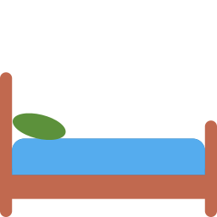  2 ___________ |   3 ___________
  4 ____________ | 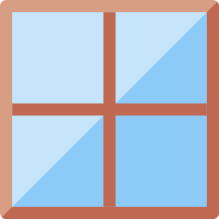  5 ___________ |   6 ___________

Part 2 · Grammar (8 points)
B Choose the correct word.
1 There (is / are) a lamp.
2 There (is / are) three chairs.
3 (Is / Are) there a garden?
4 The ball is (under / in) the chair.
C Complete the sentences.
bedroom · isn't · Are · aren't · bathroom · kitchen

1 I sleep in the ___________.
2 We cook in the ___________.
3 There ________ a garden.
4 ________ there any windows?
Part 3 · Reading and writing (6 points)
D Read and answer.
Jasur's house
Jasur lives in a house. There are four rooms and a garden. There is a lamp in his bedroom. There isn't a TV in the kitchen.

1 How many rooms are there?

2 Is there a garden?

3 Is there a TV in the kitchen?

E Put the words in the right order.
1 There / is / sofa. / a

2 lamp? / the / is / Where

3 the / window. / to / The / next / bed / is

Score: ________ / 20

