Unit 3 · My home — Worksheet A
Rooms and furniture · Destination A1 · Grade 3

Name: ______________________________ Class: ________ Date: ______________
A Look and write the words.
door · bathroom · garden · bedroom · kitchen · window · sofa · living room

  1 _______________ | 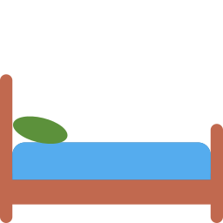  2 ___________ |   3 ___________ |   4 ____________
  5 ___________ |   6 ___________ | 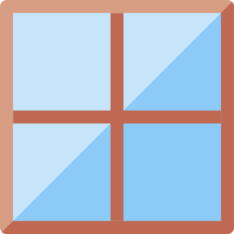  7 ___________ |   8 ___________

B Match the sentence to the place.
1 You sleep here. ____ | A living room
2 You cook here. ____ | B kitchen
3 You wash here. ____ | C bedroom
4 You watch TV here. ____ | D garden
5 You play outside here. ____ | E bathroom
6 You sit here. ____ | F sofa

C Look and complete the words.
1 k_tch_n  ___________ | 2 b_dr__m  ___________ | 3 b_thr__m  ____________
4 w_nd_w  __________ | 5 g_rd_n  __________ | 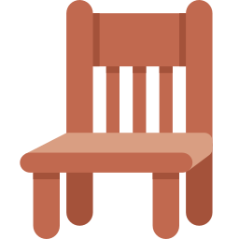  6 ch__r  ________

D Find eight words.
Find these words (→ ↓ ↘)
KITCHEN BEDROOM BATHROOM GARDEN WINDOW DOOR SOFA LAMP

F | K | L | G | R | V | B | F | Q | B | U
E | F | H | T | T | D | E | I | N | A | C
W | I | N | D | O | W | D | B | U | T | Z
S | W | E | Z | S | D | R | A | U | H | G
Y | X | I | G | A | S | O | K | D | R | A
D | R | M | E | B | O | O | I | O | O | R
Y | A | L | B | B | N | M | T | O | O | D
R | N | Y | S | O | F | A | C | R | M | E
M | K | C | G | L | E | H | H | R | M | N
M | L | T | A | O | W | V | E | L | N | M
Y | O | L | A | M | P | V | N | S | K | F

E Circle the odd one out.
1 | sofa | chair | lamp | kitchen
2 | bedroom | bathroom | kitchen | window
3 | door | window | sofa | banana

F Draw a plan of your home. Label four rooms.
My home

Score: ________ / 23

