Unit 3 · My home — Worksheet B
there is / are, prepositions, reading, writing · Destination A1 · Grade 3

Name: ______________________________ Class: ________ Date: ______________
A Choose the correct word (A, B or C).
1 There (is / are / am) a sofa in the living room.
2 There (is / are / am) two windows.
3 The lamp is (on / in / under) the table.
4 I sleep in the (bedroom / kitchen / garden).
5 We cook in the (kitchen / bathroom / bedroom).
6 My bed is (next to / between / under) the window.
B Complete the sentences with words from the box.
on · next to · behind · in · under

1  The ball is ________ the box.
2 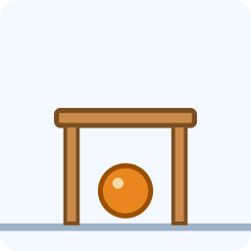 The ball is ________ the table.
3 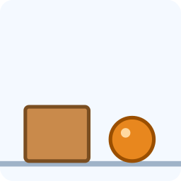 The ball is ___________ the box.
4 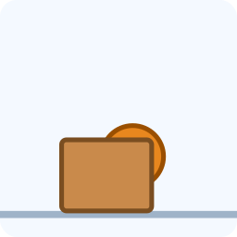 The ball is __________ the box.
C Put the words in the right order.
1 There / is / sofa. / a

2 windows. / two / are / There

3 garden? / there / Is / a

4 table. / the / The / on / is / lamp

D Read and answer.
My flat
I live in a flat in Tashkent. There are three rooms: a living room, a bedroom and a kitchen.
There is a big sofa and a TV in the living room. My bed is next to the window. There isn't a garden.

1 How many rooms are there?

2 Where is the sofa?

3 Is there a garden?

E Write about your home or your dream home.
Help box
There is a ___ .
There are ___ ___ .
My ___ is next to the ___ .
There isn't a ___ .

Score: ________ / 20

