Unit 5 · Hobbies and pastimes — Lesson plans
3 lessons × 45 minutes · Destination A1 · Grade 3

Adapted for Grade 3 (age 8–9, CEFR A1): the topic follows a unit of Destination A1 (grammar and vocabulary practice); all exercises, pictures and texts are new.
Unit at a glance
In the book | Destination A1, Unit 6 — Vocabulary: Hobbies and pastimes
Topic | What I like doing in my free time
Vocabulary | play chess, play football, go cycling, go swimming, read books, draw pictures, dance, sing, play computer games, go fishing
Grammar | • like / love / enjoy / hate + verb-ing: I like dancing.  • play + game, go + -ing activity, read / draw / sing: collocations  • What do you like doing? · Do you like reading? — Yes, I do.

Vocabulary
 | English | O'zbekcha
 | play chess | shaxmat o'ynamoq
 | play football | futbol o'ynamoq
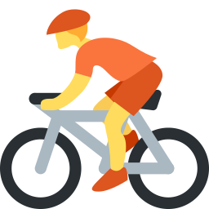 | go cycling | velosipedda sayr qilmoq
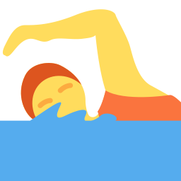 | go swimming | suzishga bormoq
 | read books | kitob o'qimoq
 | draw pictures | rasm chizmoq
 | dance | raqsga tushmoq
 | sing | qo'shiq aytmoq
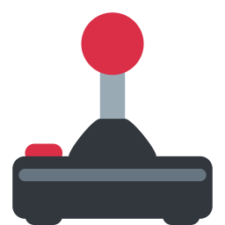 | play computer games | kompyuter o'yinlarini o'ynamoq
 | go fishing | baliq ovlashga bormoq

Extra words used in the lessons
 | English | O'zbekcha
 | like | yoqtirmoq
 | love | juda yaxshi ko'rmoq
 | enjoy | zavqlanmoq
 | hate | yomon ko'rmoq

Lesson 1: My free time
Focus | Vocabulary — ten hobbies; play / go collocations
Aims (by the end of the lesson pupils can…) | • name ten hobbies  • use play, go and other verbs with the right hobby
Key language | • play chess / football / computer games · go cycling / swimming / fishing · read books · draw pictures · dance · sing
Materials | • Flashcards (games/flashcards.pdf)  • Word card (grammar-card.pdf)  • Worksheet A exercises A, B, E
Time | 45 minutes

Min | Stage | What happens | Interaction
3 | Greeting & organisation | Ask 'What do you do in your free time?' and write answers in two columns (play / go). | T-Ss
5 | Warm-up | Charades: pupils mime hobbies; the class guesses 'You play chess!' | T-Ss
10 | Presentation | Present the ten flashcards with actions. Group them by verb: play (chess, football, computer games), go (cycling, swimming, fishing), others. | T-Ss
12 | Controlled practice | Worksheet A exercises A (label), B (match with Uzbek) and C (play / go / – circle). | S / Ss-Ss
10 | Freer practice / production | Hobby bingo: pupils write five hobbies on a grid; the teacher mimes, pupils cross out. | Ss-Ss / G
5 | Wrap-up & homework | Teacher says the hobby; pupils say the full phrase. Homework. | T-Ss

Homework: Learn the ten phrases and draw your favourite hobby (Worksheet A exercise F).
Check learning: Check that pupils use play / go correctly.
Teacher tips (o'qituvchi uchun)
- 'play chess' (o'ynamoq) lekin 'go swimming' (-ga bormoq): fe'l hobbyga bog'liq — jadval qiling.
- 'draw pictures', 'read books' — fe'l o'zi yetarli (play / go yo'q).
- Support: pictures only. Extension: add 'play the guitar', 'do karate'.

Lesson 2: I like dancing
Focus | like / love / enjoy / hate + -ing
Aims (by the end of the lesson pupils can…) | • say what they like and don't like doing: I like dancing. I don't like fishing.  • ask and answer: Do you like swimming? — Yes, I do.
Key language | • I like / love / enjoy / hate + -ing  • Do you like …ing? — Yes, I do. / No, I don't.
Materials | • Hobby flashcards  • Emotion cards (like, love, enjoy, hate)  • Worksheet B exercises A–C
Time | 45 minutes

Min | Stage | What happens | Interaction
3 | Greeting & organisation | Ask 'Do you like swimming?' — thumbs up or down. | T-Ss
5 | Warm-up | Like line: pupils stand on a line from 'hate' to 'love' for each hobby you call. | T-Ss
10 | Presentation | Write the pattern: I like / love / enjoy / hate + verb-ing. Show -ing endings (dance → dancing, swim → swimming). Show questions and short answers. | T-Ss
12 | Controlled practice | Worksheet B exercises A (circle), B (fill in) and C (unscramble). | S / Ss-Ss
10 | Freer practice / production | Class survey: pupils ask three classmates 'What do you like doing?' and record answers in a table. | Ss-Ss / G
5 | Wrap-up & homework | Report: 'Aziz likes playing chess. Malika loves dancing.' Homework. | T-Ss

Homework: Write five sentences with like / love / enjoy / hate + -ing.
Check learning: Check -ing after like and he / she + s in the reports.
Teacher tips (o'qituvchi uchun)
- 'like' dan keyin fe'l + -ing: 'I like dance' — xato; 'I like dancing'.
- Report'da: He likes …: -s unutilmasin.
- Support: sentence frames. Extension: add reasons with 'because'.

Lesson 3: Hobby poster
Focus | Describe my hobbies in writing and speaking
Aims (by the end of the lesson pupils can…) | • write 4–5 sentences about their hobbies  • present a hobby poster to the class
Key language | • I love …ing. · I like …ing. · I don't like …ing. · I go … on Saturdays.
Materials | • Paper, crayons  • Worksheet B exercises D–E
Time | 45 minutes

Min | Stage | What happens | Interaction
3 | Greeting & organisation | Show an example poster ('My hobbies') with drawings and words. | T-Ss
5 | Warm-up | Guess my hobby: you give three clues; pupils guess. | T-Ss
10 | Presentation | Read the model text (Worksheet B exercise D) and underline like / love / enjoy + -ing. | T-Ss
12 | Controlled practice | Worksheet B exercises D (reading) and E (writing). | S / Ss-Ss
10 | Freer practice / production | Hobby poster: pupils draw their hobbies and write three sentences, then present them in groups. | S / G
5 | Wrap-up & homework | Gallery walk: pupils tick a hobby they also like. Homework. | G / T-Ss

Homework: Finish your poster and ask a family member about their hobbies.
Check learning: Poster rubric: hobbies (1), sentences (1), neatness (1).
Teacher tips (o'qituvchi uchun)
- Taqdimot: har bir bola 2–3 gap aytsin; xatolarni darhol tuzatmang, oxirida umumiy fikr bildiring.
- Support: gapped text. Extension: compare two friends' hobbies.

