Unit 5 · Hobbies and pastimes — Quick quiz
15 minutes · Destination A1 · Grade 3

Name: ______________________________ Class: ________ Date: ______________
Part 1 · Hobbies (6 points)
A Look and write the hobbies.
  1 _______________ |   2 _______________ | 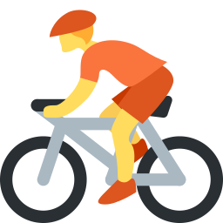  3 _______________
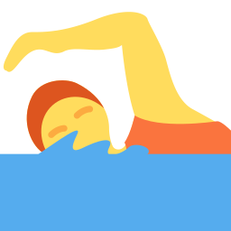  4 _______________ |   5 _______________ |   6 ___________

Part 2 · Grammar (8 points)
B Choose the correct word.
1 I like (swimming / swim).
2 She (loves / love) dancing.
3 Do you like (reading / read)?
4 We (play / go) chess.
C Write the -ing form.
1 I like ___________ (dance).
2 He enjoys ____________ (swim).
3 They love ___________ (play) football.
4 She hates ___________ (fish).
Part 3 · Reading and writing (6 points)
D Read and answer.
Dilnoza's hobbies
Dilnoza loves drawing pictures. She likes dancing too. She doesn't like playing computer games. On Sundays she goes cycling with her dad.

1 What does Dilnoza love?

2 Does she like computer games?

3 Who does she go cycling with?

E Put the words in the right order.
1 love / I / dancing.

2 swimming? / like / you / Do

3 fishing. / doesn't / She / like

Score: ________ / 20

