Unit 5 · Hobbies and pastimes — Worksheet A
Hobby words, play / go · Destination A1 · Grade 3

Name: ______________________________ Class: ________ Date: ______________
A Look and write the hobbies.
draw pictures · go swimming · read books · play football · go cycling · dance · go fishing · play chess

  1 _______________ |   2 _______________ | 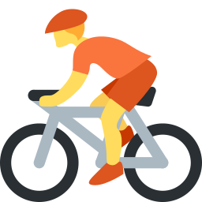  3 _______________ | 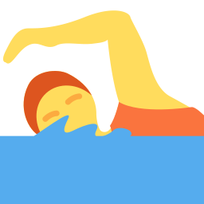  4 _______________
  5 _______________ | 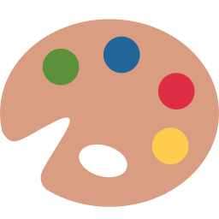  6 _______________ |   7 ___________ |   8 _______________

B Match the English phrase to the Uzbek phrase.
1 play chess ____ | A rasm chizmoq
2 go swimming ____ | B baliq ovlashga bormoq
3 read books ____ | C suzishga bormoq
4 go fishing ____ | D kitob o'qimoq
5 draw pictures ____ | E raqsga tushmoq
6 dance ____ | F shaxmat o'ynamoq

C Choose play, go or – (nothing).
1 I (play / go / –) chess.
2 She (play / goes / –) swimming.
3 They (play / go / –) football.
4 He (play / goes / –) fishing.
5 We (– / play / go) read books on Sundays.
6 I (play / go / –) draw pictures.
D Look and complete the words.
1 ch_ss  ________ | 2 f__tb_ll  ____________ | 3 sw_mm_ng  ____________
4 f_sh_ng  ___________ | 5 d_nc_  ________ |   6 s_ng  ________

E Find eight hobby words.
Find these words (→ ↓ ↘)
CHESS FOOTBALL SWIMMING FISHING DANCE SING READ DRAW

O | L | F | I | S | H | I | N | G | I
V | U | S | O | L | R | Y | V | E | P
N | K | W | F | F | D | R | A | W | R
C | Z | I | O | E | K | E | Y | O | E
E | D | M | O | W | Q | W | D | M | A
V | A | M | T | Q | Q | W | G | N | D
W | N | I | B | M | Y | D | M | L | Q
G | C | N | A | S | I | N | G | Z | S
M | E | G | L | H | G | K | P | Q | S
J | P | X | L | C | H | E | S | S | D

F Draw your favourite hobby. Write: I love ___ing.
I love ________ ing.

Score: ________ / 26

