Unit 6 · School life — Worksheet A
Subjects and school words · Destination A1 · Grade 3

Name: ______________________________ Class: ________ Date: ______________
A Look and write the words.
PE · Art · Music · English · Science · Geography · homework · Maths

  1 ___________ |   2 ___________ |   3 ___________ |   4 ___________
  5 ___________ |   6 ___________ |   7 ______________ |   8 ____________

B Match the subject to what you do.
1 You paint. ____ | A Art
2 You sing. ____ | B Geography
3 You run and jump. ____ | C PE
4 You count. ____ | D Maths
5 You learn about countries. ____ | E Music
6 You learn about plants and animals. ____ | F Science

C Look and complete the words.
1 sc__nc_  ___________ | 2 g__gr_phy  ______________ | 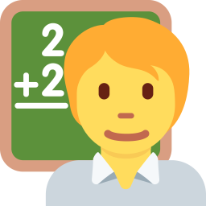  3 t__ch_r  ___________
  4 p_p_l  ________ | 5 h_m_w_rk  ____________ | 6 engl_sh  ___________

D Find eight words.
Find these words (→ ↓ ↘)
MATHS ENGLISH SCIENCE ART MUSIC GEOGRAPHY TEACHER PUPIL

P | N | Y | D | B | T | S | S | E | F
L | A | Q | G | Y | E | Q | C | N | N
V | U | E | E | Q | A | R | I | G | S
H | Q | F | O | M | C | E | E | L | T
U | L | P | G | G | H | W | N | I | O
M | L | U | R | A | E | H | C | S | M
U | X | P | A | C | R | T | E | H | N
S | Z | I | P | A | U | J | G | X | A
I | Z | L | H | M | A | T | H | S | J
C | U | D | Y | G | A | R | T | O | E

E Circle the odd one out.
1 | Maths | Art | Music | teacher
2 | Art | Music | PE | Monday
3 | easy | difficult | fun | Music

F Draw your favourite subject. Write: My favourite subject is ___ .
My favourite subject

Score: ________ / 23

