Unit 7 · Food and shopping — Lesson plans
3 lessons × 45 minutes · Destination A1 · Grade 3

Adapted for Grade 3 (age 8–9, CEFR A1): the topic follows a unit of Destination A1 (grammar and vocabulary practice); all exercises, pictures and texts are new.
Unit at a glance
In the book | Destination A1, Units 22–24 — Countable and uncountable nouns; Vocabulary: Food and shopping
Topic | Buying food: quantities and prices
Vocabulary | bread, milk, cheese, rice, eggs, apples, tomatoes, potatoes, water, juice
Grammar | • countable (eggs, apples) and uncountable (milk, bread): some, any, a kilo of, a bottle of …  • How much is it? — It's 4,000 sum. · How much are the apples? — They're 10,000 sum.  • I'd like a loaf of bread, please. · Can I have …?

Vocabulary
 | English | O'zbekcha
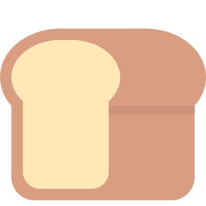 | bread | non
 | milk | sut
 | cheese | pishloq
 | rice | guruch
 | eggs | tuxumlar
 | apples | olmalar
 | tomatoes | pomidorlar
 | potatoes | kartoshkalar
 | water | suv
 | juice | sharbat

Extra words used in the lessons
 | English | O'zbekcha
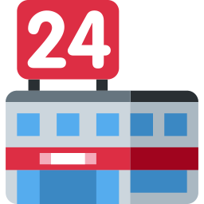 | shop | do'kon
 | money | pul
 | a kilo of | bir kilo
 | a bottle of | bir shisha
 | a packet of | bir paket
 | a loaf of | bir bo'lak (non)
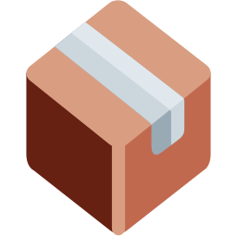 | a box of | bir quti
 | sum | so'm

Lesson 1: Food words
Focus | Vocabulary — ten food and drink words; countable and uncountable
Aims (by the end of the lesson pupils can…) | • name ten foods and drinks  • say if a noun is countable (eggs) or uncountable (milk)
Key language | • bread, milk, cheese, rice, eggs, apples, tomatoes, potatoes, water, juice  • some · any
Materials | • Flashcards (games/flashcards.pdf)  • Word card (grammar-card.pdf)  • Worksheet A exercises A, E
Time | 45 minutes

Min | Stage | What happens | Interaction
3 | Greeting & organisation | Ask 'What do you have for breakfast?' and write answers on the board. | T-Ss
5 | Warm-up | Feel and guess: pupils touch real food or toys in a bag and guess the word. | T-Ss
10 | Presentation | Present the flashcards. Sort them into two columns: things we can count (eggs, apples) and things we can't (milk, rice). | T-Ss
12 | Controlled practice | Worksheet A exercises A (label), B (match quantities), C (complete the words) and E (odd one out). | S / Ss-Ss
10 | Freer practice / production | My shopping basket: pupils draw a basket with five items and say 'I've got some bread and two apples.' | Ss-Ss / G
5 | Wrap-up & homework | Teacher says a word; pupils say 'countable' or 'uncountable'. Homework. | T-Ss

Homework: Learn the words; draw your breakfast (Worksheet A exercise F).
Check learning: Check pupils' sorting into countable and uncountable.
Teacher tips (o'qituvchi uchun)
- 'non', 'sut', 'guruch', 'suv' — sanalmaydigan; 'two breads' xato. 'a loaf of bread' deb ayting.
- Ko'plik: tomato → tomatoes, potato → potatoes (-es). Eslatib o'ting.
- Support: pictures only. Extension: add 'honey', 'sugar'.

Lesson 2: How much? A kilo of…
Focus | Quantities and prices: a kilo of, a bottle of, a packet of, a loaf of; How much is it?
Aims (by the end of the lesson pupils can…) | • use a kilo of, a bottle of, a packet of, a loaf of, a box of  • ask and answer about prices in sum
Key language | • a kilo of apples · a bottle of milk · a packet of rice · a loaf of bread · a box of eggs  • How much is it? — It's 4,000 sum.
Materials | • Price tags (in sum) for pictures or real items  • Worksheet A exercise B; Worksheet B exercises A–B
Time | 45 minutes

Min | Stage | What happens | Interaction
3 | Greeting & organisation | Hold up a price tag: 'How much is the bread? It's 4,000 sum.' | T-Ss
5 | Warm-up | Price guess: pupils guess the price of an item; closest wins. | T-Ss
10 | Presentation | Show each quantity phrase with a picture. Write 'How much is it?' and 'How much are they?' with answers. | T-Ss
12 | Controlled practice | Worksheet A exercise B (match) and Worksheet B exercises A (circle) and B (complete the dialogue). | S / Ss-Ss
10 | Freer practice / production | Price chain: pupils pass a tag around: 'How much are the apples?' — 'They're 10,000 sum.' | Ss-Ss / G
5 | Wrap-up & homework | Teacher says a price; pupils say what it could be. Homework. | T-Ss

Homework: Make a price list of five items at home or in a shop.
Check learning: Check it's / they're with prices.
Teacher tips (o'qituvchi uchun)
- 'How much is the bread?' (birlik) / 'How much are the apples?' (ko'plik) — is / are farqiga e'tibor bering.
- Raqam: 4,000 = four thousand. Katta sonlarni sekin o'qing.
- Support: price tags with numbers written in words. Extension: add change (change — qaytim).

Lesson 3: At the shop
Focus | Role-play: I'd like … Can I have …? How much is it?
Aims (by the end of the lesson pupils can…) | • buy and sell food in a role-play  • write a short shop dialogue
Key language | • Can I help you? — I'd like a loaf of bread, please. — Here you are. — How much is it?
Materials | • Play money (sum)  • Food picture cards  • Worksheet B exercises C–E
Time | 45 minutes

Min | Stage | What happens | Interaction
3 | Greeting & organisation | Set up a shop corner with cards and play money. 'Welcome to my shop!' | T-Ss
5 | Warm-up | Shopkeeper's memory: pupils name items on the table; you cover one — which is missing? | T-Ss
10 | Presentation | Model the dialogue with a volunteer. Write the key phrases on the board. | T-Ss
12 | Controlled practice | Worksheet B exercises C (unscramble), D (reading) and E (writing a dialogue). | S / Ss-Ss
10 | Freer practice / production | Shop role-play: pairs swap roles (shopkeeper / customer) and buy three things each. | Ss-Ss
5 | Wrap-up & homework | Volunteers perform for the class; the class says what they bought. Homework. | T-Ss

Homework: Write a four-line shop dialogue.
Check learning: Observe I'd like / Can I have / How much in the role-play.
Teacher tips (o'qituvchi uchun)
- Muloyim iboralar: please, thank you, here you are. Ularni doim talab qiling.
- 'I'd like' = 'I would like' (istayman) — qisqartma sifatida o'rgating.
- Support: dialogue frame. Extension: add 'Anything else?'

