Unit 7 · Food and shopping — Quick quiz
15 minutes · Destination A1 · Grade 3

Name: ______________________________ Class: ________ Date: ______________
Part 1 · Food words (6 points)
A Look and write the words.
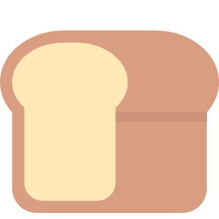  1 ___________ |   2 ___________ |   3 ___________
  4 ___________ |   5 ___________ |   6 ____________

Part 2 · Grammar (8 points)
B Choose the correct word.
1 I'd like (some / any) rice.
2 Have you got (some / any) cheese?
3 How (much / many) is the milk?
4 A (loaf / bottle) of bread.
C Complete the sentences.
like · any · are · some · How much

1 I'd ________ a kilo of tomatoes.
2 ____________ is the juice?
3 There aren't ________ eggs.
4 Here you ________.
Part 3 · Reading and writing (6 points)
D Read and answer.
Bobur's shopping
Bobur buys a packet of rice and a kilo of apples. The rice is 9,000 sum. The apples are 10,000 sum. There aren't any tomatoes.

1 What does Bobur buy?

2 How much is the rice?

3 Are there any tomatoes?

E Put the words in the right order.
1 Can / I / some / have / milk?

2 the / is / much / How / bread?

3 eggs. / aren't / There / any

Score: ________ / 20

