Unit 7 · Food and shopping — Worksheet A
Food words and quantities · Destination A1 · Grade 3

Name: ______________________________ Class: ________ Date: ______________
A Look and write the words.
apples · rice · eggs · milk · cheese · tomatoes · potatoes · bread

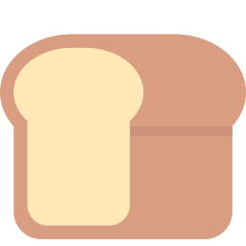  1 ___________ |   2 ___________ |   3 ___________ |   4 ___________
  5 ___________ |   6 ___________ | 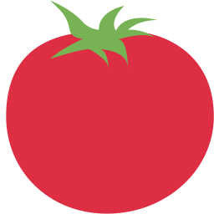  7 ____________ |   8 ____________

B Match the quantity to the food. Use each food once.
1 a kilo of ____ | A bread
2 a bottle of ____ | B eggs
3 a packet of ____ | C milk
4 a loaf of ____ | D apples
5 a box of ____ | E rice

C Look and complete the words.
1 ch__s_  __________ | 2 t_m_t__s  ____________ | 3 p_t_t__s  ____________
  4 j__c_  ________ |   5 w_t_r  ________ | 6 appl_s  __________

D Find eight food words.
Find these words (→ ↓ ↘)
BREAD MILK CHEESE RICE EGGS APPLES TOMATOES POTATOES

F | C | G | U | D | V | L | D | E | K
R | A | E | B | A | K | G | M | T | Y
N | E | T | K | O | P | T | I | O | N
G | R | I | C | E | T | W | L | M | P
P | C | H | E | E | S | E | K | A | F
P | O | T | A | T | O | E | S | T | W
B | R | E | A | D | E | Y | G | O | E
I | E | S | W | S | M | M | Y | E | K
O | V | F | T | E | G | G | S | S | W
I | X | A | P | P | L | E | S | U | W

E Circle the one you can count (the odd one out).
1 | milk | water | rice | apples
2 | eggs | apples | tomatoes | bread
3 | juice | cheese | potatoes | water

F Draw your shopping basket. Write: I'd like ___ .
My shopping basket

Score: ________ / 22

