Unit 8 · Weather and seasons — Quick quiz
15 minutes · Destination A1 · Grade 3

Name: ______________________________ Class: ________ Date: ______________
Part 1 · Weather words (6 points)
A Look and write the words.
  1 ___________ | 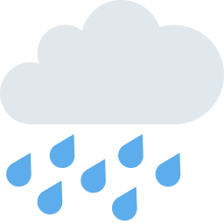  2 ___________ |   3 ___________
  4 ___________ |   5 ___________ |   6 ___________

Part 2 · Grammar (8 points)
B Choose the correct word.
1 It's (sunny / sun) today.
2 In winter it's (cold / hot).
3 What's the weather (like / is)?
4 I like summer (because / but) it's hot.
C Complete the sentences.
like · raining · in · summer · on · winter

1 What's the weather ________?
2 In __________ it's cold and snowy.
3 It's ___________ now.
4 We wear coats ________ winter.
Part 3 · Reading and writing (6 points)
D Read and answer.
Autumn
It is autumn. It is windy and cloudy. Aziz is flying a kite in the park. He is wearing a coat. He likes autumn because it is windy.

1 What's the weather like?

2 What is Aziz doing?

3 Why does he like autumn?

E Put the words in the right order.
1 sunny / It's / today.

2 like? / weather / the / What's

3 winter. / I / like

Score: ________ / 20

