Unit 8 · Weather and seasons — Worksheet A
Weather and seasons · Destination A1 · Grade 3

Name: ______________________________ Class: ________ Date: ______________
A Look and write the weather words.
hot · cloudy · snowy · rainy · windy · cold · stormy · sunny

  1 ___________ |   2 ___________ |   3 ___________ |   4 ___________
  5 ___________ |   6 ___________ |   7 ___________ | 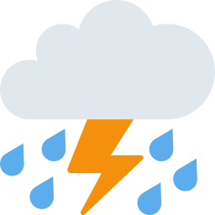  8 ___________

B Match the season to the weather.
1 In spring ____ | A it's cold and snowy.
2 In summer ____ | B it's windy and cloudy.
3 In autumn ____ | C it's warm and rainy.
4 In winter ____ | D it's hot and sunny.

C Look and complete the words.
1 s_nny  ________ | 2 cl__dy  __________ | 3 w_ndy  ________
  4 s_mm_r  __________ | 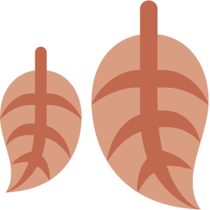  5 a_t_mn  __________ |   6 w_nt_r  __________

D Find eight words.
Find these words (→ ↓ ↘)
SUNNY RAINY WINDY CLOUDY SNOWY SPRING SUMMER AUTUMN

L | N | R | S | U | M | M | E | R | Y
Y | N | J | S | B | V | Y | U | N | W
K | C | H | R | A | I | N | Y | D | B
U | P | T | A | U | T | U | M | N | E
I | F | E | B | I | D | K | H | A | N
H | Q | S | U | N | N | Y | F | W | A
E | S | N | O | W | Y | G | A | I | V
A | S | P | R | I | N | G | C | N | G
V | C | C | L | O | U | D | Y | D | C
J | C | W | G | B | P | L | C | Y | L

E Circle the odd one out.
1 | sunny | rainy | windy | Monday
2 | spring | summer | autumn | March
3 | hot | cold | warm | apple

F Draw the weather today. Write: It's ___ .
Today it's ________ .

Score: ________ / 21

