Unit 9 · Clothes and appearance — Lesson plans
3 lessons × 45 minutes · Destination A1 · Grade 3

Adapted for Grade 3 (age 8–9, CEFR A1): the topic follows a unit of Destination A1 (grammar and vocabulary practice); all exercises, pictures and texts are new.
Unit at a glance
In the book | Destination A1, Units 27 and 33 — Vocabulary: Character and appearance; Clothes and fashion
Topic | What people wear and what they look like
Vocabulary | T-shirt, jeans, dress, cap, shoes, socks, coat, scarf, gloves, hat
Grammar | • He is wearing a blue T-shirt. · I'm wearing a coat.  • She has got long hair. · He has got brown eyes. · They haven't got hats.  • He is tall. · She is young. · Who is it?

Vocabulary
 | English | O'zbekcha
 | T-shirt | futbolka
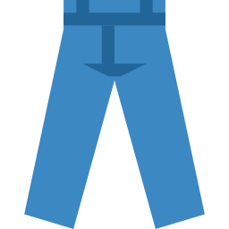 | jeans | jinsi
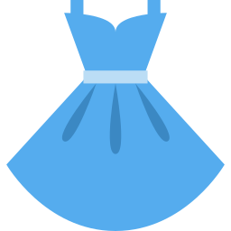 | dress | ko'ylak (qizlar uchun)
 | cap | kepka
 | shoes | poyabzal
 | socks | paypoq
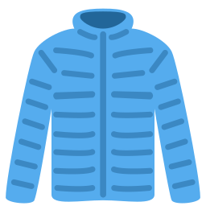 | coat | palto
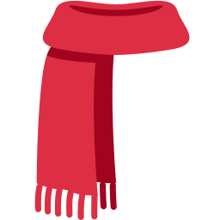 | scarf | sharf
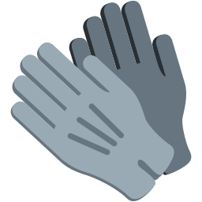 | gloves | qo'lqop
 | hat | shlyapa

Extra words used in the lessons
 | English | O'zbekcha
 | tall | baland bo'yli
 | short | past bo'yli
 | long hair | uzun soch
 | short hair | kalta soch
 | brown eyes | jigarrang ko'z
 | young | yosh
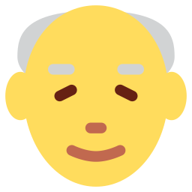 | old | keksa

Lesson 1: Clothes
Focus | Vocabulary — ten clothes words; He is wearing …
Aims (by the end of the lesson pupils can…) | • name ten clothes  • say what someone is wearing: He is wearing a blue cap.
Key language | • T-shirt, jeans, dress, cap, shoes, socks, coat, scarf, gloves, hat  • He / She is wearing …
Materials | • Flashcards (games/flashcards.pdf)  • Word card (grammar-card.pdf)  • Worksheet A exercises A, B
Time | 45 minutes

Min | Stage | What happens | Interaction
3 | Greeting & organisation | Ask 'What are you wearing today?' and write answers on the board. | T-Ss
5 | Warm-up | Who is wearing…? 'Stand up if you are wearing something blue.' Pupils respond with 'I'm wearing blue socks.' | T-Ss
10 | Presentation | Present the flashcards. Point out plural words (jeans, socks, shoes, gloves). | T-Ss
12 | Controlled practice | Worksheet A exercises A (label), B (match clothes and where we wear them), C (complete) and D (word search). | S / Ss-Ss
10 | Freer practice / production | Dress the doll: pairs dress a paper figure and describe it: 'It is wearing a red hat.' | Ss-Ss / G
5 | Wrap-up & homework | Teacher says a clothes word; pupils say the colour and put a counter on the matching picture. Homework. | T-Ss

Homework: Learn the words; draw yourself in your favourite clothes (Worksheet A exercise F).
Check learning: Point at cards for 5 pupils; note gaps.
Teacher tips (o'qituvchi uchun)
- 'jeans', 'socks', 'shoes', 'gloves' — doim ko'plik: 'These jeans are …' (this jeans emas).
- 'wear' (kiymoq, kiyib yurmoq) — 'put on' (kiyib olmoq) bilan aralashtirmang.
- Support: pictures only. Extension: add colours to each item.

Lesson 2: What does he look like?
Focus | Appearance: is / has got + tall, short, long hair, brown eyes, young, old
Aims (by the end of the lesson pupils can…) | • describe a person: He is tall. He has got short hair.  • use is / has got correctly
Key language | • He is tall. · She is young. · He has got brown eyes. · She hasn't got short hair.
Materials | • Pictures of people  • Worksheet A exercise E; Worksheet B exercises A–C
Time | 45 minutes

Min | Stage | What happens | Interaction
3 | Greeting & organisation | Show a picture: 'Who is this? What does he look like?' | T-Ss
5 | Warm-up | Describe and draw: you describe a face; pupils draw it. | T-Ss
10 | Presentation | Show the two patterns on the board: is + adjective; has got + hair / eyes. Colour them differently. | T-Ss
12 | Controlled practice | Worksheet B exercises A (circle), B (fill in) and C (unscramble). | S / Ss-Ss
10 | Freer practice / production | My partner: pupils describe their partner in three sentences and the partner says 'right' or 'wrong'. | Ss-Ss / G
5 | Wrap-up & homework | Quick-fire: teacher says a description; pupils say whether it fits a given picture. Homework. | T-Ss

Homework: Describe a family member in four sentences.
Check learning: Check is vs has got.
Teacher tips (o'qituvchi uchun)
- 'He has got long hair' — 'is' bilan emas! 'He is long hair' — keng tarqalgan xato.
- 'short' ikki ma'noli: past bo'yli (short) va kalta (short hair).
- Support: sentence frames. Extension: add colours of hair and eyes.

Lesson 3: Guess who?
Focus | Describe people and clothes in a guessing game and in writing
Aims (by the end of the lesson pupils can…) | • describe a person with clothes and appearance  • write 5 sentences about a friend
Key language | • He is tall. He has got short hair. He is wearing a red cap and jeans. Who is he?
Materials | • A picture of 6 people  • Worksheet B exercises D–E
Time | 45 minutes

Min | Stage | What happens | Interaction
3 | Greeting & organisation | Show the picture of 6 people: 'I'm thinking of one person.' | T-Ss
5 | Warm-up | Yes / no: pupils ask 'Is it a boy? Has he got short hair?' to guess. | T-Ss
10 | Presentation | Read the model text (Worksheet B exercise D) and underline is / has got / is wearing. | T-Ss
12 | Controlled practice | Worksheet B exercises D (reading) and E (writing). | S / Ss-Ss
10 | Freer practice / production | Guess who? In pairs: one pupil describes a classmate; the other guesses. | Ss-Ss
5 | Wrap-up & homework | Volunteers describe a classmate and the class guesses. Homework. | T-Ss

Homework: Describe a friend or family member and draw them.
Check learning: Mark Worksheet B exercise E for is / has got / is wearing.
Teacher tips (o'qituvchi uchun)
- O'yin paytida bolalar ismini aytmasin — faqat tasvir. Hurmat qoidasi: tashqi ko'rinish haqida xushmuomala gapiring.
- Support: gapped model text. Extension: add 'but' (He is tall but she is short).

