Unit 9 · Clothes and appearance — Quick quiz
15 minutes · Destination A1 · Grade 3

Name: ______________________________ Class: ________ Date: ______________
Part 1 · Clothes (6 points)
A Look and write the clothes.
  1 ___________ | 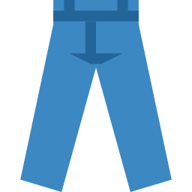  2 ___________ | 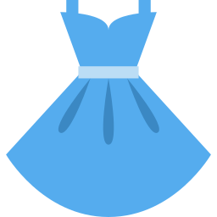  3 ___________
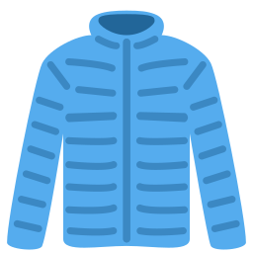  4 ___________ | 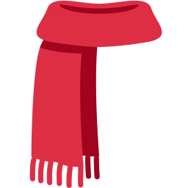  5 ___________ | 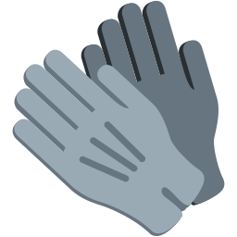  6 ___________

Part 2 · Grammar (8 points)
B Choose the correct word.
1 He (is / has) tall.
2 She (has / is) got long hair.
3 I (am / is) wearing a coat.
4 They (are / is) wearing gloves.
C Complete the sentences.
is · are · am · have · has

1 She ________ wearing a hat.
2 He ________ got brown eyes.
3 We ________ wearing jeans.
4 I ________ wearing socks.
Part 3 · Reading and writing (6 points)
D Read and answer.
My sister
My sister is young. She has got long hair and blue eyes. She is wearing a yellow dress and a white hat.

1 Is she young?

2 What colour are her eyes?

3 What is she wearing on her head?

E Put the words in the right order.
1 He / has / short / got / hair.

2 a / wearing / is / She / coat.

3 tall. / They / are

Score: ________ / 20

