Unit 9 · Clothes and appearance — Worksheet A
Clothes words · Destination A1 · Grade 3

Name: ______________________________ Class: ________ Date: ______________
A Look and write the clothes.
socks · cap · shoes · jeans · dress · coat · scarf · T-shirt

  1 ___________ | 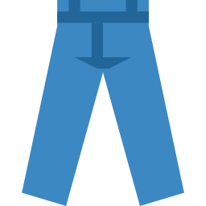  2 ___________ | 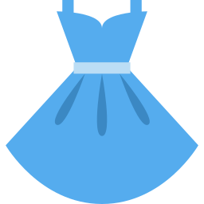  3 ___________ |   4 ___________
  5 ___________ |   6 ___________ | 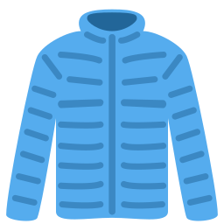  7 ___________ | 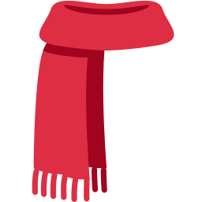  8 ___________

B Match the clothes to where we wear them.
1 You wear them on your feet. You take them off at the door. ____ | A scarf
2 You wear them on your hands. ____ | B socks
3 You wear it round your neck. ____ | C shoes
4 You wear them inside your shoes. ____ | D gloves
5 You wear it over your clothes when it's cold. ____ | E jeans
6 You wear them on your legs. ____ | F coat

C Look and complete the words.
1 j__ns  ________ | 2 sc_rf  ________ | 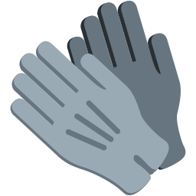  3 gl_v_s  __________
4 s_cks  ________ | 5 dr_ss  ________ | 6 c__t  ________

D Find eight clothes words.
Find these words (→ ↓ ↘)
JEANS SCARF GLOVES SOCKS DRESS COAT SHOES HAT

X | Y | D | R | E | S | S | S | L | M
S | C | A | R | F | B | J | H | C | Y
G | R | T | Y | T | J | F | O | O | W
K | L | J | E | A | N | S | E | U | S
H | W | O | U | A | M | W | S | Z | L
T | A | S | V | G | H | P | F | Q | N
D | R | T | O | E | F | C | O | A | T
Q | P | E | Q | C | S | N | Z | M | L
J | R | X | N | W | K | P | C | K | I
X | X | O | J | W | J | S | X | R | P

E Circle the odd one out.
1 | jeans | dress | scarf | banana
2 | coat | gloves | scarf | window
3 | socks | shoes | cap | tall

F Draw yourself. Colour your clothes. Write: I am wearing ___ .
I am wearing ________ .

Score: ________ / 23

