Quarter 2 test
Unit 3 School days · Unit 4 My day · 40 points · 40 minutes · Guess What! · Grade 3

Name: ______________________________ Class: ________ Date: ______________
Part 1 · Listening (10 points)
A  Listen. Dilnoza talks about her day. Circle the times.
1 Get up: (7:00 / 8:00)
2 Go to school: (8:00 / 8:30)
3 Have lunch: (12:00 / 1:00)
4 Go home: (3:00 / 3:30)
5 Go to bed: (8:30 / 9:00)
B Listen and write T (true) or F (false).
1 They've got Science on Tuesday. | ( T ) ( F )
2 They've got PE on Wednesday. | ( T ) ( F )
3 They've got Music on Wednesday. | ( T ) ( F )
4 Lily has got swimming club on Friday. | ( T ) ( F )
5 They've got PE on Thursday. | ( T ) ( F )

Part 2 · Vocabulary (8 points)
C Look and write the phrases.
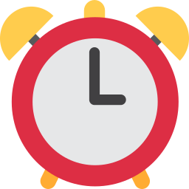  1 ___________ |   2 _______________ |   3 ___________ | 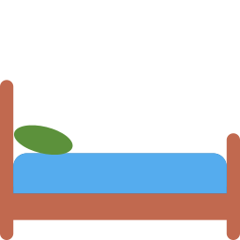  4 ______________

D Put the days in order (1–4).
[ ] | Friday
[ ] | Wednesday
[ ] | Thursday
[ ] | Tuesday

Part 3 · Grammar (10 points)
E Circle the correct word.
1 (Have / Has) we got Maths on Monday?
2 Has she got PE on Tuesday? — No, she (hasn't / haven't).
3 I (get / gets) up at seven o'clock.
4 What time (do / does) you go to school?
5 I go to bed at nine. — (So / Too) do I.
F Complete the sentences.
on · at · half past · have · in · don't · has

1 We've got Science ________ Wednesday.
2 What club ________ he got in the evening?
3 I have lunch ________ half past twelve.
4 It's 7:30. It's ______________ seven.
5 I go to bed at eight. — I ________. I go to bed at nine.
Part 4 · Reading (6 points)
G Read and answer.
Anna's week
Hi! I'm Anna. On Monday I've got Maths and English. I've got Art on Tuesday.
I get up at half past six on school days. I go to school at eight o'clock and I have lunch at one o'clock. In the evening I've got swimming club.

1 You are Anna. What have you got on Tuesday?

2 What time do you get up?

3 What club have you got in the evening?

H Put the words in the right order.
1 time / What / you / up? / do / get

2 got / Friday? / we / Art / Have / on

3 I. / So / do

Part 5 · Writing (6 points)
I Write 4–5 sentences about your school day.
Help box
On Monday I've got ___ and ___ .
I get up at ___ .
I go to school at ___ .
I've got ___ club on ___ .

Score: ________ / 40

