Final test (Quarter 4)
Unit 7 At the market · Unit 8 At the beach + the whole year · 40 points · 40 minutes · Guess What! · Grade 3

Name: ______________________________ Class: ________ Date: ______________
Part 1 · Listening (10 points)
A  Listen and write the numbers 1–5 in the boxes.
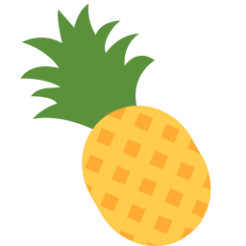  [ ] | 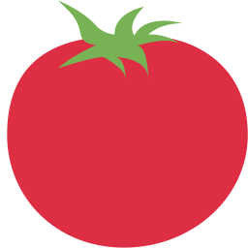  [ ] |   [ ] | 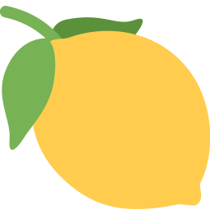  [ ] |   [ ]

B Listen and write T (true) or F (false).
1 The red towel is Anna's. | ( T ) ( F )
2 The blue towel is Lily's. | ( T ) ( F )
3 The yellow towel is Lily's. | ( T ) ( F )
4 There are some shells on the sand. | ( T ) ( F )
5 There are lots of burgers. | ( T ) ( F )

Part 2 · Vocabulary (8 points)
C Look and write the words.
  1 _______________ | 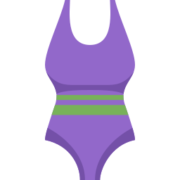  2 ____________ |   3 ___________ | 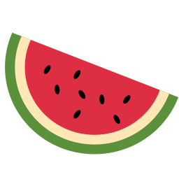  4 _______________

D Circle the odd one out.
1 | rabbit | snail | flower | tortoise
2 | library | gym | playground | juice
3 | karate | piano | badminton | towel
4 | Monday | Friday | January | Sunday

Part 3 · Grammar (10 points)
E Circle the correct word.
1 There (are / is) lots of grapes.
2 (Are / Is) there any pears? — No, there aren't.
3 Whose shorts are these? — They're (mine / my).
4 She (plays / play) the guitar on Saturdays.
5 What are they (doing / do)? — They're swimming.
F Complete the sentences.
any · theirs · at · some · Do · Does · Whose

1 There aren't ________ limes.
2 ________ towel is this? — It's hers.
3 Which towel is __________? — The purple one.
4 I get up ________ seven o'clock.
5 ________ he like swimming? — Yes, he does.
Part 4 · Reading (6 points)
G Read and answer.
A trip to the beach
It's a hot day. Bobur and his family are at the beach. There are lots of people on the sand.
Bobur's sister is in the sea. She's wearing her swimsuit. Bobur is eating a burger. His dad is reading a book. The blue towel is Dad's. It's his.

1 Where is Bobur's family?

2 What is Bobur eating?

3 Whose is the blue towel?

H Put the words in the right order.
1 Whose / jacket / this? / is

2 pears. / some / are / There

3 get / What / up? / you / time / do

Part 5 · Writing (6 points)
I Write a postcard from the beach (4–5 sentences).
Help box
Dear ___ ,
I'm at the beach. The sea is ___ .
There are lots of ___ . I'm ___ing.
Love, ___

Score: ________ / 40

