Unit 1 · In the garden — Quick quiz
15 minutes · Guess What! · Grade 3

Name: ______________________________ Class: ________ Date: ______________
Part 1 · Words (6 points)
A Look and write the words.
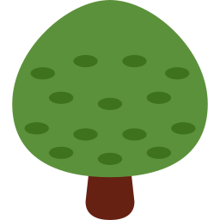  1 ___________ |   2 ___________ |   3 ______________
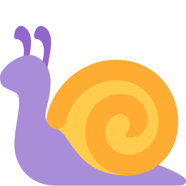  4 ___________ | 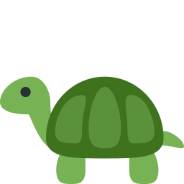  5 ____________ |   6 ___________

Part 2 · Grammar (8 points)
B Circle the correct word.
1 Lily has a rabbit. (Her / His) rabbit is white.
2 We have a snail. (Our / Their) snail is slow.
3 What (are / is) those? They're flowers.
4 (What's / What are) that? It's a tree.
C Complete the sentences.
His · What are · Their · Her · What's

1 Max has a tortoise. ________ tortoise is old.
2 __________ that? — It's a butterfly.
3 ____________ those? — They're leaves.
4 Anna and Lily have a pet. ________ pet is a guinea pig.
Part 3 · Reading and writing (6 points)
D Read and answer.
Tom's pet
Tom has a pet. It is a rabbit. Its name is Fluffy. His rabbit is big and brown. Fluffy eats grass and green leaves.

1 What is Tom's pet?

2 What is its name?

3 What does it eat?

E Put the words in the right order.
1 Her / pet / a / is / snail.

2 are / What / those?

3 leaf. / a / It's / green

Score: ________ / 20

