Unit 1 · In the garden — Worksheet A
Words · Guess What! · Grade 3

Name: ______________________________ Class: ________ Date: ______________
A Look and write the words.
flower · rabbit · butterfly · leaf · caterpillar · tortoise · snail · tree

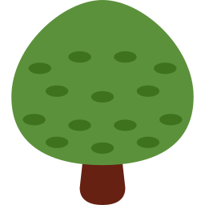  1 ___________ |   2 ___________ |   3 _______________ |   4 ___________
  5 ______________ |   6 ___________ | 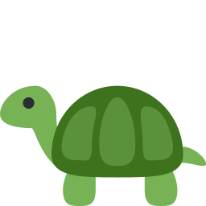  7 ____________ | 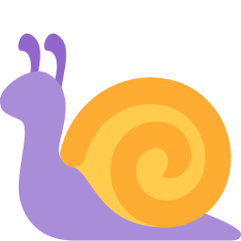  8 ___________

B Match the English words to the Uzbek words.
1 tree ____ | A salyangoz
2 rabbit ____ | B daraxt
3 snail ____ | C quyon
4 leaf ____ | D gul
5 butterfly ____ | E kapalak
6 flower ____ | F barg

C Look and complete the words. Some letters are missing.
1 c_t_rp_ll_r  ________________ | 2 b_tt_rfly  ______________ | 3 t_rt__s_  ____________
4 r_bb_t  __________ | 5 sn__l  ________ |   6 gr_ss  ________

D Find the garden words.
Find these words (→ ↓ ↘)
TREE LEAF SNAIL RABBIT FLOWER GRASS BUTTERFLY TORTOISE CATERPILLAR

D | R | I | Q | B | K | D | N | M | L | D | Y
L | X | B | D | J | Y | O | Q | K | J | R | Q
E | C | A | T | E | R | P | I | L | L | A | R
A | T | R | E | E | Q | J | K | D | V | Q | G
F | L | Z | B | A | S | N | A | I | L | C | R
J | I | M | W | E | Y | X | W | N | X | W | A
P | T | O | R | T | O | I | S | E | O | J | S
D | B | M | T | W | H | M | B | T | K | D | S
P | H | E | H | C | W | X | R | J | Q | U | V
U | D | E | M | M | V | R | A | B | B | I | T
U | P | B | U | T | T | E | R | F | L | Y | Y
S | Y | S | L | Q | F | L | O | W | E | R | F

E Circle the odd one out.
1 | rabbit | tortoise | flower | snail
2 | tree | grass | butterfly | leaf
3 | snail | caterpillar | rabbit | leaf
4 | flower | tree | grass | tortoise

F Draw your garden. Label five things.
My garden

Score: ________ / 24

