Unit 2 · At school — Worksheet A
School places · Guess What! · Grade 3

Name: ______________________________ Class: ________ Date: ______________
A Look and write the places.
gym · classroom · science room · dining hall · library · art room · playground · reception

  1 ______________ |   2 _______________ |   3 ___________ |   4 ______________
  5 _______________ | 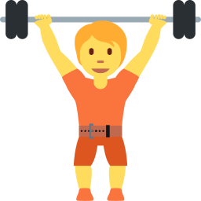  6 ___________ |   7 ____________ |   8 _______________

B Match the sentences to the places.
1 You read books here. ____ | A art room
2 You eat lunch here. ____ | B library
3 You play on the slide here. ____ | C dining hall
4 You run races and play football here. ____ | D gym
5 You paint pictures here. ____ | E science room
6 You sing songs here. ____ | F music room
7 You do experiments here. ____ | G sports field
8 You do gymnastics here. ____ | H playground

C Look and complete the words.
1 l_br_ry  ___________ | 2 cl_ssr__m  ______________ | 3 pl_ygr__nd  _______________
4 r_c_pt__n  ______________ | 5 sc__nc_  ___________ |   6 m_s_c  ________

D Find the school words.
Find these words (→ ↓ ↘)
LIBRARY CLASSROOM PLAYGROUND GYM RECEPTION SCIENCE MUSIC DINING

P | W | Q | C | P | D | T | W | L | U | M
K | R | P | L | I | T | H | D | I | C | U
T | E | L | Q | D | T | S | I | B | L | S
S | C | A | F | G | Y | C | N | R | A | I
U | E | Y | Y | N | X | I | I | A | S | C
U | P | G | Q | D | G | E | N | R | S | K
J | T | R | H | R | Y | N | G | Y | R | H
W | I | O | C | I | M | C | X | K | O | M
X | O | U | M | B | K | E | X | C | O | N
I | N | N | T | F | D | J | G | N | M | F
E | A | D | K | C | I | X | Q | I | G | A

E Circle the odd one out.
1 | library | classroom | sunflower | gym
2 | playground | sports field | garden | library
3 | paint | sing | run | library

F Draw your dream school. Label five places.
My dream school

Score: ________ / 25

