Unit 4 · My day — Quick quiz
15 minutes · Guess What! · Grade 3

Name: ______________________________ Class: ________ Date: ______________
Part 1 · Words (6 points)
A Look and write the phrases.
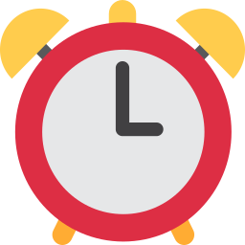  1 ___________ |   2 _______________ |   3 _______________
  4 _______________ | 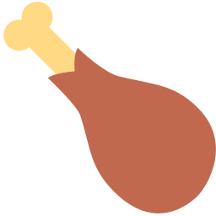  5 _______________ | 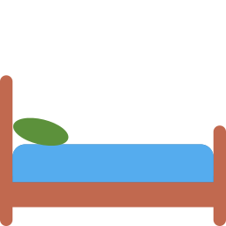  6 ______________

Part 2 · Grammar (8 points)
B Circle the correct word.
1 I (get / gets) up at half past seven.
2 What time (do / does) you go to school?
3 I have lunch (at / on) twelve o'clock.
4 I have breakfast at eight. — (So / Too) do I.
C Complete the sentences.
do · don't · nine · does · at

1 What time ________ you get up?
2 I go to school ________ eight o'clock.
3 I have dinner at six. — I ________. I have dinner at seven.
4 It's 9:30. It's half past ________.
Part 3 · Clocks and writing (6 points)
D Write the times.
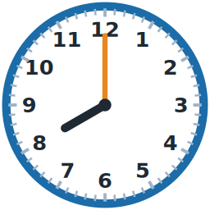  1 _______________ | 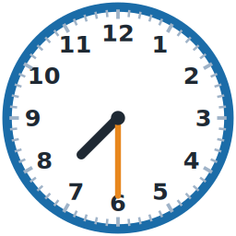  2 _______________ | 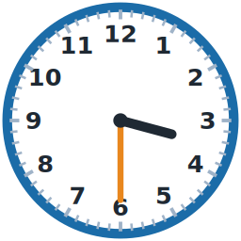  3 _______________

E Put the words in the right order.
1 time / What / you / up? / do / get

2 home / o'clock. / go / at / I / three

3 I. / So / do

Score: ________ / 20

