Unit 4 · My day — Worksheet A
Daily routines and clocks · Guess What! · Grade 3

Name: ______________________________ Class: ________ Date: ______________
A Look and write the phrases.
have lunch · clean my teeth · go to school · get dressed · have breakfast · have a shower · go to bed · get up

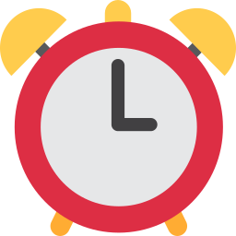  1 ___________ |   2 _______________ |   3 _______________ |   4 _______________
  5 _______________ |   6 _______________ |   7 _______________ | 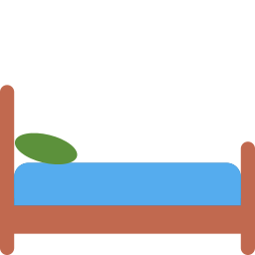  8 ______________

B Match the clocks to the times.
1 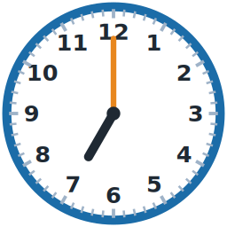 ____ | A half past eight
2 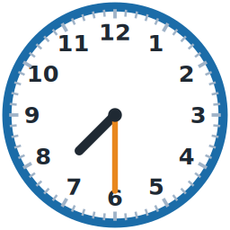 ____ | B eight o'clock
3 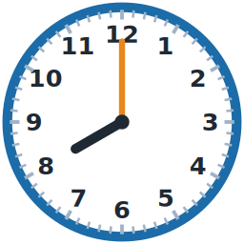 ____ | C seven o'clock
4 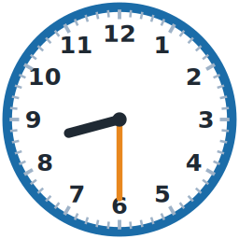 ____ | D half past three
5 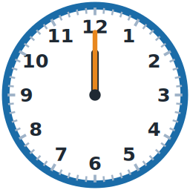 ____ | E twelve o'clock
6 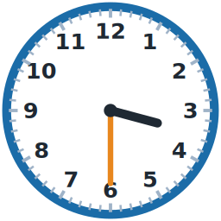 ____ | F half past seven

C Put the day in order (1–8).
[ ] | I have dinner.
[ ] | I have breakfast.
[ ] | I get dressed.
[ ] | I go to school.
[ ] | I go to bed.
[ ] | I go home.
[ ] | I get up.
[ ] | I have lunch.

D Look and complete the words.
1 br__kf_st  ______________ | 2 l_nch  ________ |   3 d_nn_r  __________
4 sh_w_r  __________ | 5 sch__l  __________ | 6 t__th  ________

E Find the words from the unit.
Find these words (→ ↓ ↘)
BREAKFAST DINNER LUNCH SCHOOL SHOWER TEETH DRESSED HOME

Y | X | D | I | N | N | E | R | U | Q | N
E | D | P | Z | L | E | D | E | J | S | S
E | R | B | Y | U | N | F | D | C | H | X
H | E | R | Z | N | Z | N | J | Q | O | U
O | S | E | W | C | U | Q | K | D | W | N
M | S | A | L | H | F | O | Z | R | E | C
E | E | K | S | C | H | O | O | L | R | T
X | D | F | V | P | A | A | W | B | W | E
N | R | A | M | O | A | J | J | X | I | E
H | F | S | V | Q | R | Q | P | U | V | T
X | Q | T | T | W | T | A | V | R | A | H

F Draw a clock. What time do you get up? Write the time.
I get up at ________ .

Score: ________ / 28

