Unit 4 · My day — Worksheet B
What time do you…? So do I / I don't · Guess What! · Grade 3

Name: ______________________________ Class: ________ Date: ______________
A Circle the correct words.
1 I (get / gets) up at seven o'clock.
2 What time (do / does) you have breakfast?
3 I go to school (at / in) eight o'clock.
4 It's 7:30. It's (half past / o'clock) seven.
5 I get up at seven. — (So / Too) do I.
6 I go to bed at nine. — I (don't / do). I go to bed at eight.
B Look at the clocks. Write the times.
twelve o'clock · half past three · half past eight · half past nine · six o'clock · seven o'clock

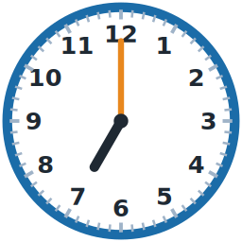  1 _______________ | 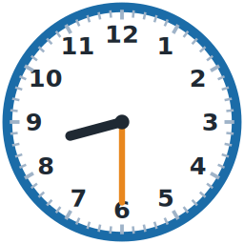  2 _______________ | 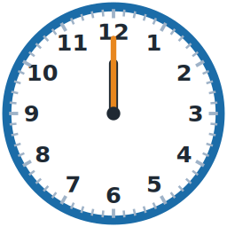  3 _______________
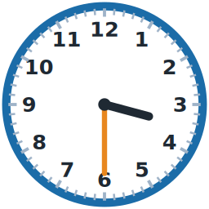  4 _______________ | 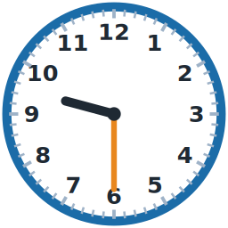  5 _______________ | 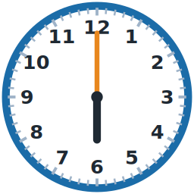  6 _______________

C Complete the dialogue with words from the box.
do · So · don't · does · at

1 What time ________ you get up?
2 I get up ________ seven o'clock.
3 I have breakfast at eight o'clock. — ________ do I.
4 I go to bed at nine o'clock. — I ________. I go to bed at half past eight.
D Put the words in the right order.
1 time / What / you / up? / do / get

2 up / o'clock. / get / at / I / seven

3 I. / So / do

4 o'clock. / twelve / I / at / lunch / have

E Read and answer.
Lucas's day
I get up at seven o'clock. I have breakfast at half past seven. I go to school at eight o'clock.
I have lunch at one o'clock. I go home at three o'clock. I have dinner at six o'clock and I go to bed at half past eight.

1 You are Lucas. What time do you get up?

2 What time do you have lunch?

3 What time do you go to bed?

F Write about your day.
Help box
I get up at ___ .
I have breakfast at ___ .
I go to school at ___ .
I go to bed at ___ .

Score: ________ / 26

