Unit 6 · Hobbies — Quick quiz
15 minutes · Guess What! · Grade 3

Name: ______________________________ Class: ________ Date: ______________
Part 1 · Words (6 points)
A Look and write the phrases.
  1 _______________ |   2 _______________ | 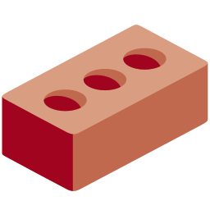  3 _______________
  4 ______________ |   5 _______________ |   6 _______________

Part 2 · Grammar (8 points)
B Circle the correct word.
1 She (does / do) gymnastics on Sundays.
2 Tom (plays / play) table tennis after school.
3 (Does / Do) he make films? — No, he doesn't.
4 Yes, she (does / do).
C Complete the sentences.
does · Does · doesn't · do · plays

1 She ________ karate in the evening.
2 He ________ the guitar on Saturdays.
3 ________ Lily make models? — Yes, she does.
4 No, he ___________.
Part 3 · Reading and writing (6 points)
D Read and answer.
Bobur's week
Bobur is very busy. He plays volleyball on Saturdays and does gymnastics on Sundays. He makes models on Mondays after school. He doesn't play on the computer in the evening.

1 When does Bobur play volleyball?

2 Does he do gymnastics on Sundays?

3 Does he play on the computer in the evening?

E Put the words in the right order.
1 She / plays / piano. / the

2 karate? / do / he / Does

3 badminton. / doesn't / He / play

Score: ________ / 20

