Unit 6 · Hobbies — Worksheet A
Hobbies and sports · Guess What! · Grade 3

Name: ______________________________ Class: ________ Date: ______________
A Look and write the phrases.
do karate · make models · make films · play the guitar · play the recorder · do gymnastics · play table tennis · play the piano

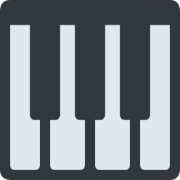  1 _______________ | 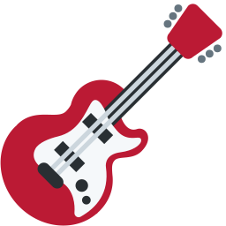  2 _______________ | 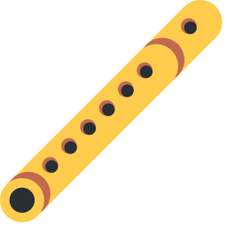  3 _______________ | 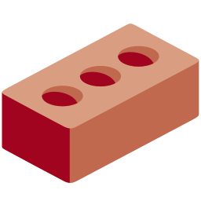  4 _______________
  5 _______________ | 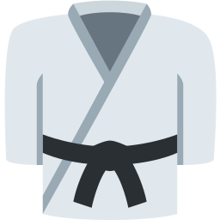  6 ______________ | 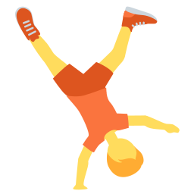  7 _______________ | 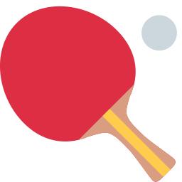  8 _______________

B Match the English phrases to the Uzbek phrases.
1 play the piano ____ | A kino suratga olmoq
2 do karate ____ | B voleybol o'ynamoq
3 make models ____ | C karate bilan shug'ullanmoq
4 play volleyball ____ | D pianino chalmoq
5 play the guitar ____ | E gitara chalmoq
6 make films ____ | F maketlar yasamoq

C Look and complete the words.
1 p__n_  ________ | 2 g__t_r  __________ | 3 k_r_t_  __________
4 gymn_st_cs  _______________ | 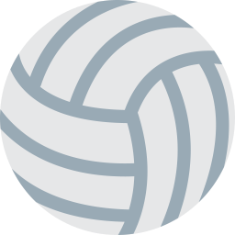  5 v_ll_yb_ll  _______________ | 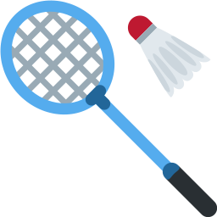  6 b_dm_nt_n  ______________

D Find the hobby words.
Find these words (→ ↓ ↘)
PIANO GUITAR RECORDER MODELS FILMS KARATE GYMNASTICS TENNIS BADMINTON VOLLEYBALL

W | S | V | A | T | K | M | O | D | E | L | S
G | D | H | G | E | R | S | R | V | B | J | D
C | L | C | Y | N | E | F | G | O | A | T | P
E | W | U | M | N | C | J | D | L | D | Z | I
Y | F | K | N | I | O | T | T | L | M | P | A
S | I | G | A | S | R | D | R | E | I | C | N
Y | L | U | S | S | D | I | U | Y | N | V | O
L | M | I | T | L | E | M | Q | B | T | A | K
K | S | T | I | T | R | L | A | A | O | O | C
X | L | A | C | T | O | H | H | L | N | B | R
I | F | R | S | Q | L | R | B | L | O | A | S
K | A | R | A | T | E | L | I | D | L | T | A

E Circle the correct verb: play, do or make.
1 I (play / do) the piano.
2 She (does / plays) karate.
3 We (make / play) models.
4 They (play / make) volleyball.
5 He (does / makes) gymnastics.
6 I (make / do) films.
F Draw your hobby.
My hobby: ________

Score: ________ / 26

