Unit 8 · At the beach — Worksheet A
Beach words · Guess What! · Grade 3

Name: ______________________________ Class: ________ Date: ______________
A Look and write the words.
shorts · sunglasses · swimsuit · burger · chips · shell · sea · sun

  1 ___________ | 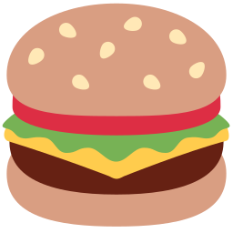  2 ___________ |   3 ___________ |   4 _______________
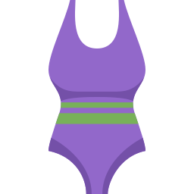  5 ____________ | 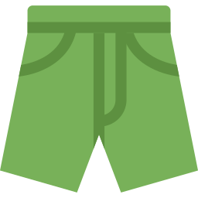  6 ___________ |   7 ___________ |   8 ___________

B Match the English words to the Uzbek words.
1 sun ____ | A chig'anoq
2 sand ____ | B shortik
3 sea ____ | C dengiz
4 shell ____ | D qum
5 towel ____ | E sochiq
6 shorts ____ | F quyosh

C Look and complete the words.
1 s_ngl_ss_s  _______________ | 2 sw_ms__t  ____________ | 3 sh_rts  __________
4 sh_ll  ________ | 5 b_rg_r  __________ | 6 ch_ps  ________

D Find the beach words.
Find these words (→ ↓ ↘)
BURGER CHIPS SUNGLASSES SWIMSUIT SHORTS TOWEL SHELL SEA SAND

S | P | R | T | Y | L | S | A | K | T | A | A
S | H | V | B | O | Z | C | S | A | N | D | V
S | U | O | L | F | W | X | H | G | T | P | N
S | O | N | R | C | G | E | D | I | T | O | B
W | T | S | G | T | J | N | L | L | P | K | U
I | A | G | E | L | S | O | R | Y | I | S | R
M | Q | R | U | A | A | F | S | K | Z | G | G
S | Q | V | F | M | A | S | L | H | J | D | E
U | B | D | N | A | F | G | S | A | E | F | R
I | M | W | L | D | A | D | G | E | M | L | G
T | K | O | E | P | U | F | X | U | S | R | L
U | D | R | I | Y | J | Q | Z | V | V | G | V

E Circle the odd one out.
1 | sun | sand | sea | burger
2 | shorts | swimsuit | sunglasses | chips
3 | burger | chips | shell | sandwich

F Draw a beach. Label five things.
At the beach

Score: ________ / 23

