English–Uzbek glossary
Guess What! Grade 3 · 141 words and phrases, A–Z · Guess What! · Grade 3

 | English | O'zbekcha | Unit
 | after school | darsdan keyin | U6
 | Anna | Anna (qiz bola) | Welcome
 | any | biron, hech qanday | U7
 | apples | olmalar | U7
 | April | aprel | Welcome
 | Art | tasviriy san'at | U3
 | Art room | tasviriy san'at xonasi | U2
 | August | avgust | Welcome
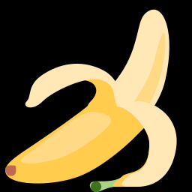 | bananas | bananlar | U7
 | brush your teeth | tishni tozalamoq | U4
 | burger | burger | U8
 | butterfly | kapalak | U1
 | cafeteria | oshxona, ovqatlanish zali | U2
 | carrots | sabzilar | U7
 | caterpillar | kapalak qurti | U1
 | chess club | shaxmat to'garagi | U3
 | classroom | sinf xonasi | U2
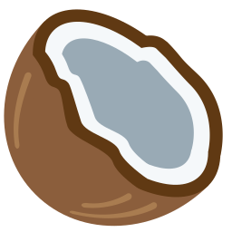 | coconuts | kokos yong'oqlari | U7
 | cucumbers | bodringlar | U7
 | December | dekabr | Welcome
 | do gymnastics | gimnastika bilan shug'ullanmoq | U6
 | do homework | uy vazifasini bajarmoq | U5
 | do karate | karate bilan shug'ullanmoq | U6
 | do the dishes | idish-tovoq yuvmoq | U5
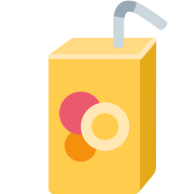 | drink juice | sharbat ichmoq | U5
 | eat a sandwich | buterbrod yemoq | U5
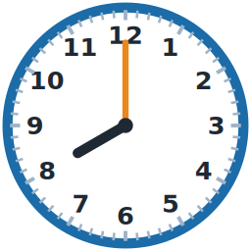 | eight o'clock | soat sakkiz (aniq) | U4
 | English | ingliz tili | U3
 | enjoy | zavqlanmoq | U5
 | February | fevral | Welcome
 | flower | gul | U1
 | Friday | juma | U3
 | fries | kartoshka fri | U8
 | get dressed | kiyinmoq | U4
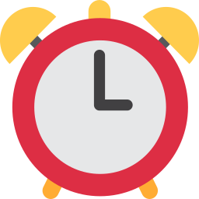 | get up | uyg'onmoq, o'rnidan turmoq | U4
 | glass | shisha | U2
 | go home | uyga qaytmoq | U4
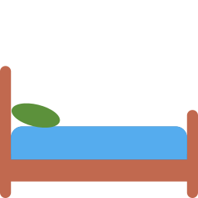 | go to bed | uxlashga yotmoq | U4
 | go to school | maktabga bormoq | U4
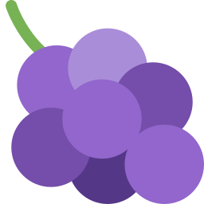 | grapes | uzum | U7
 | grass | o'tloq, maysa | U1
 | guinea pig | dengiz cho'chqasi | U1
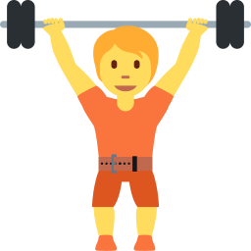 | gym | sport zali | U2
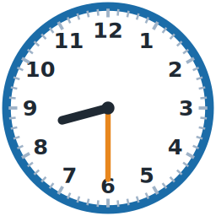 | half past eight | sakkiz yarim | U4
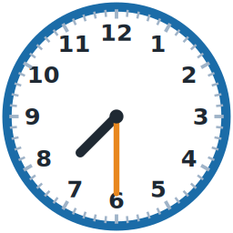 | half past seven | yetti yarim | U4
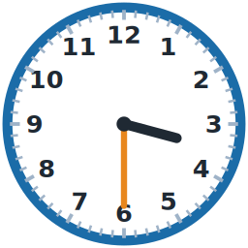 | half past three | uch yarim | U4
 | hate | yomon ko'rmoq | U5
 | have breakfast | nonushta qilmoq | U4
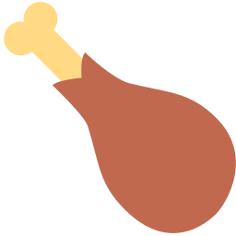 | have dinner | kechki ovqat yemoq | U4
 | have lunch | tushlik qilmoq | U4
 | hers | uniki (ayol) | U8
 | his | uniki (erkak) | U8
 | in the afternoon | tushdan keyin | U6
 | in the evening | kechqurun | U6
 | in the morning | ertalab | U6
 | January | yanvar | Welcome
 | July | iyul | Welcome
 | June | iyun | Welcome
 | leaf | barg | U1
 | lemons | limonlar | U7
 | library | kutubxona | U2
 | like | yoqtirmoq | U5
 | Lily | Lili (qiz bola) | Welcome
 | limes | laymlar (yashil limon) | U7
 | listen to music | musiqa tinglamoq | U5
 | lots of | ko'p | U7
 | love | juda yaxshi ko'rmoq | U5
 | Lucas | Lukas (o'g'il bola) | Welcome
 | make a cake | tort (kek) tayyorlamoq | U5
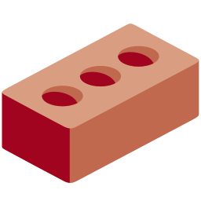 | make models | maketlar yasamoq | U6
 | make movies | kino (movie) suratga olmoq | U6
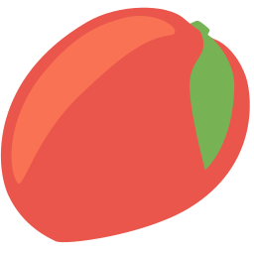 | mangoes | mangolar | U7
 | March | mart | Welcome
 | Math | matematika | U3
 | Max | Maks (o'g'il bola) | Welcome
 | May | may | Welcome
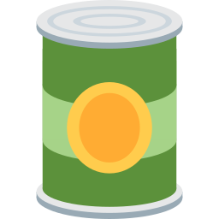 | metal | metall | U2
 | mine | meniki | U8
 | Monday | dushanba | U3
 | Music | musiqa | U3
 | Music room | musiqa xonasi | U2
 | November | noyabr | Welcome
 | ocean | okean | U8
 | October | oktabr | Welcome
 | on Saturdays | shanba kunlari | U6
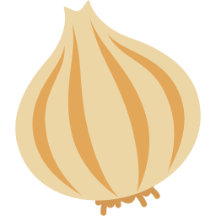 | onions | piyozlar | U7
 | ours | bizniki | U8
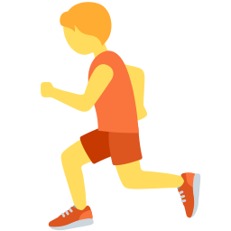 | P.E. | jismoniy tarbiya | U3
 | painting | rasm chizmoqda | U2
 | paper | qog'oz | U2
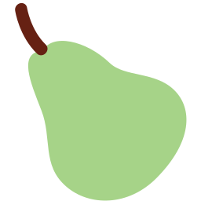 | pears | noklar | U7
 | pineapples | ananaslar | U7
 | plastic | plastmassa | U2
 | play badminton | badminton o'ynamoq | U6
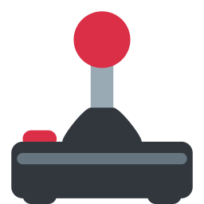 | play on the computer | kompyuterda o'ynamoq | U5
 | play ping-pong | stol tennisi o'ynamoq | U6
 | play the guitar | gitara chalmoq | U6
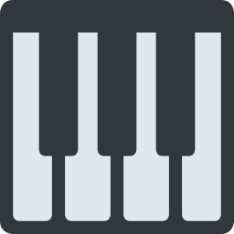 | play the piano | pianino chalmoq | U6
 | play the recorder | fleyta chalmoq | U6
 | play volleyball | voleybol o'ynamoq | U6
 | playground | o'yin maydonchasi | U2
 | potatoes | kartoshkalar | U7
 | purple | binafsha | U8
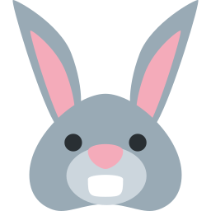 | rabbit | quyon | U1
 | read a book | kitob o'qimoq | U5
 | reading | o'qimoqda | U2
 | reception | qabulxona | U2
 | running | yugurmoqda | U2
 | sand | qum | U8
 | Saturday | shanba | U3
 | Science | tabiiy fan | U3
 | Science lab | fan (tabiiy fanlar) xonasi | U2
 | September | sentabr | Welcome
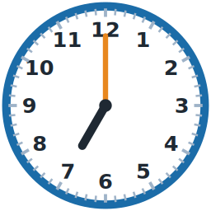 | seven o'clock | soat yetti (aniq) | U4
 | shell | chig'anoq | U8
 | shorts | shortik (kalta shim) | U8
 | singing | kuylamoqda | U2
 | snail | salyangoz | U1
 | some | bir nechta, ozgina | U7
 | sports field | sport maydoni | U2
 | sun | quyosh | U8
 | Sunday | yakshanba | U3
 | sunglasses | quyoshdan saqlovchi ko'zoynak | U8
 | swimming club | suzish to'garagi | U3
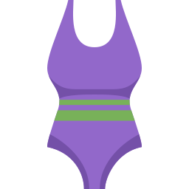 | swimsuit | cho'milish kiyimi | U8
 | take a shower | cho'milmoq, dush qabul qilmoq | U4
 | the purple one | binafsha rangdagisi | U8
 | theirs | ularniki | U8
 | Thursday | payshanba | U3
 | Tom | Tom (o'g'il bola) | Welcome
 | tomatoes | pomidorlar | U7
 | towel | sochiq | U8
 | tree | daraxt | U1
 | Tuesday | seshanba | U3
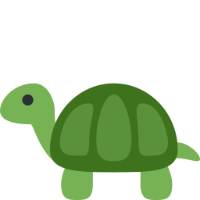 | turtle | toshbaqa | U1
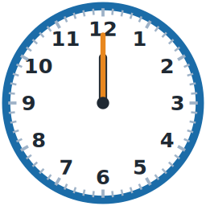 | twelve o'clock | soat o'n ikki (aniq) | U4
 | wash the car | mashinani yuvmoq | U5
 | watch TV | televizor ko'rmoq | U5
 | watermelons | tarvuzlar | U7
 | Wednesday | chorshanba | U3
 | yours | seniki, sizniki | U8

