Quarter 3 test
Unit 5 Home time · Unit 6 Hobbies · 40 points · 40 minutes · Guess What! · Grade 3

Name: ______________________________ Class: ________ Date: ______________
Part 1 · Listening (10 points)
A  Listen and write the numbers 1–5 in the boxes.
  [ ] |   [ ] |   [ ] |   [ ] | [ ]

B Listen and write T (true) or F (false).
1 Aziza plays the piano on Mondays. | ( T ) ( F )
2 She does gymnastics on Tuesdays. | ( T ) ( F )
3 She plays volleyball on Saturdays. | ( T ) ( F )
4 She plays ping-pong. | ( T ) ( F )
5 She makes movies on Sundays. | ( T ) ( F )

Part 2 · Vocabulary (8 points)
C Look and write the phrases.
  1 _______________ |   2 _______________ |   3 _______________ | 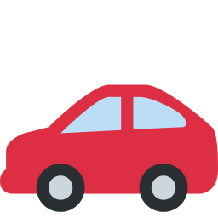  4 _______________

D Look and write the phrases.
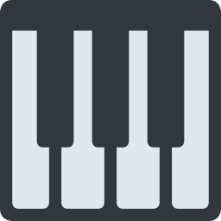  1 _______________ |   2 ______________ |   3 _______________ | 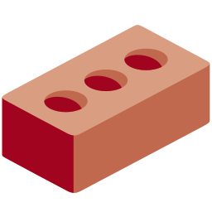  4 _______________

Part 3 · Grammar (10 points)
E Circle the correct word.
1 Tom (likes / like) washing the car.
2 She (doesn't / don't) enjoy doing homework.
3 (Does / Do) he like listening to music?
4 Lily (does / do) karate on Sundays.
5 (Does / Do) she play the guitar in the evening?
F Complete the sentences.
likes · Does · on · in · does · after · doesn't

1 My dad ________ making cakes.
2 He ___________ like washing the car.
3 ________ she enjoy reading? — No, she doesn't.
4 She plays the piano ________ Mondays.
5 Bobur plays volleyball ________ school.
Part 4 · Reading (6 points)
G Read and answer.
Dilya's Saturday
Dilya likes Saturdays. In the morning she does gymnastics. In the afternoon she makes a cake with her mom.
She doesn't like doing the dishes, but she enjoys listening to music. In the evening she plays the guitar.

1 What does Dilya do in the morning?

2 Does she like doing the dishes?

3 Does she play the guitar in the evening?

H Put the words in the right order.
1 he / Does / doing / dishes? / enjoy / the

2 on / karate / does / She / Sundays.

3 books. / He / reading / doesn't / like

Part 5 · Writing (6 points)
I Write 4–5 sentences about a friend or a family member.
Help box
My ___ likes ___ing.
He / She doesn't like ___ing.
He / She plays / does ___ on ___ .
Does he / she ...? Yes / No.

Score: ________ / 40

