Unit 2 · At school — Quick quiz
15 minutes · Guess What! · Grade 3

Name: ______________________________ Class: ________ Date: ______________
Part 1 · Words (6 points)
A Look and write the places.
  1 ___________ | 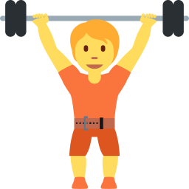  2 ___________ |   3 _______________
  4 ____________ |   5 ______________ |   6 _______________

Part 2 · Grammar (8 points)
B Circle the correct word.
1 Where (are / is) they? — They're on the sports field.
2 Tom and Max are (in / on) the gym.
3 What are you (doing / do)? — We're reading.
4 Lily (is / are) painting a picture.
C Complete the sentences.
Where · doing · are · is · singing

1 ________ is Anna? — She's in the library.
2 We're ___________ in the Music room.
3 What are they ________? — They're running.
4 The boys ________ playing soccer.
Part 3 · Reading and writing (6 points)
D Read and answer.
Break time
It is break time. Anna and Lily are in the library. They are reading books. Tom and Max are on the sports field. They are playing soccer. Mrs. Nazarova is in the cafeteria.

1 Where are Anna and Lily?

2 What are Tom and Max doing?

3 Where is Mrs. Nazarova?

E Put the words in the right order.
1 are / Where / they?

2 gym. / the / in / We're

3 book. / She / a / is / reading

Score: ________ / 20

