Unit 4 · My day — Lesson plans
8 lessons × 45 minutes · Guess What! · Grade 3

Unit at a glance
Topic | Daily routines and telling the time (o'clock, half past)
Vocabulary | get up, get dressed, have breakfast, brush your teeth, go to school, have lunch, go home, have dinner, take a shower, go to bed
Grammar | • I (have dinner) at (half past seven). What time do you (get up)? I (get up) at (seven o'clock).  • So do I. / I don't.
Skills | Reading: Do you have a healthy lifestyle?
Say it! (phonics) | ue / ew / oo — blue, chew, food
Story value | Take exercise
Talk time | Asking the time
CLIL | Math — What's the time around the world?
Review | Review Units 3 and 4

Vocabulary
 | English | O'zbekcha
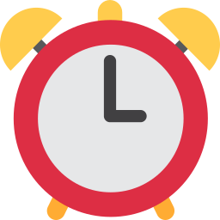 | get up | uyg'onmoq, o'rnidan turmoq
 | get dressed | kiyinmoq
 | have breakfast | nonushta qilmoq
 | brush your teeth | tishni tozalamoq
 | go to school | maktabga bormoq
 | have lunch | tushlik qilmoq
 | go home | uyga qaytmoq
 | have dinner | kechki ovqat yemoq
 | take a shower | cho'milmoq, dush qabul qilmoq
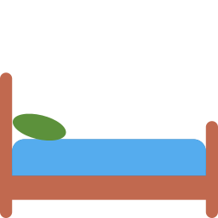 | go to bed | uxlashga yotmoq

Extra words used in the lessons
 | English | O'zbekcha
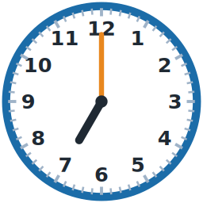 | seven o'clock | soat yetti (aniq)
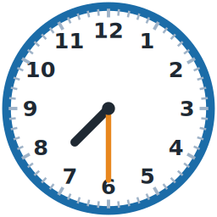 | half past seven | yetti yarim
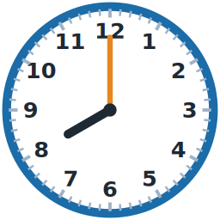 | eight o'clock | soat sakkiz (aniq)
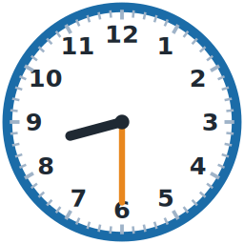 | half past eight | sakkiz yarim
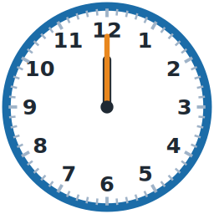 | twelve o'clock | soat o'n ikki (aniq)
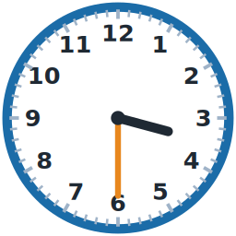 | half past three | uch yarim

Lesson 1: My day words
Focus | Vocabulary — ten daily routines
Aims (by the end of the lesson students can…) | • name ten daily routines  • say what they do: I get up. I go to school.
Key language | • get up, get dressed, have breakfast, brush your teeth, go to school, have lunch, go home, have dinner, take a shower, go to bed
Materials | • Flashcards  • Student's Book Vocabulary page + audio  • Worksheet A exercises A and C
Time | 45 minutes

Min | Stage | What happens | Interaction
3 | Greeting & organisation | Greet the class. Ask 'What time do you get up?' (answers in Uzbek are fine) and write My day on the board. | T-Ss
5 | Warm-up | Mime the morning: students stand and mime waking up, getting dressed, brushing teeth — you say the phrase and the class repeats and acts. | T-Ss
10 | Presentation | Present the ten cards in daily order with actions. Choral and individual repetition. Student's Book: *Listen and point*, *Listen, point and repeat*. | T-Ss
12 | Controlled practice | Worksheet A exercise A (label pictures) and C (put the day in order). Check with the cards on the board. | S / Ss-Ss
10 | Freer practice / production | Mime and guess in pairs: one student mimes a routine, the other says 'You get up!' Swap. | Ss-Ss / G
5 | Wrap-up & homework | Teacher says a routine; students do the action without speaking. Homework. | T-Ss

Homework: Learn the ten phrases. Draw your morning and label it (Worksheet A, exercise F).
Check learning: Point to cards at random for 5 students; note those who need review.
Teacher tips (o'qituvchi uchun)
- 'have breakfast / lunch / dinner' — 'have' + ovqat nomi. O'zbekchada 'nonushta qilmoq', lekin inglizchada 'eat' emas 'have' ishlatiladi.
- 'brush your teeth' — tishni cho'tka bilan tozalamoq ('clean' emas, 'brush'). Gapda: I brush my teeth. 'take a shower' — dush qabul qilmoq.
- Support: daily-order picture strip on the wall. Extension: add 'wash my face'.

Lesson 2: What time is it?
Focus | Telling the time (o'clock, half past) and the pattern I get up at seven o'clock
Aims (by the end of the lesson students can…) | • tell the time on the hour and the half hour  • say: I get up at seven o'clock. I have dinner at half past seven.
Key language | • What time is it? — It's (seven o'clock). / It's (half past seven).  • I (get up) at (seven o'clock).
Materials | • A big cardboard clock with moving hands  • Worksheet A exercise B, Worksheet B exercise B  • Clock faces (drawn by students)
Time | 45 minutes

Min | Stage | What happens | Interaction
3 | Greeting & organisation | Ask 'What time is it now?' Show the real classroom clock. | T-Ss
5 | Warm-up | Clock mime: use your arms as clock hands: 'It's three o'clock!' Students copy. | T-Ss
10 | Presentation | Teach o'clock first (minute hand on 12), then half past (minute hand on 6). Show each with the cardboard clock and say it three times. Then link to routines: 'I get up at seven o'clock.' | T-Ss
12 | Controlled practice | Worksheet A exercise B (match clocks and times) and Worksheet B exercise B (write the times). Student's Book time activities. | S / Ss-Ss
10 | Freer practice / production | Set the clock: pairs — A says 'half past eight', B sets their cardboard clock; then swap and add a routine: 'I go to school at half past eight.' | Ss-Ss / G
5 | Wrap-up & homework | Race: teacher says a time, students hold up the right clock drawn on mini-whiteboards. | T-Ss

Homework: Draw four clocks and write the times. Write two sentences: I … at …
Check learning: Check who confuses o'clock and half past.
Teacher tips (o'qituvchi uchun)
- O'zbekcha 'soat yetti yarim' = 7:30 = inglizcha 'half past seven'. So'zma-so'z o'xshash, shuning uchun o'quvchilar tez o'zlashtiradi.
- 'at' + vaqt: at seven o'clock. O'zbek tilidagi '-da' qo'shimchasiga mos keladi.
- Support: clock with numbers written. Extension: add 'a quarter past' (oral).

Lesson 3: What time do you get up?
Focus | Grammar — What time do you …? I … at …; So do I. / I don't.
Aims (by the end of the lesson students can…) | • ask and answer: What time do you get up? I get up at seven.  • agree or disagree: So do I. / I don't.
Key language | • What time do you (get up)? — I (get up) at (seven o'clock).  • So do I. / I don't.
Materials | • Routine flashcards + clocks  • Student's Book Grammar pages  • Worksheet B exercises A, C, D
Time | 45 minutes

Min | Stage | What happens | Interaction
3 | Greeting & organisation | Ask three students 'What time do you get up?' and write the answers on the board. | T-Ss
5 | Warm-up | Find someone who…: students stand and look for classmates who get up at the same time. | Ss-Ss
10 | Presentation | Model the dialogue with a student: 'I get up at seven.' — 'So do I.' — 'I get up at half past six.' — 'I don't. I get up at seven.' Write it on the board and mark So do I = the same / I don't = different. | T-Ss
12 | Controlled practice | Student's Book Grammar activities (listen and choose, then speak). Worksheet B exercises A (circle), C (fill) and D (unscramble). | S / Ss-Ss
10 | Freer practice / production | Class survey: students ask three classmates two questions and respond with So do I / I don't, then report: 'Aziz and I get up at seven.' | Ss-Ss
5 | Wrap-up & homework | Whole-class chain: 'I get up at … ' — next student 'So do I.' / 'I don't. I …'. Homework. | T-Ss

Homework: Workbook grammar page; ask a family member two questions and write the answers.
Check learning: Check do / don't, at + time and So do I in the survey.
Teacher tips (o'qituvchi uchun)
- 'So do I' = 'Men ham' (xuddi shunday); 'I don't' = 'Men esa yo'q'. O'zbek tilidagi 'men ham' bilan bog'lang.
- Ko'p xato: 'What time you get up?' (do tushib qoladi). Doskada savol sxemasini: What time + do + you.
- Support: sentence strips. Extension: add a reason: 'I get up at six because I go to school early.'

Lesson 4: A healthy lifestyle
Focus | Skills: Reading and writing — Do you have a healthy lifestyle?
Aims (by the end of the lesson students can…) | • read a short text about a day and answer questions  • write four sentences about their own day
Key language | • healthy · exercise · sleep · breakfast  • I get up at …, I go to bed at …
Materials | • Student's Book Reading page  • Worksheet B exercises E–F
Time | 45 minutes

Min | Stage | What happens | Interaction
3 | Greeting & organisation | Ask 'Are you healthy? What do you do to be healthy?' (answers in Uzbek and English). | T-Ss
5 | Warm-up | Healthy or not? Show picture cards (fruit, sweets, sport, computer); students show thumbs up or down. | T-Ss
10 | Presentation | Pre-reading: predict from the pictures and title. Read aloud once; students underline the times they hear. Check words: healthy, sleep, exercise. | T-Ss
12 | Controlled practice | Silent reading and questions (Student's Book, then Worksheet B exercise E). Check in pairs. | S / Ss-Ss
10 | Freer practice / production | Writing: using the frame in Worksheet B exercise F, students write four sentences about their day. Volunteers read aloud. | S
5 | Wrap-up & homework | Students swap texts and check 'healthy' things; class discusses what makes a healthy day. Homework. | Ss-Ss

Homework: Finish the writing; add one healthy idea ('I play soccer.').
Check learning: Collect five texts; check at + time, routine phrases and capital letters.
Teacher tips (o'qituvchi uchun)
- 'healthy' — sog'lom; 'lifestyle' — hayot tarzi. Oddiy so'zlar bilan: 'sport, sleep, good food'.
- Support: provide a gapped text. Extension: compare two friends' days.

Lesson 5: Take exercise!
Focus | Story value (take exercise), Talk time (asking the time), Say it! ue / ew / oo
Aims (by the end of the lesson students can…) | • follow the story and say why exercise is good  • ask the time politely: Excuse me, what time is it? It's half past three.  • pronounce /uː/ in blue, chew, food, moon
Key language | • Excuse me, what time is it? — It's (half past three). — Thank you.  • Sound: ue / ew / oo → /uː/ (blue, chew, food)
Materials | • Student's Book story + audio  • Student's Book Say it! page  • cardboard clocks
Time | 45 minutes

Min | Stage | What happens | Interaction
3 | Greeting & organisation | Do two minutes of exercise with the class (stretch, jump) and ask 'Do you like exercise?' | T-Ss
5 | Warm-up | Exercise clock: call a time; students do that many jumps (seven o'clock = seven jumps). | T-Ss
10 | Presentation | Story: predict from the pictures, listen, answer 'Who takes exercise? Why?' Discuss in Uzbek, then conclude in English: 'Take exercise. It's good for you.' | T-Ss
12 | Controlled practice | Talk time: model 'Excuse me, what time is it?'; practice in pairs using the cardboard clocks. Say it!: listen, repeat, then find more oo / ue / ew words. | Ss-Ss
10 | Freer practice / production | What time is it, Mr. Wolf? The class asks the time; the 'wolf' answers with a time until they say 'It's dinner time!' — then everyone runs. | G
5 | Wrap-up & homework | Chant the Say it! tongue twister. Homework. | T-Ss

Homework: Workbook story page; do exercise with a family member.
Check learning: Listen for Excuse me and a correct time answer in the pairs.
Teacher tips (o'qituvchi uchun)
- 'Excuse me' — 'Kechirasiz'. Mulozamat iborasini har doim birga o'rgating.
- /uː/ — o'zbekcha 'u' dan uzun. 'food' va 'foot' farqini juftliklar bilan mashq qiling.

Lesson 6: Time around the world
Focus | CLIL Math — What's the time around the world?
Aims (by the end of the lesson students can…) | • compare times in different places using a simple time-zone map  • say: It's twelve o'clock in Tashkent. It's ten o'clock in Moscow.
Key language | • It's (twelve o'clock) in (Tashkent). It's (ten o'clock) in (Moscow).  • earlier · later
Materials | • Student's Book CLIL pages  • a world map or globe  • paper plates to make clocks
Time | 45 minutes

Min | Stage | What happens | Interaction
3 | Greeting & organisation | Show a globe. Ask 'Where is Uzbekistan?' and find Tashkent. | T-Ss
5 | Warm-up | Noon somewhere: 'It's twelve o'clock in Tashkent. What time is it in Moscow?' — students guess. | T-Ss
10 | Presentation | Explain that different places have different times. Use cities with no summer-time change: Moscow is two hours earlier, Dubai one hour earlier, Delhi half an hour later and Tokyo four hours later than Tashkent. | T-Ss
12 | Controlled practice | Student's Book CLIL activities (time-zone map and questions). Students complete a small table: City | Time when it is 12:00 in Tashkent. | S / Ss-Ss
10 | Freer practice / production | Time-zone clocks in groups: make four paper-plate clocks and set them to the times of four cities, label them and present. | G
5 | Wrap-up & homework | Each group says one sentence: 'It's four o'clock in Tokyo.' Homework. | T-Ss

Homework: Ask a family member if they have friends or relatives in another country; find the time there.
Check learning: Check the group clocks are correct (Moscow 10, Dubai 11, Delhi 12:30, Tokyo 16 when it is 12 in Tashkent).
Teacher tips (o'qituvchi uchun)
- Bu yerda yozgi vaqtga o'tmaydigan shaharlarni tanlang (Moskva, Dubay, Dehli, Tokio) — javoblar yil bo'yi to'g'ri bo'ladi. Toshkent = UTC+5.
- Support: provide ready-made clock faces. Extension: students calculate the time in a fifth city.

Lesson 7: Unit 4 review and quiz
Focus | Review of Unit 4; quick quiz
Aims (by the end of the lesson students can…) | • use routine phrases and the time accurately  • complete the unit quiz
Key language | • All language from Unit 4
Materials | • Quiz (worksheets/quiz.pdf)  • Bingo (games/bingo.pdf)  • Flashcards
Time | 45 minutes

Min | Stage | What happens | Interaction
3 | Greeting & organisation | Greet and set the goal: 'Today we show what we know about our day.' | T-Ss
5 | Warm-up | Bingo with the ten routine phrases (8 different cards ready to print). | Ss-Ss
10 | Presentation | Mind-map on the board: routines, o'clock / half past, the question and So do I / I don't. | T-Ss
12 | Controlled practice | Pairs: Pairs game; spot three mistakes on the board (What time you get up? / I get up in seven). | Ss-Ss
10 | Freer practice / production | Quiz (15 minutes, 20 points). Collect and mark with the key. | S
5 | Wrap-up & homework | Go over common mistakes; praise progress. | T-Ss

Homework: Correct your quiz mistakes.
Check learning: Mark with the answer keys and record results.
Teacher tips (o'qituvchi uchun)
- Quiz 20 ball: 18–20 → «5», 15–17 → «4», 11–14 → «3», 10 va past → «2» (86 / 71 / 55 foiz chegaralari; maktabingizning ichki qoidasiga moslang).
- Weak students: read instructions aloud. Extension: write a schedule for a perfect Saturday.

Lesson 8: Review: Units 3 and 4
Focus | Student's Book Review pages for Units 3 and 4
Aims (by the end of the lesson students can…) | • recycle Unit 3 and Unit 4 language in games and puzzles  • show confidence with days, do / does questions, routines and time
Key language | • Unit 3 and Unit 4 language
Materials | • Student's Book Review (Units 3 and 4) + audio  • Workbook review pages  • Flashcards from both units
Time | 45 minutes

Min | Stage | What happens | Interaction
3 | Greeting & organisation | Greet the class and explain that today is a mixed review with games. | T-Ss
5 | Warm-up | Two-unit quiz show: two teams answer quick questions from both units. | G
10 | Presentation | Go through the Review page instructions and model one item of each activity type. | T-Ss
12 | Controlled practice | Students do the Review activities in pairs (listening / word puzzles / speaking). Monitor and note errors. | Ss-Ss
10 | Freer practice / production | Play the review board game; every square needs a full-sentence answer. | G
5 | Wrap-up & homework | Students write one thing they can do well and one thing to practice. Homework. | T-Ss

Homework: Workbook review pages.
Check learning: Observation checklist: days, do / does questions, routines, times.
Teacher tips (o'qituvchi uchun)
- Bu dars 2-chorak nazorat ishiga tayyorgarlik sifatida ham ishlaydi.
- Support: pair weaker students with stronger ones. Extension: students write their own review questions.

