Unit 8 · At the beach — Quick quiz
15 minutes · Guess What! · Grade 3

Name: ______________________________ Class: ________ Date: ______________
Part 1 · Words (6 points)
A Look and write the words.
  1 ___________ |   2 _______________ | 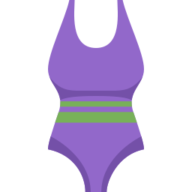  3 ____________
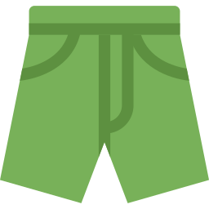  4 ___________ |   5 ___________ |   6 ___________

Part 2 · Grammar (8 points)
B Circle the correct word.
1 Whose jacket is this? — It's (mine / my).
2 That is Lily's towel. It's (hers / her).
3 Which towel is (theirs / their)? — The blue one.
4 Whose shoes are these? — They're (Tom's / Tom).
C Complete the sentences.
Whose · yours · his · hers · ours

1 ________ bag is this? — It's mine.
2 This is our umbrella. It's ________.
3 Which towel is ________? — The red one.
4 Those are Max's shorts. They're ________.
Part 3 · Reading and writing (6 points)
D Read and answer.
On the sand
There are two towels on the sand. The green one is Lily's. It's hers. The purple one is Tom's. It's his. There are sunglasses next to the purple towel. They're Tom's too.

1 Whose is the green towel?

2 Which towel is Tom's?

3 Whose are the sunglasses?

E Put the words in the right order.
1 Whose / shoes / these? / are

2 mine. / They're

3 hers. / The / is / purple / one

Score: ________ / 20

