Mr. Valet - Location Check-In QR Codes
Print these QR codes and place them at the respective sites for workers to scan upon arrival and departure. Do not resize them too small to ensure they are scannable by mobile cameras.

Site: 121 Tower
Address: West Bay, Doha, Qatar
Coordinates: 25.321, 51.529
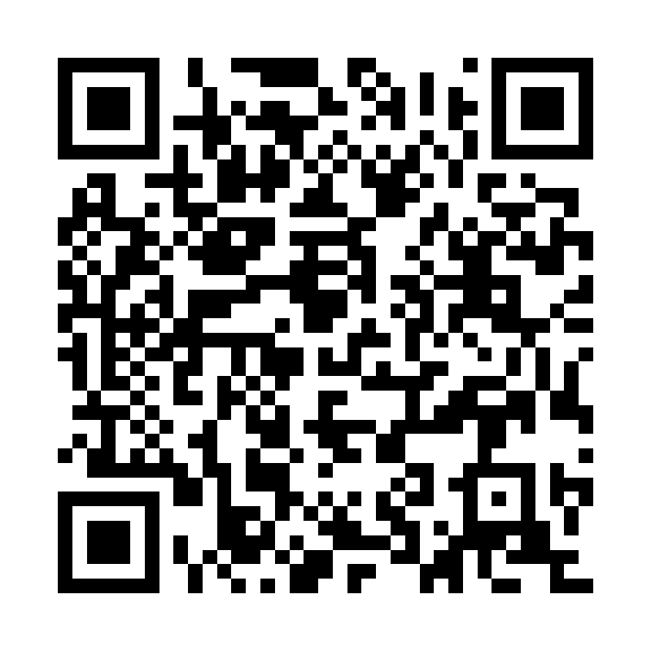

Site: 21 High Street Hotel
Address: 21 High Street, Katara, Doha, Qatar
Coordinates: 25.359, 51.526
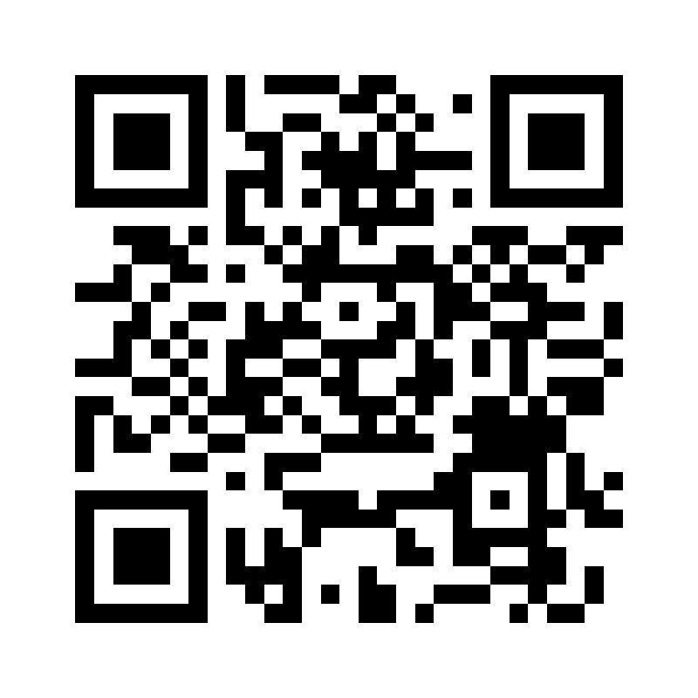

Site: 35 West Bay Tower
Address: Diplomatic Area, West Bay, Doha, Qatar
Coordinates: 25.3245, 51.5312
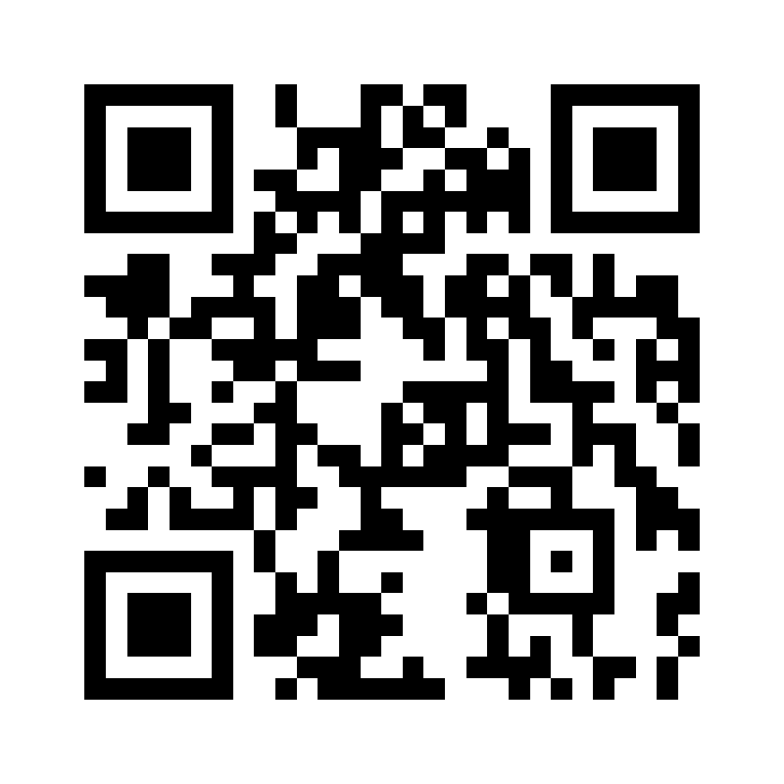

Site: Adrenaline Gym
Address: Al Sadd, Doha, Qatar
Coordinates: 25.282, 51.515
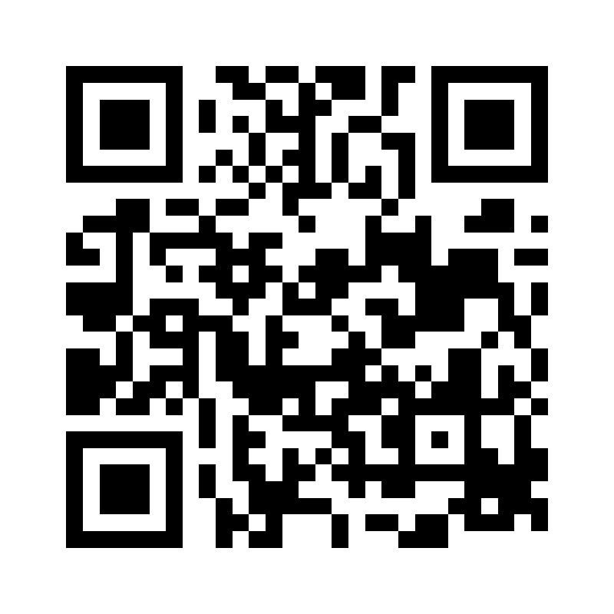

Site: Al Ahli Hospital
Address: Al Ahli Hospital, Ahmed Bin Ali St, Qatar
Coordinates: 25.304, 51.503
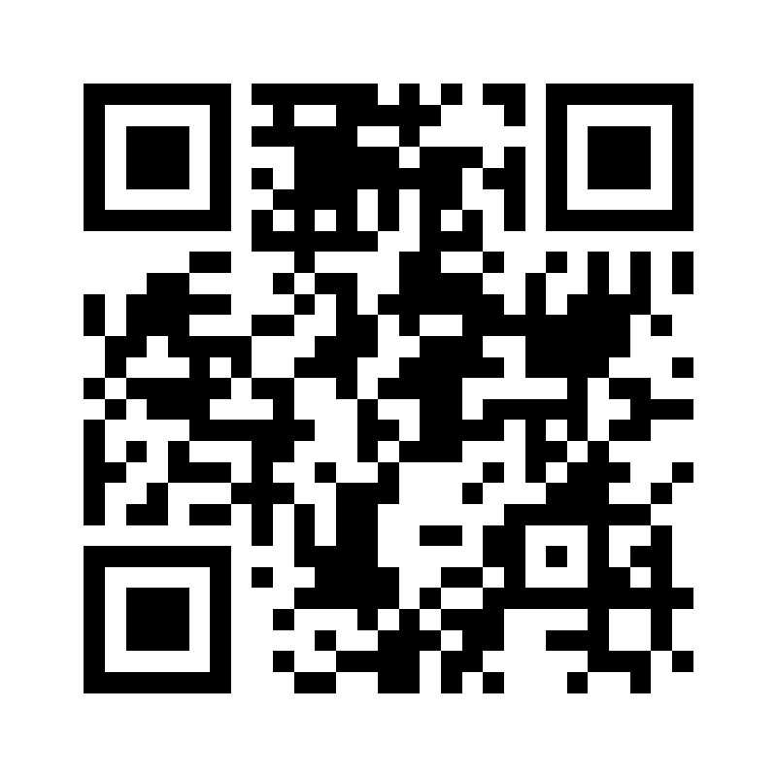

Site: Al Maha Island
Address: Al Maha Island, Lusail, Qatar
Coordinates: 25.4312, 51.5328
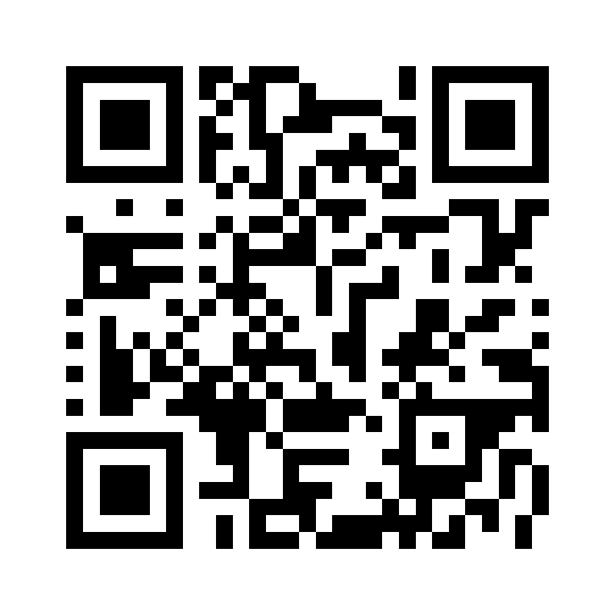

Site: Al Najada Hotel
Address: Al Najada Doha Hotel by Tivoli, Qatar
Coordinates: 25.286, 51.534
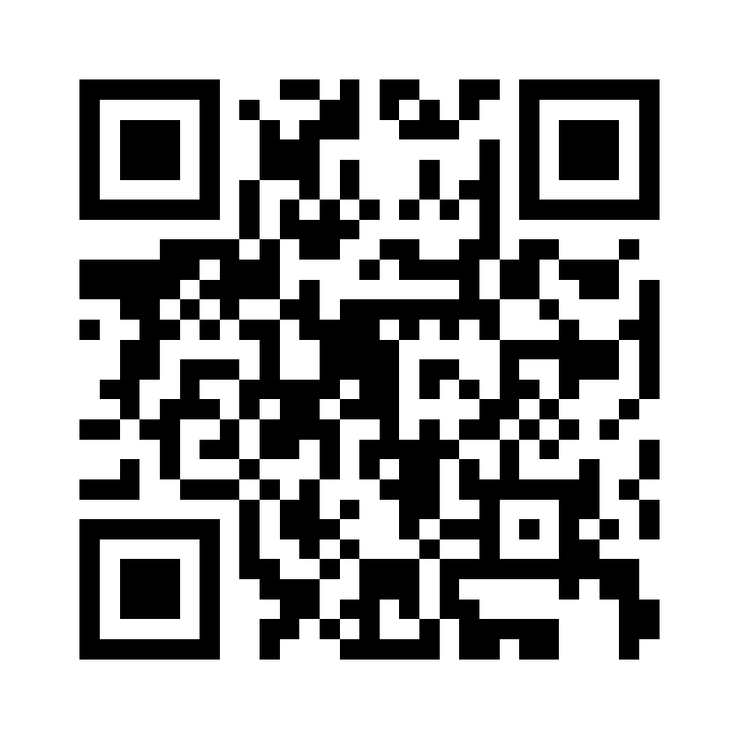

Site: Al-Aziziya Hotel
Address: Al Aziziyah Boutique Hotel, Aspire Zone, Qatar
Coordinates: 25.258, 51.442
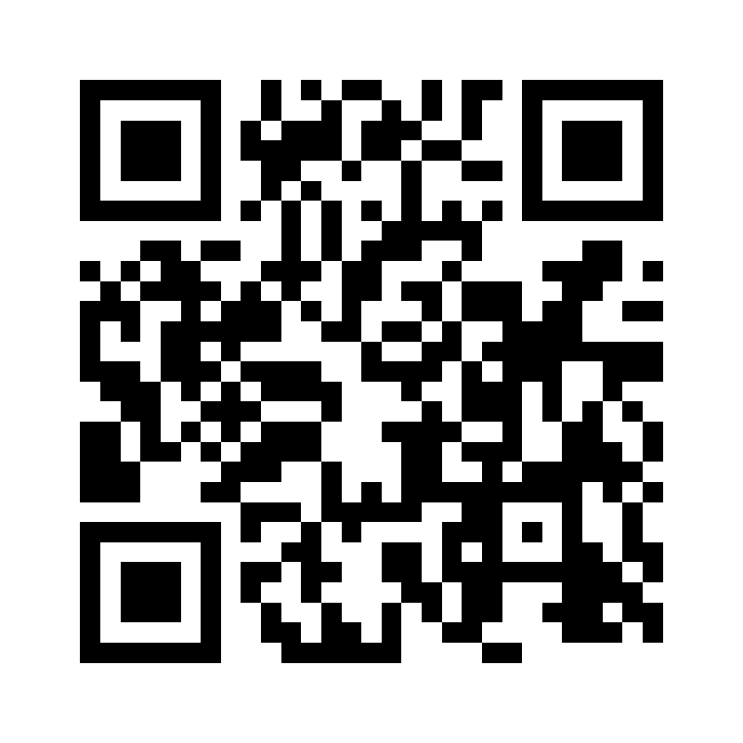

Site: Al-Rayyan Hotel
Address: AlRayyan Hotel Doha, Curio Collection, Mall of Qatar
Coordinates: 25.321, 51.341
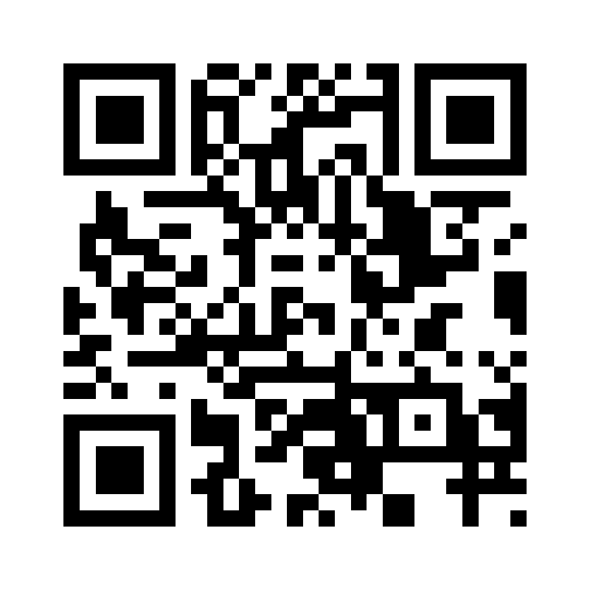

Site: Andaz Doha Hotel
Address: Andaz Doha, West Bay, Qatar
Coordinates: 25.328, 51.534
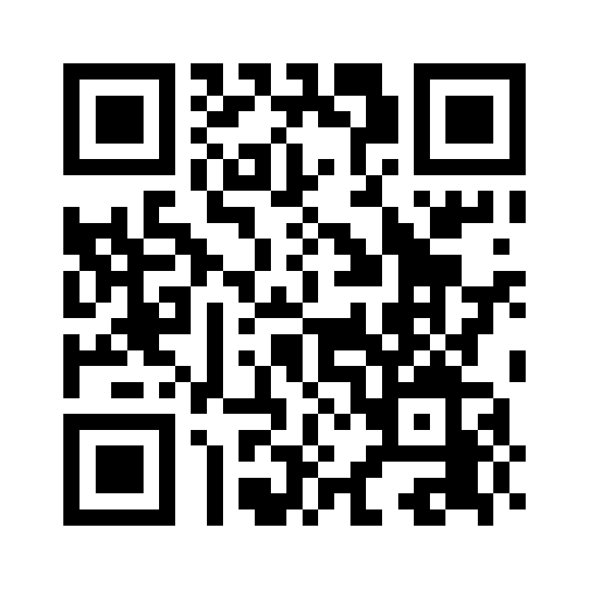

Site: Banana Island
Address: Banana Island Resort Doha by Anantara, Qatar
Coordinates: 25.297, 51.642
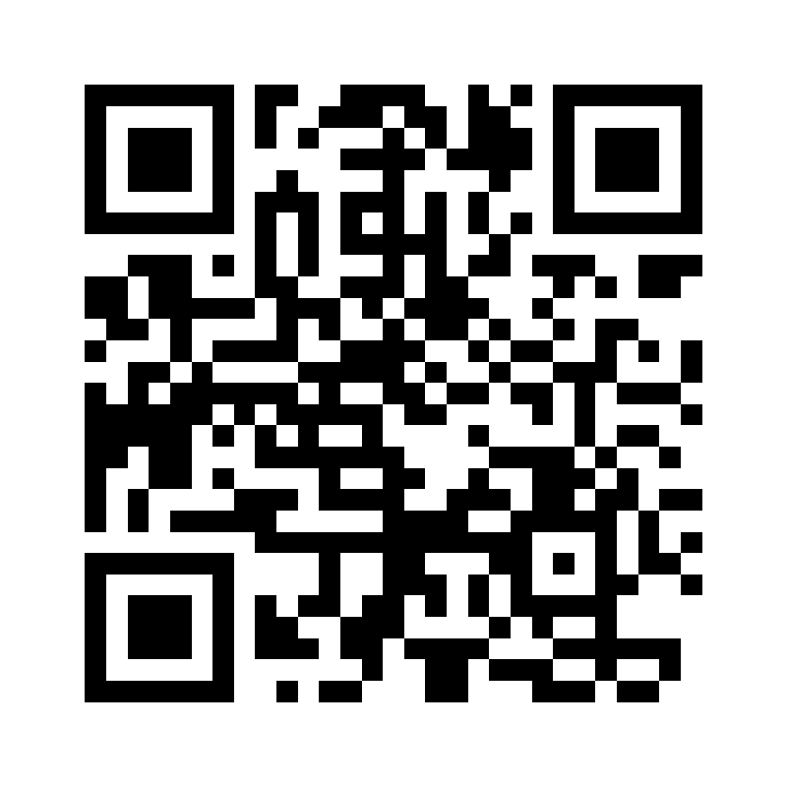

Site: Banyan Tree Hotel
Address: Banyan Tree Doha At La Cigale Mushaireb, Qatar
Coordinates: 25.282, 51.521
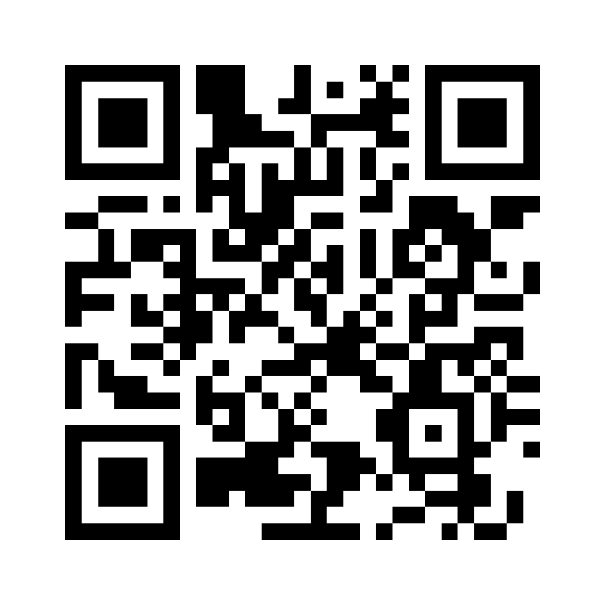

Site: Beiruti Restaurant
Address: Al Sadd, Doha, Qatar
Coordinates: 25.289, 51.51
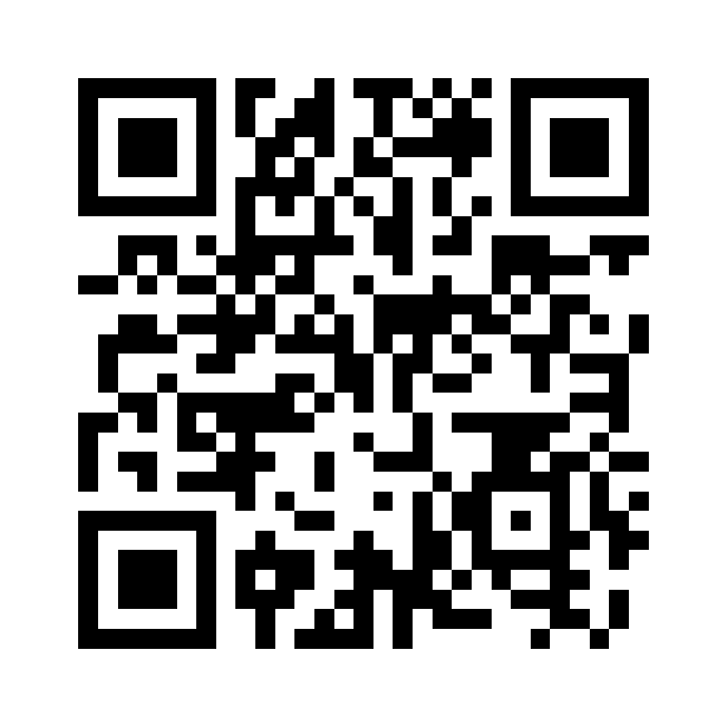

Site: Belhamber Restaurant
Address: Corniche, Doha, Qatar
Coordinates: 25.292, 51.539
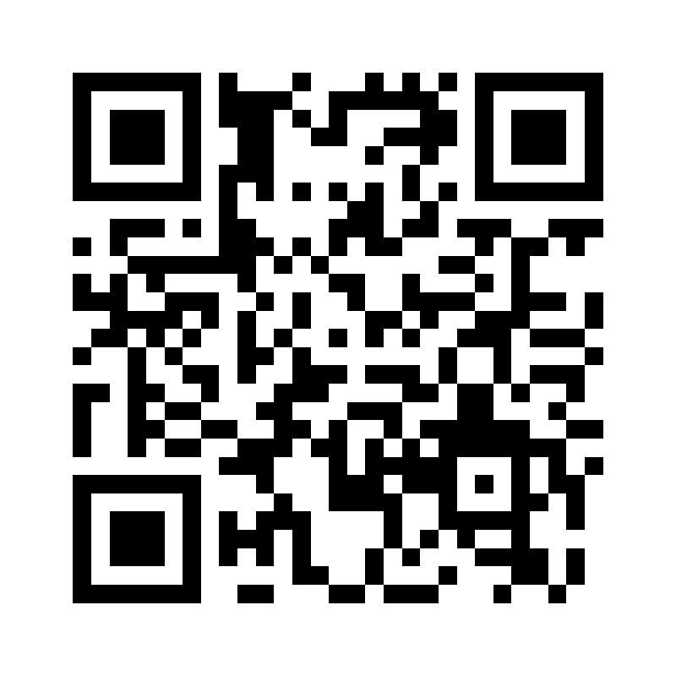

Site: CAC TUS - Lusail
Address: Lusail Marina Promenade, Qatar
Coordinates: 25.4215, 51.531
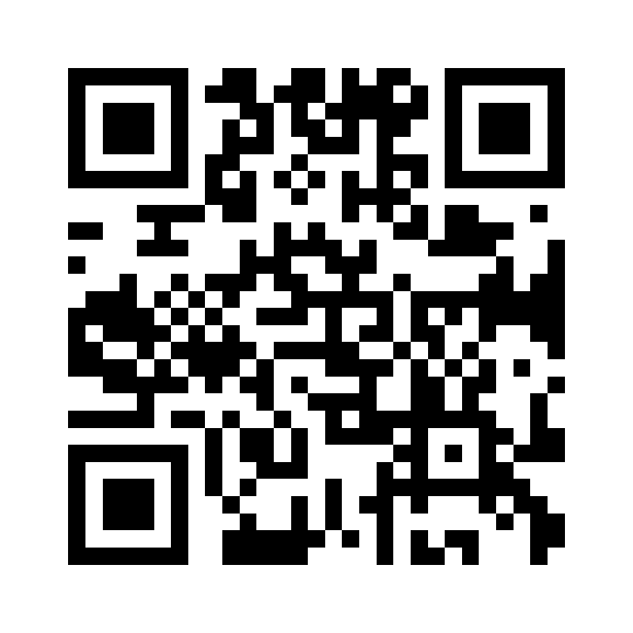

Site: Centro Mall
Address: Centro Mall, Barwa Commercial Avenue, Qatar
Coordinates: 25.263, 51.512
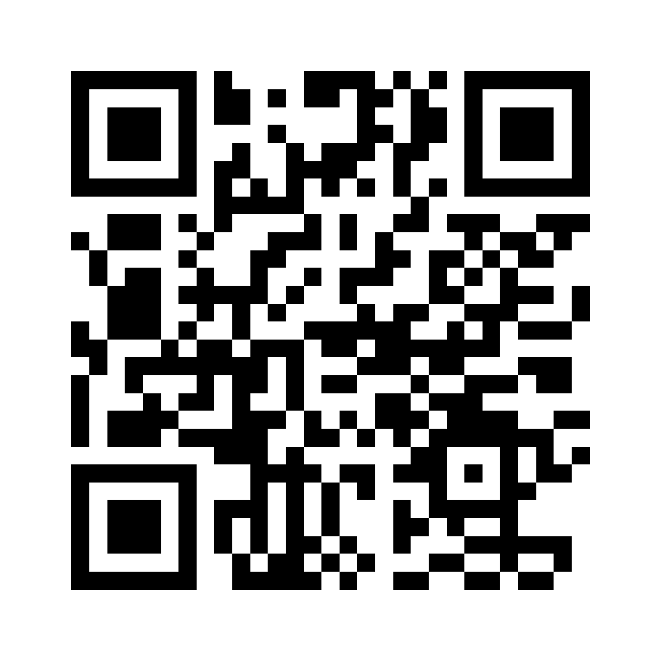

Site: Century Marina Mall
Address: Lusail Marina, Qatar
Coordinates: 25.419, 51.528
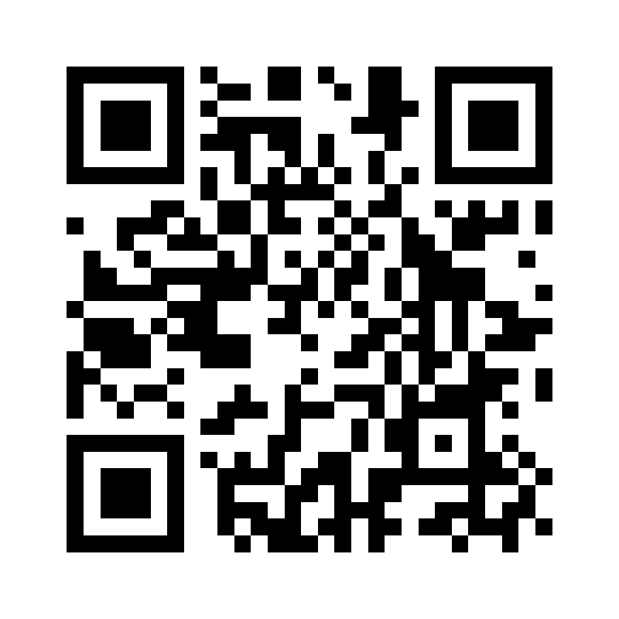

Site: Cielo Hotel
Address: Lusail, Qatar
Coordinates: 25.426, 51.523
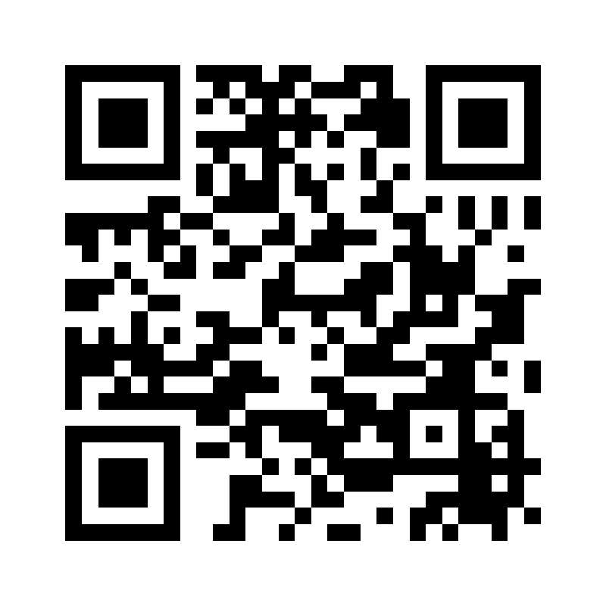

Site: City Center
Address: City Center Mall, West Bay, Doha, Qatar
Coordinates: 25.3252, 51.5306
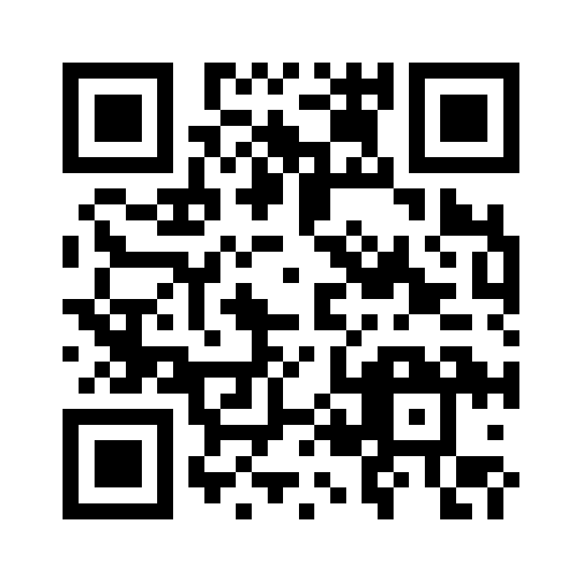

Site: Dar Global
Address: West Bay, Doha, Qatar
Coordinates: 25.323, 51.531
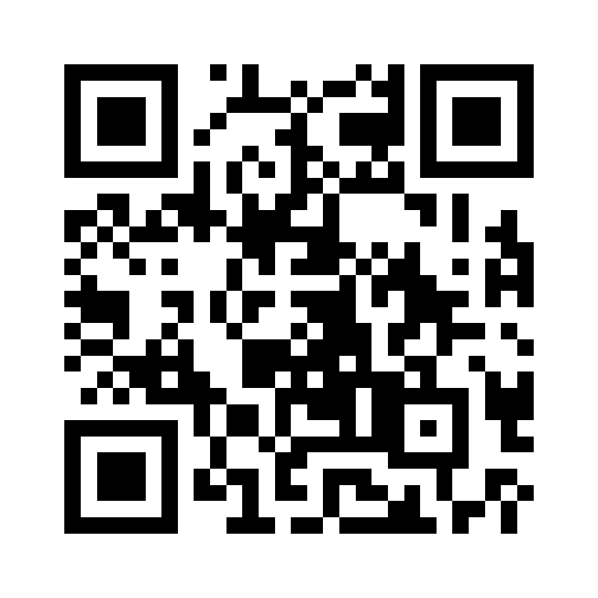

Site: Doha Clinic
Address: Doha Clinic Hospital, Al Mirqab Al Jadeed, Qatar
Coordinates: 25.278, 51.508
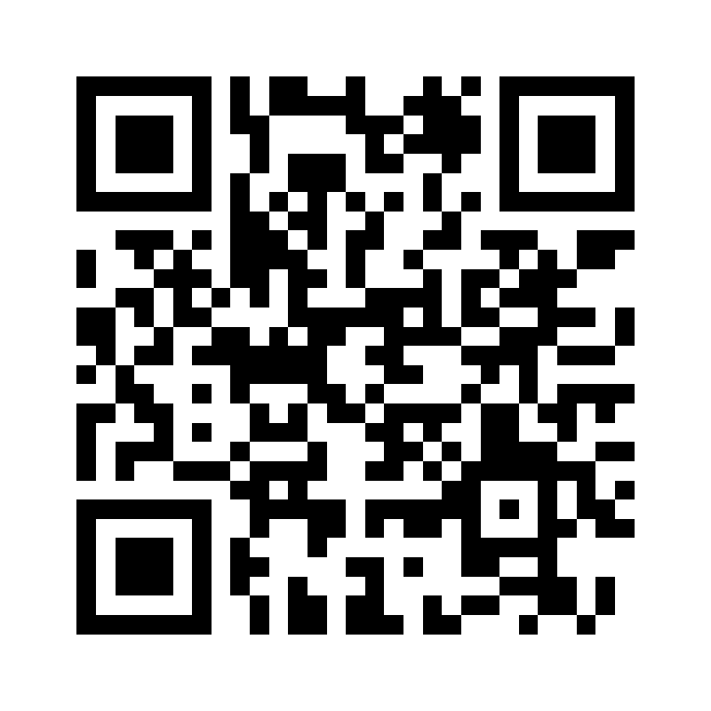

Site: Doha Festival City
Address: Doha Festival City, Umm Salal Muhammed, Qatar
Coordinates: 25.418, 51.444
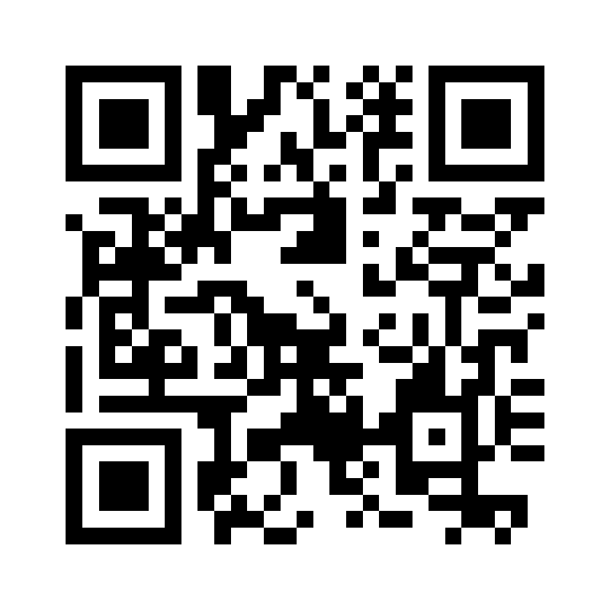

Site: Doha oasis
Address: Doha Oasis, Al Khulaifat, Doha, Qatar
Coordinates: 25.2815, 51.5215
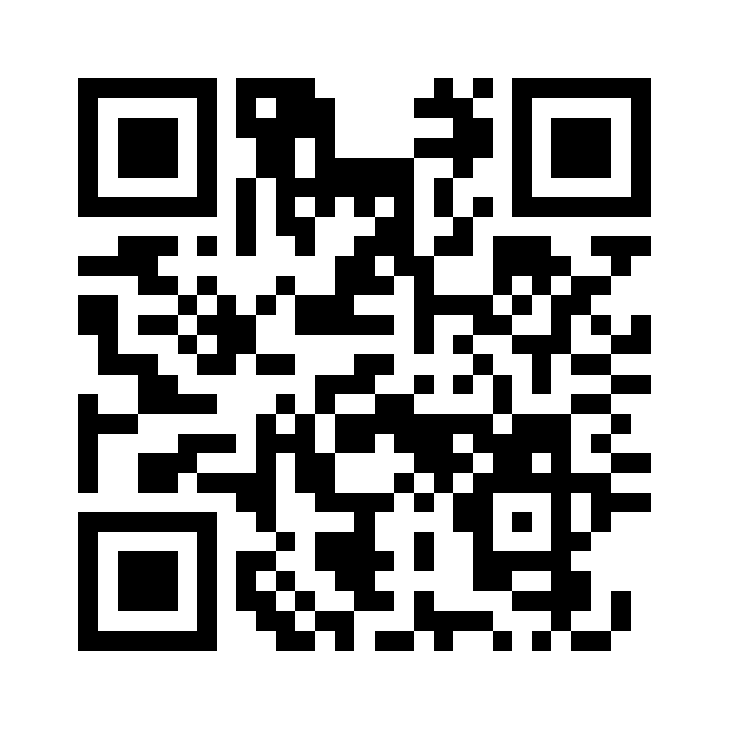

Site: Dusit Hotel
Address: Dusit Doha Hotel, West Bay, Qatar
Coordinates: 25.326, 51.529
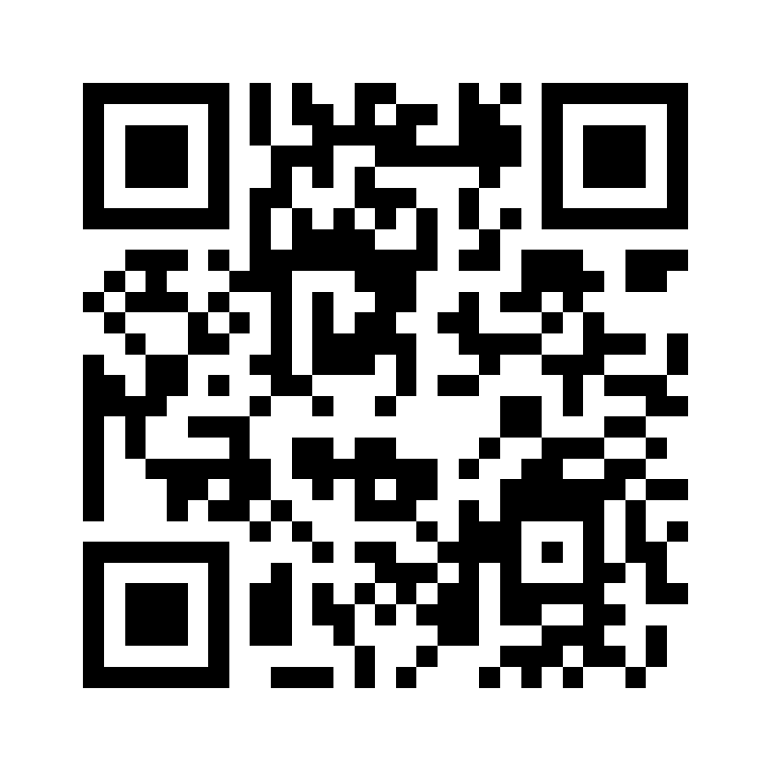

Site: Embassy Suites by Hilton
Address: Embassy Suites by Hilton Doha Old Town, Qatar
Coordinates: 25.275, 51.545
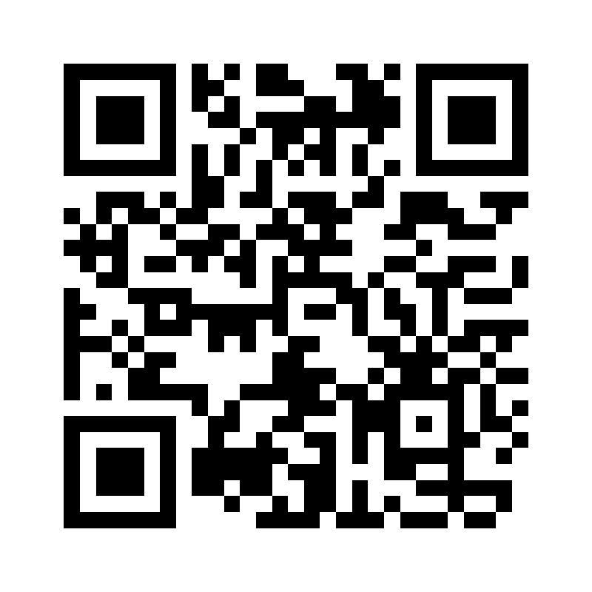

Site: Ezdan Palace
Address: Ezdan Palace Hotel, Al Shamal Rd, Qatar
Coordinates: 25.361, 51.468
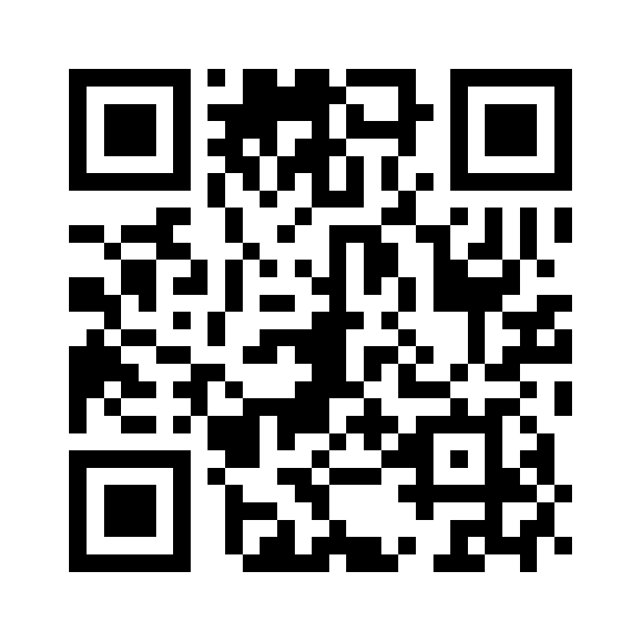

Site: Fairmont Hotel
Address: Katara Towers, Lusail Marina, Qatar
Coordinates: 25.3888, 51.5315
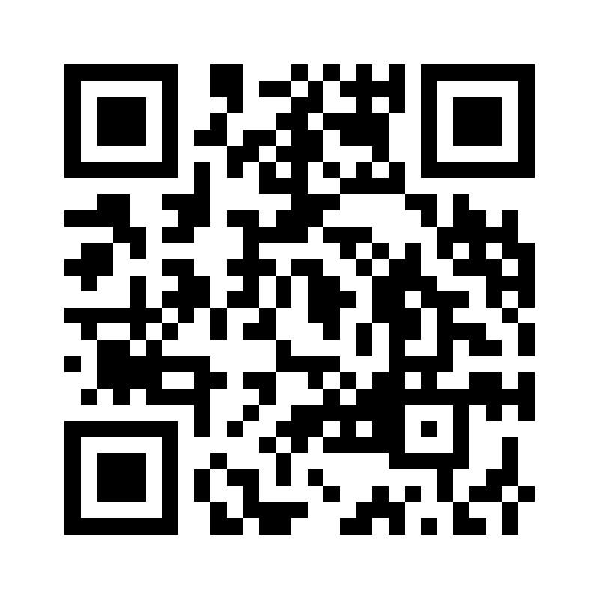

Site: Gewan Island
Address: Gewan Island, The Pearl, Qatar
Coordinates: 25.378, 51.545
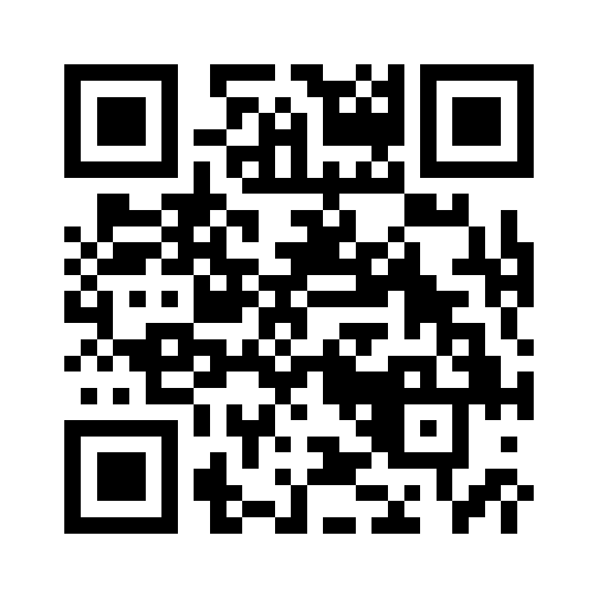

Site: Hilton the pearl residence
Address: Hilton Doha The Pearl Residences, Qatar
Coordinates: 25.372, 51.551
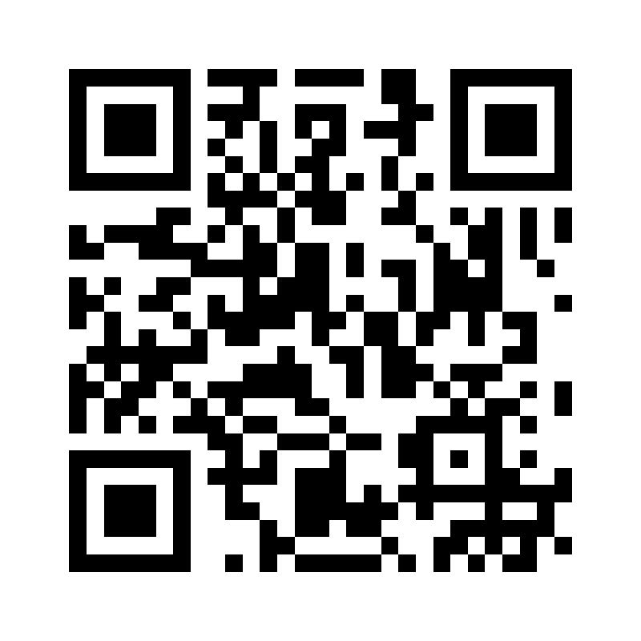

Site: Ibis and Adagio
Address: Ibis & Adagio Doha, Alwaab / B-Ring, Qatar
Coordinates: 25.272, 51.511
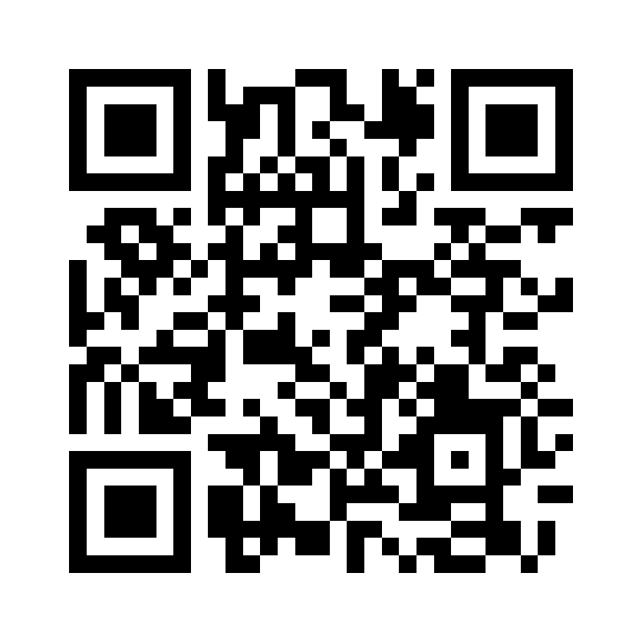

Site: Intercontinental Doha
Address: InterContinental Doha Beach & Spa, Qatar
Coordinates: 25.352, 51.533
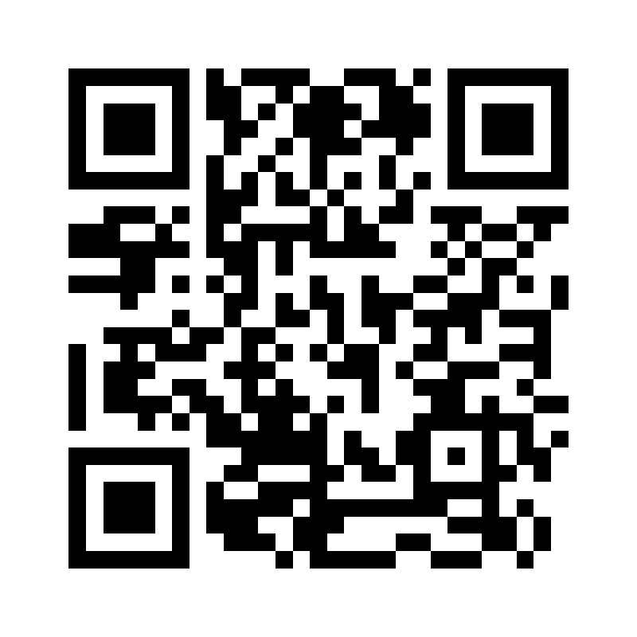

Site: Katara hills
Address: Katara Hills LXR Hotels & Resorts, Qatar
Coordinates: 25.362, 51.524
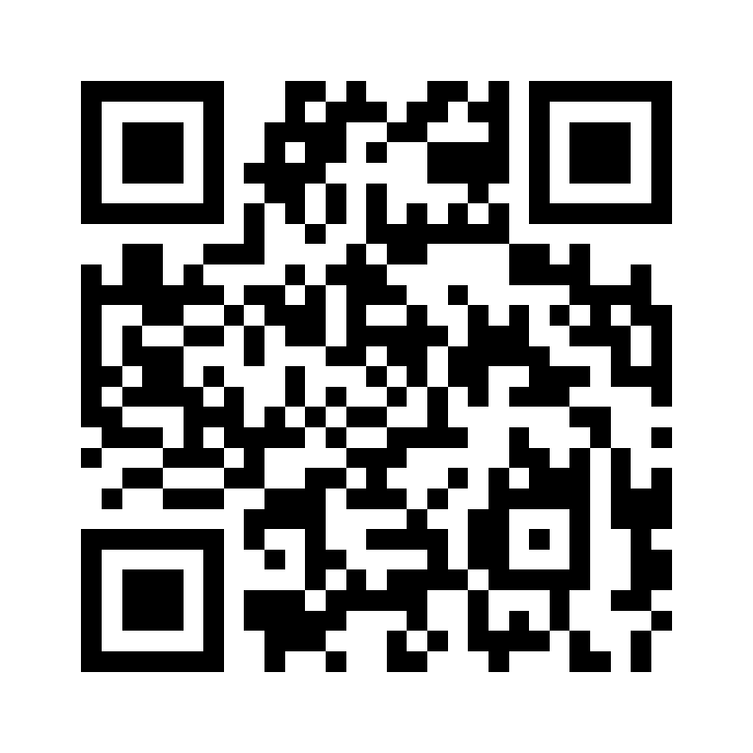

Site: Katara Village
Address: Katara Cultural Village, Doha, Qatar
Coordinates: 25.358, 51.525
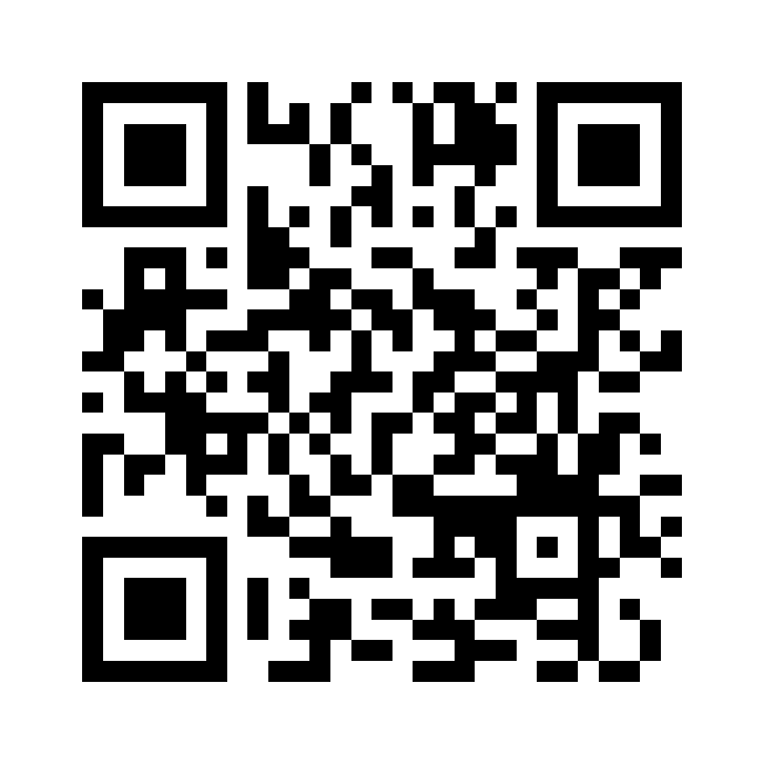

Site: Kempinski residence and suites
Address: Kempinski Residences & Suites, West Bay, Qatar
Coordinates: 25.323, 51.532
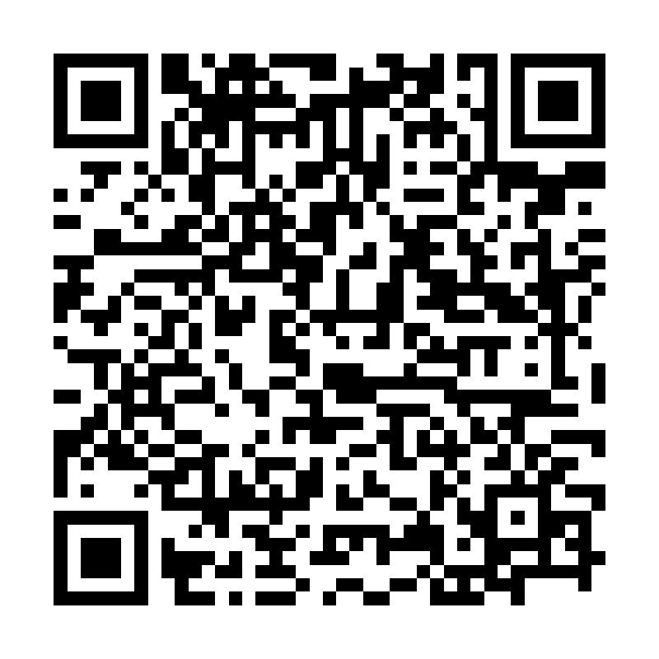

Site: Korean Medical Center
Address: Lusail Medical District, Qatar
Coordinates: 25.428, 51.524
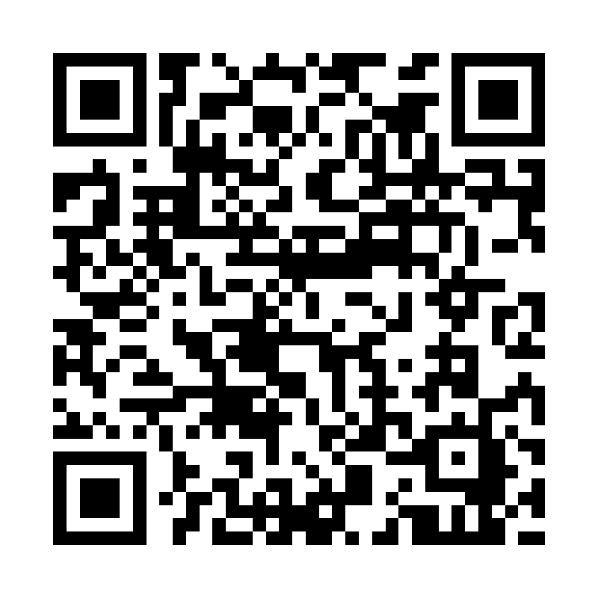

Site: La Cigale Hotel
Address: La Cigale Hotel, Suhaim Bin Hamad St, Qatar
Coordinates: 25.285, 51.507
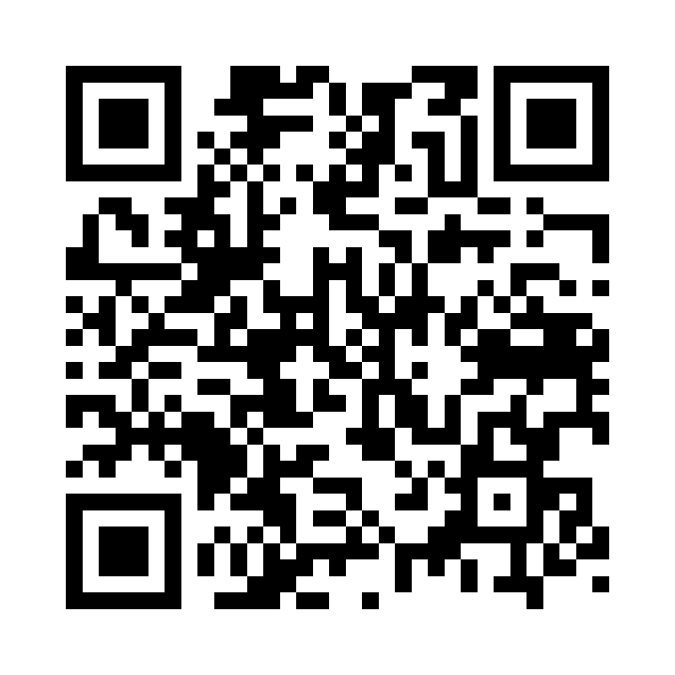

Site: Laffan Tower
Address: West Bay, Doha, Qatar
Coordinates: 25.32, 51.528
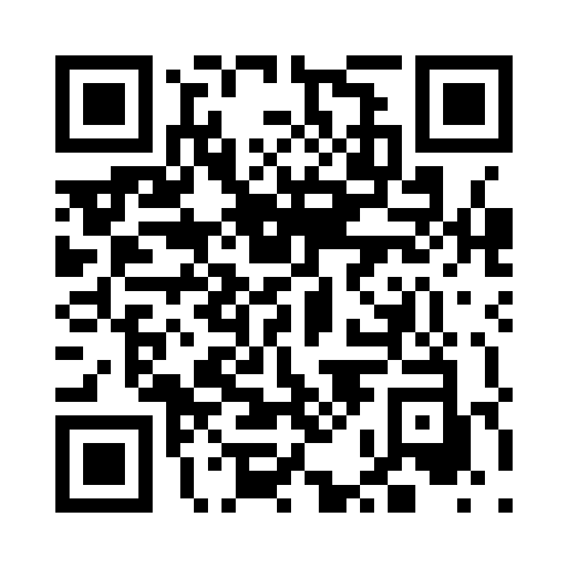

Site: Lagoona Mall
Address: Lagoona Mall, West Bay Lagoon, Qatar
Coordinates: 25.377, 51.521
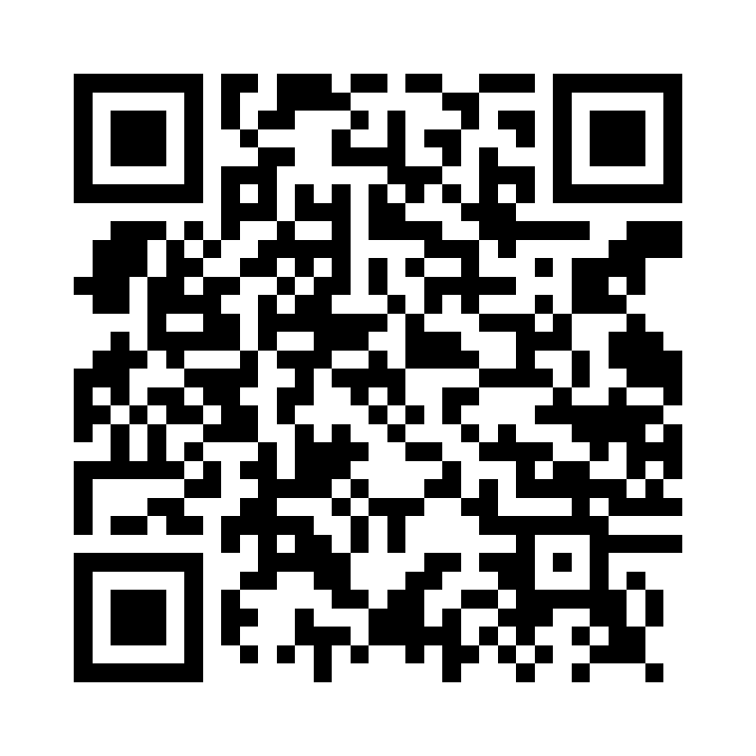

Site: Little Sailor Restaurant
Address: Al Sadd, Doha, Qatar
Coordinates: 25.279, 51.514
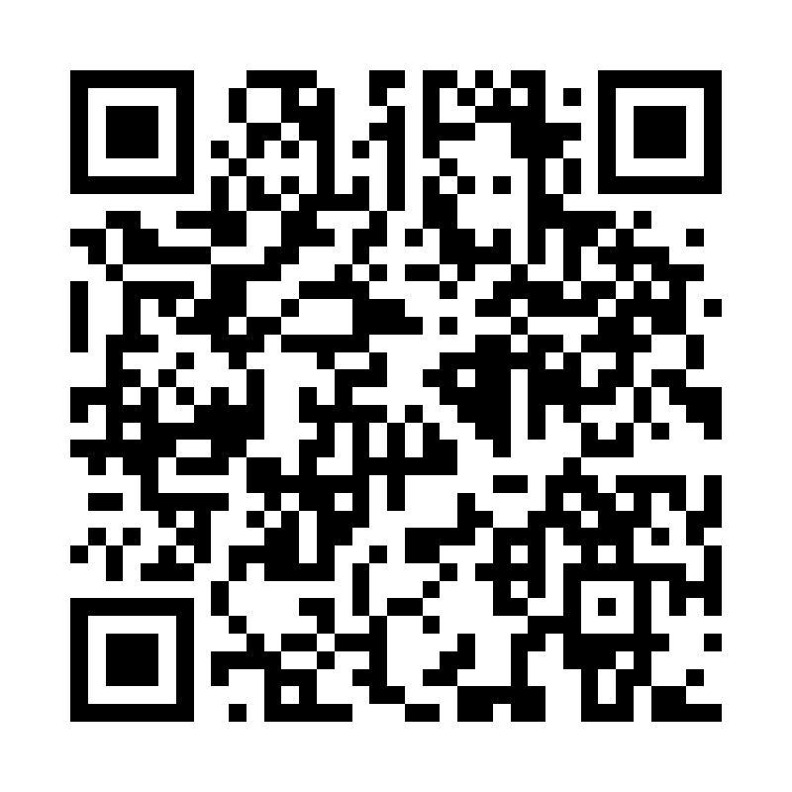

Site: M Gallery hotel
Address: Alwadi Hotel Doha MGallery, Msheireb, Qatar
Coordinates: 25.2875, 51.529
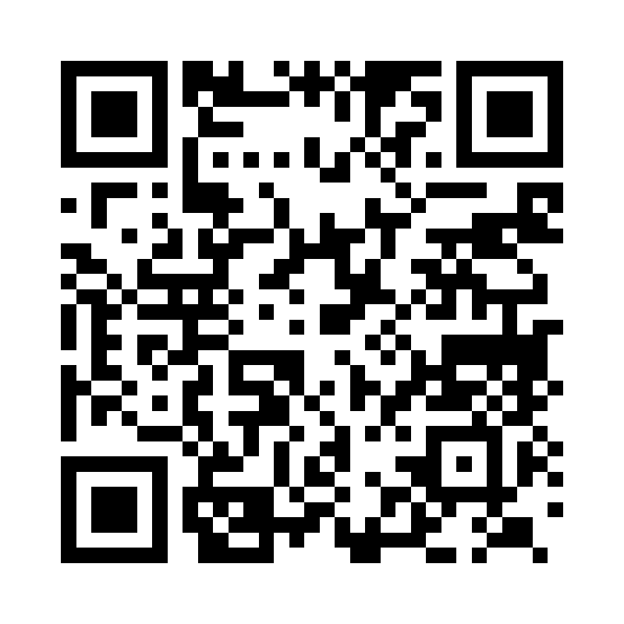

Site: Medina Central
Address: Medina Centrale, The Pearl, Qatar
Coordinates: 25.37, 51.544
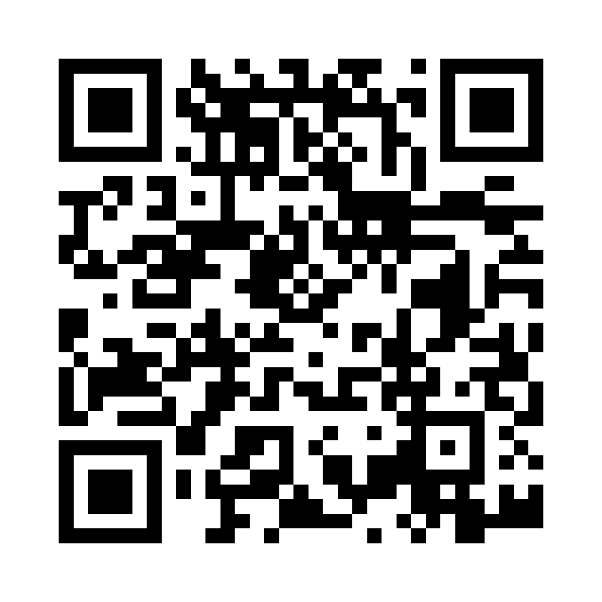

Site: Mall Of Qatar
Address: Mall of Qatar, Al Rayyan, Qatar
Coordinates: 25.322, 51.342
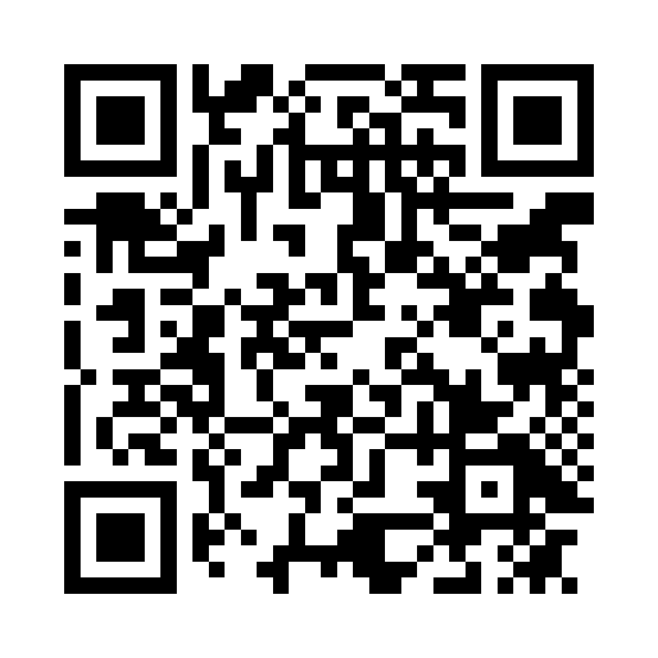

Site: Manarat Lusail Tower
Address: Lusail Marina, Qatar
Coordinates: 25.4205, 51.5295
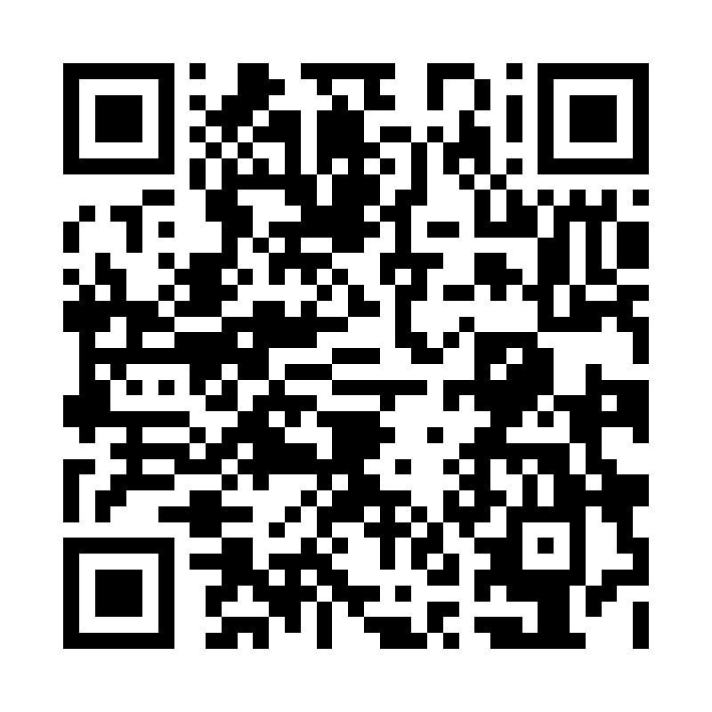

Site: Mandarin Oriental Doha
Address: Mandarin Oriental, Msheireb Downtown, Qatar
Coordinates: 25.287, 51.527
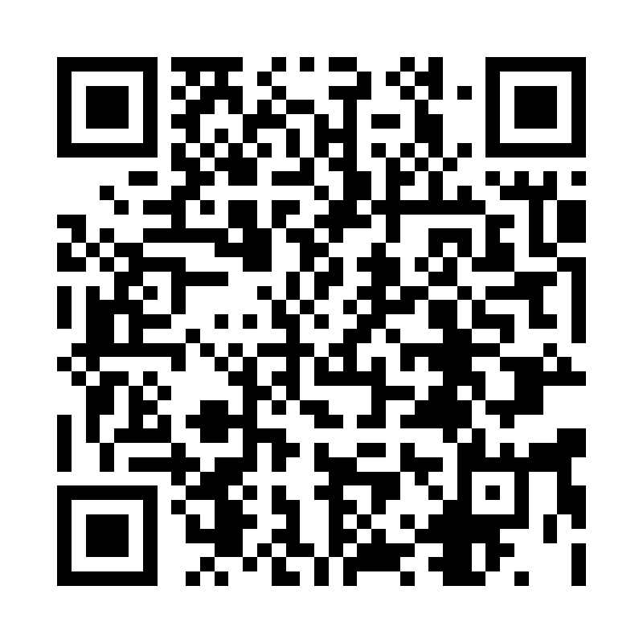

Site: Marsa Malaz Kempinski
Address: Marsa Malaz Kempinski, The Pearl, Qatar
Coordinates: 25.375, 51.558
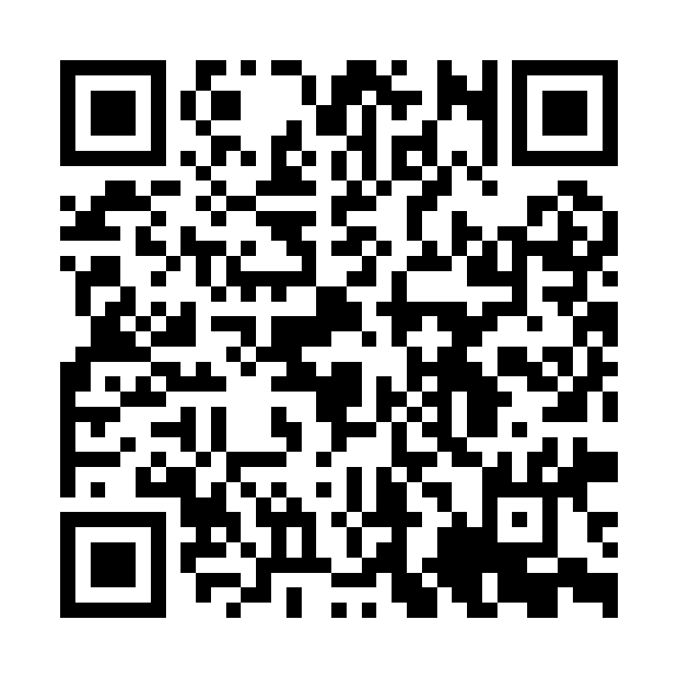

Site: Maysan LXR
Address: Maysan Doha, LXR Hotels & Resorts, Aspire, Qatar
Coordinates: 25.249, 51.438
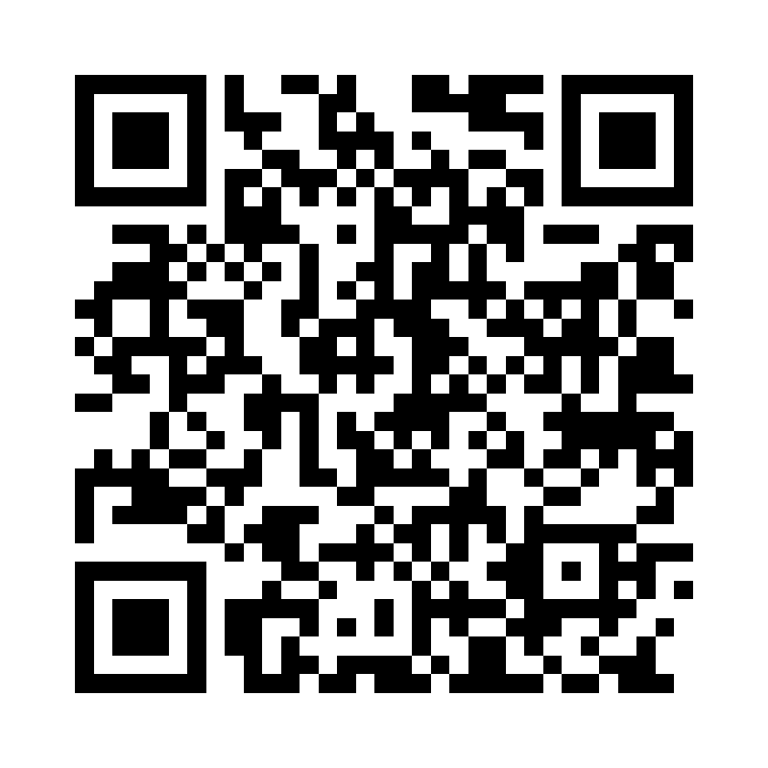

Site: Messila Resort
Address: Al Messila, a Luxury Collection Resort & Spa, Qatar
Coordinates: 25.295, 51.472
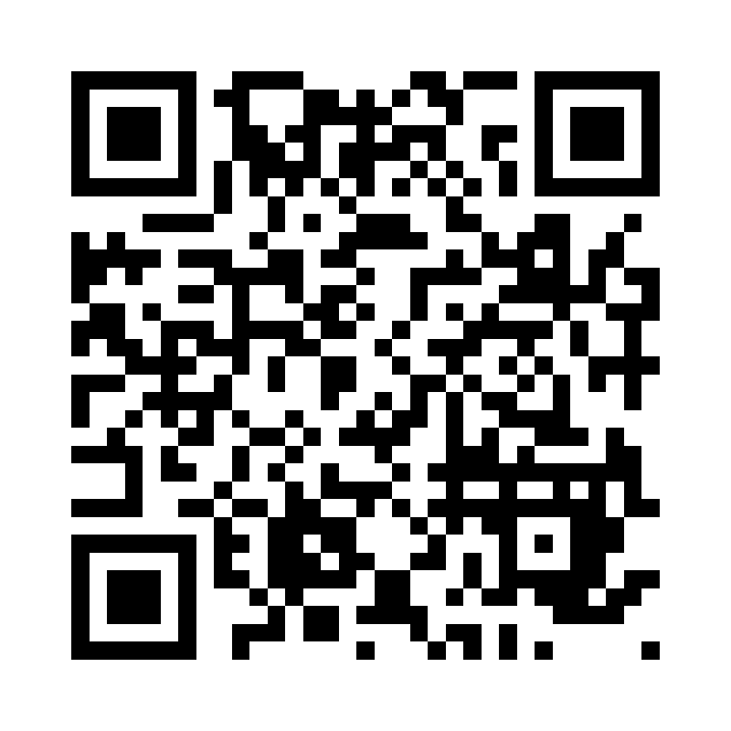

Site: Millennium Hotel and resort - em sherif
Address: Millennium Hotel Doha, Jawaan St, Qatar
Coordinates: 25.283, 51.502
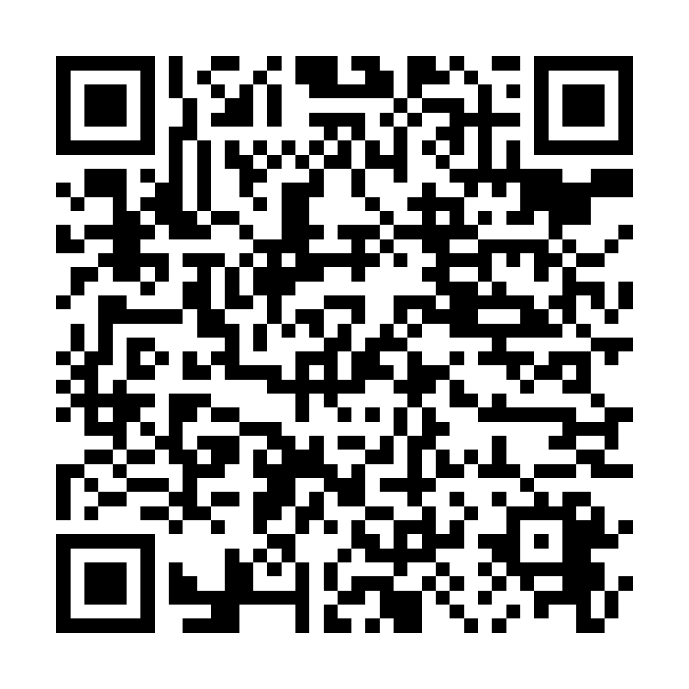

Site: Ministry Of Foreign Affairs (MOFA)
Address: Ministry of Foreign Affairs, Corniche, Qatar
Coordinates: 25.305, 51.528
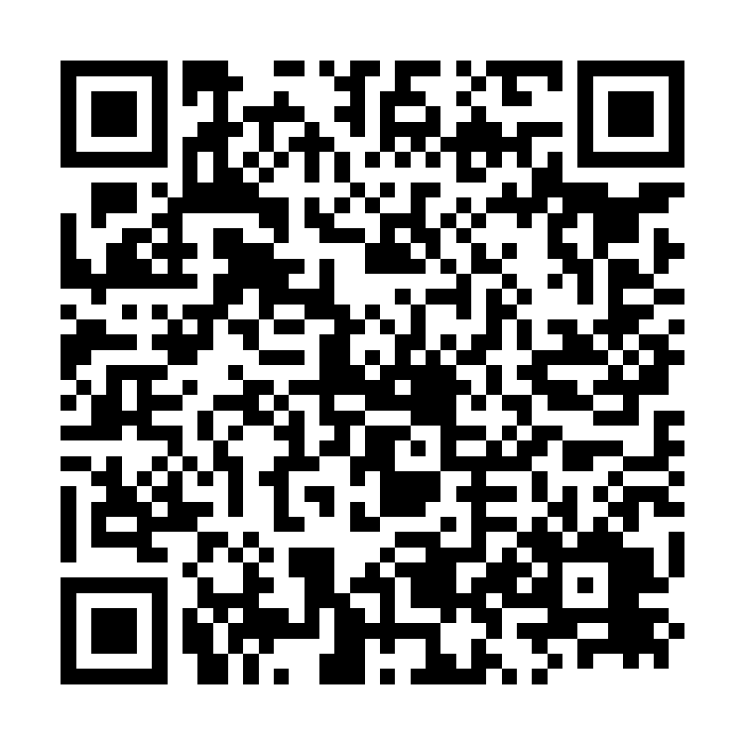

Site: Msheireb Downtown
Address: Msheireb Downtown Doha, Qatar
Coordinates: 25.2865, 51.528
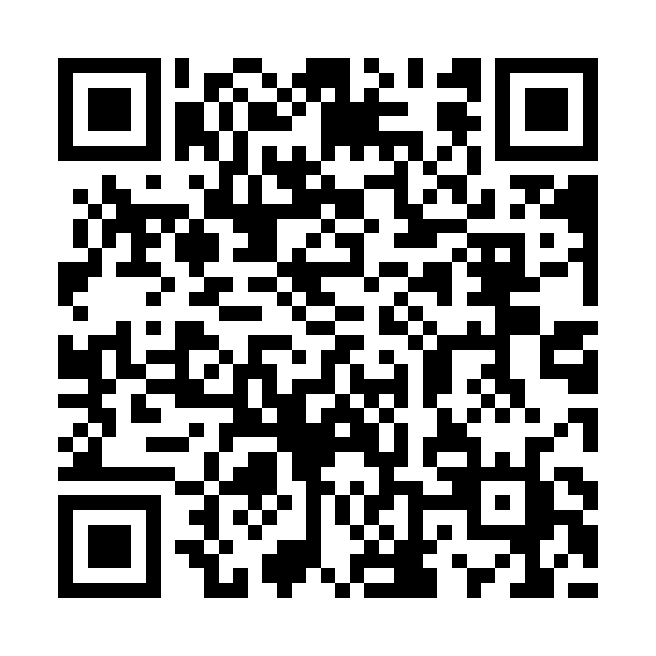

Site: Novo Cinema
Address: Novo Cinemas, Mall of Qatar / The Pearl, Qatar
Coordinates: 25.323, 51.343
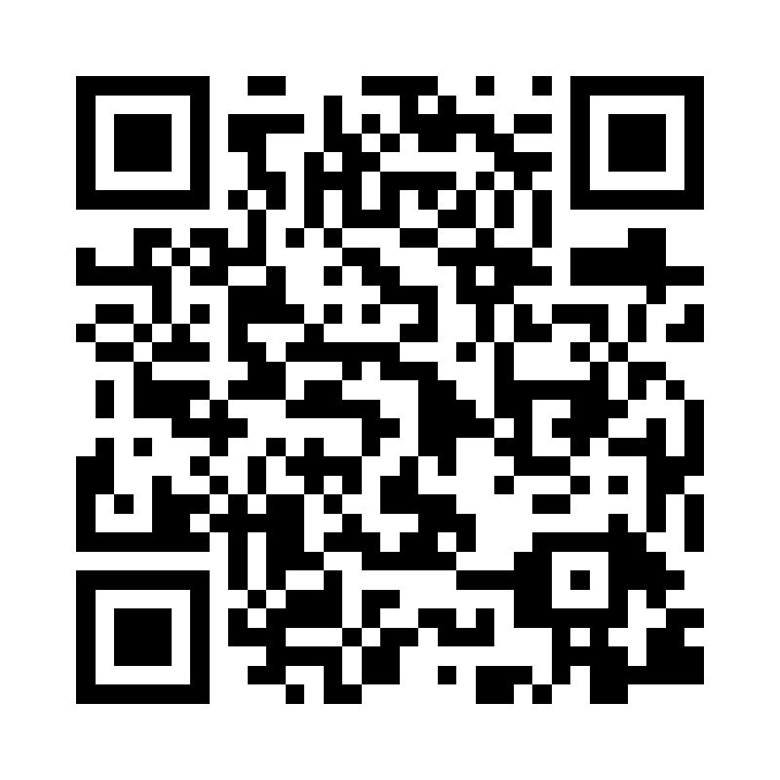

Site: Old Doha Port
Address: Mina District, Old Doha Port, Qatar
Coordinates: 25.295, 51.547
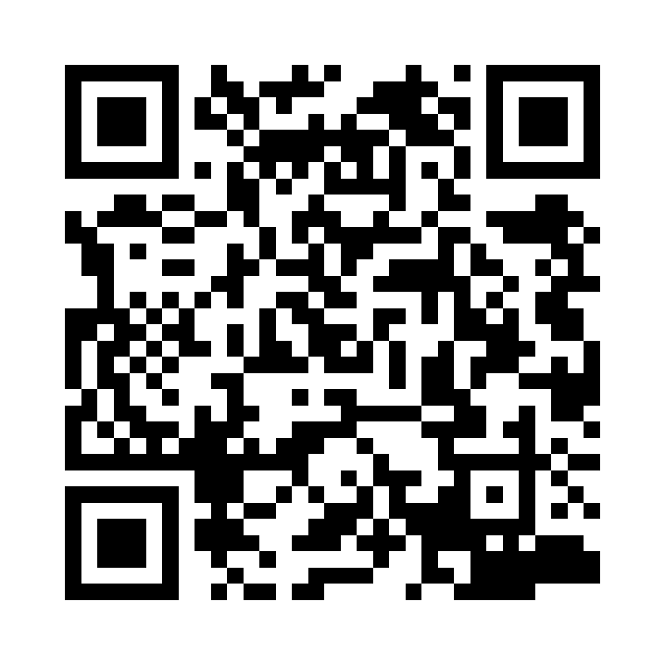

Site: Ooredoo
Address: Ooredoo HQ, West Bay, Doha, Qatar
Coordinates: 25.3235, 51.534
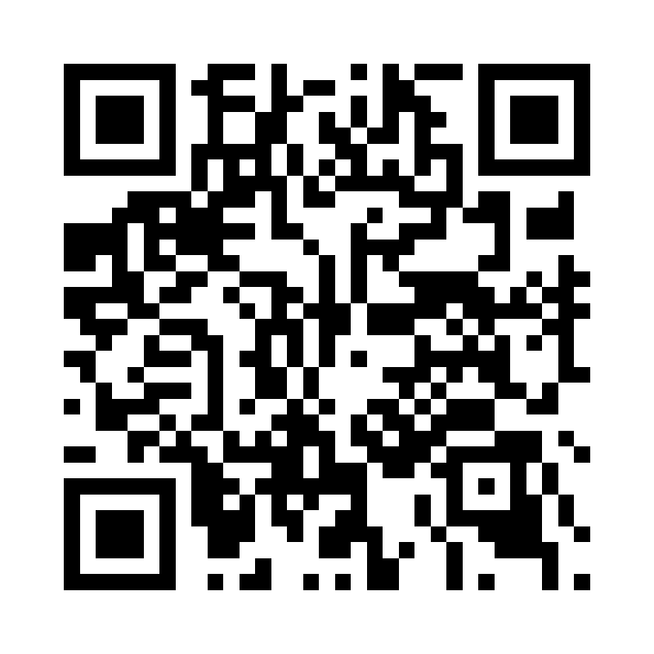

Site: Orient Pearl
Address: Orient Pearl Restaurant, Corniche, Qatar
Coordinates: 25.293, 51.544
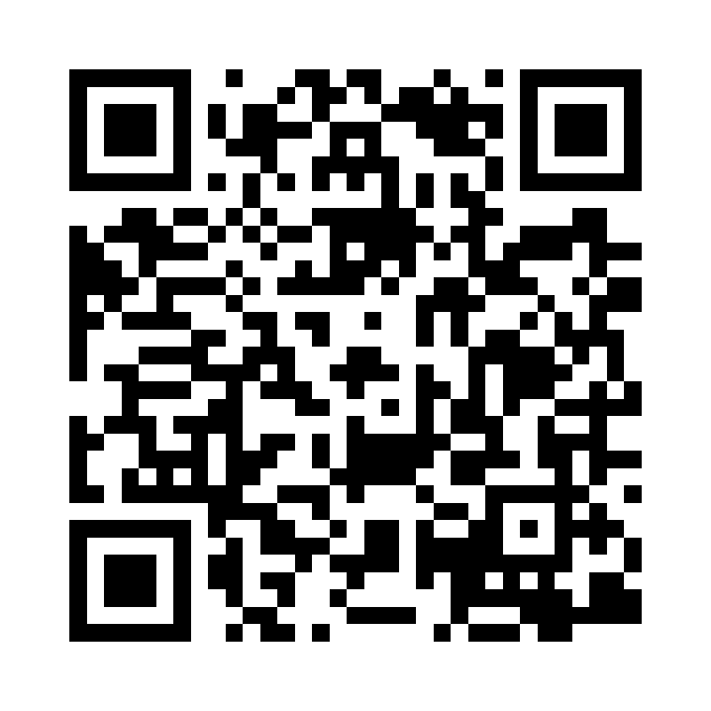

Site: Park Hyatt Doha
Address: Park Hyatt Doha, Msheireb Downtown, Qatar
Coordinates: 25.288, 51.526
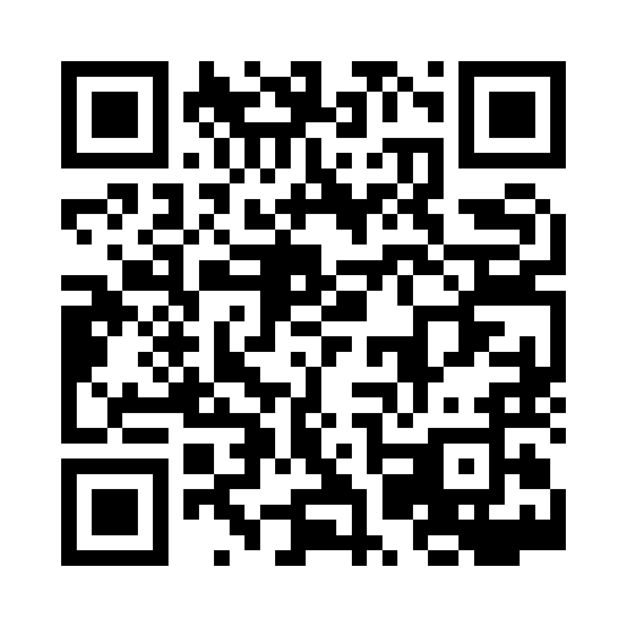

Site: Porto Arabia - UDC
Address: Porto Arabia, The Pearl, Qatar
Coordinates: 25.368, 51.549
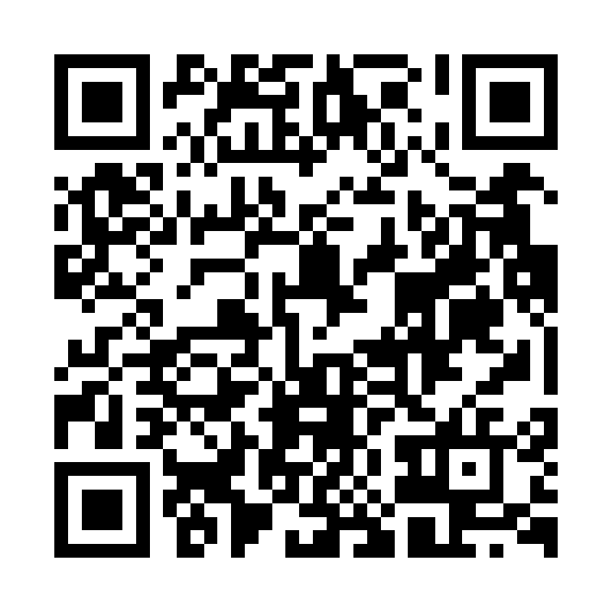

Site: Pullman Hotel
Address: Pullman Doha West Bay, Qatar
Coordinates: 25.3225, 51.53
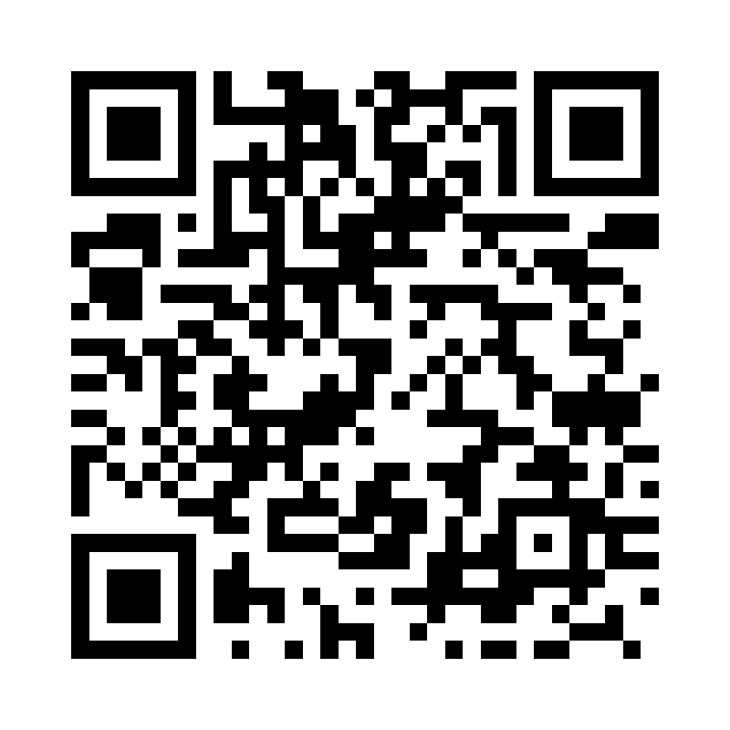

Site: QQ
Address: Qanat Quartier, The Pearl, Qatar
Coordinates: 25.374, 51.542
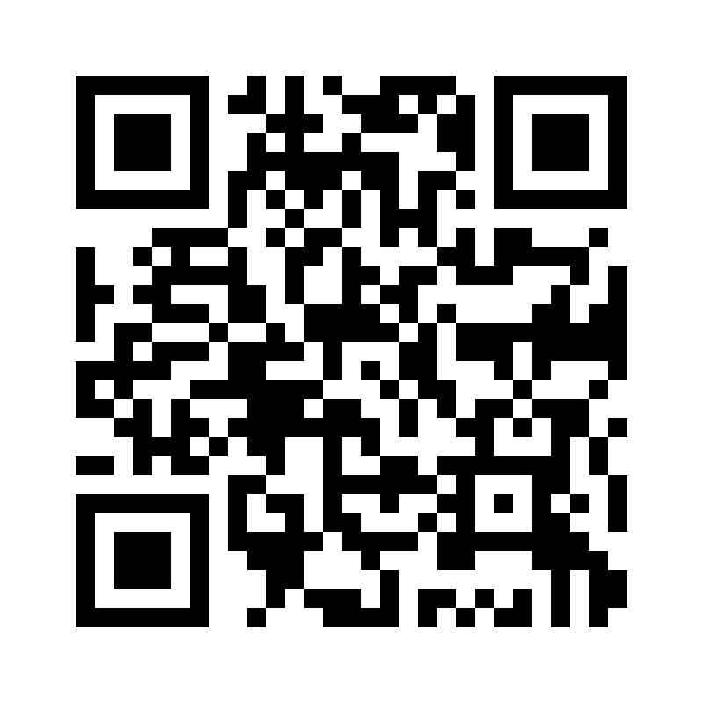

Site: Raffles Hotel
Address: Katara Towers, Lusail Marina, Qatar
Coordinates: 25.3888, 51.5315
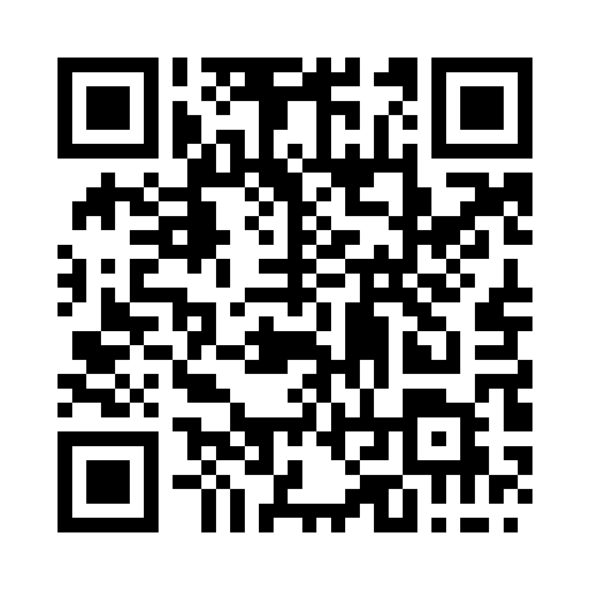

Site: Ritz Carlton hotel
Address: The Ritz-Carlton, Doha, Qatar
Coordinates: 25.38, 51.528
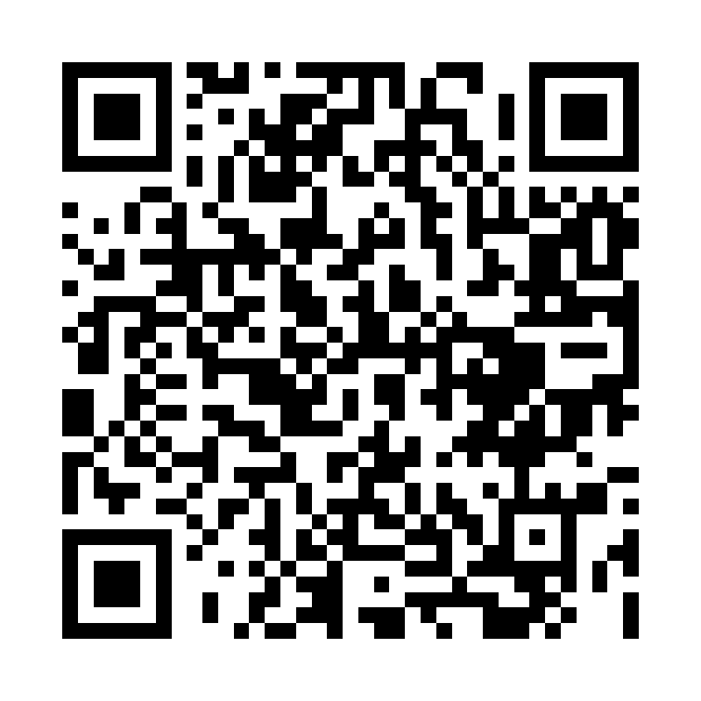

Site: Rixos Qetaifan
Address: Qetaifan Island North, Lusail, Qatar
Coordinates: 25.445, 51.542
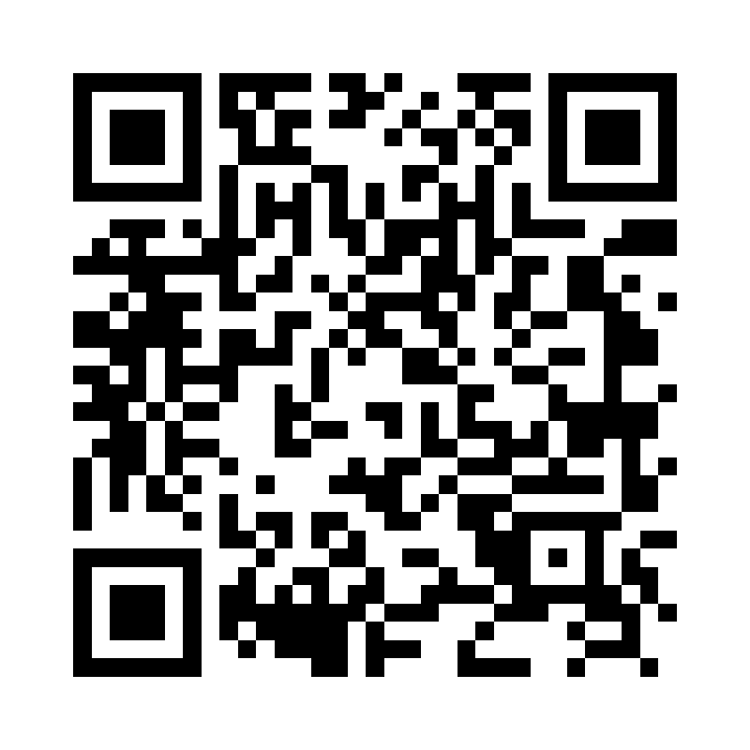

Site: Rosewood Hotel
Address: Lusail Marina, Qatar
Coordinates: 25.423, 51.533
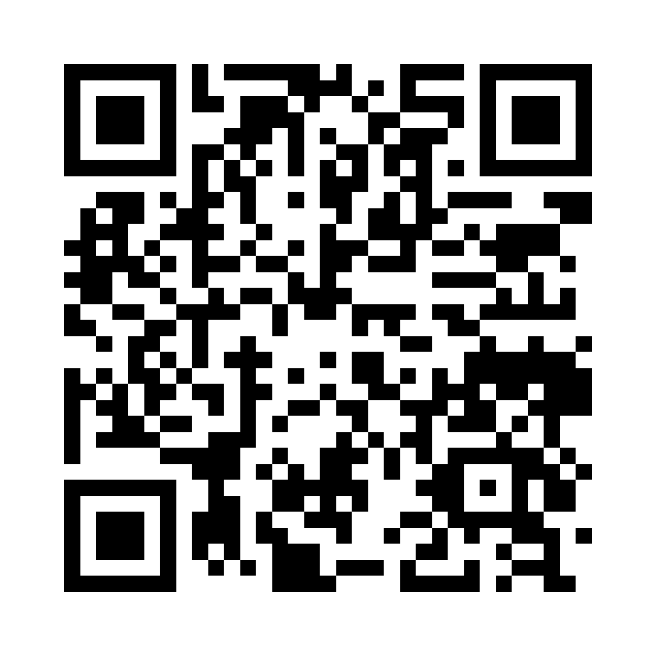

Site: Sharq Village
Address: Sharq Village & Spa, a Ritz-Carlton Hotel, Qatar
Coordinates: 25.298, 51.554
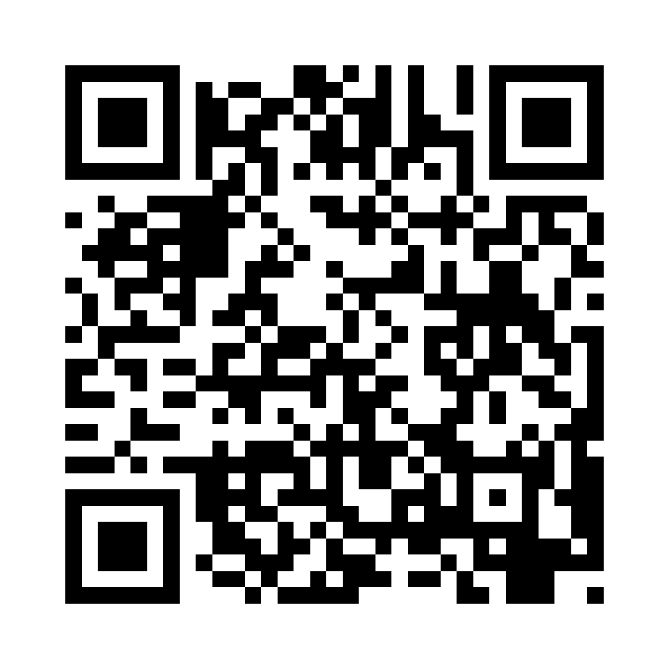

Site: Shoumoukh Tower
Address: Shoumoukh Towers, C-Ring Road, Doha, Qatar
Coordinates: 25.277, 51.501
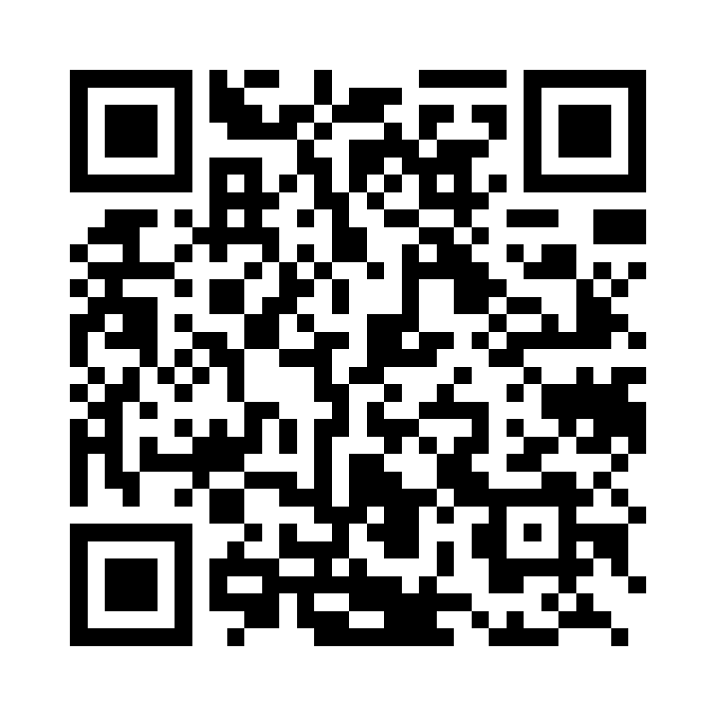

Site: St Regis Doha
Address: The St. Regis Doha, Al Gassar Resort, Qatar
Coordinates: 25.356, 51.531
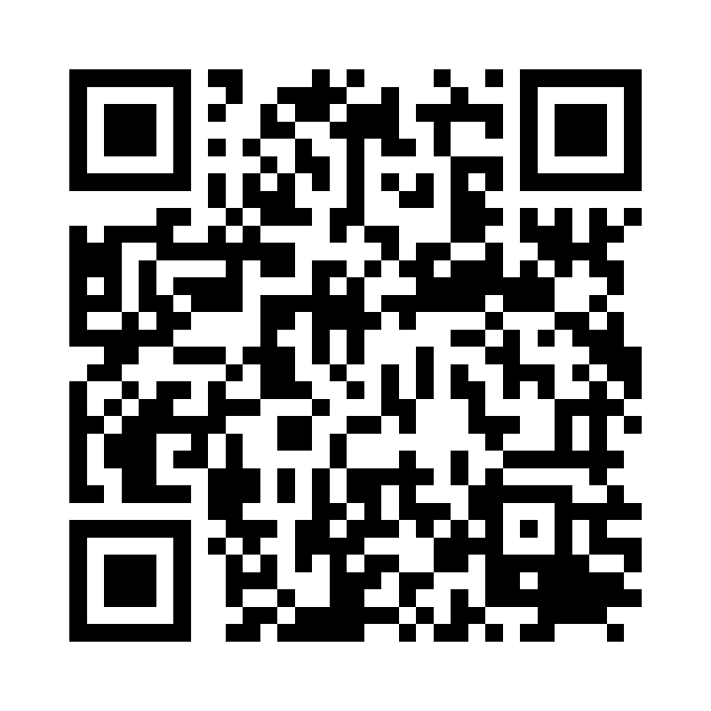

Site: St regis Marsa Arabia
Address: The St. Regis Marsa Arabia Island, The Pearl, Qatar
Coordinates: 25.369, 51.547
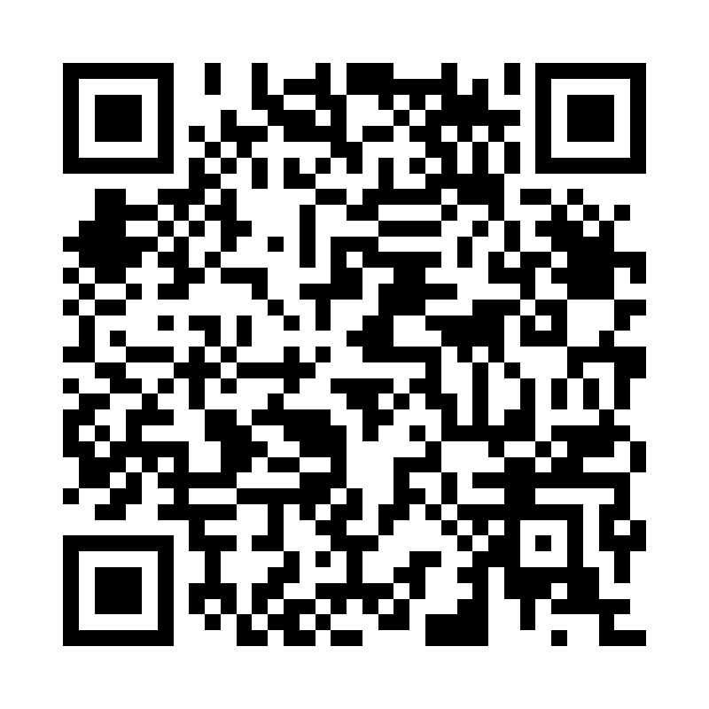

Site: Surgi Art Hospital
Address: Al Waab, Doha, Qatar
Coordinates: 25.286, 51.498
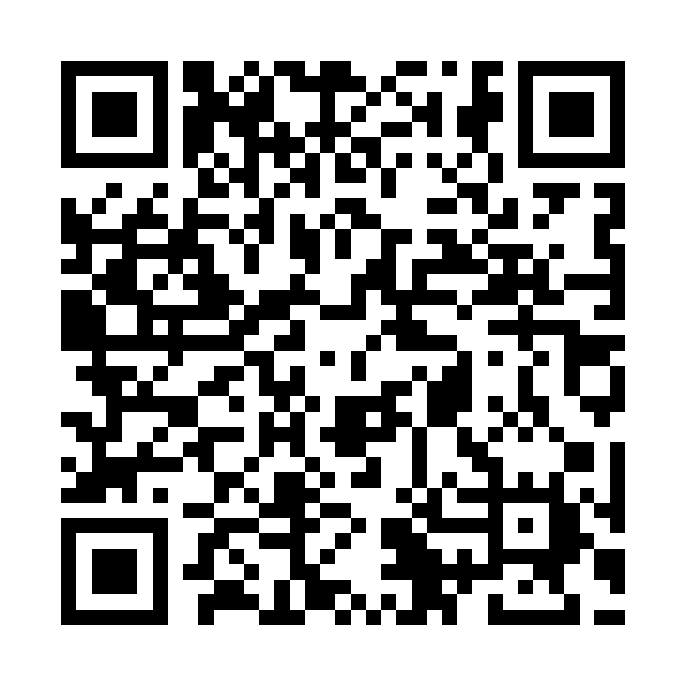

Site: Tawar Mall
Address: Tawar Mall, Al Markhiya St, Doha, Qatar
Coordinates: 25.334, 51.482
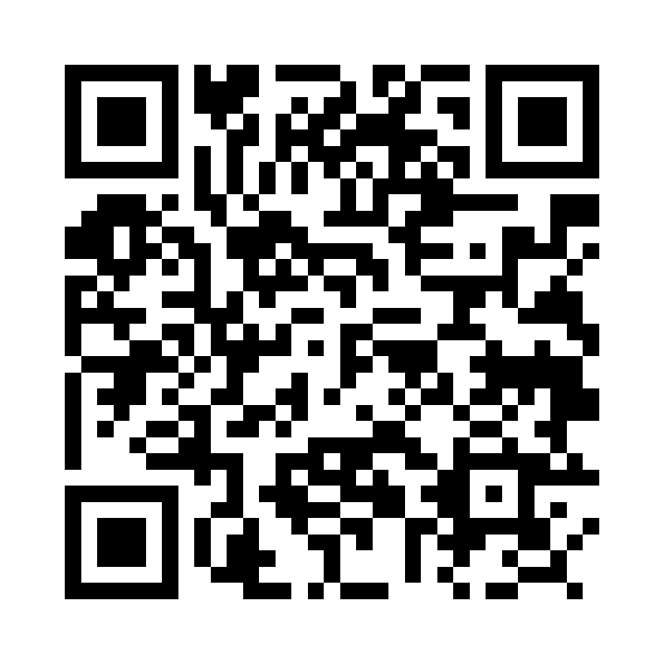

Site: The chedi katara Hotel
Address: The Chedi Katara Hotel & Resort, Qatar
Coordinates: 25.364, 51.527
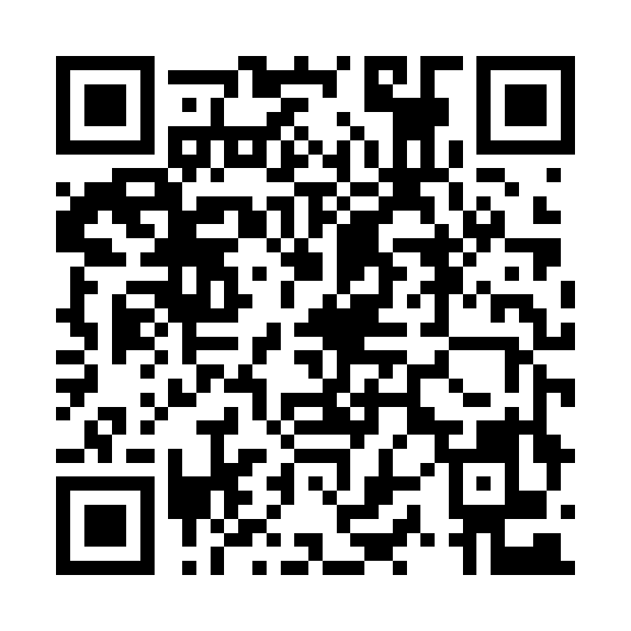

Site: The Ned Doha
Address: The Ned Doha, Corniche, Qatar
Coordinates: 25.299, 51.532
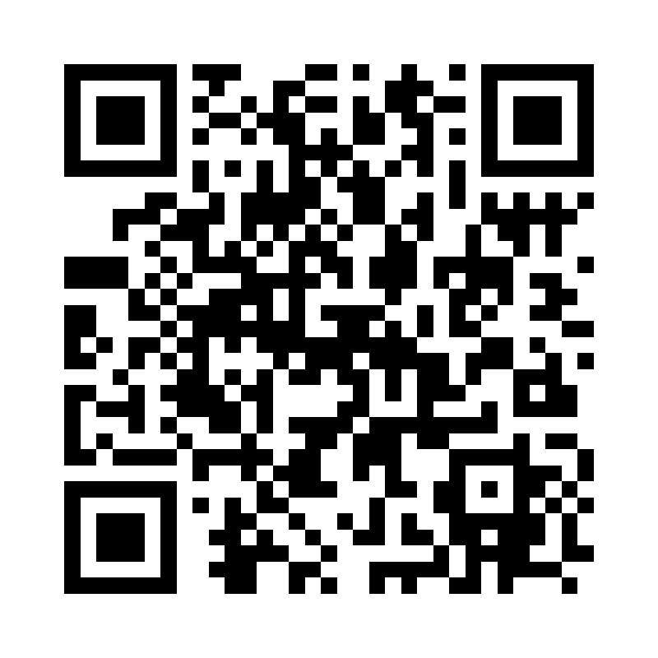

Site: The Pearl Hospital
Address: The Pearl, Doha, Qatar
Coordinates: 25.371, 51.546
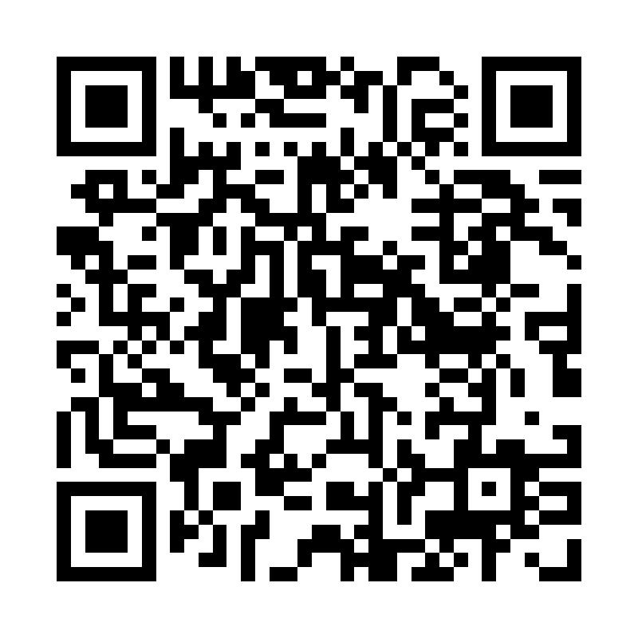

Site: The Plaza by Anantara
Address: The Plaza Doha by Anantara, Ras Abu Abboud, Qatar
Coordinates: 25.294, 51.551
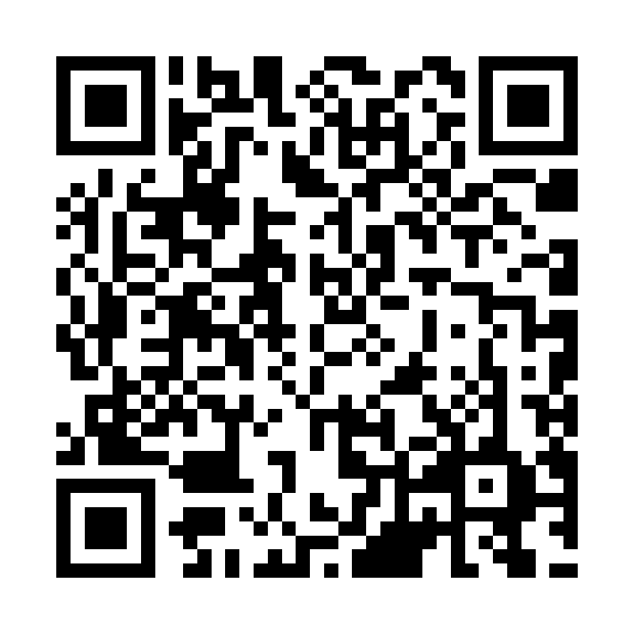

Site: The torch Hotel
Address: The Torch Doha, Aspire Zone, Qatar
Coordinates: 25.261, 51.443
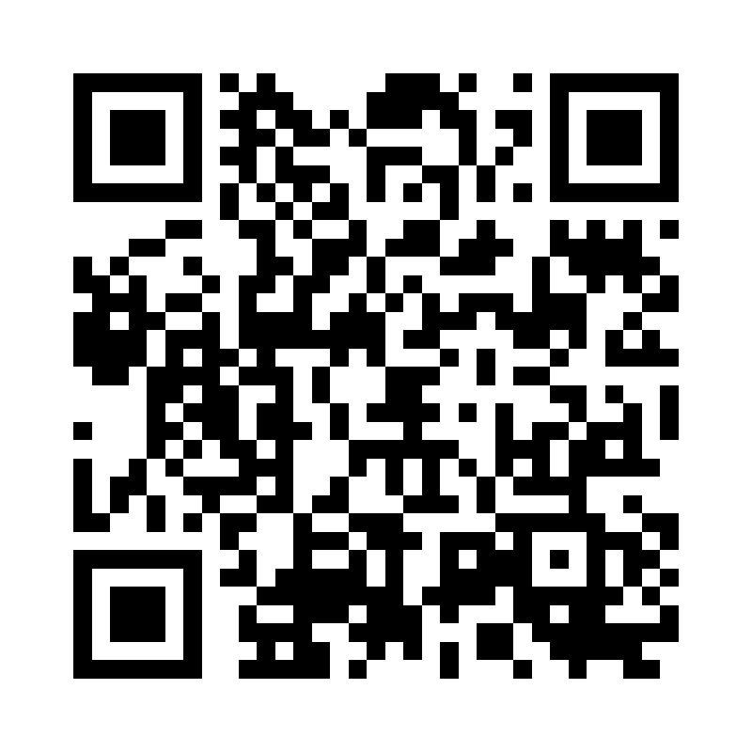

Site: The View Hospital
Address: The View Hospital, Al Qutaifiya, Qatar
Coordinates: 25.378, 51.519
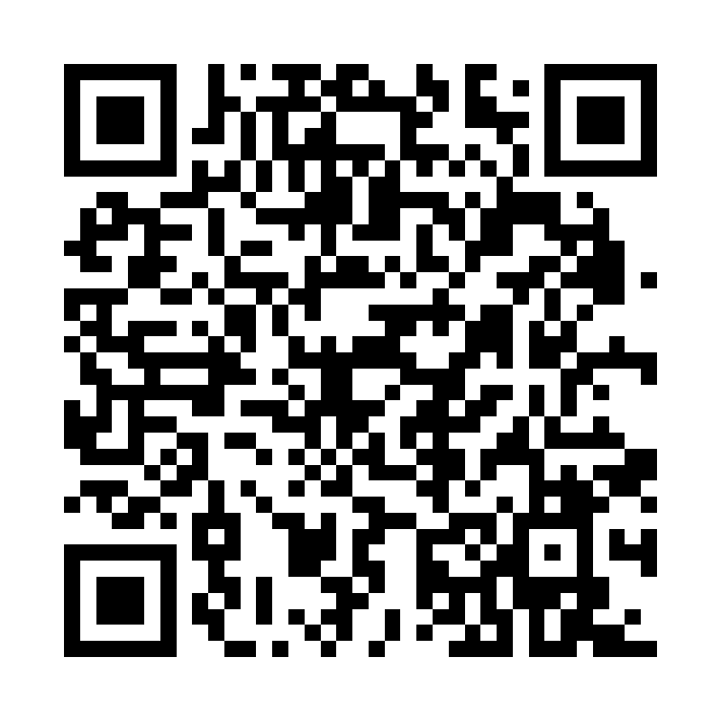

Site: Tower 18
Address: Lusail Marina, Qatar
Coordinates: 25.421, 51.529
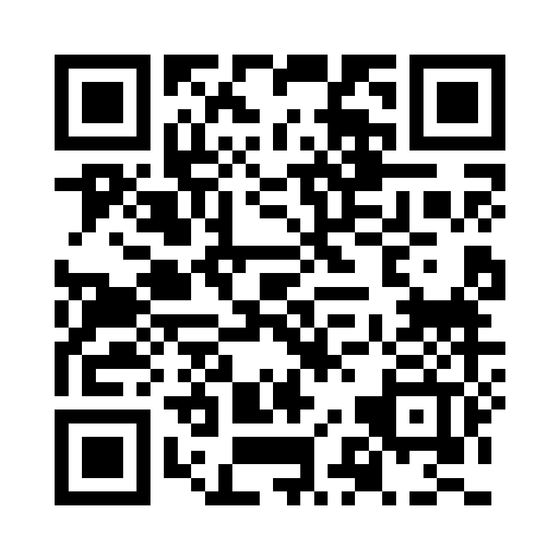

Site: Twin Tower Lusail
Address: Lusail Marina, Qatar
Coordinates: 25.4195, 51.5305
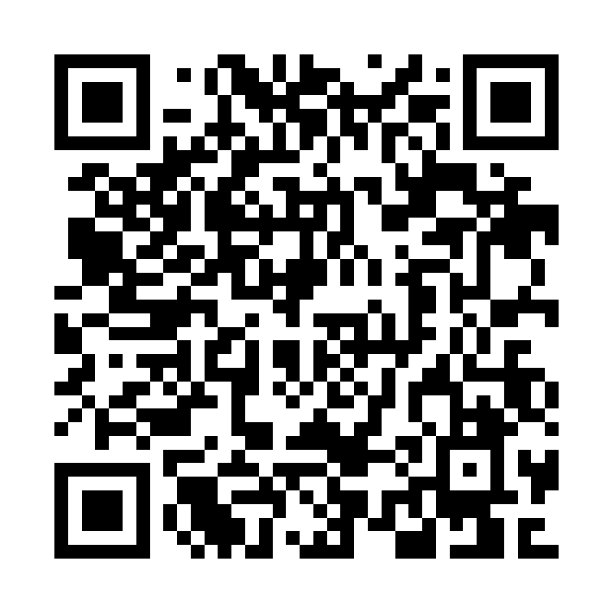

Site: UDC Tower
Address: UDC Tower, The Pearl, Qatar
Coordinates: 25.367, 51.543
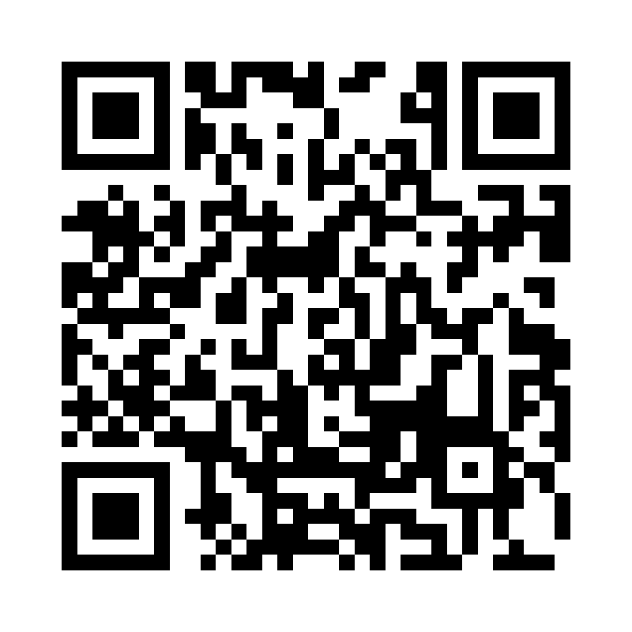

Site: Villaggio Mall
Address: Villaggio Mall, Aspire Zone, Al Waab, Qatar
Coordinates: 25.259, 51.444
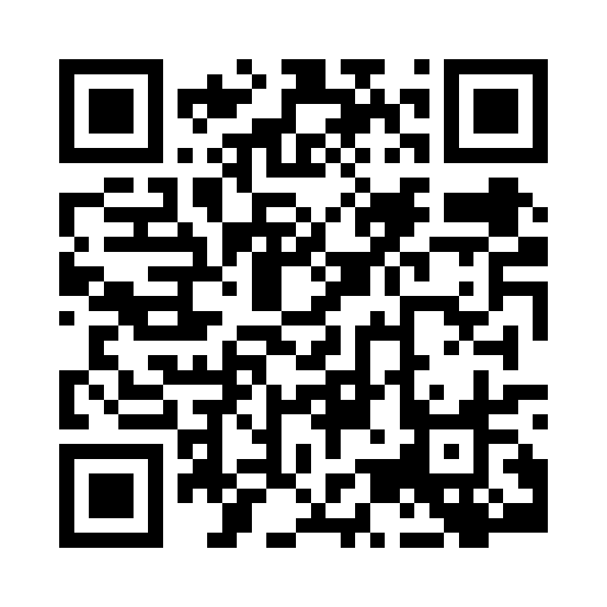

Site: Voco Hotel
Address: voco Doha West Bay Suites, Qatar
Coordinates: 25.328, 51.526
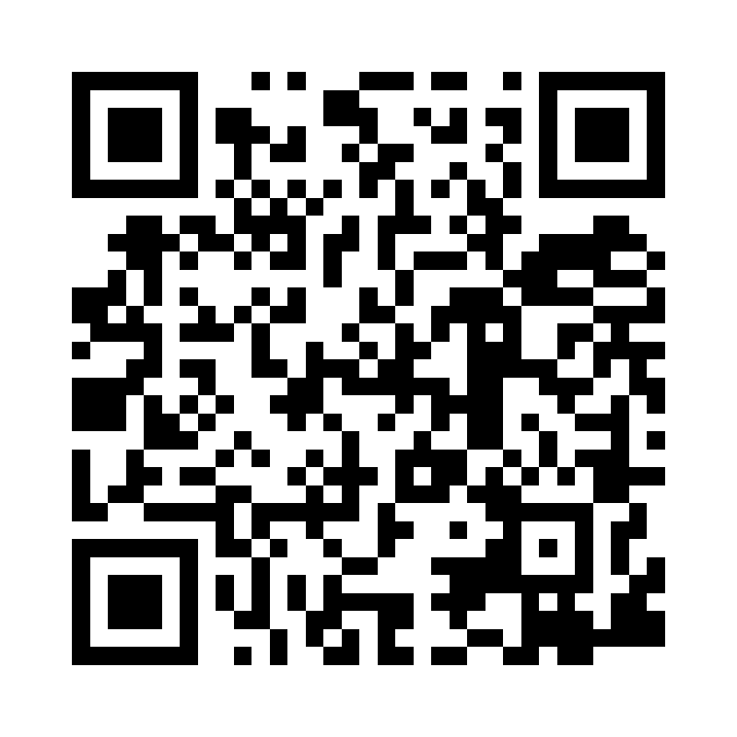

Site: Waldorf Astoria
Address: Waldorf Astoria Lusail, Qatar
Coordinates: 25.441, 51.538
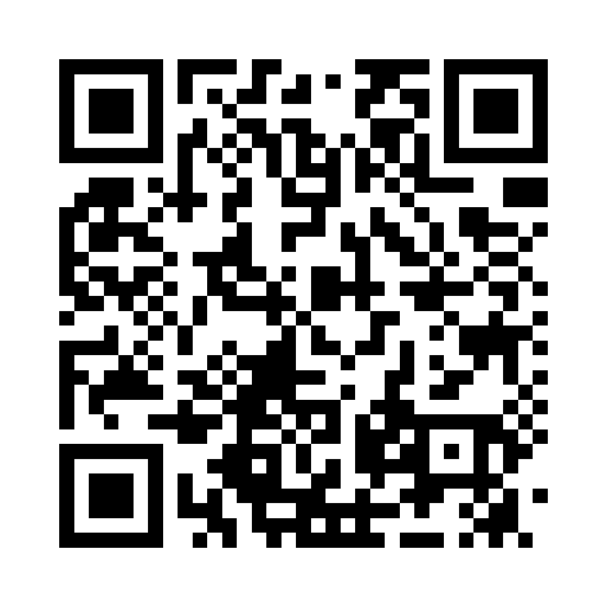

Site: West Walk
Address: West Walk, Al Waab, Doha, Qatar
Coordinates: 25.271, 51.488
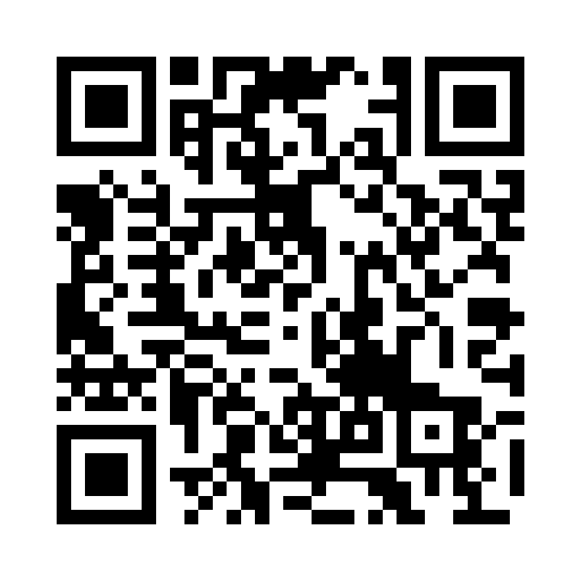

Site: Wyndham Hotel West Bay
Address: Maysaloun St, West Bay, Doha, Qatar
Coordinates: 25.3255, 51.5285
