**SageMaker:**

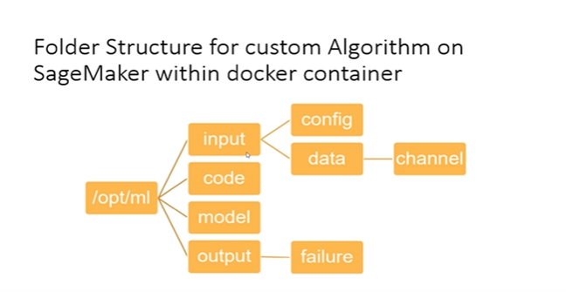

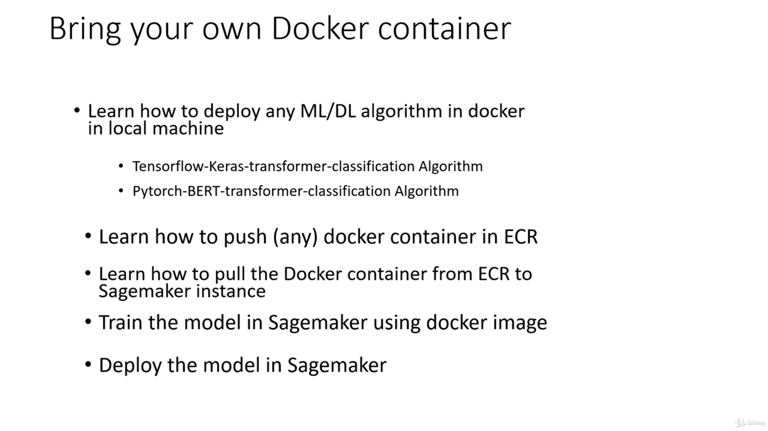

Build the docker file:

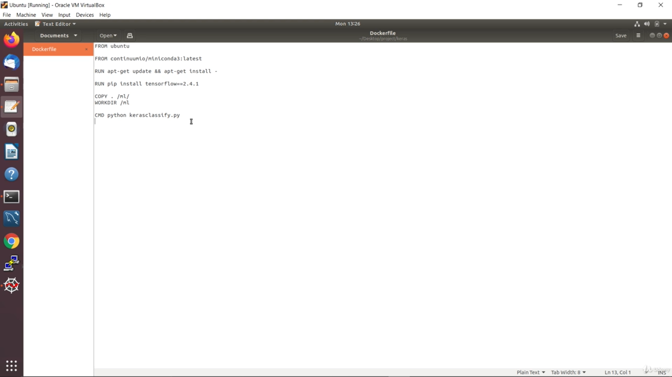d

Sagemaker docker file:

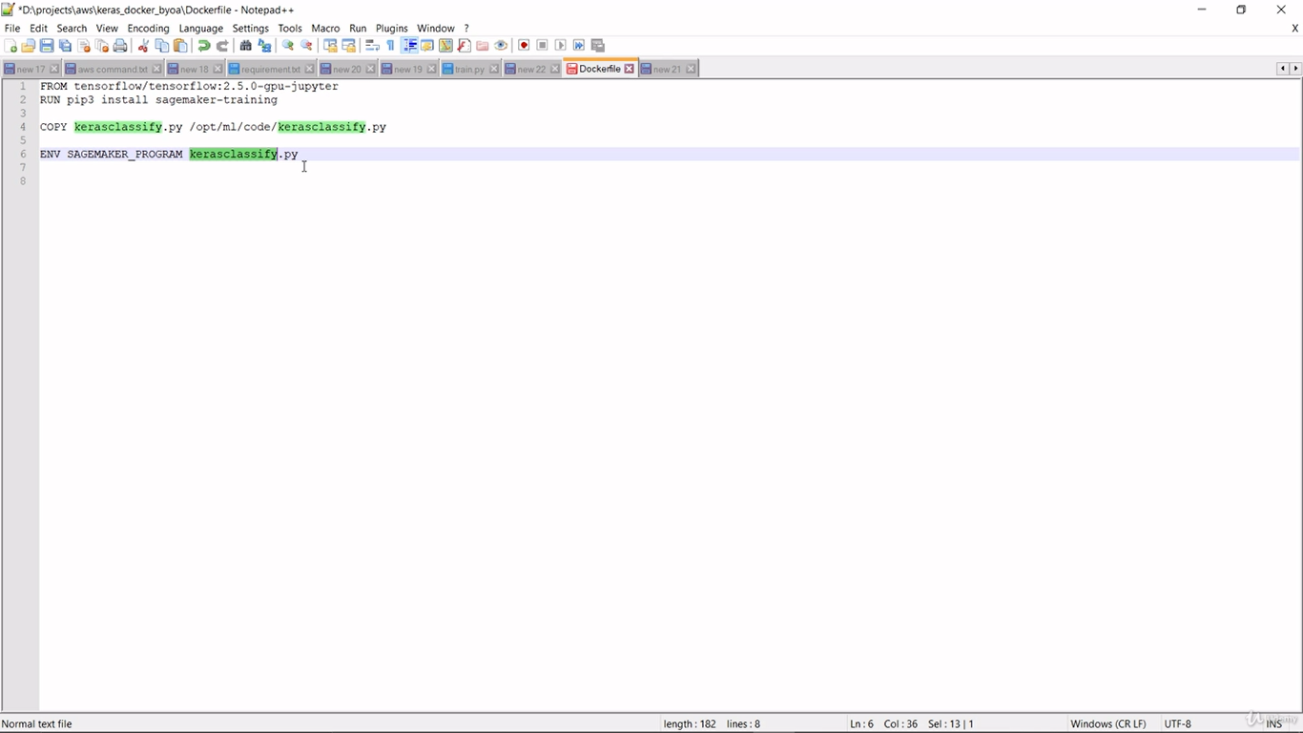

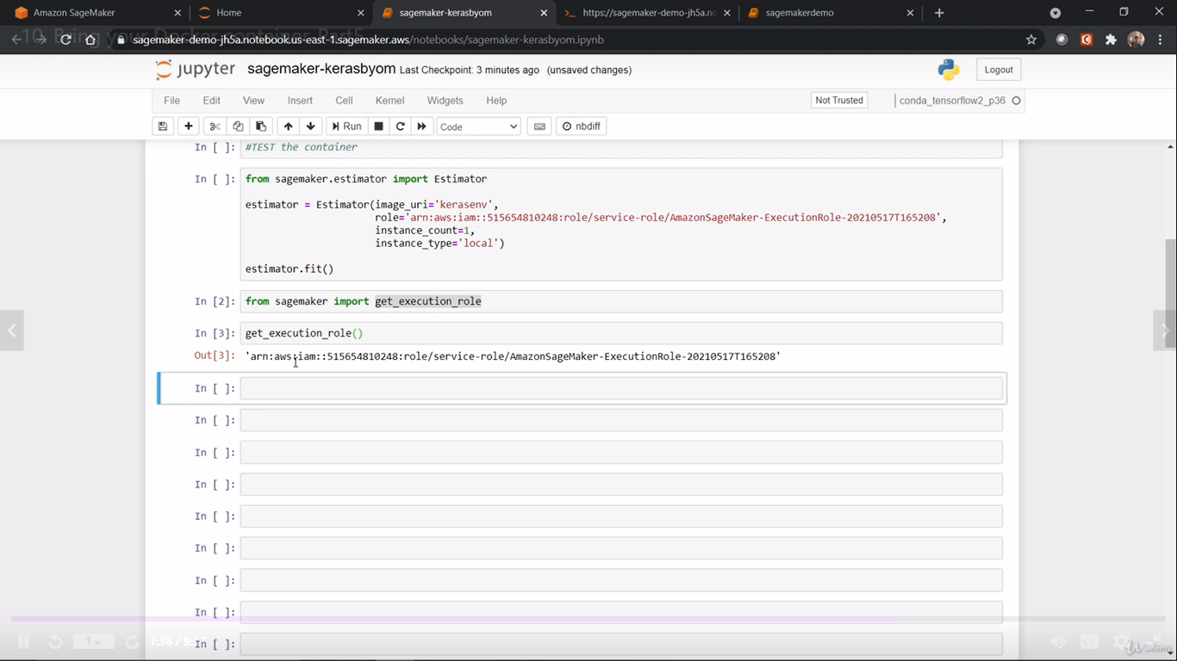

2. Multiclass classification model in Bert:

We have three classes [P,E,A] P= PERSON, E= ENTERPRISE, A= ADDRESS

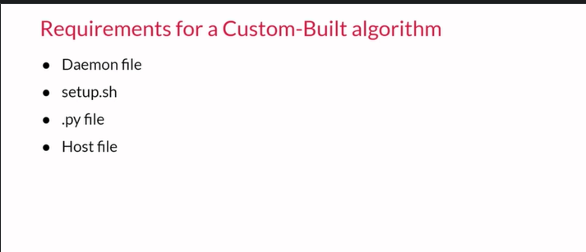

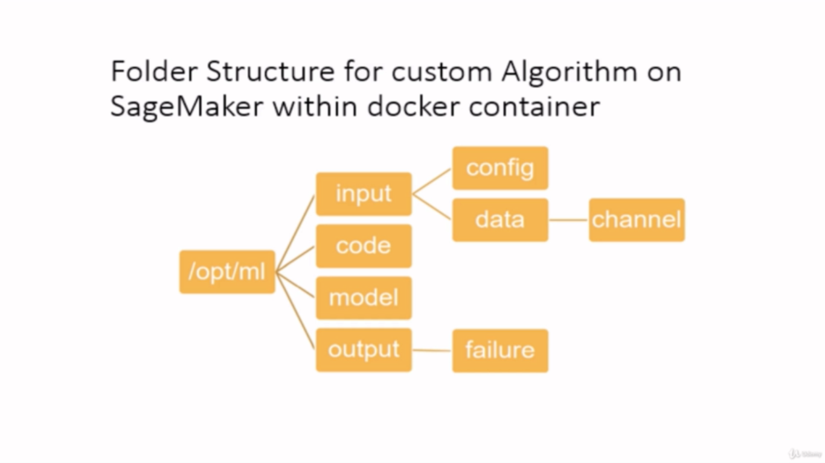

For byoa:

1. We need to change the hyper parameters
2. In the model function,We need to change Algo as per below screen shot and the remaining script will be same
3. 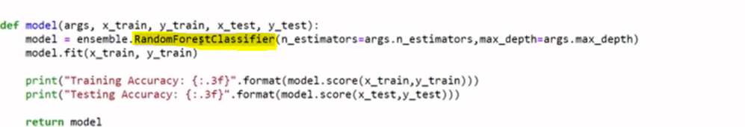
4. Daemon.json – contains json that tells us which kind of processing OS would be installed inside the docker container.
5. 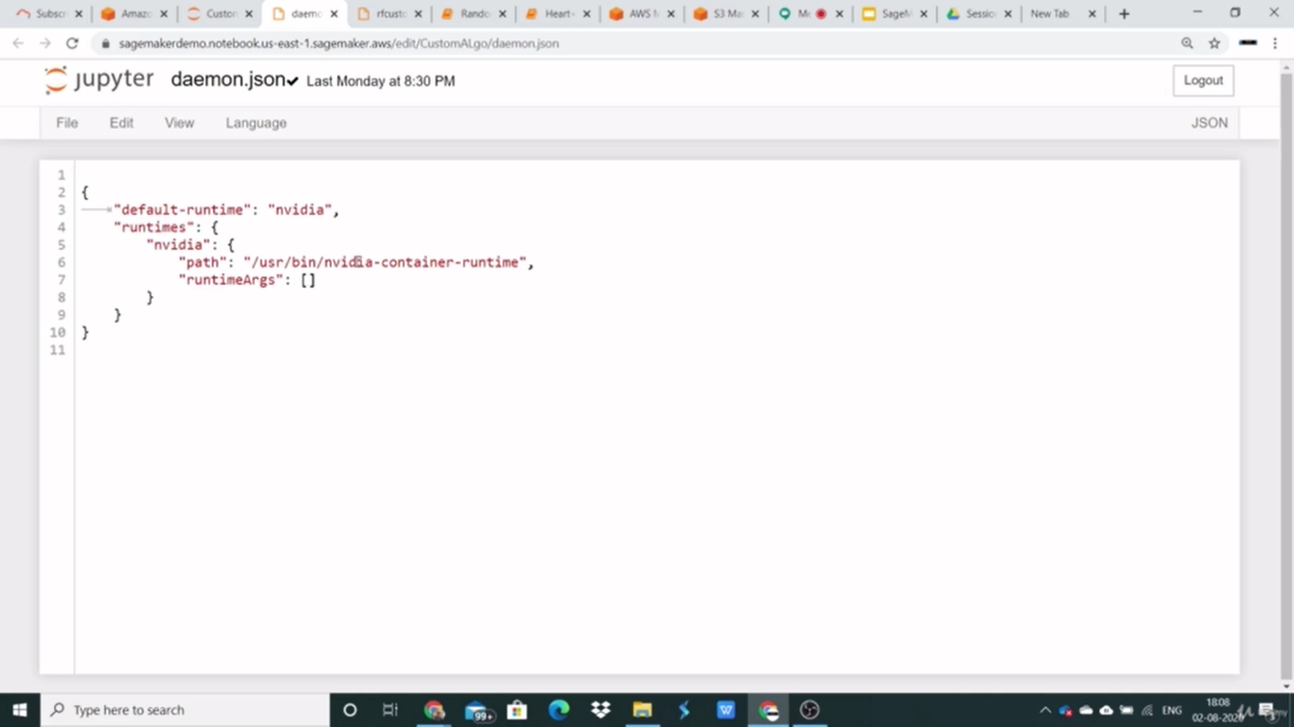
6. Setup.sh : It will automatically create docker for us.
7. We need train data and test data