# 1. Your Stress Level

|  |  |
| --- | --- |
| Stress Level Score | |
| 17.90 | |
| Description | Indicator |
| Emotional Stress (Above 12%) is more connected to the heart; thus, more socially connected. Your Stress comes from emotion which means you are a person who cares for others more than yourself. You tend to look at others and be ready to help others. Most of the time, you tend to take on other people's problems and likely look into yourself. Caring for others is a kindness act, and if you manage to overwhelm or be loaded with it, that will potentially trigger mental disabilities where you tend to worry about others and forget the self. | lorem ipsum lorem ipsumlorem ipsumlorem ipsumlorem ipsumlorem ipsumlorem ipsumlorem ipsumlorem ipsumlorem ipsumlorem ipsumlorem ipsumlorem ipsumlorem ipsumlorem ipsumlorem ipsumlorem ipsumlorem ipsumlorem ipsumlorem ipsumlorem ipsum |

# 2. Your Emotional State

|  |  |
| --- | --- |
| Empowering | Your Positive Emotion |
| CALM, CHEER | Your positive emotions are associated with tranquility and happiness. |
| CALM, CHEER | Your positive emotions are associated with tranquility and happiness. |

|  |  |
| --- | --- |
| Dis-empowering | Your Negative Emotion |
| FEAR, SADNESS | Your negative emotions are associated with dread, fear, and overwhelming sorrow. |
| FEAR, SADNESS | Your negative emotions are associated with dread, fear, and overwhelming sorrow. |

|  |  |  |
| --- | --- | --- |
| Note 1 | General Reaction | Social Behaviour Pattern |
| E | Always looking for joy, but with contradictions. Can be very happy but also very sad. Up and down. Brooding, sad, but always hope to get relief. Cool, difficult to be figured out. Dreamy behaviour, either very positive or very negative. Serious, official-like behaviour. Appear superior. Possibly in a dependent and ‘desperate’ situation. Kind of moody and fearful. Negative sometimes – can over-react. | lorem ipsum |

|  |  |  |
| --- | --- | --- |
| Note 2 | General Reaction | Social Behaviour Pattern |
| E | Always looking for joy, but with contradictions. Can be very happy but also very sad. Up and down. Brooding, sad, but always hope to get relief. Cool, difficult to be figured out. Dreamy behaviour, either very positive or very negative. Serious, official-like behaviour. Appear superior. Possibly in a dependent and ‘desperate’ situation. Kind of moody and fearful. Negative sometimes – can over-react. | lorem ipsum |

# 3. Rhythmic Pattern

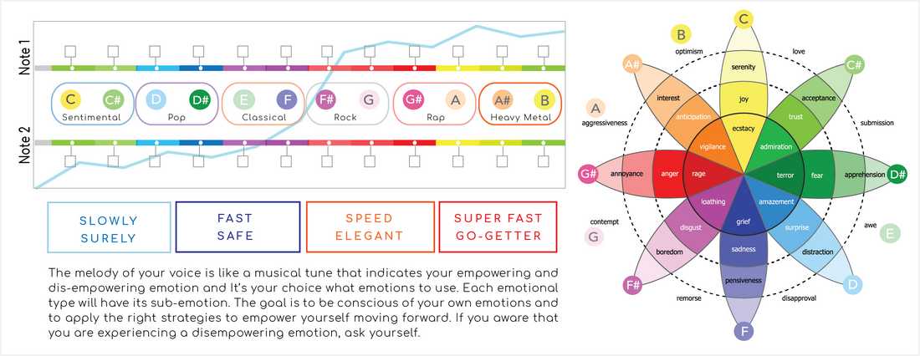

|  |  |  |  |
| --- | --- | --- | --- |
| Frequent Emotion: The emotion that keeps showing up. | | | |
| f4 | Funny, active, radiant, cheerful. |  | lorem ipsum |
| Core Emotion: Strongest emotion underneath the frequent emotion. | | | |
| p1 | Possible life fear. | Deep-rooted fears that are not always related to self. Could be the fear of losing somebody (e.g. parent, child, relative, pet and etc.) | lorem ipsum |

# 4. Your Present Sensory Attributes

|  |  |
| --- | --- |
| BASE When you receive information, this is the first sensory attribute you will use to proccess the data. | NEXT This is next sensory attribute you will use more of to process and proccess the information. |
| FEELING  Outward  Extrovert | FEELING  Outward  Introvert |

# 5. Brain Activities

|  |  |
| --- | --- |
| Left | Right |
| 230 | 1209 |

# 6. Present Character and Real Intention

|  |  |  |  |  |
| --- | --- | --- | --- | --- |
| Present Character | | | | |
| Character | Present Character | Summary | Work Environment | Ideal Jobs |
| 5 - Observer | Omniscience awareness | Private, measured, logical and an intellectual seeker. Observers avoid (emotional) attachment. They focus on gaining knowledge. Observers can be re-active, overly self-controlled, detached from their emotions. Predictability is safety; they do not like surprises. | lorem ipsum | lorem ipsum |

|  |  |  |  |  |  |  |
| --- | --- | --- | --- | --- | --- | --- |
| Real Intention | | | | | | |
| Character | Real Intention | Summary | Career Choice | Ideal Workspace | Ideal Jobs | Grow Path |
| 3 - Winner | Self-improvement, Competency | Success-oriented & pragmatic, setting clear goals and objective towards excellence. | lorem ipsum | lorem ipsum | lorem ipsum | lorem ipsum |

# 7. The Seven Leadership Dynamics

|  |  |
| --- | --- |
| 1 - Purpose : Values, Passion, Purpose | 2 - Self Awareness : Insights to Beliefs |
| High | High |
| 3 - Self Development : Knowledge to Communicate | 4 - Self Management : Relationships to Love |
| Good | Low |
| 5 - Self Belief : Willpower to Wealth | 6 - Self Esteem : Belonging to Pleasure |
| Low | Good |
| 7 - Being : Experience to Foundation |  |
| Good |  |

# 8. Your Top 5 Constructive Attributes

You are consciously aware of your constructive attributes; you are aware that the action you take will empower you to create possibilities. These are the areas where you feel positive with high energy.

|  |  |  |
| --- | --- | --- |
| No. | Constructive | Description |
| 1 | s2 - Seek control, calm, good manners. | But you are not always aware of this. |
| 2 | h10 - Natural kind of behaviour. | You are easy-going and popular. |
| 3 | c7 - Can translate worldly matters into spiritual insights. |  |
| 4 | i3 - Disciplined and persevering. | You work hard for a better future. You want to prove yourself. |
| 5 | i4 - Natural leader. |  |

# 9. Your Top 5 Restrictive Attributes

Past incidents could be a block to your present actions. These are the areas that potentially trigger some unpleasant memories and they will shape your behaviour in line with your thoughts.

|  |  |  |
| --- | --- | --- |
| No. | Restrictive | Description |
| 1 | p9 - Pay very close attention to any changes in his or her physical body? |  |
| 2 | l9 - Lonely, remembering the better days. |  |
| 3 | a1 - Perfectionist. | You are often afraid of making mistakes and in doubt of doing any task well. |
| 4 | c18 - Compulsively trying to hold control. | Control with possible rituals. Can go over to a Obsessive compulsive disorder. (OCD) is a mental disorder characterized by intrusive thoughts that produce anxiety, by repetitive behaviours aimed at reducing anxiety, or by combinations of such thoughts (obsessions) and behaviours. |
| 5 | t11 - Feel claimed. | You feel being trapped in the circumstances. Family plays an important part in this phase of your life. Psychological pressure usually comes from a demanding parent and you feel obligated. You possibly feel a need to care for a sick neighbour. |

# 10: Past Experiences Shaped Your Thoughts

|  |  |
| --- | --- |
| Code | Value |
| 01. C | 4 |
| 02. C# | 3 |
| 03. D | 2 |
| 04. D# | 1 |
| 05. E | 1 |
| 06. F | 1 |
| 07. F# | 1 |
| 08. G | 3 |
| 09. G# | 4 |
| 10. A | 5 |
| 11. A# | 7 |
| 12. B | 5 |

# 12: Organ Affected by Wellness Challenge

|  |  |
| --- | --- |
| Organ | Description |
| Colon | lorem ipsum |
| Lung | lorem ipsum |
| Gallbladder | lorem ipsum |
| Lymphatic | lorem ipsum |

|  |  |
| --- | --- |
| Health Area Impacted by Organ | Description |
| lorem ipsum | lorem ipsum |

# 12. Potential Mental & Physical Wellness Challenge

|  |  |  |
| --- | --- | --- |
| No. | Wellness Challenge | Description |
| 1 | o6 - Overstimulated nervous system | Imbalance in nervous system may indicate that you are not listening to self. Insufficient own space. Perhaps too consumed by getting attention and appreciation from family, friends, work and studies. Always trying to prove self. |
| 2 | l7 - Lymphatic system overactive, possible allergies | Fear to be or see self. Too much focus on one thing and unable to see all possibilities in life. |
| 3 | e2 - Endocrine stress | The endocrine system consists of a number of glands, such as thyroid, gonads and adrenal glands and the hormones that are produced, such as thyroxin, estrogen, testosterone and adrenaline. Regulatory effect in development, growth, reproduction and behaviour. When there is stress, there is an imbalance. Ignore own authority and place authority outside self. The eagle that sees self as a sparrow. |