1. Registered users password forgot email

Path : sehionapp/apps/controllers/Reg.php

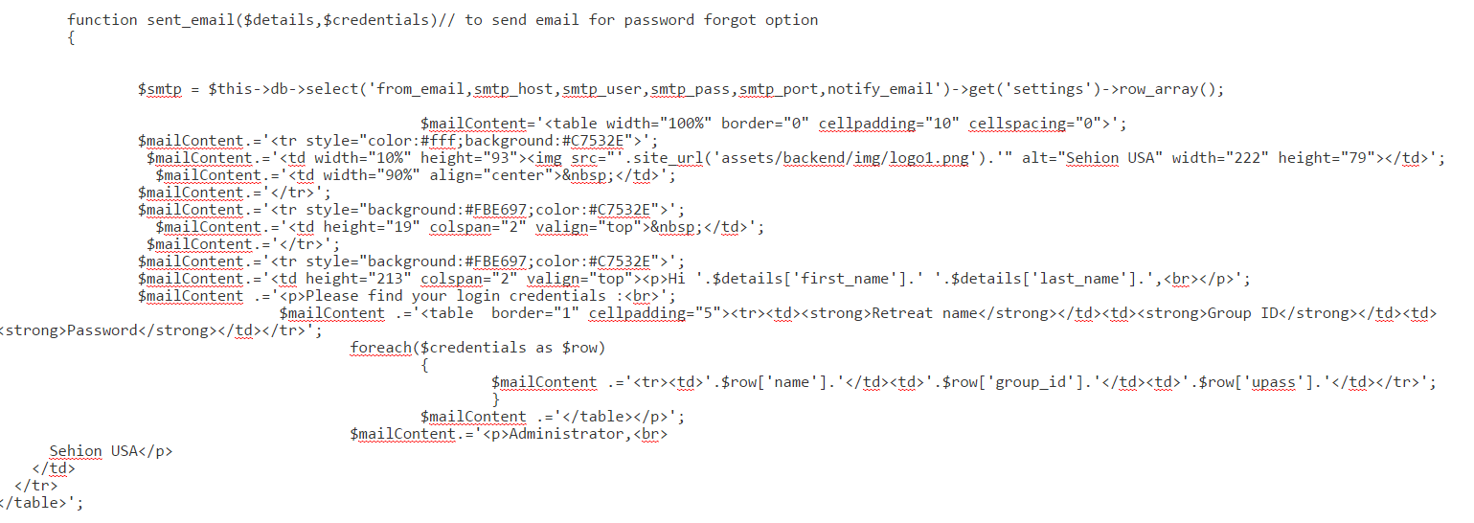

1. Registration Complete email – both check and paypal

Path : sehionapp/apps/controllers/Reg.php

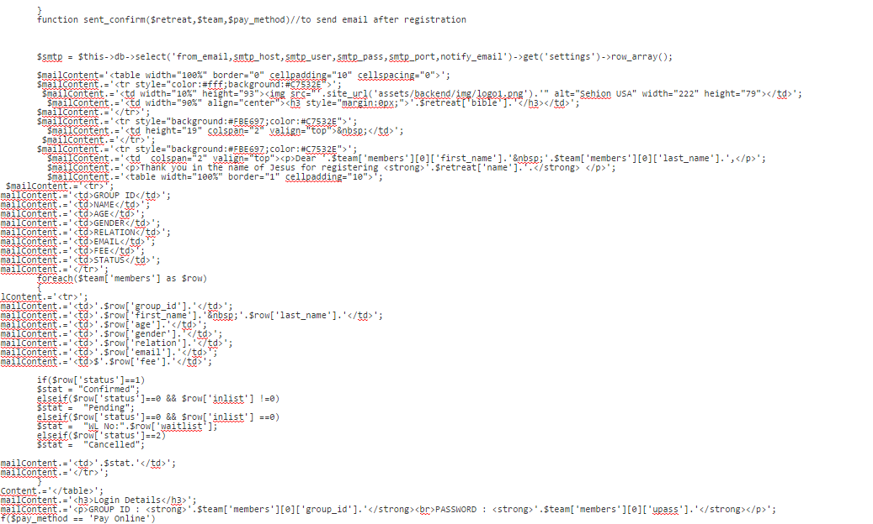

1. Email after paypal payment

Path : sehionapp/apps/controllers/Paypal.php

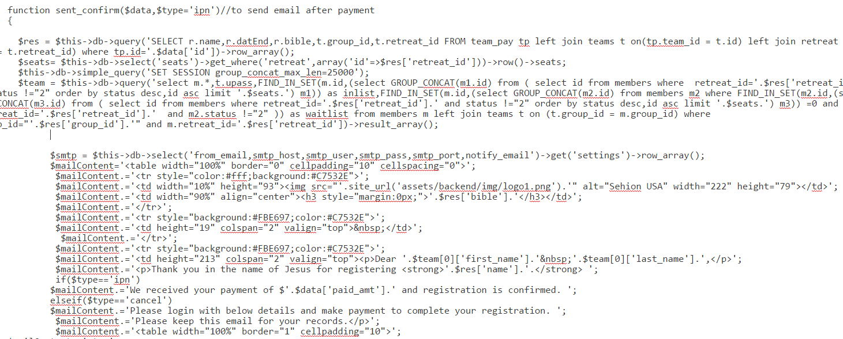

1. Add permission to managers

Path : sehionapp/apps/controllers/ Managers.php

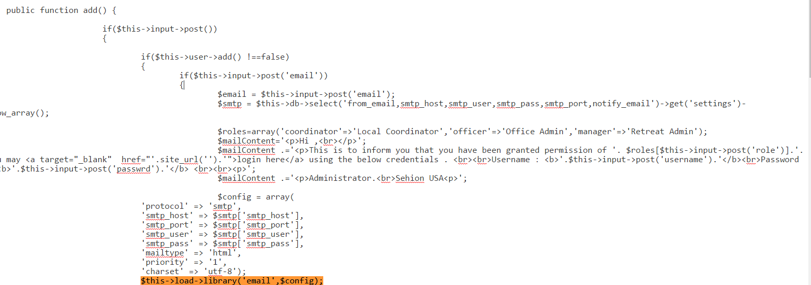

1. Edit permission of managers

Path : sehionapp/apps/controllers/ Managers.php

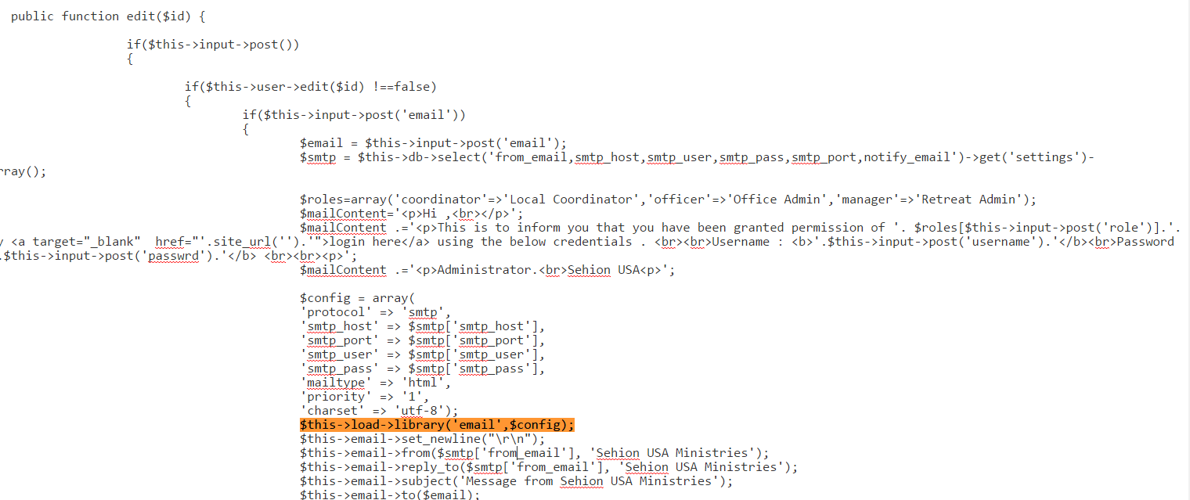

1. Updating group information - mail or status change

Path : sehionapp/apps/controllers/ Groups.php

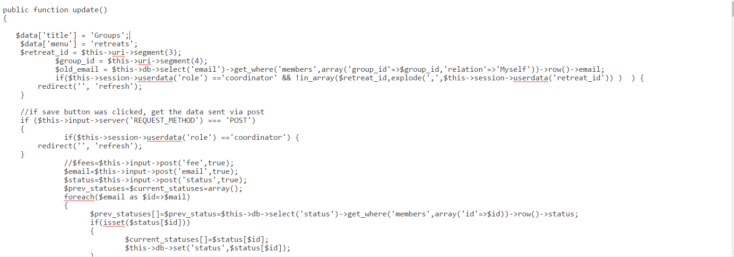

1. Waiting list status change

Path : sehionapp/apps/libraries/Waitlist.php

