- How many observations are there in the data set?
There are total 34677 observations.
- What are the names of the variables? and what is the class of each variable?
[,1] [,2] [,3] [,4]
names "id" "title" "body" "lat"
class "character" "character" "character" "numeric"
names "long" "posted" "updated" "drive" "odometer"
class "numeric" "POSIXct" "POSIXct" "factor" "integer"
[,10] [,11] [,12] [,13] [,14]
names "type" "header" "condition" "cylinders" "fuel"
class "factor" "character" "factor" "integer" "factor"
[,15] [,16] [,17] [,18] [,19]
names "size" "transmission" "byOwner" "city" "time"
class "factor" "factor" "logical" "factor" "POSIXct"
[,20] [,21] [,22] [,23]
names "description" "location" "url" "price"
class "character" "character" "character" "integer"
[,24] [,25] [,26]
names "year" "maker" "makerMethod"
class "integer" "character" "numeric"
- What is the average price of all the vehicles? the median price? and the deciles? Displays these on a plot of the distribution of vehicle prices.
mean is 49449.9 median = 6700 quantile is 21997.(without moving out any wired observations)
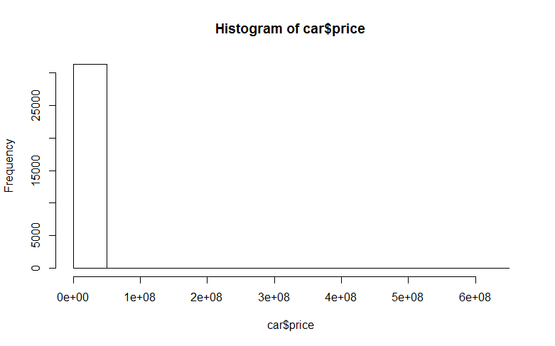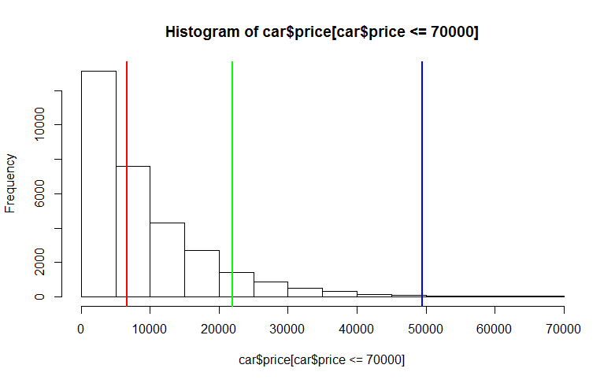
Original plot Fixed plot
After I draw the plot, I realized there are many extremely large values, so I chose the value less than $70000 and draw a new plot. And marked the three values, the red line is median, the green line is the 0.9 quantile, and the blue line is mean. For those three values, I still used the values from the first part.
- What are the different categories of vehicles, i.e. The type variable/column? What is the proportion for each category ?
There are 13 different categories of vehicles.
This is the table of the categories of vehicles with the proportion of each vehicle type.
bus convertible coupe hatchback mini-van
0.001171147 0.037583178 0.086558424 0.043598616 0.024114985
offroad other pickup sedan SUV truck
0.003513442 0.035453820 0.048389673 0.374767101 0.224168219 0.063987224
van wagon
0.026989619 0.029704552
- Display the relationship between fuel type and vehicle type. Does this depend on transmission type?
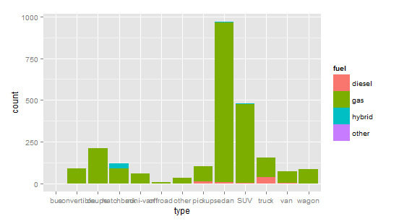
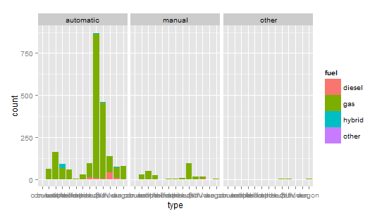
Before I draw this graph, I remove all the NA first. From the graph fuel/transmission/type, we can see, no matter what type of transmission, most of them use gas. But for the different car type, like truck use more diesel compare to other type, and hatchback use more hybrid compare to other car type. (bause it is hard to see the x axis label on the graph, so I list them on here "bus""convertible""coupe""hatchback""mini-van""offroad""other""pickup""sedan""SUV""truck" "van" "wagon")
- How many different cities are represented in the dataset?
Seven cities.
- Visually display how the number/proportion of "for sale by owner" and "for sale by dealer" varies across city?
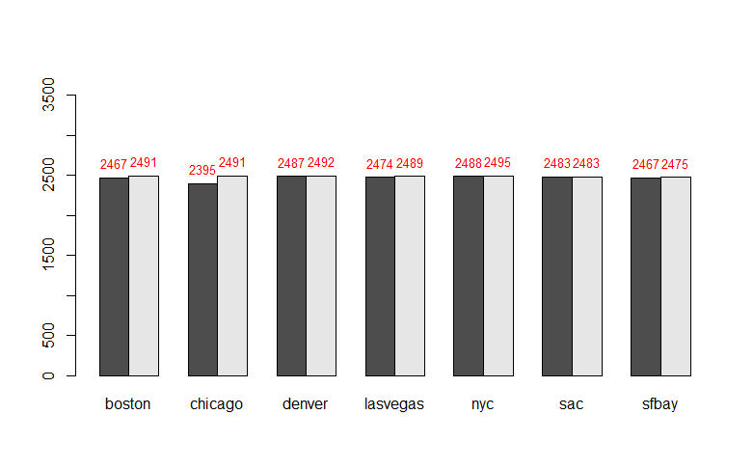
The black bar is “for sale by owner”, the gray bar is “for sale by dealer”
- What is the largest price for a vehicle in this data set? Examine this and fix the value. Now examine the new highest value for price.
The larger one is 600030000, I looked at the post, he wanted to say that the price is between $5,000 to $30,000. So based on the information he provided, I searched on KBB, the price around $25,000.After I fixed this post, then the highest value is $30,002,500, I found the original post, it should be $3500(This is the link http://chicago.craigslist.org/chc/cto/5233285975.html).After fix this one, the largest value is $9,999,999, I looked at the post, actually it no long existed, so I assume this is a junk post, so I deleted this one, Finally the largest value is $569,500, I looked the post, it is right number, but I think it is a typo, because that car won’t worth this much. I searched it on KBB, the price should be $5,730. After fixed those prices, the highest price is $400,000.
- What are the three most common makes of cars in each city for "sale by owner" and for "sale by dealer"? Are they similar or quite different?
The left three is sale by owner, the right three is sale by dealer
$boston
ford toyota chevrolet ford honda chevrolet
333 288 215 353 263 226
$chicago
chevrolet ford nissan chevrolet ford honda
305 305 208 365 331 180
$denver
ford chevrolet dodge ford chevrolet toyota
313 291 210 378 313 191
$lasvegas
ford nissan chevrolet ford chevrolet toyota
307 249 238 394 306 193
$nyc
nissan toyota honda nissan toyota honda
328 238 220 308 274 260
$sac
ford toyota chevrolet toyota ford chevrolet
337 273 206 340 305 299
$sfbay
toyota ford bmw toyota honda ford
269 245 227 332 322 257
Table of Maker by owner:
ford chevrolet toyota honda nissan
6 5 5 4 1
Table of Maker by dealer :
ford chevrolet toyota nissan bmw dodge honda
6 5 4 3 1 1 1
In order to compare if there are similar or different, I create table for both of them, We can see that the most common car makers are very similar between sale by dealer and sale by owner for different cities.
- Visually compare the distribution of the age of cars for different cities and for "sale by owner" and "sale by dealer". Provide an interpretation of the plots, i.e., what are the key conclusions and insights?
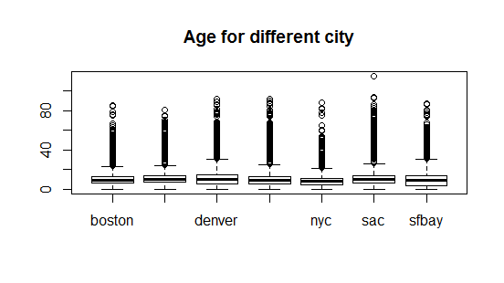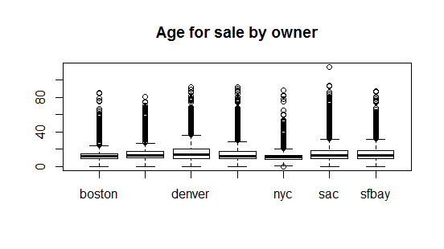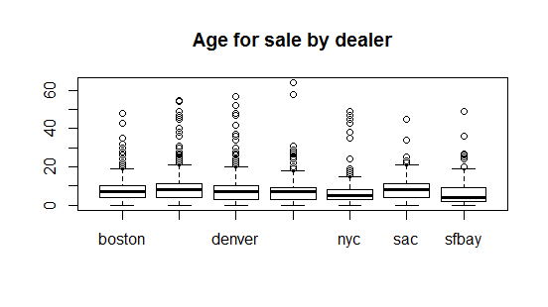
There are three boxplots, they all give the median, first and third quartile. In those plots, we can see there are some cars are very old in all the city, and the overall plot is very similar to the sale by owner. Comparing the distribution for different cities the median of them are very similar. The cars sale by dealer seem like have small age compare to the cars that sale by owner, which makes sense because the dealers don’t like old cars. (the names of each city can’t show on the plot, because the plot is shorter than the length of all the cities’ name, the city’s name is in the following order "boston" "chicago" "denver" "lasvegas" "nyc" "sac" "sfbay" )
- Plot the locations of the posts on a map? What do you notice?
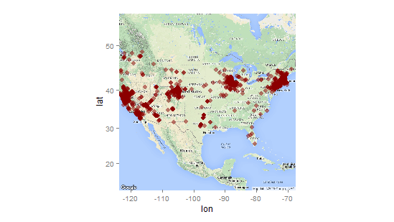
Most points are around the major cities. From the above question, we know that there are seven different cities are represented in the dataset, but if we look at the map, there are some points that are not exactly on those cites.
- Summarize the distribution of fuel type, drive, transmission, and vehicle type. Find a good way to display this information.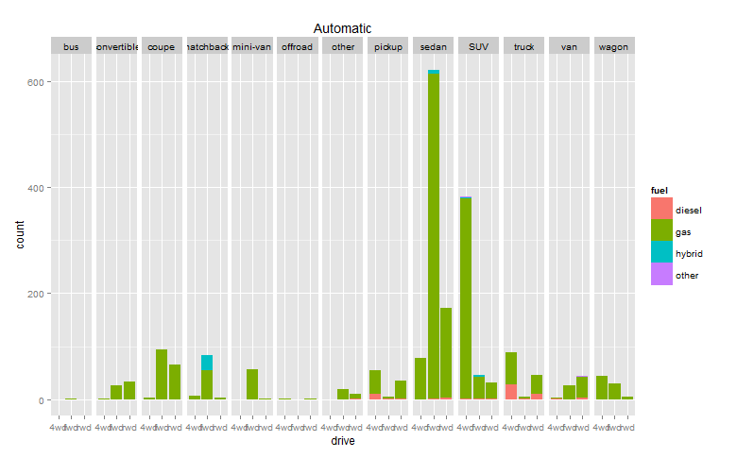
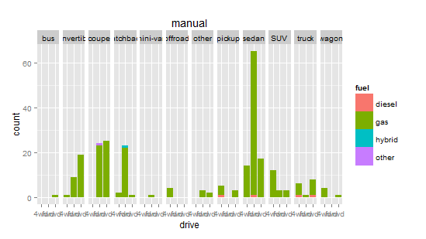
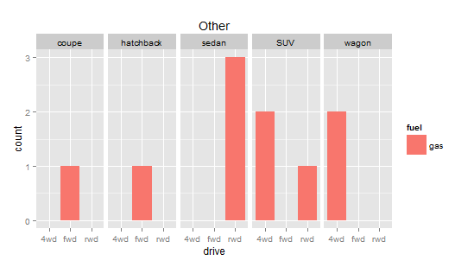
- Plot odometer reading and age of car? Is there a relationship? Similarly, plot odometer reading and price? Interpret the result(s). Are odometer reading and age of car
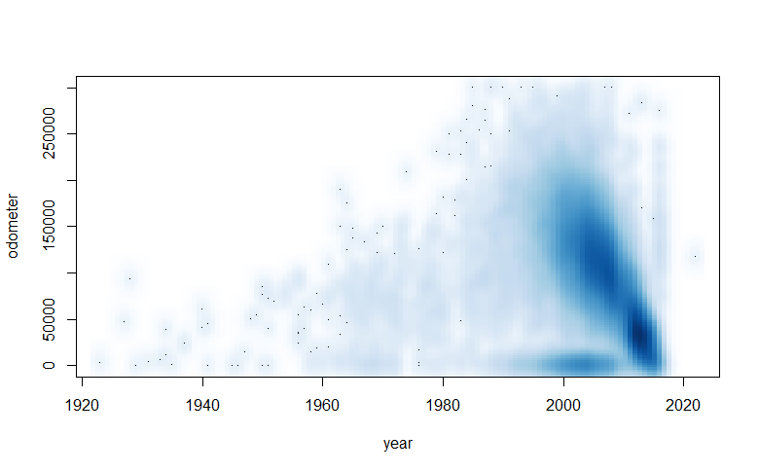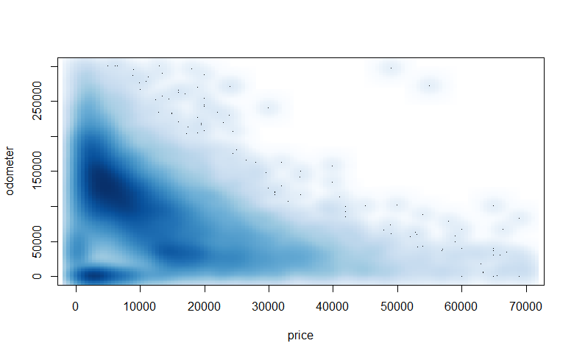
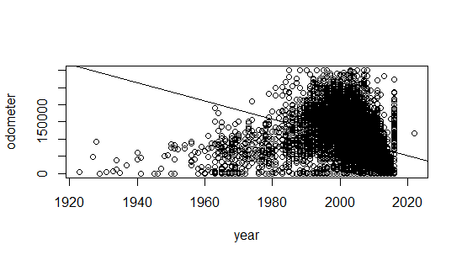
From the first plot which is “years vs odometer”, we can see there is a strong linear relation when the year greater than 2000, so I did a liner regression, it gives me odo = 5426618-26631*year. The ANOVA table gives me P value is <2.2 e^-16, which we will reject the null hypothesis that year and odometer doesn’t have any liner relation. The last graph shows the regression line.
- Identify the "old" cars. What manufacturers made these? What is the price distribution for these?
amc bentley buick cadillac chevrolet
4 1 28 32 295
chrysler datsun desoto dodge eagle
11 6 1 40 1
fiat ford geo gmc harley davidson
7 205 1 18 1
honda hudson international jaguar jeep
1 3 10 2 13
lincoln maserati mazda mercedes mercury
17 1 2 7 19
mg mitsubishi nissan oldsmobile plymouth
10 1 1 24 28
pontiac porsche rolls royce shelby studebaker
37 6 4 7 4
toyota triumph volkswagen volvo willys
9 5 58 2 12 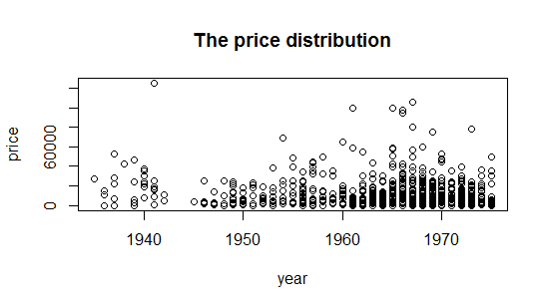
I define the age of cars between 40 years to 80 years as old car.
- I have omitted one important variable in this data set. What do you think it is? Can we derive this from the other variables? If so, sketch possible ideas as to how we would compute this variable.
VIN number, but I don’t know how to get it out. I know how to check how many posts have VIN number, so I did check that, I got 12772 posts have VIN number, I know the total number of posts are 34677, but there are many NA in the dataset, so I think most of them contain the VIN number.
- Display how condition and odometer are related. Also how condition and price are related. And condition and age of the car. Provide a brief interpretation of what you find.
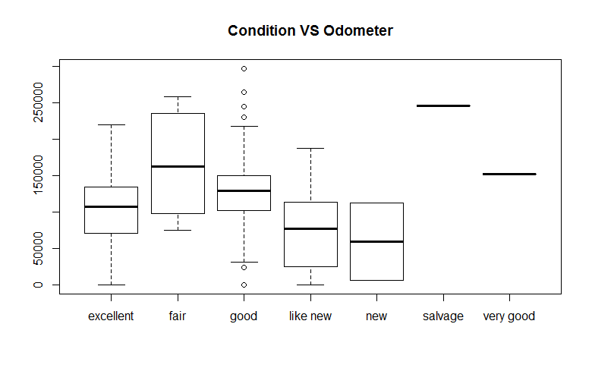
We can see that as the condition decreasing, the odometer is increasing, the order of median of odometer for different condition of car is new > like new > excellent > good > verygood > fair > salvage, we can see the reading of odometer is increasing as the condition goes bad. When I draw this plot, the original plot has lots of outliers, so I only include the odometer that less than 300.000 miles, because I think most cars are in this range. Also I omitted some conditions of the car, because they have less observations compare others, some conditions only have 1 or 2 observations, but some have hundreds or thousands observations, so I think I can remove them and make the plot better to read, it is also applied to the another two plots.
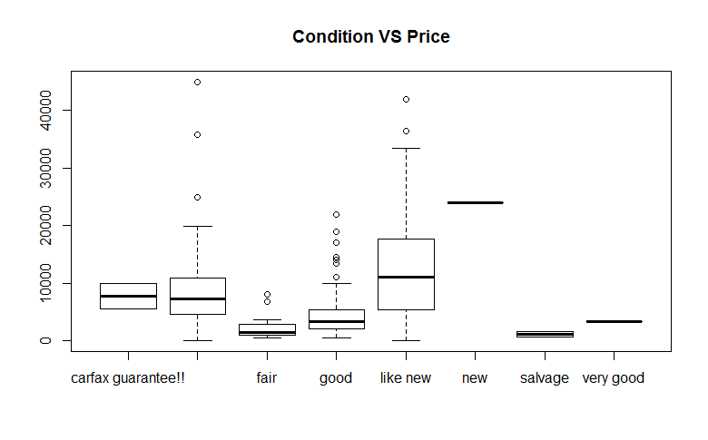
The price and condition relation is similar like the odometer and condition, as the condition gose bad, the price also gose down, from the plot we can see the order of median of the price by different condition is salvage < fair < good <very good < excellent < carfax guarantee < like new < new.
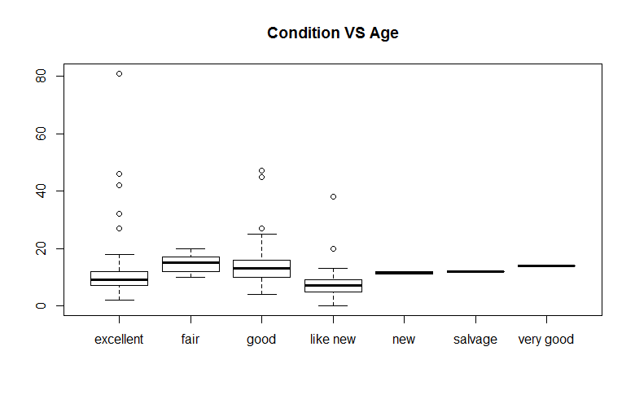
The relation between age and condition is similar as the two on above, first the age of new car is very high, it shouldn’t be like that, but except the new condition, others are follows when condition goes down, the age of the car goes up. If I order the median of the age for the different car type, like new < excellent < new < good < salvage < very good < fair.

R code
setwd("I:/R Data/141")
load("vehicles.rda")
###1 How many observations are there in the data set?
car = vposts
dim(car)

### total 34677 obs
test = car[!(is.na(car$price)),]
fuck_what_it_is = test[test$price == 600030000, ]

###2 What are the names of the variables? and what is the class of each variable?
## split
names = names(car)
class = sapply(car,class)

###3 What is the average price of all the vehicles? the median price? and the deciles? Displays these on a plot of the distribution of vehicle prices.

mean(car$price, na.rm = T)
median(car$price, na.rm = T)
quantile(car$price, 0.9, na.rm = T)
hist(car$price, na.rm = T)

h = mean(car$price, na.rm = T)
i = median(car$price, na.rm = T)
j = quantile(car$price, 0.9, na.rm = T)
hist(car$price[car$price<=70000], na.rm = T)

abline(v = h, col = "blue", lwd = 2)
abline(v = i, col = "red", lwd = 2)
abline(v = j, col = "green", lwd = 2)
max(car$price, na.rm = T)

###4 What are the different categories of vehicles, i.e. the type variable/column? What is the proportion for each category ?
a = table(car$type)
prop = a/sum(a)
barplot(prop)

###5 Display the relationship between fuel type and vehicle type. Does this depend on transmission type?
### mosaicplot las = 1i
library(ggplot2)
ggplot(na.omit(car), aes(x=type, fill=fuel)) + geom_bar()

ggplot(na.omit(car), aes(fuel,fill = type),) + geom_bar() +
facet_grid(. ~ transmission)

###6 How many different cities are represented in the dataset?
length(levels(car$city))

###7 Visually how the number/proportion of "for sale by owner" and "for sale by dealer" varies across city?

temp = car$byOwner
citybyo = car[temp,]$city
to = table(citybyo)

citybyd = car[!temp,]$city
td = table(citybyd)
value = rbind(as.vector(to), as.vector(td))
ylim <- c(0, 1.5*max(value))
p = barplot(value, beside = T, names = names(to), ylim = ylim)
text(x =p, y = value, label = value, pos = 3, cex = 0.8, col = "red")

###8 What is the largest price for a vehicle in this data set? Examine this and fix the value. Now examine the new highest value for price.
p = car$price
p [p == max(p,na.rm = TRUE)]=25000
p [p == max(p,na.rm = TRUE)]=3500
p [p == max(p,na.rm = TRUE)]=NA
p [p == max(p,na.rm = TRUE)]=5730
p [p == max(p,na.rm = TRUE)]=5730
p [p == max(p,na.rm = TRUE)]=NA

###9 What are the three most common makes of cars in each city for "sale by owner" and for "sale by dealer"? Are they similar or quite different?
temp = car$byOwner
citybyo = car[temp,]$city
makerbyo = car[temp,]$maker
table = table(citybyo, makerbyo)
dim(table)
makerbyo=list(sort(table[1,], decreasing = T)[1:3])

for(i in 2:7)
{
temp = sort(table[i,], decreasing = T)[1:3]
makerbyo = c(makerbyo, list(temp))
}
names(makerbyo)=c("boston","chicago","denver", "lasvegas", "nyc", "sac", "sfbay")

citybyd = car[!temp,]$city
makerbyd = car[!temp,]$maker
table = table(citybyd, makerbyd)
dim(table)
makerbyd=list(sort(table[1,], decreasing = T)[1:3])

for(i in 2:7)
{
temp = sort(table[i,], decreasing = T)[1:3]
makerbyd = c(makerbyd, list(temp))
}
names(makerbyd)=c("boston","chicago","denver", "lasvegas", "nyc", "sac", "sfbay")

sort(table(sapply(makerbyo, names)), decreasing = TRUE)
sort(table(sapply(makerbyd, names)), decreasing = TRUE)

###10 Visually compare the distribution of the age of cars for different cities and for "sale by owner" and "sale by dealer". Provide an interpretation of the plots, i.e., what are the key conclusions and insights?

plot(car[!car$year == 4,]$city, abs(car[!car$year == 4,]$year-2015), main = "Age for different city")
plot(subcar$year)

par(mfrow=c(1,1))
temp = car$byOwner
citybyo = car[temp,]$city
agebyo = abs(car[temp,]$year-2015)
citybyo = citybyo[-3435]
agebyo = agebyo[-3435]
plot(citybyo,agebyo, main = "Age for sale by owner")

citybyd = car[!temp,]$city
agebyd = abs(car[!temp,]$year-2015)
plot(citybyd,agebyd, main = "Age for sale by dealer")
#

###11 Plot the locations of the posts on a map? What do you notice?
## how to make it biger
library(maps)
map(regions = "USA")
points(car$long, car$lat, col = "red")

### 12 Summarize the distribution of fuel type, drive, transmission, and vehicle type. Find a good way to display this information.
library(ggplot2)
library(gridExtra)

plots = list()
p1 = ggplot(na.omit(car[car$transmission == "automatic",]), aes(drive,fill = fuel)) + geom_bar() +
facet_grid(. ~ type) + ggtitle("Automatic")
plots[[1]] <- p1

p2 = ggplot(na.omit(car[car$transmission == "manual",]), aes(drive,fill = fuel)) + geom_bar() +
facet_grid(. ~ type) + ggtitle("manual")
plots[[2]] <- p2

p3 = ggplot(na.omit(car[car$transmission == "other",]), aes(drive,fill = fuel)) + geom_bar() +
facet_grid(. ~ type) + ggtitle("Other")
plots[[3]] <- p3

###13 Plot odometer reading and age of car? Is there a relationship? Similarly, plot odometer reading and price? Interpret the result(s). Are odometer reading and age of car related?
### quad regression
odoage = data.frame(cbind(car$odometer, car$year))
smoothScatter(odoage$X2[odoage$X1<=300000],odoage$X1[odoage$X1<=300000], xlab = "year", ylab = "odometer")

a = car[car$odometer <= 300000, ]
b = a[a$price <= 70000,]
smoothScatter(b$price, b$odometer, xlab = "price", ylab = "odometer")

age = a$year
odo = a$odometer
age2 = age^2
y = lm(odo~age)
anova(y)
plot(odoage$X2[odoage$X1<=300000],odoage$X1[odoage$X1<=300000], xlab = "year", ylab = "odometer")
abline(y)

###14 Identify the "old" cars. What manufacturers made these? What is the price distribution for these?.
a = car[(car$year>=1935 & car$year <=1975),]
table(a$maker)
b = a$price
b [b == max(b,na.rm = TRUE)]=NA
plot(a$year, b, xlab = 'year', ylab = 'price', main = "The price distribution")

### 15 I have omitted one important variable in this data set. What do you think it is? Can we derive this from the other variables? If so, sketch possible ideas as to how we would compute this variable.
sum(str_count(car$body, "VIN"))
###16 Display how condition and odometer are related. Also how condition and price are related. And condition and age of the car. Provide a brief interpretation of what you find.

### move out the outliers

new1 = na.omit(car)
new2 = new1[new1$odometer<=300000,]

con = new2$condition
odo = new2$odometer
i = names(table(new2$condition)[table(new2$condition)>0])
con1 = con[con==i]
con1 = factor(con1)
odo1 = odo[con==i]
plot(con1,odo1, main = "Condition VS Odometer")

new3 = new1[new1$price<=80000,]
con = new3$condition
price = new3$price
i = names(table(new3$condition)[table(new3$condition)>0])
con1 = con[con==i]
con1 = factor(con1)
price1 = price[con==i]
plot(con1,price1, main = "Condition VS Price")

con = new1$condition
year= new1$year
i = names(table(new1$condition)[table(new1$condition)>0])
con1 = con[con==i]
con1 = factor(con1)
year1 = year[con==i]
plot(con1,abs(year1-2015), main = "Condition VS Age")

