**ESE 448 Systems Engineering Laboratory**

**Final Project Report**

**Tracking of the position of the remote sensor system (SS01) ball by the Ball and Beam system (BB01)**

Done by: Billy Gilbert Habimana Cyusa

Manohar BN Pradhan

Date: 4/29/2019

Submitted to: Dr. Jinsong Zhang

**1. Introduction**

**1.1 BB01 & SS01 position control experiment using practical PD controller**

Goals: The goal of our experiment was to design a practical PD controller for the Ball and Beam system (BB01) to meet the following transient performance requirements while the ball on the beam is tracking the movement of the ball on the remote sensor system (SS01):

* Percentage Overshoot (PO): $≤$ 10%
* Steady state error (ess) 0.001m (with the SS01 ball moving at a constant speed on the trail)
* Settling time (ts) 3.5s

**1.2 BB01 & SS01 position control experiment using ideal PD controller**

Goals: The goal of our experiment was to design an ideal PD controller for the Ball and Beam system (BB01) to meet the following transient performance requirements while the ball on the beam is tracking the movement of the ball on the remote sensor system (SS01):

* Percentage Overshoot (PO): $≤$ 10%
* Steady state error (ess) 0.001m (with the SS01 ball moving at a constant speed on the trail)
* Settling time (ts) 3.5s

**2. Analysis and Procedure**

**2.1 BB01 & SS01 position control experiment using practical PD controller**

**Procedure:**

The PV and PD controllers were designed and incorporated into the Simulink model as shown in Figure 1 with the parameters of the PD controller (Kc and z) and the parameters of the PV controller (the proportional and velocity gain) tuned properly to meet the required transient performance requirements. The HIL Read block reads from the Encoder channel whereas the HIL Write block writes to the Encoder channel everytime the block is executed. A calibration factor (BB calibration) was incorporated to measure the ball position from the voltage output. Another channel, ie channel 1 was linked to the HIL read block from which the output signal was sent through another calibration factor(bsp) before being recorded at the scope (tracking performance) where the position of the ball on the remote sensor system was measured (SS01).

In order to investigate the transient performance, we had two different test conditions:

* SS01 ball at different static locations on the trail
* SS01 ball moves at a constant speed on the trail

To evaluate the OS% and ts, we simulated a step input signal by putting the SS01 ball at different static positions on the trail and observing the BB01 system response. We did this a total of three times and averaged the values of percentage overshoot as well as the settling time.

To evaluate the steady-state error, we simulated a sawtooth input signal by moving the SS01 ball at constant speed on the trail and observing the response from the BB01 system and then estimating the steady-state error value. Once again, we did three trials and took an average to find the steady-state error.

**Analysis: Practical PD Controller Design**

The derivative operator/block in the ideal PD controller is replaced with a derivative filter with the following transfer function:

 Eqn(1)

Where wf is the cut-off frequency and equal to 6.28 rad/s. Also, a weight parameter, bsp is added which varies the amount of set point that is used to compute the error velocity. The closed loop transfer function of the Ball and Beam system is as follows:

 Eqn(2)

A third order characteristic polynomial can be written as:

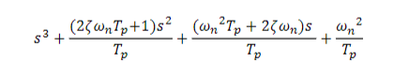 Eqn(3)

And the characteristic polynomial of the closed loop system using a practical PD controller is as follows:

 Eqn(4)

Comparing Eqn(3) and Eqn(4) we find that,

 Eqn(5)

Where Tp is the pole decay in seconds. Similarly, parameters, Kc and z can be found using the equations below:

 Eqn(6)

The values we obtained for Tp, Kc and z are through the following MATLAB script.

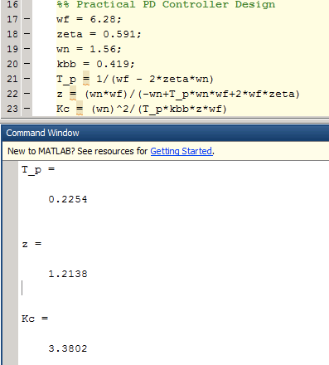

The calculated values had to be further tuned in order to satisfy our performance requirements when doing the simulation both with and without the servo dynamics.

However, these values had to be tuned in order to meet our transient performance requirements Thus, our final value for parameters are summarized below in table 1:

Table 1: Summary of Parameter Tuning for Practical PD Controller

|  |  |
| --- | --- |
| Kc | z |
| 2.4 | 1.1 |

Aside from the parameters Kc and z, the practical PD controller consists of a derivative filter whose transfer function is given by:

 Eqn(7)

Where wf is set to 6.28 rad/s. The purpose of using the derivative filter is to reduce the grinding noise caused by the amplified high frequency signal.

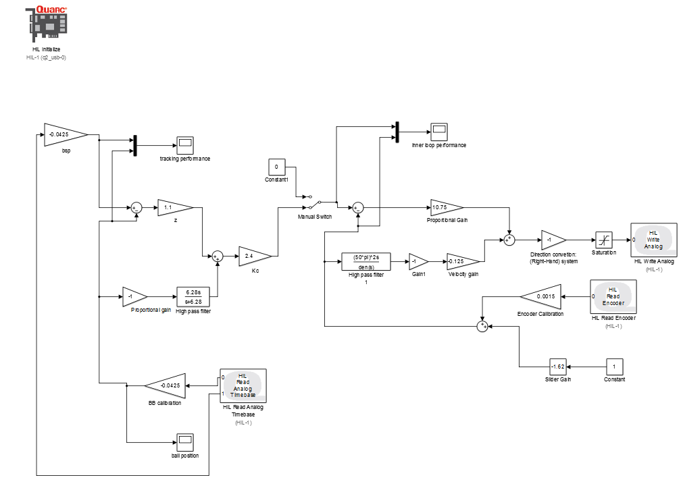

Figure 1: Simulink model of the Practical PD controller with SRV02 system

**2.2 BB01 & SS01 position control experiment using ideal PD controller**

**Procedure**

The PD and PV controllers were designed and incorporated into the Simulink model as shown in Figure 2 with the parameters of the PD controller (Kc and z) and the parameters of the PV controller (the proportional and velocity gain) tuned properly to meet the required transient performance requirements. The HIL Read block reads from the Encoder channel whereas the HIL Write block writes to the Encoder channel everytime the block is executed. A calibration factor (BB calibration) was incorporated to measure the ball position from the voltage output. Another channel, ie channel 1 was linked to the HIL read block from which the output signal was sent through another calibration factor(bsp) before being recorded at the scope (tracking performance) where the position of the ball on the remote sensor system was measured (SS01).

In order to investigate the transient performance, we had two different test conditions:

* SS01 ball at different static locations on the trail
* SS01 ball moves at a constant speed on the trail

To evaluate the OS% and ts, we simulated a step input signal by putting the SS01 ball at different static positions on the trail and observing the BB01 system response. We did this a total of three times and averaged the values of percentage overshoot as well as the settling time.

To evaluate the steady-state error, we simulated a sawtooth input signal by moving the SS01 ball at constant speed on the trail and observing the response from the BB01 system and then estimating the steady-state error value. Once again, we did three trials and took an average to find the steady-state error.

**Analysis: Ideal PD Controller Design**

The traditional PD controller has the following form:

 Eqn(8)

Where Kc and z are the gain and open loop pole respectively. Due to noise in the signals, the traditional PD controller is slightly modified where a differentiator block is added to get rid of the noise signals.

The closed loop transfer function of the Ball & Beam system is as follows:

 Eqn(9)

Comparing this with our second order underdamped canonical system, we get

 Eqn(10)

The following MATLAB script shows our calculations on the controller parameters in order to satisfy the transient performance requirements:

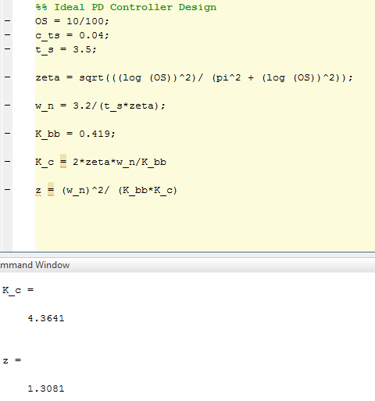

However, these calculated values had to be further tuned in order to meet our transient performance requirements. Thus, our final value for parameters are summarized below in Table 2:

Table 2: Summary of Parameter Tuning for Ideal PD Controller

|  |  |
| --- | --- |
| Kc | z |
| 2.5 | 1.1 |

The ideal PD controller does not incorporate a derivative filter and has a derivative block instead of the derivative filter in its design.

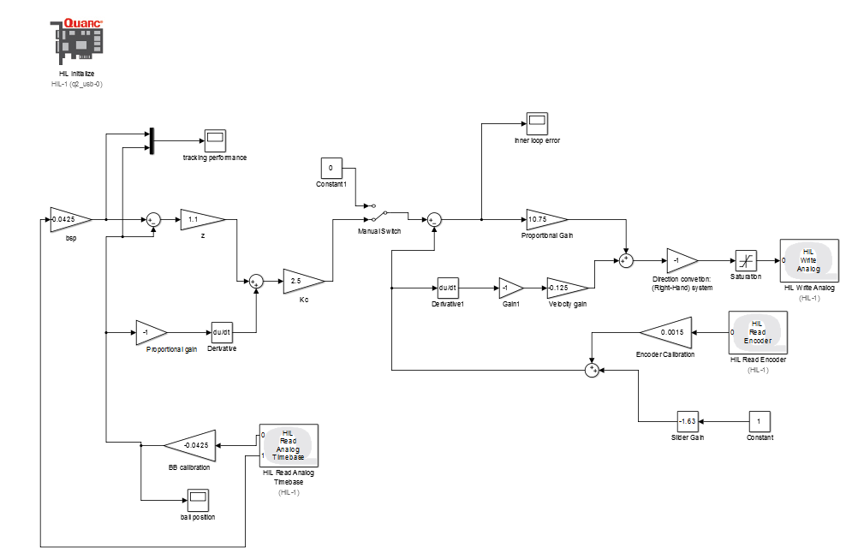

Figure 2:Simulink model of the ideal PD controller with servo dynamics

**3. Results**

**3.1 BB01 & SS01 position control experiment using practical PD controller**

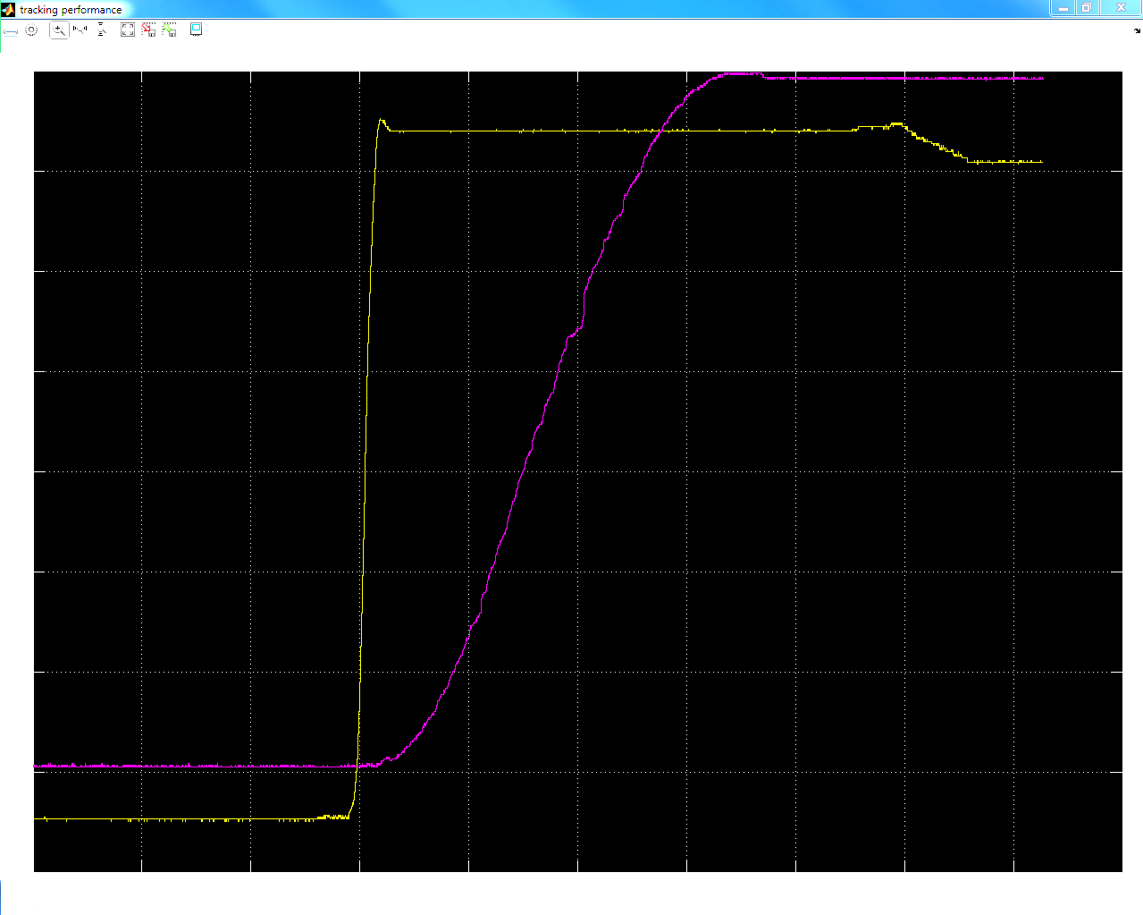 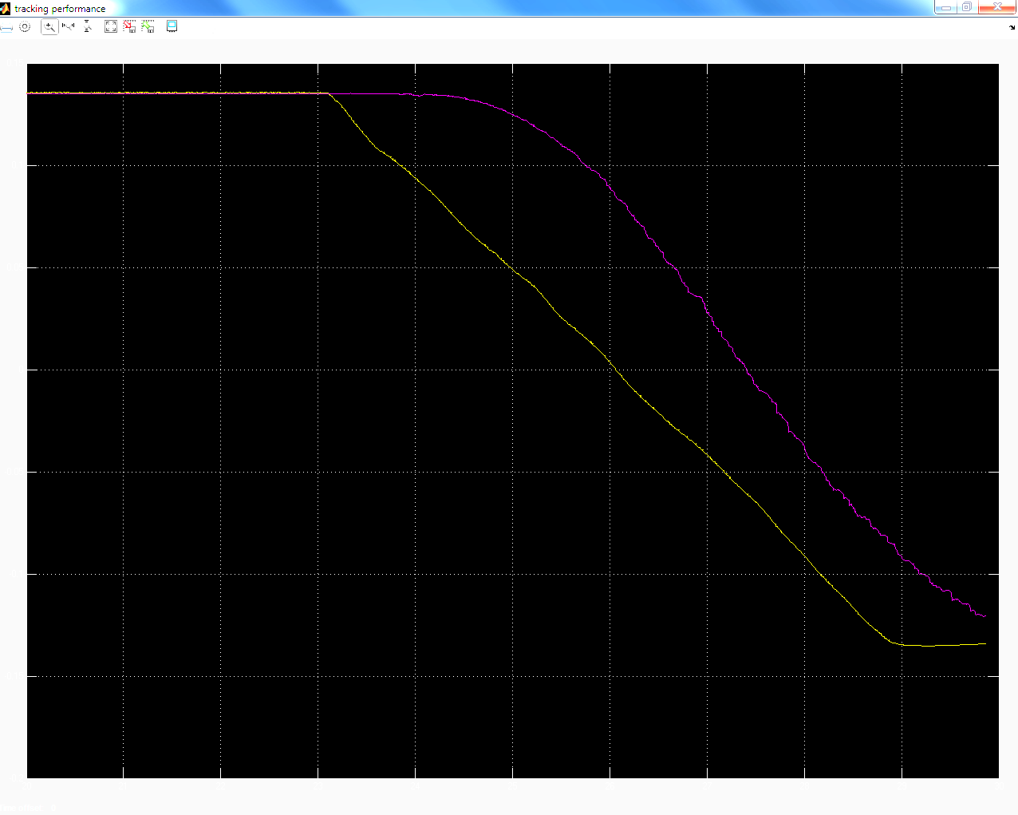

Figure 3: Step response using the Figure 4: Ramp response using the

practical PD controller practical PD controller

**3.2 BB01 & SS01 position control experiment using ideal PD controller**

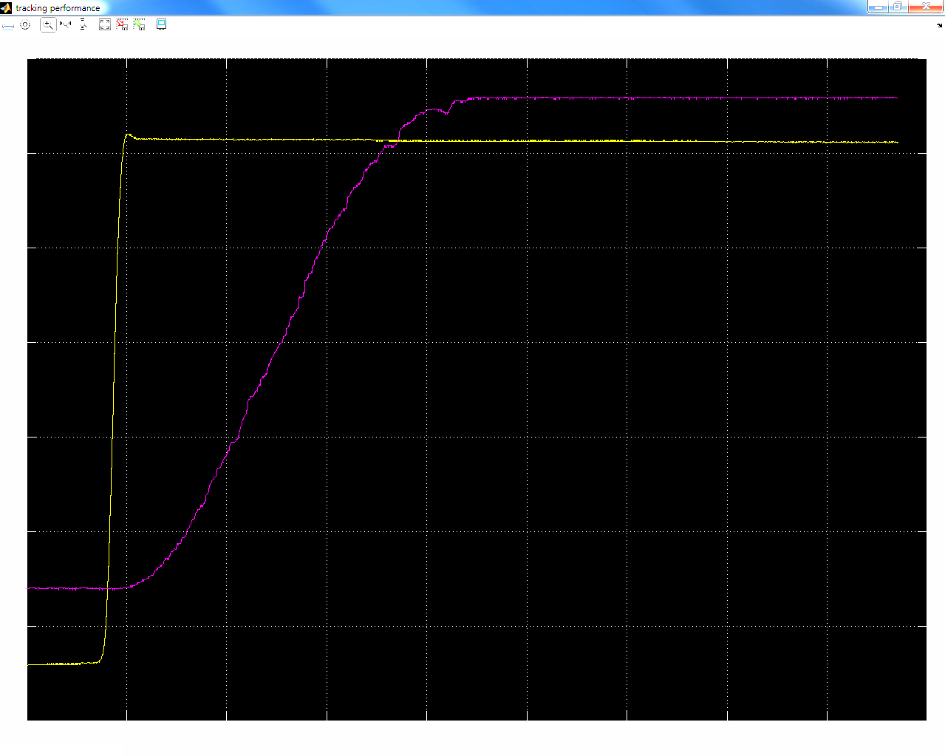 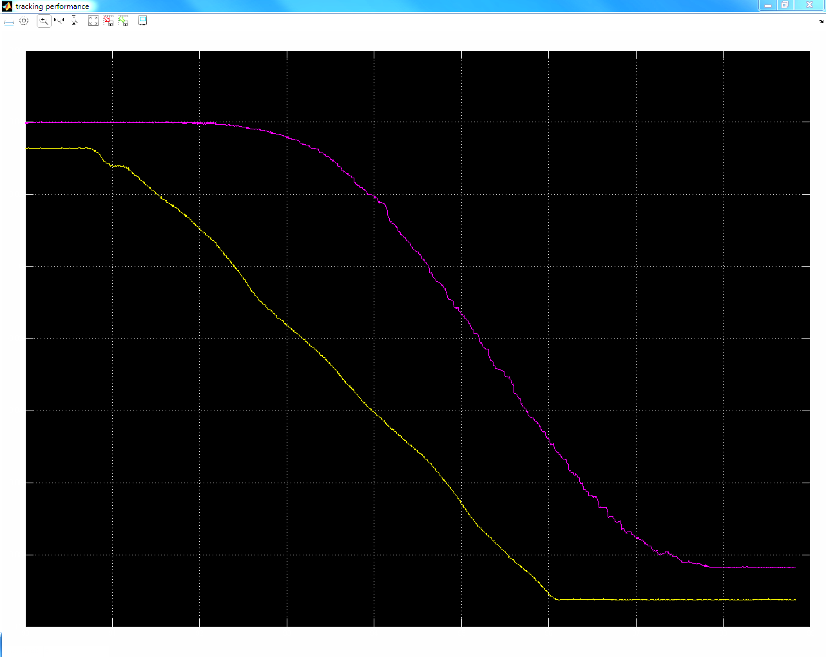

Figure 5: Step response using the Figure 6: Ramp response using the

ideal PD controller ideal PD controller

**Table 3: Transient performance of the system**

|  |  |  |
| --- | --- | --- |
| Controllers | OS% (average of 3 trials) | ts (average of 3 trials) |
| Ideal PD controller | 11% (±0.5%) | 3.3s (±0.05s) |
| Practical PD controller | 10% (±0.5%) | 3.44s(±0.1s) |

Note: The steady-state error was constant and 𝑒𝑠𝑠 ≤ 0.01m for all 6 trials.

**4. Conclusions**

After performing the experiment and evaluating the transient performance using both the practical and ideal PD controllers, we conclude that the overall performance given by the practical controller satisfied our transient and steady state error requirements. We were able to attain both the required overshoot percentage as well as meet the settling time requirements and also able to narrow the constant steady state error to less than 0.01m in all of our trials. However, the performance from the ideal PD controller was not far off and there was a slight trade off in trying to meet the settling time and overshoot requirements concurrently. In other words, the incorporation of the derivative filter might have contributed greatly to improve the transient performance in the practical PD controller design.

**4.1 Comments on performance requirements of the system**

Based on the results summarized in Table 3, using the practical PD controller the system satisfies the performance requirements. As can be seen in Table 3, we were able to tune the system so that it had a percentage overshoot of 10% and a settling time of 3.44s.

For the ideal PD controller, while tuning we were unable to successfully find values of Kc and z so that the system would meet all performance requirements. Therefore, we decided to tradeoff OS% for ts. The system settled within a satisfactory amount of time: 3.3s but the OS% was 10.56%.

Both the ideal and practical PD controllers satisfied the steady-state error requirement. The steady-state error was ≤ 0.01m.

The reason why the ideal PD controller could not quite meet all the performance requirements is because it was only using a derivative block. So the system was not filtering for noise to the best of its ability. Once, we replaced this block by a derivative (high-pass) filter, the system met the performance requirement.

**4.2 Problems encountered and how we solved them**

As the experiment involving the movement of the ball on the SS01 had to be performed at a constant speed, moving the ball at a constant speed manually was inaccurate and might have affected our performances. Repeated trials were performed until a constant looking sloped input was produced to solve this issue (though not exact).

There was also a significant challenge moving the ball manually the same distance to generate identical inputs when performing different trials of the experiment. This was solved by assigning markers and moving the ball from one end of the marker to the other.

**4.3 Do the filters for ball position sensors improve the performance of the system? Discuss this based on experimental data**

We used the derivative filter instead of the derivative block to improve performance when experiment was performed with the practical PD controller. This enabled us to achieve our transient and steady state error requirements. The filter was able to reduce the grinding noise caused by the amplified high frequency signal on the analog sensor.