Mobi is a decentralized, federated, and distributed graph data platform for teams and communities to publish and discover data, data models, and analytics that are instantly consumable  
  
<https://github.com/inovexcorp/mobi>

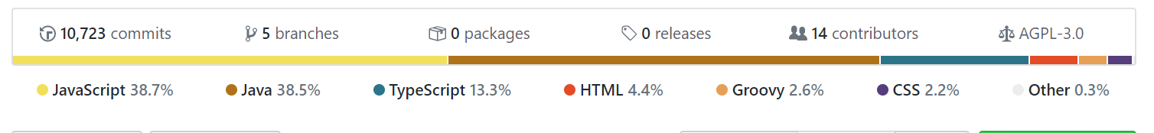

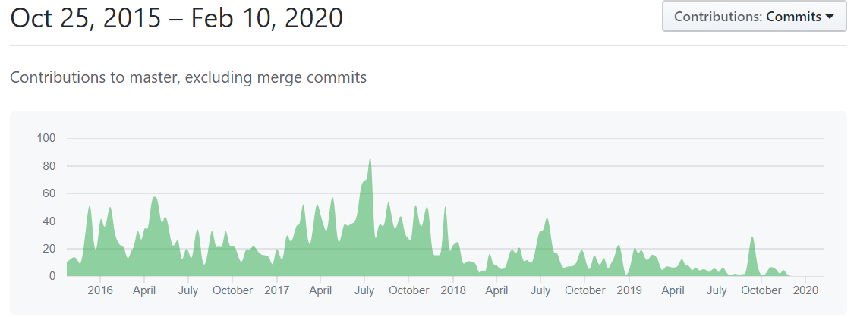

No Development since December

Java

Maven

NodeJS

Uses maven for deps

**com.mobi.web -** This module contains the Mobi web application.

"angular": "1.7.7",

Building - maven <id>npm run build (compile)</id>

## [com.mobi.catalog.rest](https://github.com/inovexcorp/mobi/tree/ba1c99e7159da95fe1f04a79bb5533545e4ddfc6/com.mobi.catalog.rest) @Path("/catalogs") @Path("/commits") @Path("/merge-requests") @Path("{requestId}/comments") [com.mobi.dataset.rest](https://github.com/inovexcorp/mobi/tree/ba1c99e7159da95fe1f04a79bb5533545e4ddfc6/com.mobi.dataset.rest)

@Path("/datasets")  
 Retrieves all DatasetRecords in the local Catalog  
 Creates a new DatasetRecord in the local Catalog and Dataset in the specified repository  
 Gets a specific DatasetRecord from the local Catalog  
**com.mobi.ontology.rest  
com.mobi.etl.rest**private String convertExcelRows(File input, int numRows) throws IOException, InvalidFormatException {

Converts the specified number of rows of a Excel file into JSON and returns

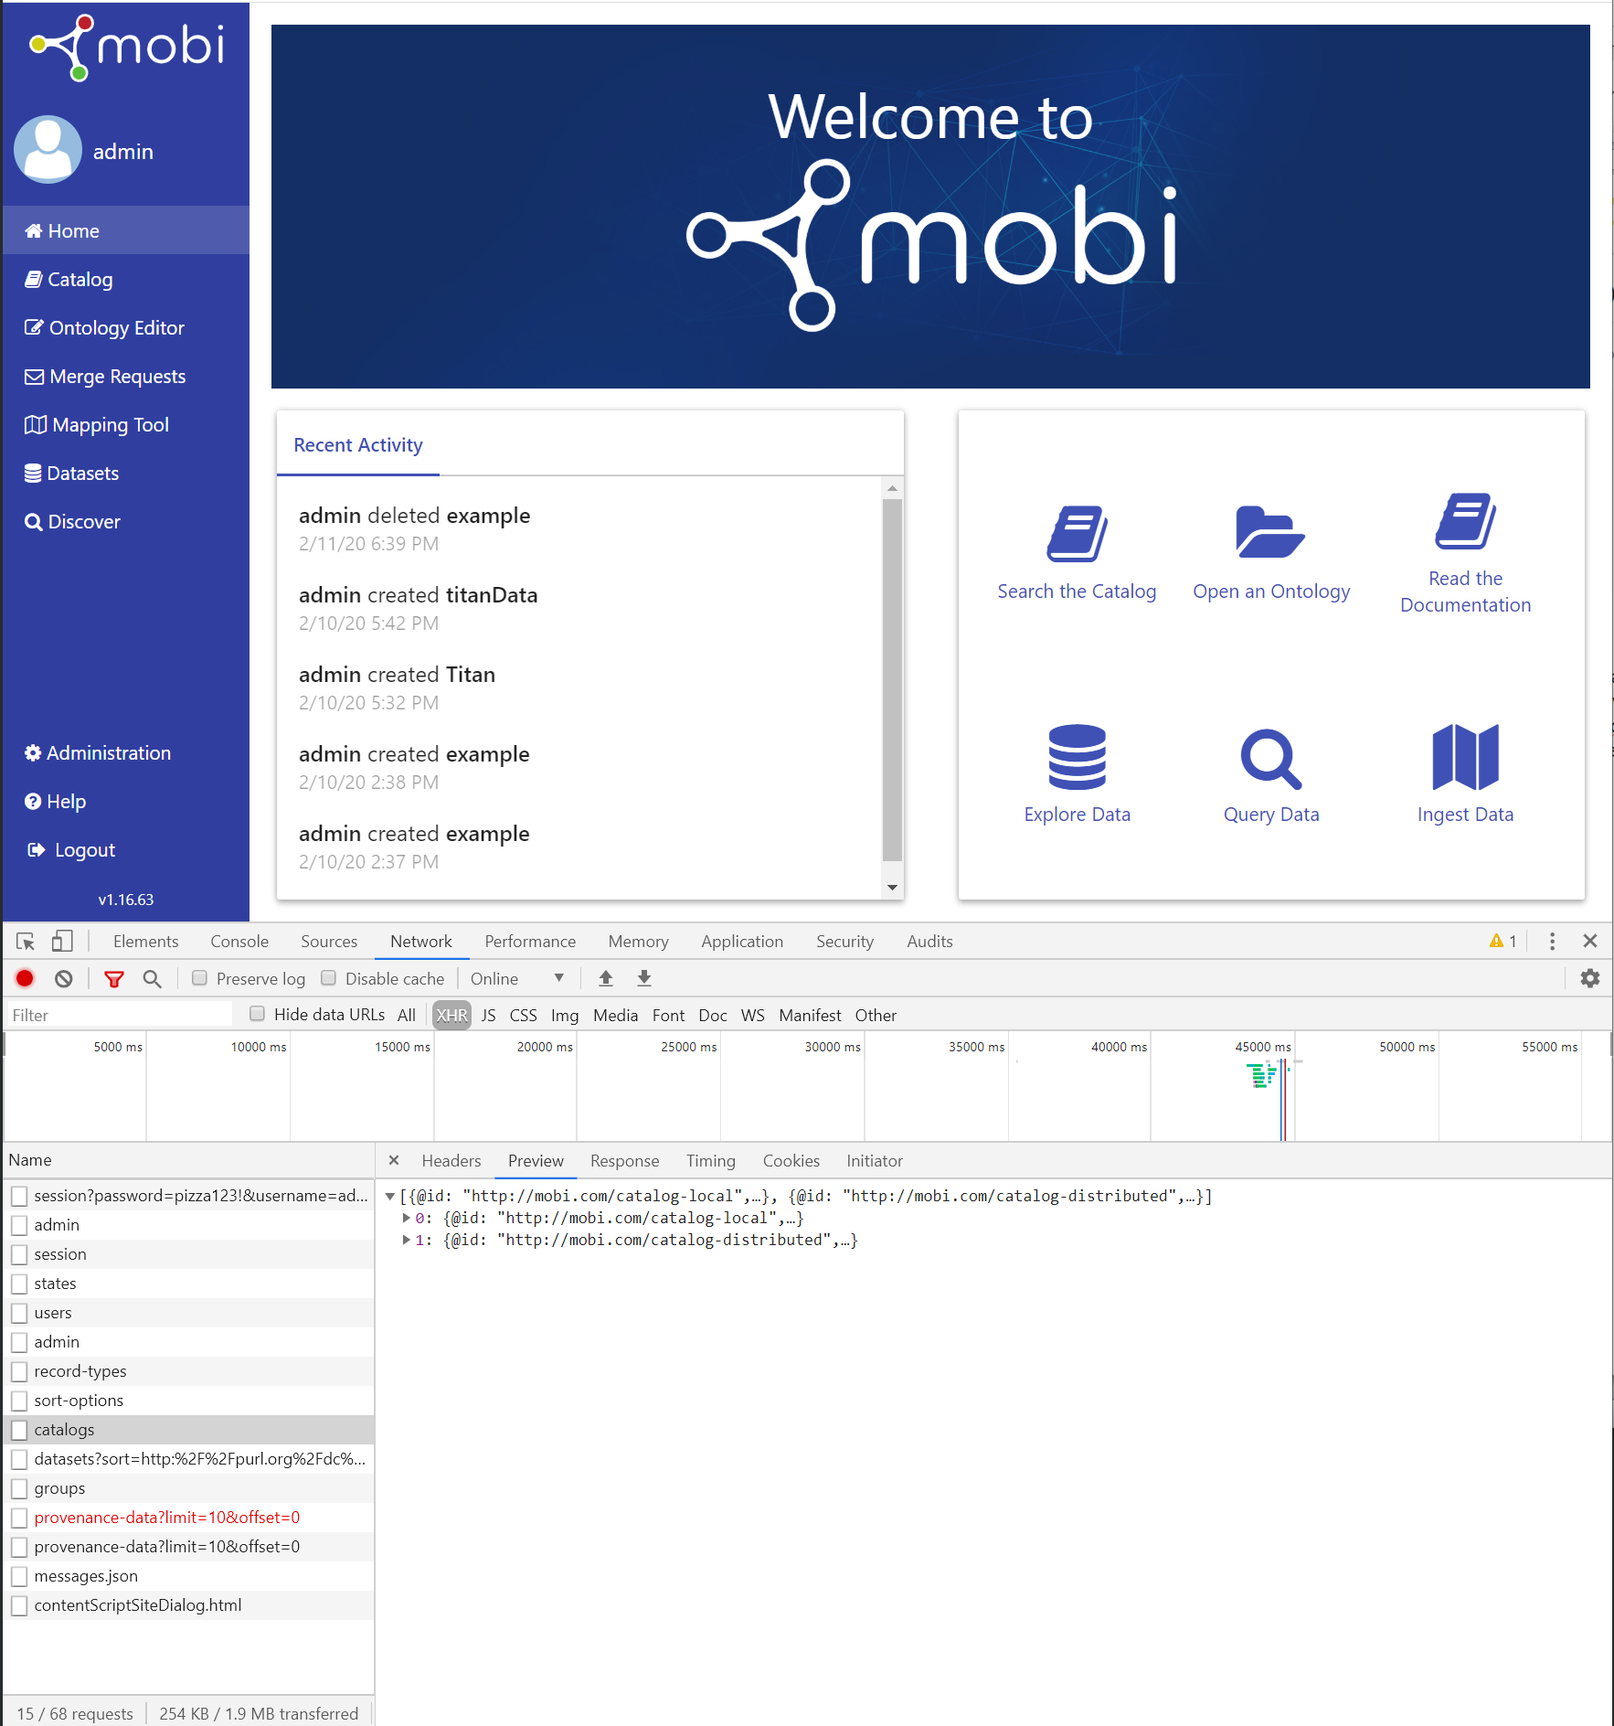

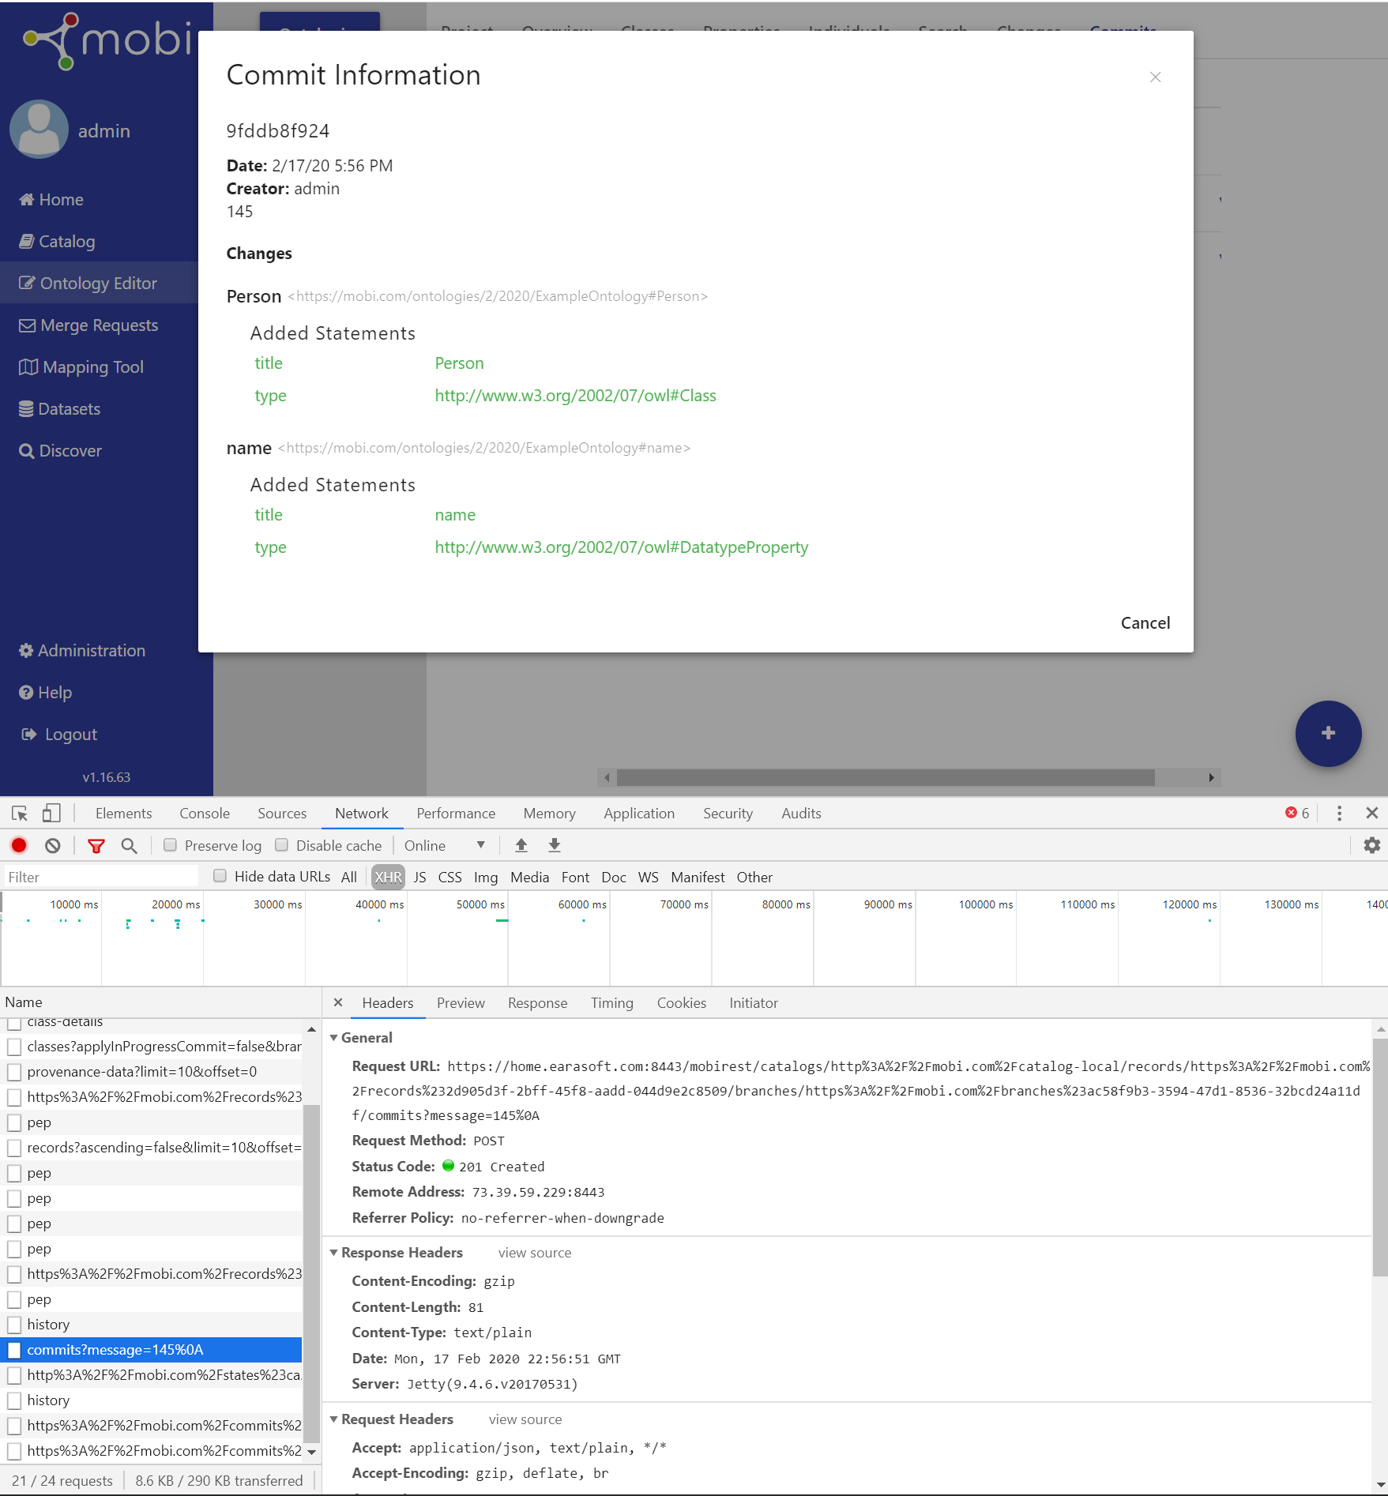

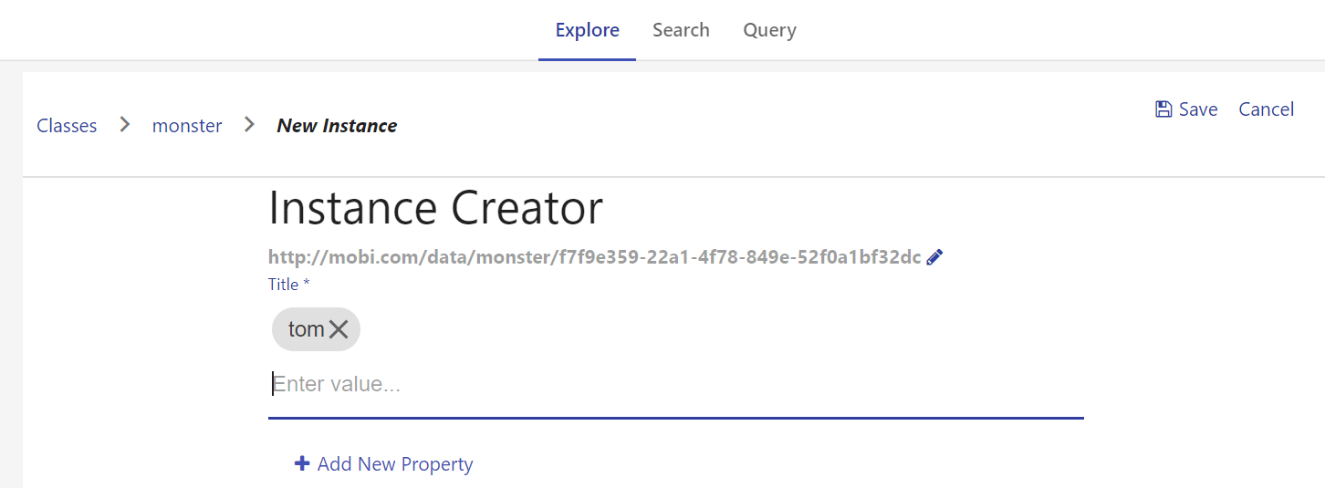

------

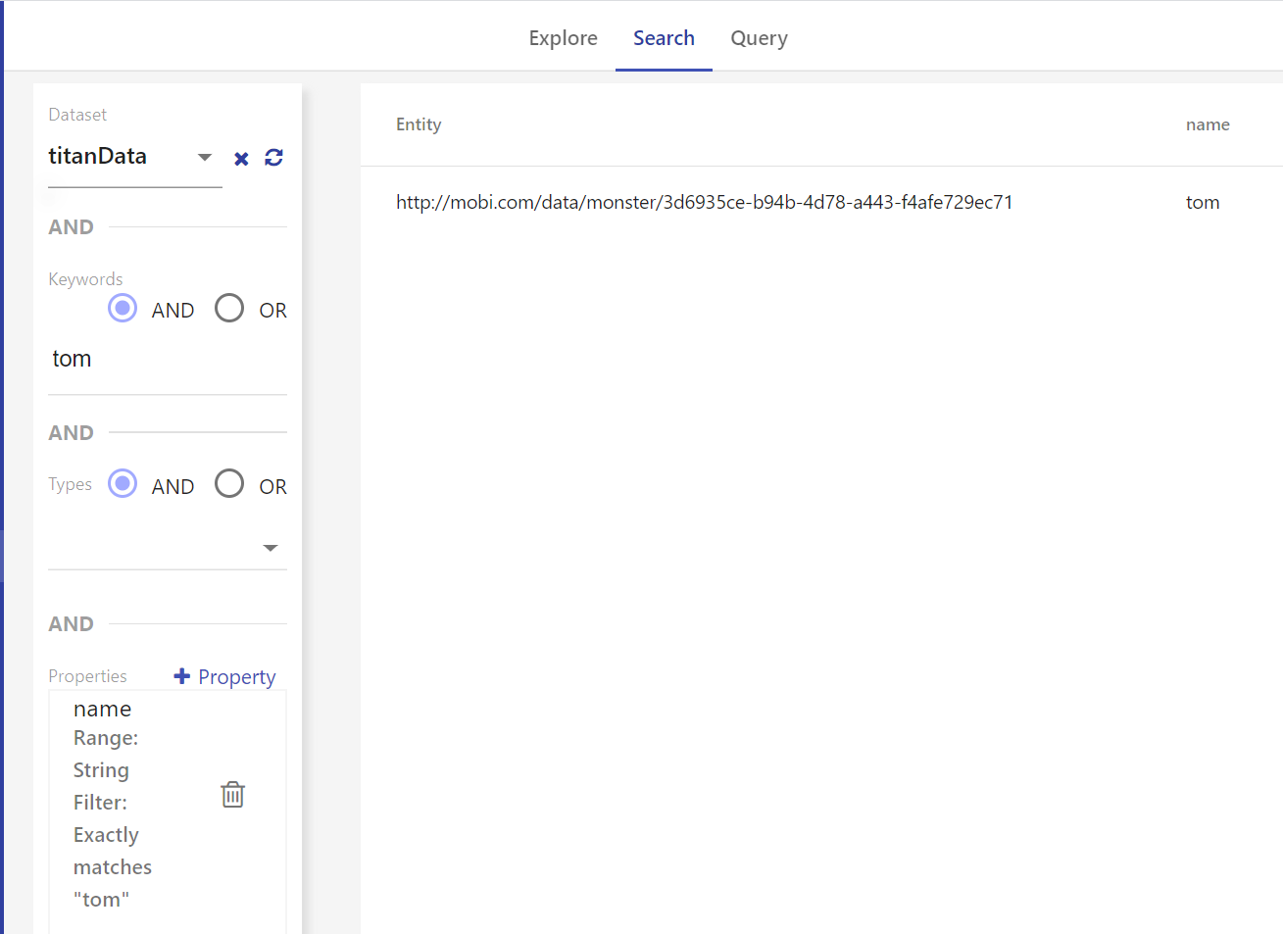

SPARQL

<https://www.w3.org/People/Berners-Lee/card>

<https://www.w3.org/2009/Talks/0615-qbe/> (example queries)

<https://www.w3.org/TR/rdf-sparql-query/#matchingRDFLiterals>

