2104 screenshot

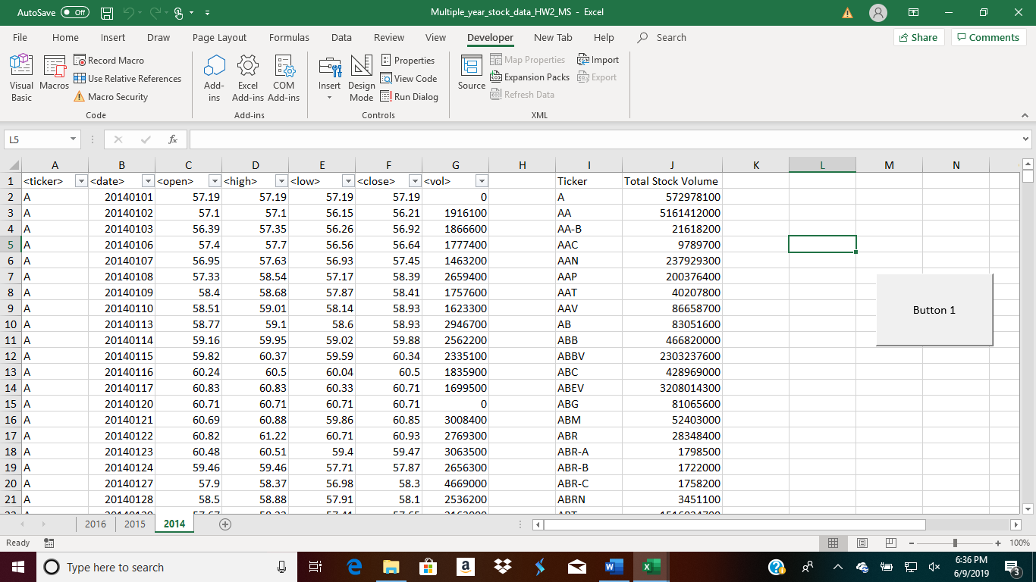

2015 screenshot

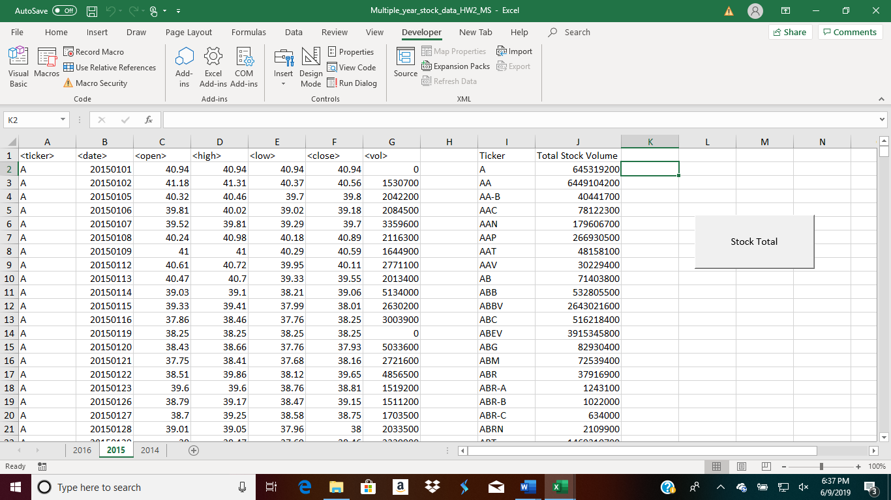

2016 screenshot

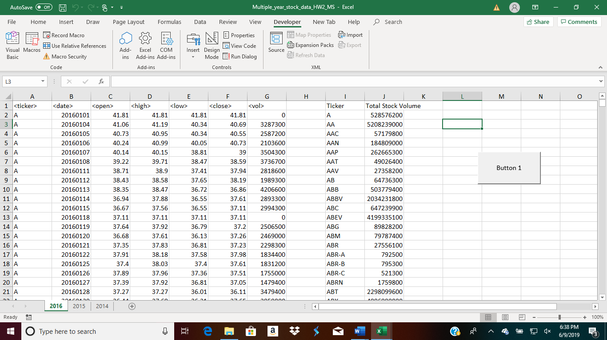

Sub stock_2014()

' Set an initial variable for holding the stock name

Dim Stock_Name As String

' Set an initial variable for holding the total per stock

Dim Stock_Total As Double

'initialize the variable to zero

Stock_Total = 0

' Keep track of the location for each stock in the summary table

Dim Summary_Table_Row As Integer

Summary_Table_Row = 2

' Loop through all credit card purchases

For i = 2 To 705714

' Check if we are still within the same stock, if it is not...

If Cells(i + 1, 1).Value <> Cells(i, 1).Value Then

' Set the stock

Stock_Name = Cells(i, 1).Value

' Add to the Stock Total

Stock_Total = Stock_Total + Cells(i, 7).Value

' Print the Stock Name in the Summary Table

Range("I" & Summary_Table_Row).Value = Stock_Name

' Print the Stock Amount to the Summary Table

Range("J" & Summary_Table_Row).Value = Stock_Total

' Add one to the summary table row

Summary_Table_Row = Summary_Table_Row + 1

' Reset the Brand Total

Stock_Total = 0

' If the cell immediately following a row is the same stock...

Else

' Add to the Brand Total

Stock_Total = Stock_Total + Cells(i, 7).Value

End If

Next i

End Sub