

FINAL YEAR PROJECT REPORT

Enhancing Object Discovery and Recognition Through Strategic Clue Placement and Spatial Level Design in Investigation Games

By
Fun Cheng Jun
TP071586
APD3F2601CDG

Course in the degree of BSc (Hons) Computer Games Development at
ASIA PACIFIC UNIVERSITY OF TECHNOLOGY AND INNOVATION

Supervised by:
Ms. Nabilah Raihan Binti Zakaria
Second Marker:
Mr. Marcus Tan Zhi Chuen

Acknowledgement
First, I would like to sincerely thanks to everyone who has supported me throughout the development of this project.
I would like to thanks to my supervisors, Ms. Nabilah Raihan Binti Zakaria and Mr. Marcus Tan Zhi Chuen, for their continuous guidance, support, and valuable feedback throughout the development of this investigation report. Their advice has greatly helped me in shaping the direction of this research.
I would also like to thank my family. Their unwavering love and encouragement have been my greatest source of strength, and their support has sustained me throughout the entire development of this project.
Finally, I would like to thank my friends and fellow students for their support, shared experiences and encouragement during the project. Their insights and feedback have played a vital role in refining my research.
This project could not have been completed without the support of all those mentioned above. My heartfelt thanks to you all.

Abstract
This study investigates how players discover and recognize important objects in investigation-based games, with a focus on the role of spatial level design and strategic clue placement. In many investigation games, players are often guided by visual indicators such as object highlighting or UI prompts, which may reduce the depth of exploration and overall immersion. Therefore, this research aims to explore how players naturally identify relevant objects and how level design elements can influence this process.
Data for this study was collected through an online questionnaire distributed via Google Forms, with a total of 30 participants. The survey included questions related to players’ gaming experience, exploration behaviour, object recognition strategies, and their preferences towards different level design elements such as layout, object placement, and environmental cues.
The findings indicate that players rely on a combination of visual cues, environmental context, and interaction feedback when discovering and identifying important objects. In addition, factors such as clear spatial layout, effective object placement, and reduced environmental clutter were found to significantly influence player exploration and experience.
Overall, this study provides insights into how level design can support more intuitive object discovery and recognition. These findings were applied in the development of a Unity-based investigation game prototype that demonstrates exploration, object interaction, dialogue, map navigation, localisation, audio settings, and computer-based investigation features.

SDG Goal 4: Quality Education
Keywords: Creativity, Visual Communication, Gamification and Rewards, Visual Communication Gamification

Table of Contents
Acknowledgement 2
Abstract 3
LIST OF FIGURES 6
LIST OF TABLES 8
Chapter 1: Introduction 9
1.1 Background of Study 9
1.2 Problem Statement 10
1.2.1 Over-Reliance on UI-Based Guidance Systems 10
1.2.2 Lack of Effective Environmental Guidance 11
1.2.3 Difficulty in Distinguishing Relevant and Non-Relevant Objects 11
1.2.4 Research Gap 12
1.3 Project Aims 12
1.4 Project Objectives 12
1.5 Research Questions 13
1.6 Project Scope 13
1.6.1 Tasks to be Executed 13
1.6.2 Constraints 14
1. Development and Design Complexity 14
1.6.3 What will be done in this project 15
1.6.4 What will not be done in this project 16
1.7 Potential Benefits 17
1.7.1 Tangible Benefits 17
1.7.2 Intangible Benefits 17
1.7.3 Target Users 18
1.8 Overview 19
1.9 Project Plan 20
CHAPTER 2: LITERATURE REVIEW 21
2.1 Introduction to literature review (LR) 21
2.2 Domain Research 22
2.2.1 Investigation-Based Games 22
2.2.2 Player Exploration Behaviour 22
2.2.3 Object Discovery in Games 23
2.2.4 Object Recognition and Clue Identification 23
2.3 Similar Systems / Existing Games 25
2.3.1 The Case of the Golden Idol 25
2.3.2 Her Story 26
2.3.3 Return of the Obra Dinn 27
2.3.4 Comparative Analysis of Existing Systems 28
2.4 Technical Research 28
2.4.1 Unity 29
2.4.2 Photoshop 30
2.4.3 draw.io 31
Chapter 3: Methodology 32
3.1 System Development Methodology 32
3.1.1 Introduction 32
3.1.2 Methodology Choice and Justification 35
3.1.3 Phase of Prototyping Model 36
3.2 Data Gathering Design 38
3.2.1 Survey Design 39
3.3 Analysis 48
3.3.2 Section B: Exploration and Object Discovery 51
3.3.3 Section C: Object Recognition and Clue Identification 54
3.3.4 Section D: Level Design and Player Experience 57
3.3.5 Section E: Preferences and Feedback 59
3.3.6 Section 2B: Reasons for Not Playing Investigation Games 62
3.3.6 User Requirements 66
3.3.7 Summary 67
CHAPTER 4: CONCLUSION 69
References 71
APPENDICES 73
Appendix A: Proposal 73
Appendix B: Ethics Form (Fast Track) 74
Appendix C: Log Sheet 78
Appendix D: Gantt Chart 81
Appendix E: Respondence Demographic Profile 84

LIST OF FIGURES
Figure 1 HUD in Game “Disco Elysium” 10
Figure 2 The Case of the Golden Idol in game 25
Figure 3 Inference UI of The Case of the Golden Idol 25
Figure 4 Her Story in Game 26
Figure 5 Return of the Obra Dinn in Game 27
Figure 6 Inference UI of Return of the Obra Dinn 27
Figure 7 Unity Icon 29
Figure 8 Photoshop Icon 30
Figure 9 draw.io Icon 31
Figure 10 Prototyping Model 32
Figure 11 Rapid Application Development (RAD) 33
Figure 12 Agile Methodology 34
Figure 13 Google Forms Icon 38
Figure 14 Survey Question 1 48
Figure 15 Survey Question 2 49
Figure 16 Survey Question 3 49
Figure 17 Survey Question 4 50
Figure 18 Survey Question 5 51
Figure 19 Survey Question 6 52
Figure 20 Survey Question 7 52
Figure 21 Survey Question 8 53
Figure 22 Survey Question 9 54
Figure 23 Survey Question 10 55
Figure 24 Survey Question 11 55
Figure 25 Survey Question 12 56
Figure 26 Survey Question 13 57
Figure 27 Survey Question 14 57
Figure 28 Survey Question 15 58
Figure 29 Survey Question 16 58
Figure 30 Survey Question 17 59
Figure 31 Survey Question 18 59
Figure 32 Survey Question 19 60
Figure 33 Survey Question 3 60
Figure 34 Survey Question 21 62
Figure 35 Survey Question 22 62
Figure 36 Survey Question 23 63
Figure 37 Survey Question 24 63
Figure 38 Survey Question 25 64
Figure 39 Survey Question 26 65
Figure 40 Survey Question 27 65
Figure 41 Proposal 73
Figure 42 Ethics Form (Fast Track) Page 1 74
Figure 43 Ethics Form (Fast Track) Page 2 75
Figure 44 Ethics Form (Fast Track) Page 3 76
Figure 45 Ethics Form (Fast Track) Page 4 77
Figure 46 Meeting Log Sheet-1 78
Figure 47 Meeting Log Sheet-2 79
Figure 48 Meeting Log Sheet-3 80
Figure 49 Gantt Chart-1 81
Figure 50Gantt Chart-2 81
Figure 51 Gantt Chart-3 82
Figure 52 Gantt Chart-4 82
Figure 53 Gantt Chart-5 83

LIST OF TABLES
Table 1: Table of Project plan 20
Table 2: Comparison of Development Methodologies 35
Table 3: Survey Structure Overview 39
Table 4: Section A Participant Background 40
Table 5: Section B Exploration and Object Discovery 41
Table 6: Section C Object Recognition and Clue Identification 42
Table 7: Section D Level Design and Player Experience 43
Table 8: Section E Player Preferences and Feedback 44
Table 9: Section 2B Player Preferences and Feedback 45
Table 10: Section A Demographic Information 48
Table 11: Section B Exploration and Object Discovery 51
Table 12 Section C Object Recognition and Clue Identification 54
Table 13: Section D Level Design and Player Experience 57
Table 14: Section E: Preferences and Feedback 59
Table 15: Section 2B: Reasons for Not Playing Investigation Games 62
Table 16: Table of User Requirements 66
Table 17:Table of Respondence Demographic Profile 84

Chapter 1: Introduction

Background of Study
Investigation-based games have become an increasingly popular genre that emphasizes player exploration, observation, and problem-solving. Unlike action-oriented games that focus on reflex and mechanics, investigation games require players to interact with the environment, search for clues, and identify relevant objects in order to progress. This creates a gameplay experience that relies heavily on the player’s ability to explore and interpret the game world (Fernández-Vara, 2015).
In many modern investigation games, object discovery and recognition are often supported by artificial guidance systems such as highlighting important objects or providing clear UI indicators. While these features improve accessibility, they may also reduce the level of challenge and limit the player’s engagement with the environment. As game design focuses on creating meaningful player experiences through active participation, excessive guidance may reduce the sense of discovery and player involvement (Schell, 2019).
Level design plays a crucial role in shaping how players explore game environments and interact with objects. Elements such as spatial layout, object placement, visual cues, and environmental storytelling can influence player attention and guide them towards important objects without the need for explicit instructions. Game environments can function as “narrative architectures,” where spatial design conveys meaning and supports player understanding (Jenkins, 2004). In addition, principles of wayfinding suggest that spatial organization and visual hierarchy help users navigate environments effectively (Passini, 1992).
A well-designed environment can encourage players to naturally discover and recognize relevant objects, creating a more immersive and satisfying gameplay experience. This aligns with design principles that emphasize intuitive interaction and perceptual clarity in user experience design (Norman D. A., 2013).
Therefore, this study focuses on understanding how players discover and recognize important objects in investigation-based games, and how spatial level design and strategic clue placement can support this process. By examining player behaviour and preferences, this research aims to provide insights into more effective and engaging game design approaches.

Problem Statement
Investigation-based games require players to explore environments, interpret visual information, and identify relevant objects in order to progress. However, the effectiveness of this experience is often influenced by how information is presented through level design and game systems. Several key issues can be identified in current investigation game design.

Over-Reliance on UI-Based Guidance Systems
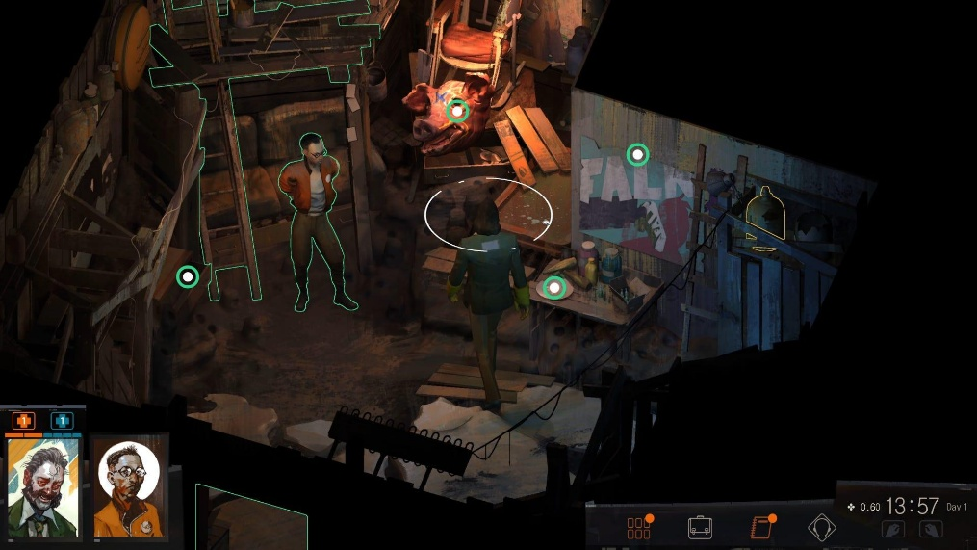
Figure 1 HUD in Game “Disco Elysium”
One major issue in modern investigation games is the over-reliance on artificial guidance systems such as object highlighting, markers, and UI prompts. While these systems improve accessibility and reduce player confusion, they also reduce the need for active exploration and critical observation.
Game design principles emphasize that meaningful gameplay experiences are created when players are actively engaged in problem-solving and discovery. When excessive guidance is provided, the sense of challenge and exploration may be reduced, causing players to become more passive in their interaction with the game environment (Schell, 2019).
In addition, the MDA framework proposed by Hunicke, LeBlanc, and Zubek (Hunicke, 2004) emphasizes that player experience emerges from the interaction between mechanics, dynamics, and aesthetics, rather than direct instruction. This suggests that excessive reliance on UI-based guidance may negatively affect the intended gameplay dynamics and reduce player engagement

Lack of Effective Environmental Guidance

On the other hand, some investigation games fail to provide sufficient environmental guidance through level design. When spatial layout, object placement, or visual hierarchy are not properly designed, players may experience confusion or frustration.
Research on spatial cognition and wayfinding highlights the importance of environmental cues in navigation. Passini explains that users rely on spatial structure, landmarks, and visual cues to interpret and navigate environments effectively (Passini, 1992). Without these elements, users may struggle to understand their surroundings and locate important objects.
In game environments, this issue is often observed when important objects are visually indistinguishable from background elements or when too many irrelevant objects are present. This leads to inefficient exploration, where players rely on trial-and-error rather than intentional observation, increasing cognitive effort and reducing overall gameplay efficiency (Sweller, 1988).

1.2.3 Difficulty in Distinguishing Relevant and Non-Relevant Objects
Another key challenge is the difficulty players face in distinguishing relevant objects from non-relevant ones. In investigation-based gameplay, not all objects are important, but poorly designed environments may fail to communicate this distinction clearly.
When object design lacks visual contrast, contextual meaning, or interaction feedback, players may struggle to determine which objects are significant. This problem is further amplified in cluttered environments, where the presence of too many objects increases cognitive load and reduces player efficiency (Sweller, 1988).
As described by Jenkins, game environments function as “narrative architectures,” where spatial design communicates meaning and guides player interaction. If the environment fails to provide clear narrative or visual cues, players may be unable to interpret which elements are relevant to progression. (Jenkins, 2004)

1.2.4 Research Gap
Although previous studies have discussed player engagement, spatial navigation, and environmental storytelling, there is still a lack of focused research on how level design specifically influences object discovery and recognition in investigation-based games.
Existing approaches often rely either on UI-based guidance systems or leave players without sufficient environmental support. There is limited understanding of how spatial layout, object placement, and environmental cues can be strategically designed to support intuitive discovery and recognition without reducing player engagement. (Fullerton, 2018) (Fernández-Vara, 2015)
Therefore, this study aims to address this gap by examining how players discover and recognize important objects, and how spatial level design and strategic clue placement can enhance this process.

Project Aims
To investigates how strategic clue placement and spatial level design enhance players' ability to discover and identify relevant items within investigative games, while minimising reliance on artificial UI guidance systems.

Project Objectives
To achieve the aim of this study, the following objectives are defined:
- To analyse how players discover important objects during exploration in investigation-based games.
- To examine how players recognize and differentiate relevant objects from non-relevant ones.
- To evaluate how level design elements such as spatial layout, object placement, and environmental cues influence player exploration and object recognition.
- To assess player preferences and experiences in relation to object discovery and recognition without heavy reliance on UI guidance systems.

1.5 Research Questions
Based on the aim and objectives of this study, the following research questions are formulated:
- How do players discover important objects during exploration in investigation-based games?
- How do players recognize and differentiate relevant objects from non-relevant ones?
- How do level design elements such as spatial layout, object placement, and environmental cues influence player exploration and object recognition?
- What are player preferences regarding object discovery and recognition without heavy reliance on UI-based guidance systems?

Project Scope
This scope of this project involves developing a narrative-driven investigation game prototype that focuses on object discovery and recognition through level design. The game aims to enhance player exploration by utilizing spatial layout, object placement, and environmental cues instead of relying heavily on UI-based guidance systems.

Tasks to be Executed
1. Level Design and Gameplay Development
a) Design exploration-based gameplay where players navigate environments to discover important objects.
b) Develop level layouts that guide player movement and attention through spatial design.
c) Implement object placement strategies to support intuitive discovery and recognition.
2. Object Discovery and Recognition System
a) Design objects with clear visual distinction to differentiate important items from background elements.
b) Implement interaction mechanics that allow players to examine and identify objects.
c) Apply environmental cues such as lighting, contrast, and context to guide player attention.
3. Game Prototype Development
a) Develop a functional game prototype using Unity to demonstrate level design concepts.
b) Create visual assets and UI elements using Photoshop to support gameplay clarity.
c) Design system flow and level structure using draw.io to organize development.
4. Player Experience Evaluation
a) Collect player data through a questionnaire to understand exploration and recognition behaviour.
b) Analyse survey results to identify patterns in player preferences and challenges.
c) Apply findings to refine game design decisions.

Constraints

1. Development and Design Complexity
Designing a game that focuses on object discovery and recognition through level design requires careful balancing between clarity and challenge. There is a risk that objects may be too obvious, reducing gameplay difficulty, or too hidden, causing player frustration. Achieving this balance requires continuous iteration and refinement, which increases development complexity.

2. Limited Development Resources
Since this project is developed individually, there are limitations in terms of time, technical capability, and available resources. This restricts the scope of implementation and limits the complexity of features that can be included in the prototype.

3. Data Collection Limitation
The research relies primarily on questionnaire responses rather than direct gameplay observation. This means that the findings are based on self-reported data, which may not fully reflect actual player behaviour during gameplay.

4. Time Constraint
The project must be completed within a fixed academic timeline. As a result, development, testing, and analysis phases are limited in duration, which may affect the depth of implementation and refinement.

1.6.3 What will be done in this project
1. Investigation-Based Gameplay Design
The project will design a game that focuses on exploration and object discovery. Players will navigate through environments and interact with objects to identify relevant clues. The gameplay will emphasize observation and interpretation rather than direct instruction.

2. Level Design for Object Discovery
The game will incorporate level design elements such as spatial layout, object placement, and environmental cues to guide players. These elements will be used to naturally direct player attention without heavy reliance on UI indicators.

3. Object Recognition System
Objects in the game will be designed with clear visual distinction and contextual relevance. Players will be able to recognize important objects based on visual appearance, placement, and interaction.

4. Playable Game Prototype
A functional prototype will be developed using Unity to demonstrate the proposed design concepts. The prototype will include basic gameplay mechanics, level structure, and object interaction systems.

1.6.4 What will not be done in this project
1. Advanced Gameplay Systems
This project will not implement complex gameplay mechanics such as combat systems, advanced artificial intelligence, or large-scale open-world exploration. These features are beyond the scope of this research as they do not directly contribute to the study of object discovery and recognition. Instead, the project will focus specifically on core mechanics related to exploration, object interaction, and level design to ensure that the research remains targeted and manageable.

2. Full Game Development
The project will not produce a complete or fully polished game. The prototype developed will serve as a proof-of-concept that demonstrates key design ideas and research findings. Features such as detailed animations, extensive content, and full optimization will not be included, as the primary objective is to validate design concepts rather than deliver a commercial-level product.

3. Multiplayer or Online Features
The game will be designed as a single-player experience and will not include multiplayer or online functionality. Implementing network systems would significantly increase development complexity and is not relevant to the core research focus. Therefore, the project will concentrate solely on individual player interaction with the game environment.

4. Large-Scale User Testing
Extensive user testing through live gameplay sessions will not be conducted due to time and resource limitations. Instead, the evaluation will rely primarily on questionnaire data collected from participants. While this approach provides useful insights into player preferences, it may not fully capture real-time player behaviour during gameplay.

1.7 Potential Benefits

1.7.1 Tangible Benefits
1. Playable Game Prototype
This project will result in a functional investigation-based game prototype that demonstrates how level design can support object discovery and recognition. The prototype serves as a practical output that can be tested, evaluated, and further developed in future work. It also provides a visual and interactive representation of the research findings, making the concepts easier to understand and apply.

2. Design Guidelines for Level Design
The project will produce a set of design insights and guidelines based on real player data collected from the survey. These guidelines can help future developers improve object placement, visual clarity, and exploration flow in games. By applying these principles, developers can create more intuitive and engaging gameplay experiences.

3. Game Design Documentation
A structured design approach and documentation will be developed throughout the project. This includes design decisions, level planning, and system structure, which can serve as a reference for future projects. The documentation also helps demonstrate the development process and provides a foundation for further improvement or expansion of the game.

1.7.2 Intangible Benefits

1. Improved Player Engagement
By enhancing object discovery through level design, the game can create a more immersive and engaging experience for players. Players are encouraged to explore actively and interact with the environment, leading to a deeper level of involvement in the gameplay.

2. Enhanced Observation and Thinking Skills
The gameplay encourages players to observe carefully and think critically when identifying important objects. This process promotes problem-solving and decision-making skills, as players must interpret visual and contextual information within the game environment.

3. Contribution to Game Design Research
The project provides valuable insights into player behaviour and preferences related to exploration and object recognition. These findings can contribute to future research in game design, particularly in understanding how level design influences player interaction and experience.

1.7.3 Target Users
The target users for this project include players who are interested in investigation-based and puzzle-oriented gameplay, particularly those who enjoy exploring environments and solving problems through observation and reasoning. These players are typically motivated by curiosity and prefer gameplay that requires active engagement rather than passive guidance.
Based on the survey findings, the primary target audience consists of young adult players aged between 18 and 27. This group represents the majority of respondents and is generally more familiar with modern game mechanics, including exploration, interaction, and environmental storytelling. As such, they are more likely to appreciate gameplay that emphasizes object discovery and recognition through level design.
In addition, the game is designed to accommodate both casual and experienced players. Casual players may benefit from clearer visual cues and optional guidance systems, while experienced players may prefer a more challenging and exploration-driven experience. Therefore, the design aims to provide a balanced approach that can cater to different levels of player experience.
Furthermore, this project may also appeal to game design students or developers who are interested in understanding how level design can influence player behaviour. The findings and prototype can serve as a reference for designing more engaging and intuitive gameplay experiences.

1.8 Overview
This Final Year Project Report presents a study and prototype development project on how level design can enhance object discovery and recognition in investigation-based games. The research focuses on understanding player behaviour, preferences, and challenges when interacting with game environments, and how design elements can be used to improve gameplay experience.
Chapter 1 introduces the background of the study, including the problem statement, research aim, objectives, project scope, and potential benefits. It provides an overview of the purpose and direction of the research.
Chapter 2 presents the literature review, which examines existing studies and theories related to investigation-based games, player exploration behaviour, object recognition, and level design. It also includes analysis of similar games and technical tools used in the project.
Chapter 3 describes the research methodology, including the system development approach, survey design, and data collection process. It also presents a detailed analysis of the survey results and identifies key user requirements based on player responses.
Chapter 4 presents the system design and implementation of the Unity-based investigation game prototype. Chapter 5 discusses functional testing and requirement-based evaluation. Chapter 6 concludes the report by summarizing the project outcomes, limitations, and future work. Overall, this report aims to show how strategic clue placement and spatial level design can be applied in a playable investigation game prototype.

1.9 Project Plan
Table 1: Table of Project plan
Task | Duration (Day) | Start Date | End Date
Project Proposal | 14 | 27th January 2026 | 10th February 2026
Chapter 1: Introduction
Introduction | 1 | 11th February 2026 | 11th February 2026
Problem Background | 2 | 12th February 2026 | 13th February 2026
Project Aim | 1 | 14th February 2026 | 14th February 2026
Objectives | 1 | 15th February 2026 | 15th February 2026
Scope | 3 | 16th February 2026 | 18th February 2026
Potential Benefits | 3 | 19th February 2026 | 21st February 2026
Overview | 1 | 22nd February 2026 | 22nd February 2026
Project Plan | 8 | 23rd February 2026 | 3rd March 2026
Chapter 2: Literature Review
Introduction to LR | 1 | 4th March 2026 | 4th March 2026
Domain Research | 10 | 5th March 2026 | 15th March 2026
Similar Systems | 3 | 16th March 2026 | 18th March 2026
Technical Research | 3 | 19th March 2026 | 21st March 2026
Chapter 3: Methodology
Introduction to SDM | 1 | 22nd March 2026 | 22nd March 2026
Methodology Choice and Justification | 4 | 23rd March 2026 | 26th March 2026
Data Gathering Design | 5 | 27th March 2026 | 31st March 2026
Survey Design | 3 | 1st April 2026 | 3rd April 2026
Survey Analysis | 2 | 4th April 2026 | 5th April 2026
User Requirement | 1 | 6th April 2026 | 6th April 2026
Summary | 1 | 7th April 2026 | 7th April 2026
Chapter 4: System Design and Implementation
Conclusion | 1 | 8th April 2026 | 8th April 2026

CHAPTER 2: LITERATURE REVIEW

2.1 Introduction to literature review (LR)
This chapter reviews existing studies and relevant concepts related to object discovery and recognition in investigation-based games, with a focus on how level design influences player behaviour and experience. The purpose of this literature review is to establish a theoretical foundation for the study by examining previous research in areas such as player exploration, environmental interaction, spatial design, and game mechanics.
Investigation-based games require players to actively explore their surroundings, identify important objects, and interpret environmental cues in order to progress. As such, player experience in these games is highly dependent on how information is presented within the game environment. Previous research has shown that elements such as spatial layout, object placement, and visual hierarchy can significantly influence how players navigate and interact with virtual spaces.
In addition, various game design frameworks and theories have highlighted the importance of balancing guidance and player autonomy. While UI-based systems such as markers and highlighting can assist players, over-reliance on these elements may reduce immersion and limit meaningful interaction. Therefore, understanding how level design can support natural exploration without excessive guidance is an important aspect of this study.
This chapter is structured into three main sections. Section 2.2 discusses domain research related to investigation games, player exploration, and object recognition. Section 2.3 examines similar systems and existing games to understand how these concepts are applied in real-world scenarios. Section 2.4 focuses on technical research related to level design, spatial navigation, and environmental interaction.

2.2 Domain Research

2.2.1 Investigation-Based Games
Investigation-based games are a genre of video games that emphasize exploration, observation, and problem-solving. Players are typically required to gather clues, analyse environments, and identify relevant objects in order to progress through the game. Unlike action-oriented games, where progression is often driven by combat or reflex-based mechanics, investigation games rely heavily on cognitive engagement and player interpretation. (Fernández-Vara, 2015) (Fullerton, 2018)
According to Jenkins, game environments can function as “narrative architectures,” where the spatial design itself conveys meaning and guides player interaction. This concept is particularly relevant in investigation-based games, where players must interpret environmental details to uncover clues and understand the narrative. (Jenkins, 2004)
In addition, investigation games often encourage non-linear exploration, allowing players to navigate environments freely and discover information at their own pace. This design approach enhances player agency but also increases the importance of effective level design, as players must rely on environmental cues rather than direct instructions. (Koster, 2013)

2.2.2 Player Exploration Behaviour
Player exploration behaviour refers to how players navigate and interact with game environments in search of information or objectives. In investigation-based games, exploration is a core mechanic that directly influences gameplay experience.
Research on player behaviour suggests that players often follow recognizable patterns when exploring virtual environments. Studies on player navigation indicate that players tend to rely on visual cues, spatial layout, and environmental landmarks to guide their movement and decision-making. (Lidwell, 2010) (Norman D. A., 2013)
The concept of spatial navigation is closely related to wayfinding theory, which examines how individuals orient themselves and move through environments. Passini explains that effective wayfinding depends on clear spatial organization, visual hierarchy, and the presence of identifiable landmarks. (Passini, 1992)
In the context of games, this means that level design plays a crucial role in guiding player exploration. Poorly structured environments may lead to confusion or disorientation, while well-designed spaces can naturally direct players toward important areas and objects.

2.2.3 Object Discovery in Games
Object discovery refers to the process by which players locate important items within a game environment. This process is particularly important in investigation-based games, where progression often depends on finding specific clues or interactive objects.
Many modern games support object discovery through explicit guidance systems, such as highlighting, markers, or UI indicators. However, while these systems improve usability, they may reduce the need for active exploration. Game design principles suggest that meaningful gameplay arises when players are actively engaged in discovering and understanding game elements rather than simply following instructions. (Schell, 2019) (Koster, 2013)
As a result, there is increasing interest in designing game environments that support natural object discovery through visual and spatial cues. Elements such as lighting, contrast, object placement, and environmental storytelling can draw player attention and encourage exploration without relying on artificial guidance systems. (Fullerton, 2018)

2.2.4 Object Recognition and Clue Identification
Object recognition refers to the ability of players to identify whether an object is relevant or important within the game context. In investigation-based games, not all objects are useful, and players must distinguish between relevant and non-relevant elements.
This process is influenced by several factors, including visual design, interactivity, and contextual meaning. Objects that stand out visually, can be interacted with, or are placed in meaningful locations are more likely to be recognized as important. (Lidwell, 2010)
The MDA framework proposed by Hunicke, LeBlanc, and Zube highlights that player experience is shaped by the interaction between game mechanics, dynamics, and aesthetics. In this context, object recognition can be seen as part of the player’s interpretation of game systems, where design choices influence how players perceive and respond to in-game elements. (Hunicke, 2004)
Furthermore, poorly designed environments with excessive clutter or lack of visual distinction can increase cognitive load, making it more difficult for players to identify important objects. This aligns with cognitive load theory, which suggests that excessive information can reduce efficiency in decision-making and perception. (Sweller, 1988)

2.3 Similar Systems / Existing Games

2.3.1 The Case of the Golden Idol
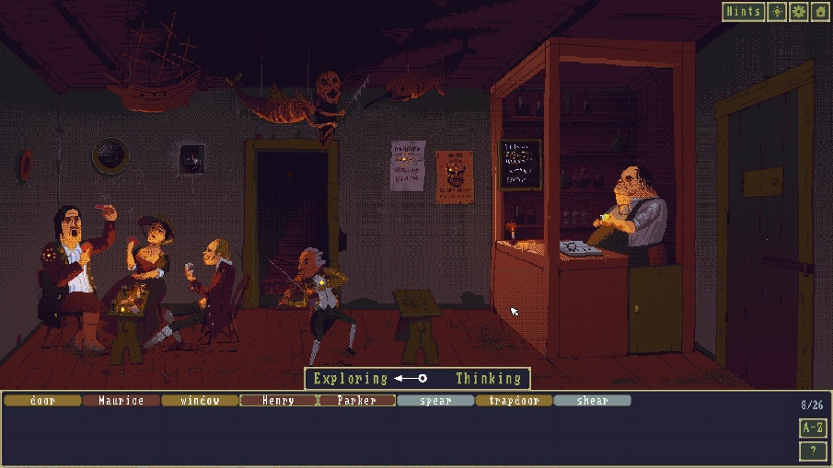
Figure 2 The Case of the Golden Idol in game
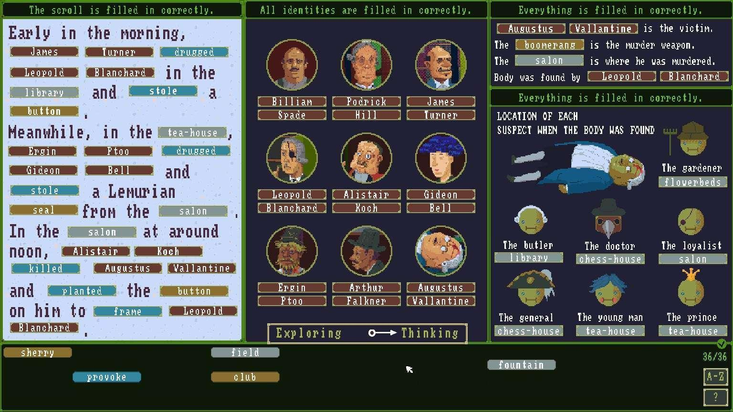
Figure 3 Inference UI of The Case of the Golden Idol
The Case of the Golden Idol (Games., 2022) is a modern investigation-based puzzle game that emphasizes observation and logical deduction. Players are presented with static scenes and must identify important objects, relationships, and events to solve each case.
Unlike many traditional investigation games, this game does not provide explicit UI guidance such as highlighting or markers. Instead, players must rely on visual details, object placement, and contextual clues to determine which elements are relevant. This encourages active exploration and critical thinking.
Object recognition in this game is strongly influenced by context. Players must interpret how objects relate to characters and events, rather than simply identifying interactable items. This design approach enhances cognitive engagement and demonstrates how minimal guidance can create a more immersive investigative experience.

2.3.2 Her Story
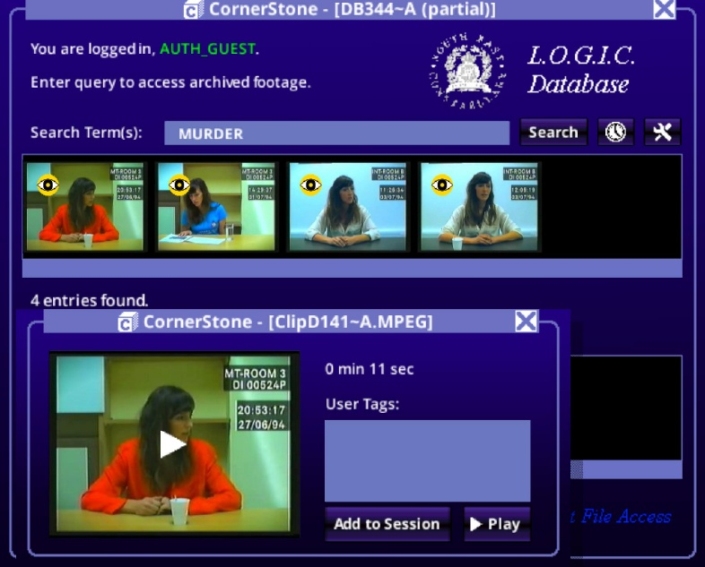
Figure 4 Her Story in Game
Her Story (Barlow., 2015) presents a different approach to investigation gameplay by removing traditional spatial exploration and focusing on information discovery through video database searches. Players must search for keywords and piece together fragments of information to understand the narrative.
In this system, object discovery is replaced by information discovery, where players must determine which keywords are relevant and how different pieces of information are connected. There is minimal guidance provided, and players must rely entirely on their own reasoning and interpretation.
This design emphasizes cognitive engagement rather than environmental exploration. Although it lacks spatial level design, it highlights the importance of player-driven discovery and the role of ambiguity in investigation gameplay. The absence of guidance increases challenge but may also lead to confusion for some players.

2.3.3 Return of the Obra Dinn
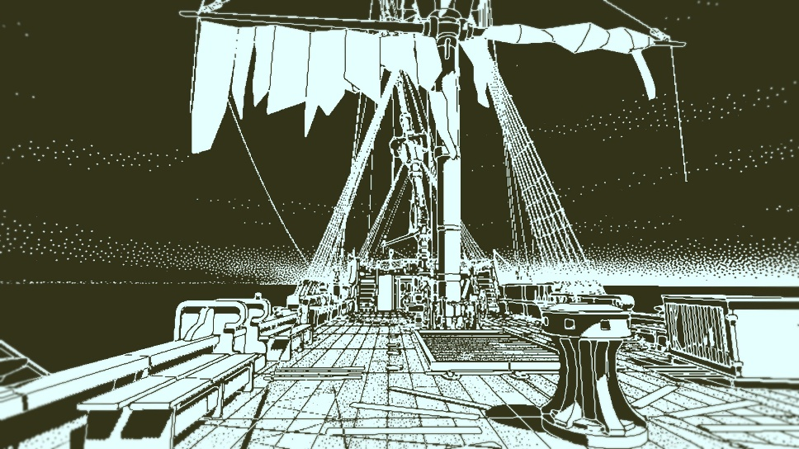
Figure 5 Return of the Obra Dinn in Game
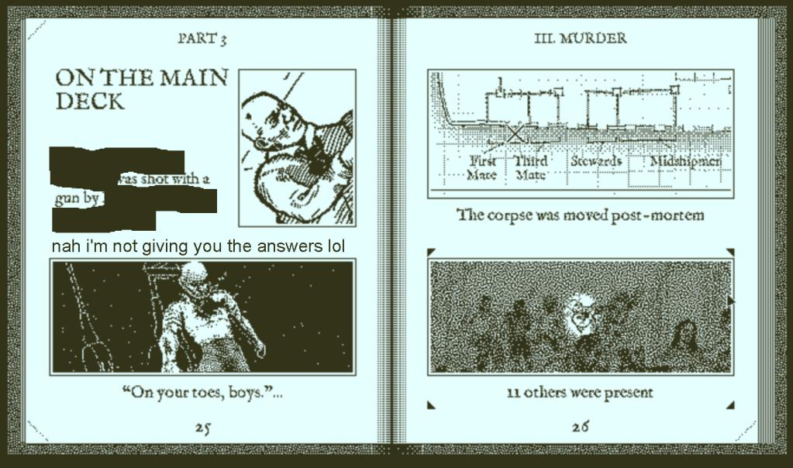
Figure 6 Inference UI of Return of the Obra Dinn
Return of the Obra Dinn (Pope., 2018) is an investigation game that heavily relies on environmental storytelling and player observation. Players explore a ship and reconstruct events by analysing static scenes and identifying clues.
Unlike many modern games, this game does not rely on strong UI-based guidance systems. Instead, it uses visual design, scene composition, and contextual clues to guide players. Important objects are not explicitly highlighted; instead, they are integrated into the environment in a way that encourages careful observation.
Object recognition in this game is closely tied to context. Players must interpret visual information, dialogue, and spatial relationships to determine the significance of objects and characters. This approach increases immersion and engagement but also requires a higher level of attention and cognitive effort from players.

2.3.4 Comparative Analysis of Existing Systems
The three games discussed above demonstrate different approaches to object discovery and recognition in investigation-based gameplay.
L.A. Noire relies heavily on UI-based guidance systems, making object discovery straightforward but reducing the need for exploration. Her Story removes spatial exploration entirely and focuses on cognitive discovery through information filtering. In contrast, Return of the Obra Dinn emphasizes environmental storytelling and minimal guidance, requiring players to actively observe and interpret their surroundings.
These differences highlight the trade-off between accessibility and player engagement. Systems with strong guidance reduce frustration but may limit immersion, while systems with minimal guidance enhance exploration but may increase difficulty.
This comparison suggests that an effective investigation game design should balance guidance and player autonomy. Instead of relying entirely on UI-based systems, level design elements such as object placement, spatial layout, and environmental cues can be used to support more natural and engaging object discovery and recognition.

2.4 Technical Research
The technical research for this project focuses on the main software used to support the development of the narrative-driven investigation game prototype. These tools are selected based on their suitability for game development, visual asset creation, and system planning.

2.4.1 Unity

Figure 7 Unity Icon
Unity (Technologies., 2023) is the primary game engine used for the development of this project. It is widely used in both 2D and 3D game development due to its flexibility, strong community support, and extensive features for interactive content creation.
In this project, Unity will be used to implement the game prototype, including level design, object placement, player interaction, and environmental mechanics. Its built-in physics system and scene management tools allow for efficient development of interactive environments that support object discovery and recognition gameplay.
Unity also supports rapid prototyping, which is essential for testing level design ideas and adjusting gameplay flow based on player feedback.

2.4.2 Photoshop

Figure 8 Photoshop Icon
Adobe Photoshop (Inc., 2023) will be used for the creation and editing of 2D visual assets within the project. This includes UI elements, textures, and environmental graphics used in the game prototype.
Photoshop provides advanced image editing tools that allow for precise control over visual design, which is important for ensuring clarity in object recognition. Since this project focuses on how players identify important objects within environments, visual clarity and contrast play an important role in guiding player attention.

2.4.3 draw.io

Figure 9 draw.io Icon
draw.io (draw.io., 2023) is used for system planning and visual documentation throughout the development process. It allows for the creation of flowcharts, system diagrams, and level design layouts.
In this project, draw.io will be used to design the structure of the game flow, including player progression, interaction systems, and level navigation paths. This helps ensure that the design of the game is well-organized and clearly defined before implementation in Unity.

Chapter 3: Methodology

3.1 System Development Methodology

3.1.1 Introduction
System development methodology refers to the structured approach used to plan, design, and develop a system or application. In the context of this project, the methodology is important to ensure that the development of the investigation-based game prototype is organized, iterative, and aligned with the research objectives.
This project focuses on designing a game prototype that explores how players discover and recognize important objects within a game environment. Therefore, a flexible and iterative development approach is required to allow continuous testing and refinement of level design, object placement, and player interaction.
Several development methodologies were considered for this project, including the Prototyping Model, Rapid Application Development (RAD), and Agile methodology. Each of these approaches supports iterative development, but they differ in terms of structure, flexibility, and suitability for game design projects.

Prototyping Model
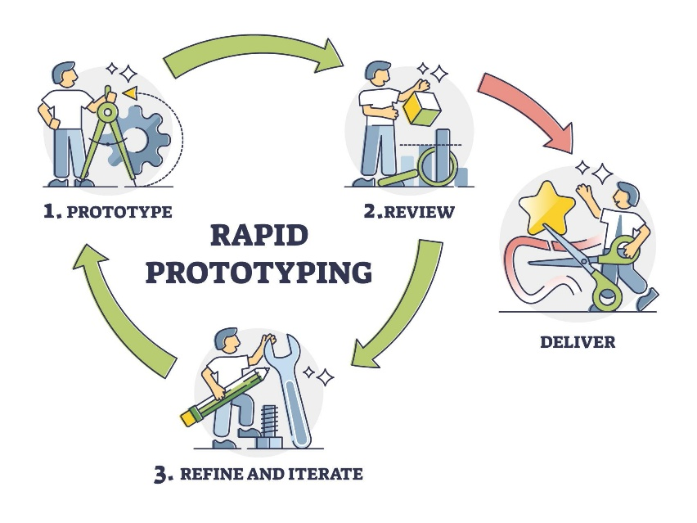
Figure 10 Prototyping Model
The Prototyping Model is a development approach that focuses on creating an initial version of the system quickly, which can then be tested and refined based on user feedback. This model is particularly suitable for projects where user interaction and experience play an important role.
In this project, the prototyping model allows the developer to create early versions of the game level and test how players interact with objects and environments. Feedback can then be used to improve object placement, visual clarity, and level design.

Rapid Application Development (RAD)
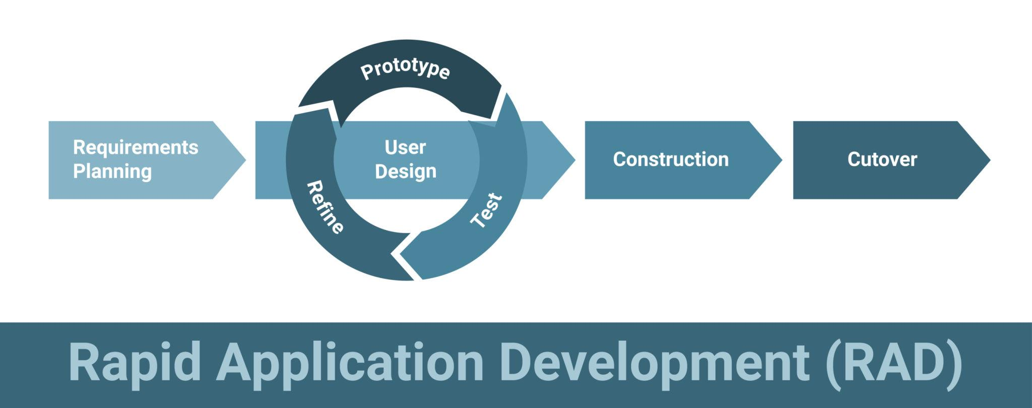
Figure 11 Rapid Application Development (RAD)
Rapid Application Development (RAD) is a methodology that emphasizes fast development and iteration through the use of reusable components and user feedback. It focuses on reducing development time while maintaining flexibility.
RAD is useful for projects that require quick delivery; however, it often prioritizes speed over detailed design. For this project, while RAD supports rapid iteration, it may not provide enough focus on the detailed refinement needed for level design and player experience.

Agile Methodology
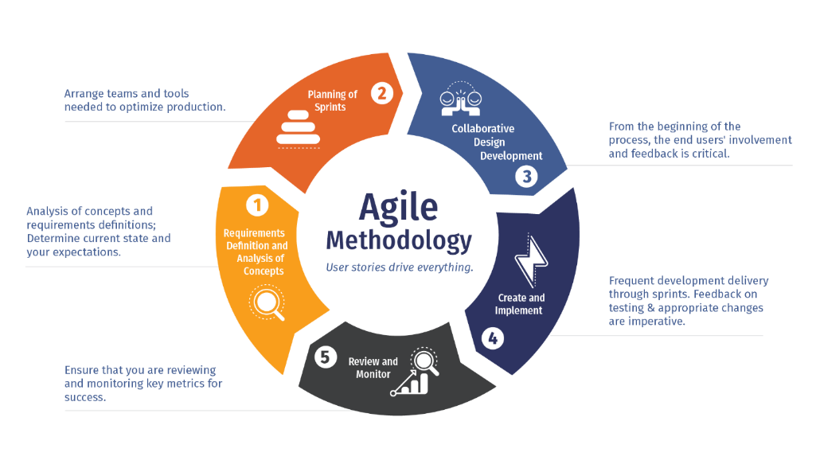
Figure 12 Agile Methodology
Agile methodology is an iterative and flexible approach that focuses on continuous development through small, incremental changes. It encourages frequent testing, collaboration, and adaptation throughout the development process.
Although Agile is widely used in software development, it typically requires a team-based environment with continuous collaboration. Since this project is developed individually, applying a full Agile process may not be practical.

3.1.2 Methodology Choice and Justification
To determine the most suitable methodology for this project, three development approaches were compared: Prototyping Model, Rapid Application Development (RAD), and Agile Methodology. Each methodology offers different advantages depending on the nature of the project.
Table 2: Comparison of Development Methodologies
Criteria | Prototyping Model | Rapid Application Development (RAD) | Agile Methodology
Development Speed | Moderate | Fast | Moderate
Flexibility | High | High | Very High
User Feedback Integration | Strong (continuous feedback) | Moderate | Strong
Suitability for Individual Project | High | Moderate | Low
Focus on User Experience | Very High | Moderate | High
Structure | Iterative with clear stages | Less structured | Continuous iteration

Justification of Selected Methodology
Based on the comparison above, the Prototyping Model is selected as the most suitable methodology for this project.
The main reason for this choice is that the project focuses heavily on player experience, particularly how players discover and recognize objects within a game environment. The Prototyping Model allows the developer to quickly create early versions of the game and test them with users. This makes it possible to gather feedback on level design, object placement, and visual clarity, which are essential aspects of this study.
In addition, the iterative nature of the Prototyping Model supports continuous refinement. The developer can improve the prototype based on user responses and testing results, ensuring that the final design better supports intuitive exploration and object recognition.
Compared to RAD, which emphasizes speed, the Prototyping Model provides a better balance between development and evaluation. While Agile also supports iteration, it is more suitable for team-based projects and may not be practical for an individual project with limited time and resources.
Therefore, the Prototyping Model is chosen as it best supports the goals of this research and allows for effective development and evaluation of the game prototype.

3.1.3 Phase of Prototyping Model
The Prototyping Model consists of several iterative phases that guide the development process from initial concept to final implementation. In this project, each phase plays an important role in ensuring that the game prototype effectively supports object discovery and recognition through level design.

1. Requirement Analysis
The first phase involves identifying the requirements of the project. In this study, the main requirements are based on the research objectives, which focus on understanding how players discover and recognize important objects in investigation-based games.
At this stage, the developer defines key elements such as gameplay mechanics, level structure, and player interaction with objects. In addition, user expectations are considered based on initial assumptions and research goals. This phase ensures that the development process is aligned with the purpose of the study.

2. Quick Design
The quick design phase involves creating an initial concept of the system. For this project, this includes designing the layout of game levels, planning object placement, and outlining how players will interact with the environment.
Simple sketches, flowcharts, and diagrams are created using tools such as draw.io to visualize the structure of the game. The focus is not on detail but on establishing a basic framework that can be quickly developed into a prototype.

3. Building Prototype
In this phase, the initial prototype of the game is developed using Unity. Basic game elements such as player movement, object interaction, and environmental layout are implemented.
The prototype does not need to be fully polished; instead, it serves as a functional model that demonstrates how the system works. This allows the developer to test whether the level design supports effective object discovery and recognition.

4. User Evaluation
Once the prototype is developed, it is tested by users to gather feedback. In this project, user evaluation is conducted through a questionnaire, where participants provide responses based on their experiences and expectations.
The feedback collected helps identify issues such as difficulty in locating objects, confusion in recognizing relevant items, or problems with level layout. This phase is essential in understanding how real users interact with the system.

5. Refining Prototype
Based on the feedback obtained from user evaluation, the prototype is improved and refined. Changes may include adjusting object placement, improving visual clarity, or modifying the level layout to enhance player navigation.
This iterative process ensures that the design becomes more effective in supporting intuitive exploration and object recognition. Multiple refinements may be made until the desired outcome is achieved.

6. Implement and Maintain
The final phase involves implementing the improved prototype and ensuring that it functions as intended. Any remaining issues are fixed, and the system is finalized.
Although this project focuses mainly on research rather than full product deployment, this phase ensures that the prototype is stable and can demonstrate the intended design concepts clearly.

3.2 Data Gathering Design
The data gathering design for this study focuses on collecting user responses related to object discovery and recognition in investigation-based games. The purpose of this phase is to obtain insights into player behaviour, preferences, and expectations when interacting with game environments.
An online survey was selected as the primary data collection method due to its efficiency in reaching a larger number of participants within a limited time frame. The survey was distributed through Google Forms, allowing participants to respond conveniently using their own devices.

Figure 13 Google Forms Icon
A total of 30 participants took part in this study. The participants consist of individuals with different levels of gaming experience, including both those who have played investigation-based games and those who have not. This helps ensure a broader perspective and allows comparison between experienced and non-experienced players.
The collected data includes both quantitative data (multiple-choice questions and rating scales) and qualitative data (open-ended responses). This combination allows for a more comprehensive analysis of player behaviour and preferences.

3.2.1 Survey Design
The survey was designed to gather information in a structured and progressive manner. The questions were divided into several sections, each focusing on a specific aspect of the study, including player background, exploration behaviour, object recognition, and level design preferences.
In addition, a conditional question structure was implemented to ensure that participants received questions relevant to their experience level. Participants who indicated that they had not played investigation-based games were directed to a separate section (Section 2B), which focuses on understanding the reasons for not engaging with the genre.
This structure ensures that participants can easily understand and respond to the questions while also allowing the study to collect meaningful data from both experienced players and non-players.

Table 3: Survey Structure Overview
Section | Description
Section A | Participant Background (basic information and gaming experience)
Section B | Exploration and Object Discovery
Section C | Object Recognition and Clue Identification
Section D | Level Design and Player Experience
Section E | Player Preferences and Feedback
*Section 2B | Reasons for Not Playing Investigation Games

Section A: Participant Background
This section collects general information about the participants, such as their gaming experience and familiarity with investigation-based games. The purpose is to categorize participants and understand their background before analysing their responses.
Table 4: Section A Participant Background
No. | Question | Answer | Justification
1 | What is your age range? | Multiple Choice: Under 18 / 18–22 / 23–27 / 28–32 / Over 32 | To identify the age distribution of respondents and determine whether age influences gameplay behaviour
2 | What is your gender? | Multiple Choice: Male / Female / Prefer not to say | To identify any variation in responses across gender groups
3 | How frequently do you play video games? | Multiple Choice: Daily / Several times a week / A few times a month / Rarely | To determine the level of gaming familiarity among participants
4 | Have you ever played a game where you had to act as an investigator or detective? | Multiple Choice: Yes / No | To identify whether participants have prior experience with investigation-based gameplay

Section B: Exploration and Object Discovery
This section focuses on how players discover objects during gameplay. Questions in this section examine player behaviour, such as how they search for objects and what methods they use during exploration.
Table 5: Section B Exploration and Object Discovery
No. | Question | Answer | Justification
5 | When exploring a game, how do you usually find important objects? | Multiple Choice: Visual highlights / Exploring every area / Following clues / Trial and error | To identify common strategies players, use to discover important objects
6 | What helps you the most when trying to find important items in a game? | Multiple Choice: Lighting / Object placement / UI indicators / Sound cues | To determine which factors, influence object discovery
7 | Do you prefer games that clearly guide you to important objects? | Multiple Choice: Yes / No / Depends | To evaluate player preference for guided vs exploratory gameplay
8 | How often do you miss important objects in games? | Multiple Choice: Very often / Sometimes / Rarely / Never | To understand challenges faced during object discovery

Section C: Object Recognition and Clue Identification
This section investigates how players determine whether an object is important or relevant. It explores factors such as visual cues, interaction feedback, and environmental context.
Table 6: Section C Object Recognition and Clue Identification
No. | Question | Answer | Justification
9 | How do you usually determine if an object is important in a game? | Multiple Choice: It stands out visually / It can be interacted with / It is placed in a noticeable location / Context of the environment | To identify how players recognize relevant objects
10 | What makes an object feel important to you? | Multiple Choice: Bright colour / Unique design / Story relevance / Interaction feedback | To examine key factors influencing object recognition
11 | Do you find it difficult to distinguish useful objects from background objects? | Multiple Choice: Yes / No / Sometimes | To evaluate player difficulty in object recognition
12 | Which factor helps you the most in identifying important objects? | Multiple Choice: Visual contrast / Position in level / Clues from environment / Sound or feedback | To determine dominant recognition cues

Section D: Level Design and Player Experience
This section examines how level design influences player behaviour. It includes questions related to spatial layout, object placement, and environmental clarity, which are key elements of this research.
Table 7: Section D Level Design and Player Experience
No. | Question | Answer | Justification
13 | How important is level layout in helping you explore a game? | Likert Scale: Not important – Very important | To evaluate the impact of spatial design on exploration
14 | Does object placement affect how easily you find items? | Multiple Choice: Yes / No / Not sure | To assess the influence of object placement on discovery
15 | Do cluttered environments make it harder to find important objects? | Multiple Choice: Yes / No / Sometimes | To examine the effect of environmental complexity
16 | Do you prefer clear and simple environments or detailed and complex ones? | Multiple Choice: Simple / Balanced / Complex | To understand player preference in level design complexity

Section E: Player Preferences and Feedback
This section gathers player opinions and suggestions. It allows participants to provide feedback on their experiences and preferences, offering qualitative insights that support the overall analysis.
Table 8: Section E Player Preferences and Feedback
No. | Question | Answer | Justification
17 | Do you prefer games that require you to think and observe rather than being guided? | Multiple Choice: Yes / No / Depends | To evaluate player preference for cognitive engagement
18 | What frustrates you the most when searching for objects in games? | Open-ended | To identify common player frustrations
19 | What do you think makes object discovery enjoyable? | Open-ended | To gather insights into positive player experience
20 | Do you have any suggestions for improving object discovery in games? | Open-ended | To collect user-driven design recommendations

Section 2B: Player Preferences and Feedback
This section is designed for participants who indicated that they have not played investigation-based games. The purpose of this section is to understand their awareness, preferences, and reasons for not engaging with the genre. The responses collected will help identify potential barriers and provide insights into how game design can be improved to attract a wider audience.
Table 9: Section 2B Player Preferences and Feedback
No. | Question | Answer | Justification
21 | Before this survey, were you aware of investigation or detective-style games? | Multiple Choice: Yes / No | To determine the level of awareness of the genre among non-players
22 | Do you enjoy exploring environments in games? | Multiple Choice: Yes / No / Sometimes | To evaluate general interest in exploration-based gameplay
23 | Do you like finding hidden objects or secrets in games? | Multiple Choice: Yes / No / Depends | To assess whether object discovery mechanics appeal to non-players
24 | Why have you not played investigation-style games? | Multiple Choice / Checkbox | To identify key barriers such as lack of interest, perceived difficulty, or unclear gameplay
25 | What would make you more interested in trying investigation games? | Multiple Choice / Checkbox | To gather insights on features that could attract new players
26 | When playing any type of game, how do you prefer important objects to be presented? | Multiple Choice | To understand preference for guidance systems among non-players
27 | Any thoughts on why you might avoid exploration or investigation-style gameplay? | Open-ended | To collect qualitative insights into player attitudes and concerns

The responses collected from the survey will be analysed to identify patterns in player behaviour, perception, and preferences related to object discovery and recognition in investigation-based games. The analysis focuses on understanding how players explore game environments, how they identify important objects, and how level design influences their interaction.
The responses from multiple-choice questions in Section B and Section C will be analysed using frequency distribution. This method allows the identification of the most common strategies used by players when discovering and recognizing objects. For example, responses related to object discovery (such as visual cues, environmental exploration, or UI guidance) will indicate which approaches are most commonly relied upon during gameplay. Similarly, responses related to object recognition will highlight key influencing factors such as visual contrast, interactivity, and contextual relevance.
If most participants select options related to UI guidance (such as highlights or indicators), this suggests a reliance on system-driven support. In contrast, a higher selection of exploration-based methods or environmental cues indicates a preference for more natural and immersive gameplay. These findings will help evaluate whether level design alone can effectively support object discovery without excessive reliance on UI systems.
The responses from Section D, which include Likert scale and multiple-choice questions, will be analysed to evaluate the impact of level design on player experience. Higher ratings for factors such as spatial layout, object placement, and environmental storytelling will indicate their importance in guiding player exploration. Conversely, responses indicating confusion or difficulty in cluttered environments will highlight potential design limitations that affect player performance.
Open-ended responses from Section E will be analysed using qualitative thematic analysis. Common themes such as player frustration, preferences, and suggestions will be identified and grouped accordingly. These insights provide deeper understanding of player expectations and help explain the reasoning behind the quantitative results.
In addition, responses from participants who have not played investigation-based games (Section 2B) will be analysed separately to identify barriers to entry, such as lack of awareness, perceived difficulty, or gameplay preferences. These responses will then be compared with those of experienced players to examine differences in behaviour, expectations, and preferences.
This comparative analysis allows the study to provide a more comprehensive understanding of both player and non-player perspectives, ensuring that the proposed game design can cater to a wider audience.
Overall, the findings from this survey will be used to inform the design of the game prototype, particularly in terms of level layout, object placement, and visual cues. This ensures that the design decisions are based on actual player behaviour and preferences, rather than assumptions.

3.3 Analysis
This section presents the analysis of the data collected from the survey. The responses are analysed to identify patterns in player behaviour, preferences, and perceptions related to object discovery and recognition in investigation-based games.

3.3.1 Section A: Demographic Information
Table 10: Section A Demographic Information
 | Question
1 | 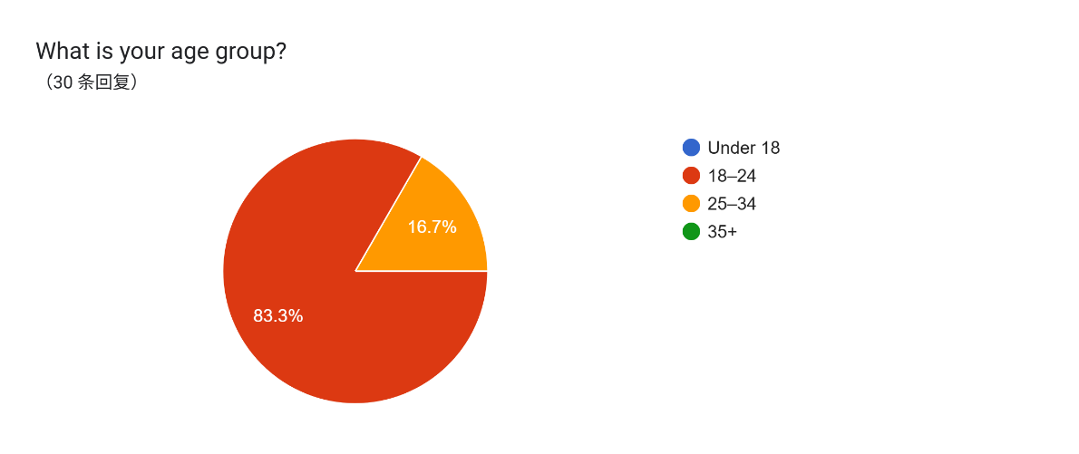  Figure 14 Survey Question 1
Analysis | Most respondents fall within the 18 to 22 age group, which consists of 15 participants (46.9%). The second largest group is 23 to 27, with 13 participants (40.6%). The remaining 4 participants (12.5%) are between the ages of 28 to 32. There are no respondents who fall under 18 or above 32 years old.  This distribution indicates that the survey successfully reached its intended target demographic, which consists mainly of young adults aged between 18 and 27. This age group is generally more active in playing video games and more familiar with modern game design elements, particularly those related to exploration and interaction.  The concentration of respondents within this age range strengthens the reliability of the findings, as the data reflects the perspectives of players who are likely to engage with investigation-based games. Therefore, the responses collected are considered relevant and suitable for analysing player behaviour in object discovery and recognition within game environments.
2 | 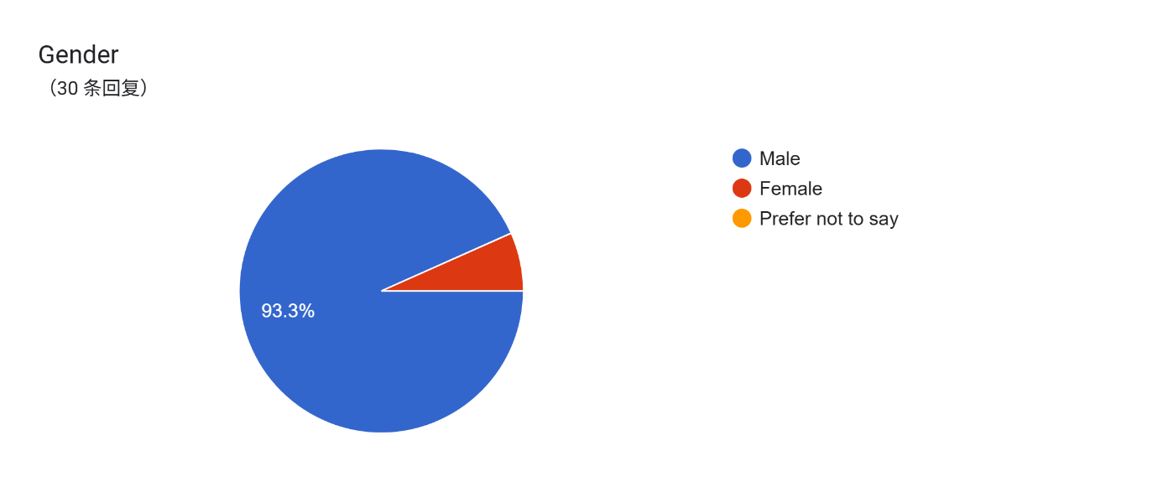  Figure 15 Survey Question 2
Analysis | Most respondents are male, accounting for 93.3% of the total participants, while 6.7% are female. There are no respondents who selected “Prefer not to say”.  This distribution shows that the sample is heavily skewed towards male participants. While gender is not the primary focus of this study, this imbalance may influence the overall results, as male players may have different gameplay preferences compared to other groups. However, since the study focuses on general player behaviour in object discovery and recognition, the data is still considered valid for analysis.
3 | 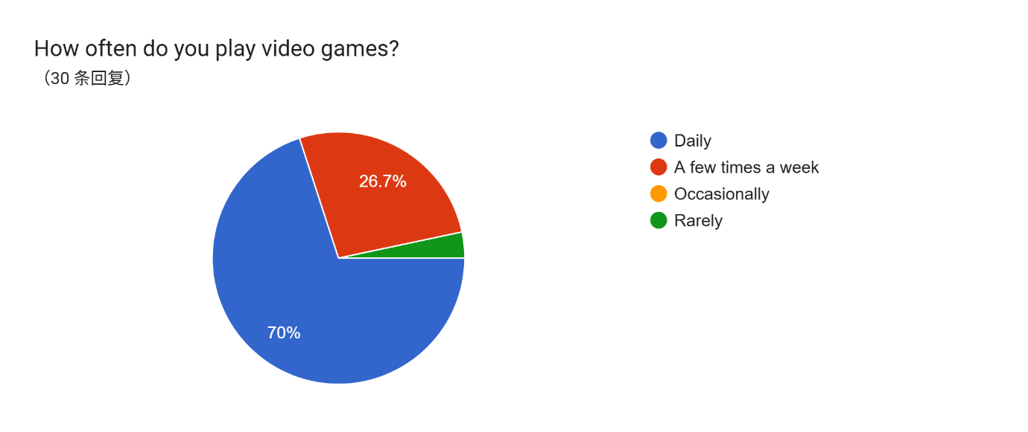  Figure 16 Survey Question 3
Analysis | Most participants reported playing video games daily, accounting for 70% of the total respondents. This is followed by 26.7% who play a few times a week, while only a small percentage of participants play occasionally or rarely.  This indicates that most respondents are active gamers with strong familiarity with game mechanics and interaction systems. As a result, their responses are likely to be more reliable when analysing behaviours related to exploration, object discovery, and recognition.
4 | 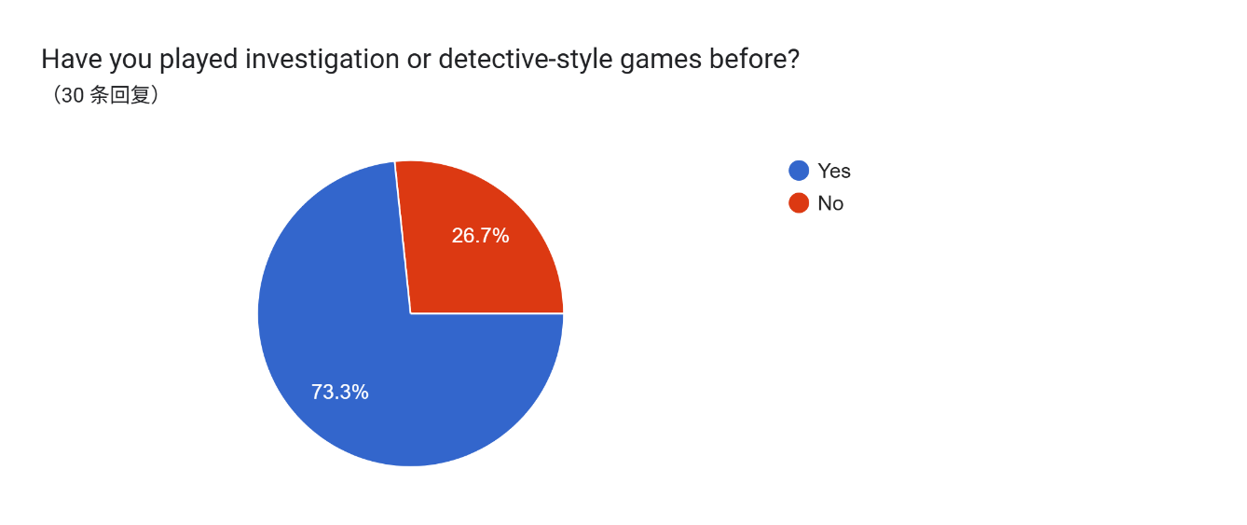  Figure 17 Survey Question 4
Analysis | The results show that 73.3% of participants have previously played investigation or detective-style games, while 26.7% have not.  This indicates that most respondents are familiar with investigation-based gameplay, including mechanics such as searching for clues and identifying important objects. This strengthens the validity of the data, as participants can provide informed responses based on prior experience. At the same time, the presence of participants without such experience allows for comparison and provides additional perspectives.

3.3.2 Section B: Exploration and Object Discovery
Table 11: Section B Exploration and Object Discovery
 | Question
5 | 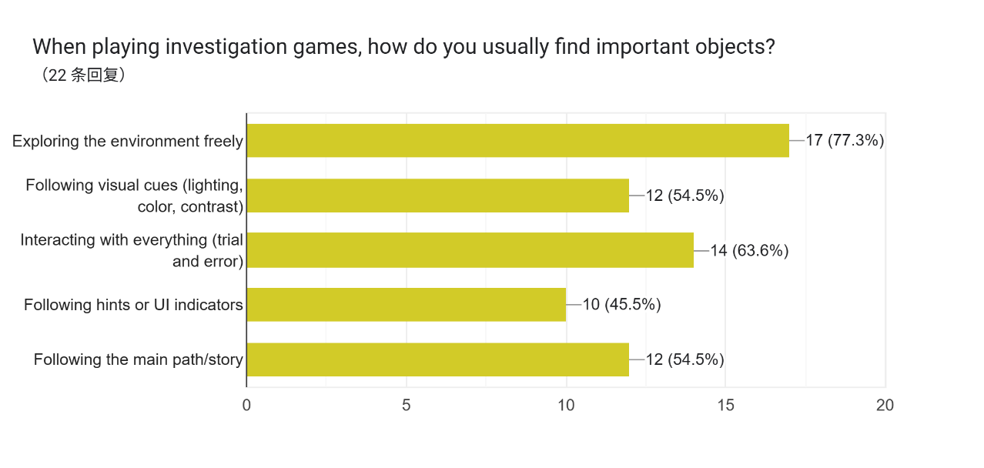  Figure 18 Survey Question 5
Analysis | The results show that the most common method used by players to find important objects is exploring the environment freely, selected by 77.3% of respondents. This is followed by interacting with everything (63.6%), and both following visual cues and following the main path/story (54.5%). The least selected option is following hints or UI indicators, at 45.5%.  This suggests that players prefer active exploration rather than relying solely on system guidance. The high percentage for exploration-based approaches indicates that players enjoy engaging with the environment and discovering objects naturally. This supports the importance of level design in guiding player behaviour.
6 | 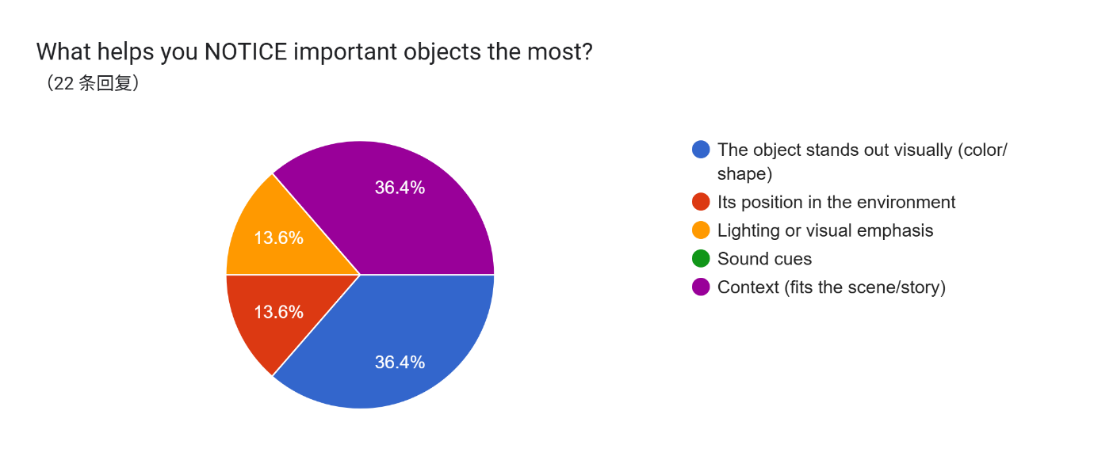  Figure 19 Survey Question 6
Analysis | The results indicate that visual appearance (36.4%) and contextual relevance (36.4%) are the most influential factors in helping players notice important objects. This is followed by object position (13.6%) and lighting or visual emphasis (13.6%), while sound cues were not selected.  This suggests that players rely more on visual clarity and environmental context rather than additional sensory cues. Objects that stand out visually or fit naturally within the scene are more likely to be recognized, highlighting the importance of visual design and environmental storytelling.
7 | 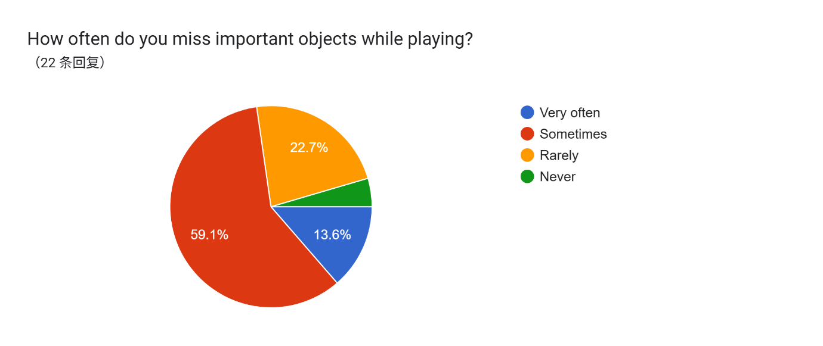  Figure 20 Survey Question 7
Analysis | Most participants (59.1%) reported that they sometimes miss important objects during gameplay. Meanwhile, 22.7% rarely miss objects, 13.6% miss them very often, and only a small percentage never miss them.  This indicates that object discovery remains a challenge for many players. Even experienced players may overlook important items, suggesting that level design and object placement need to be carefully considered to improve visibility and accessibility.
8 | 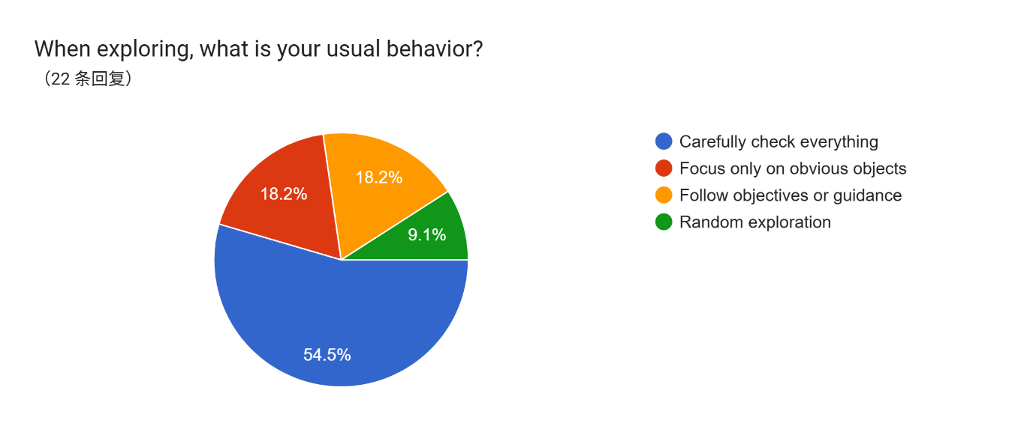  Figure 21 Survey Question 8
Analysis | Most participants (54.5%) reported that they carefully check everything when exploring. This is followed by smaller groups who focus only on obvious objects (18.2%), follow objectives (18.2%), or explore randomly (9.1%).  This shows that players tend to adopt a thorough and systematic approach when searching for objects. This behaviour suggests that players are willing to invest effort in exploration, reinforcing the importance of designing environments that reward careful observation.

3.3.3 Section C: Object Recognition and Clue Identification
Table 12 Section C Object Recognition and Clue Identification
 | Question
9 | 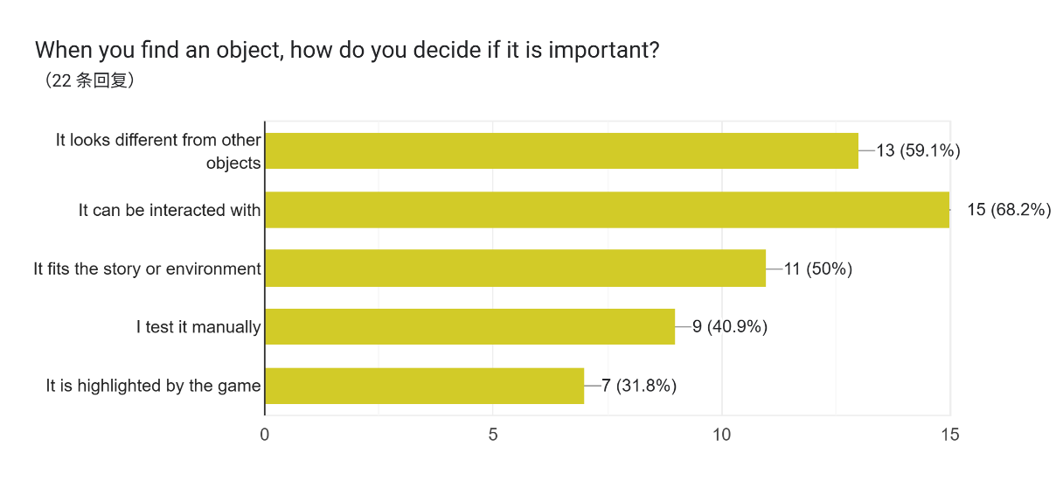  Figure 22 Survey Question 9
Analysis | The most common factor used by players to determine whether an object is important is visual difference, selected by 59.1% of participants. This is followed by interactivity (50%), contextual relevance (50%), and manual testing (40.9%). The least selected option is UI highlighting (31.8%).  This suggests that players rely more on visual and contextual cues rather than system-based indicators. Objects that stand out or can be interacted with are more likely to be recognized as important, reinforcing the role of level design in guiding player attention.
10 | 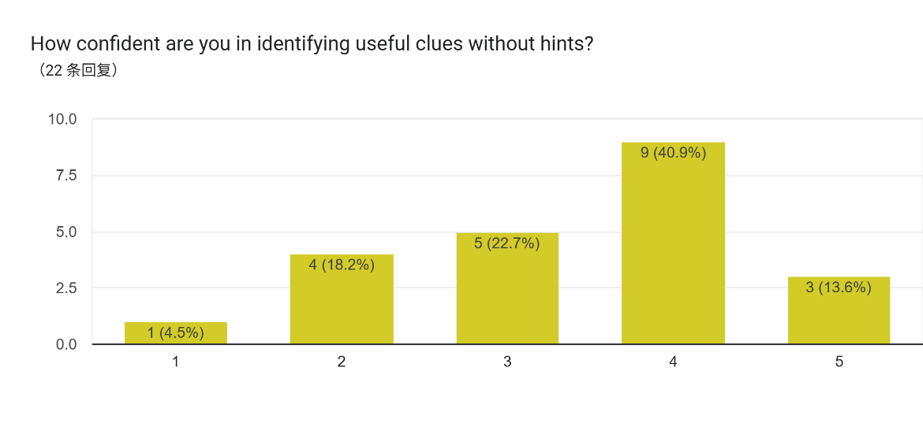  Figure 23 Survey Question 10
Analysis | Most participants rated their confidence at level 4 (40.9%), followed by level 3 (22.7%) and level 5 (13.6%). Only a small number of participants rated themselves at lower levels.  This indicates that players generally feel moderately confident in identifying important objects without relying on hints. However, the distribution also shows that not all players are fully confident, suggesting that some level of guidance or design support is still necessary.
11 | 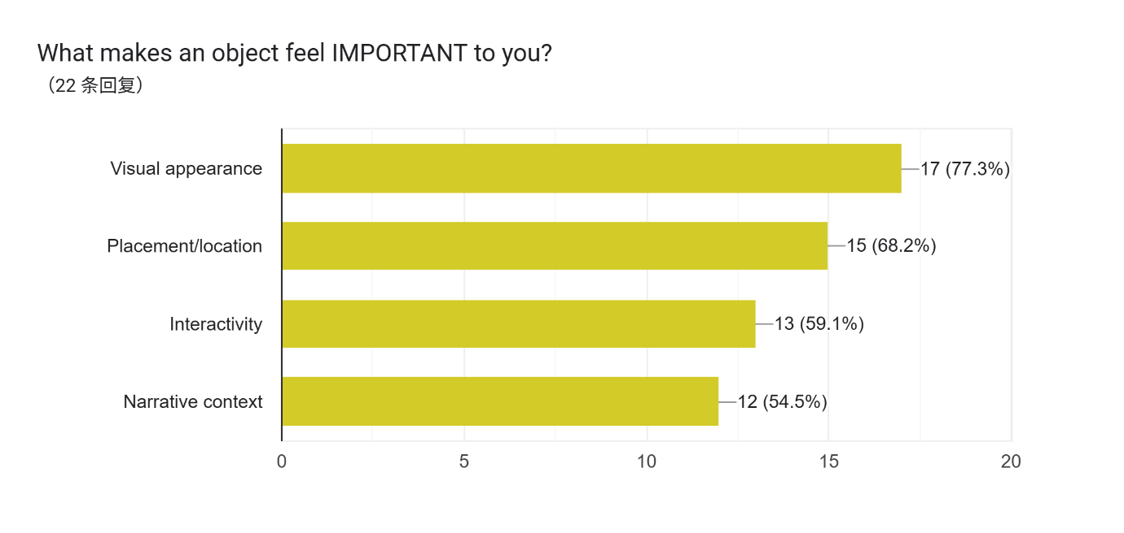  Figure 24 Survey Question 11
Analysis | The most significant factor is visual appearance (77.3%), followed by placement/location (68.2%), interactivity (59.1%), and narrative context (54.5%).  This shows that visual design plays the most important role in object recognition. However, placement and context are also highly influential, indicating that multiple design elements work together to help players identify important objects.
12 | 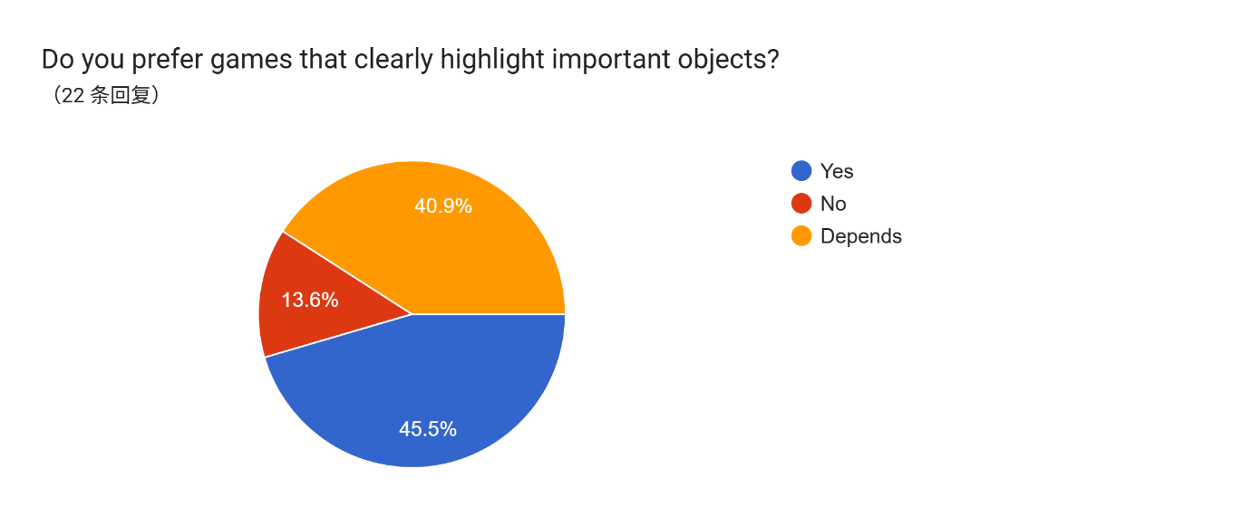  Figure 25 Survey Question 12
Analysis | 45.5% of participants prefer games that highlight important objects, while 40.9% selected “Depends” and 13.6% prefer no highlighting.  This suggests that while some players prefer clear guidance, a large portion of players prefer a balance between guidance and exploration. This supports the idea that excessive reliance on UI systems may not always provide the best experience.

3.3.4 Section D: Level Design and Player Experience
Table 13: Section D Level Design and Player Experience
 | Question
13 | 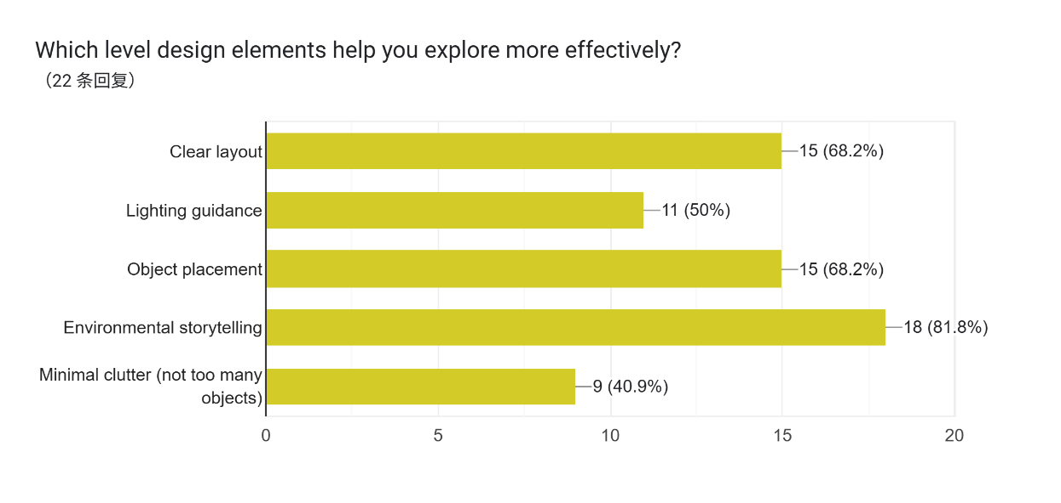  Figure 26 Survey Question 13
Analysis | Environmental storytelling is the most influential factor (81.8%), followed by clear layout and object placement (both 68.2%), lighting (50%), and minimal clutter (40.9%).  This indicates that players rely heavily on environmental context and structure when exploring. It highlights the importance of designing meaningful environments rather than relying solely on visual indicators.
14 | 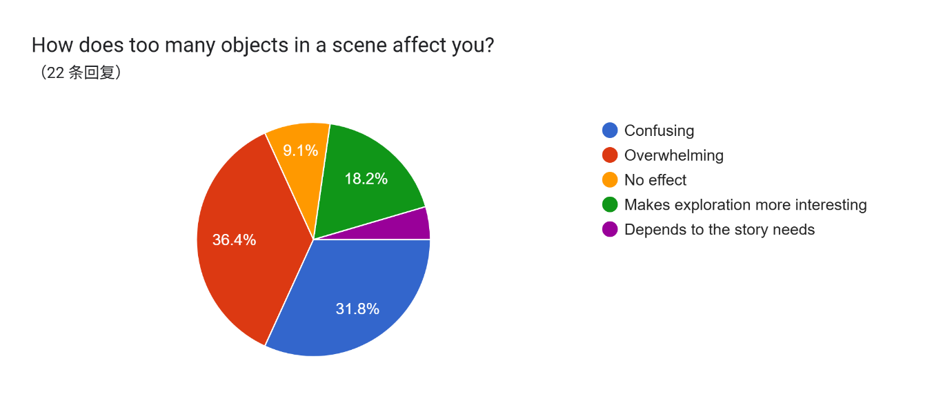  Figure 27 Survey Question 14
Analysis | The majority of participants find cluttered environments overwhelming (36.4%) or confusing (31.8%). Only a small percentage find it more interesting or unaffected.  This suggests that excessive objects can negatively impact player experience, making it harder to identify important items. Therefore, controlling environmental complexity is essential in level design.
15 | 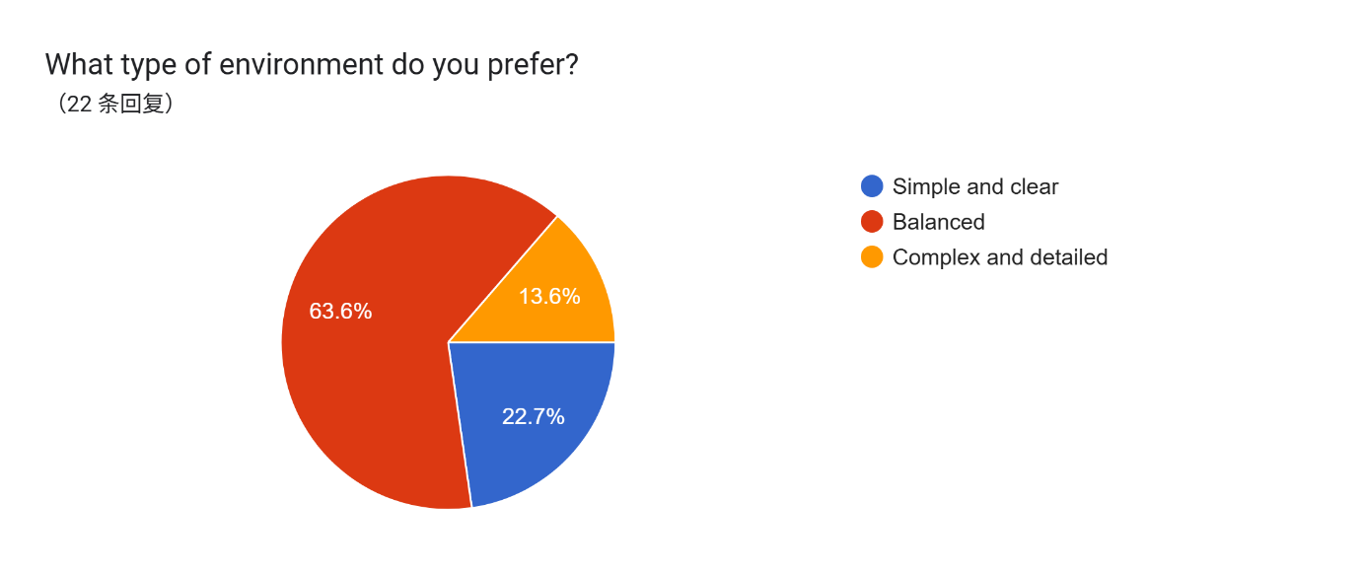  Figure 28 Survey Question 15
Analysis | Most participants (63.6%) prefer a balanced environment, followed by simple environments (22.7%), while only 13.6% prefer complex environments.  This indicates that players prefer a balance between clarity and detail, supporting the idea that environments should not be overly simple or overly cluttered.
16 | 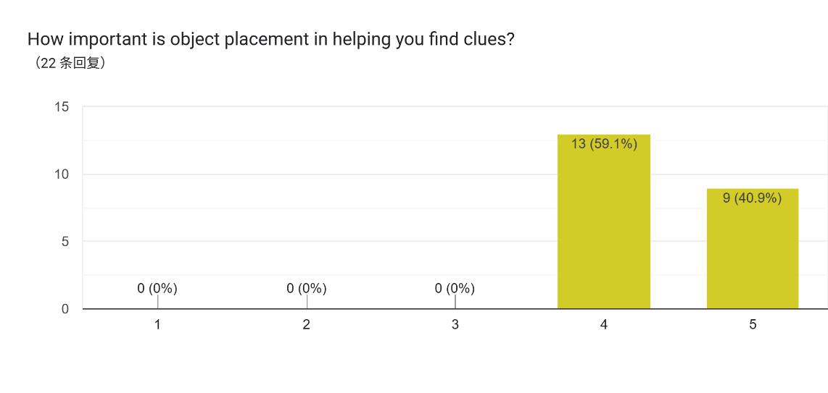  Figure 29 Survey Question 16
Analysis | All participants rated object placement as important, with 59.1% selecting level 4 and 40.9% selecting level 5.  This clearly shows that object placement is a critical factor in helping players discover and recognize important items, reinforcing the importance of level design.

3.3.5 Section E: Preferences and Feedback
Table 14: Section E: Preferences and Feedback
 | Question
17 | 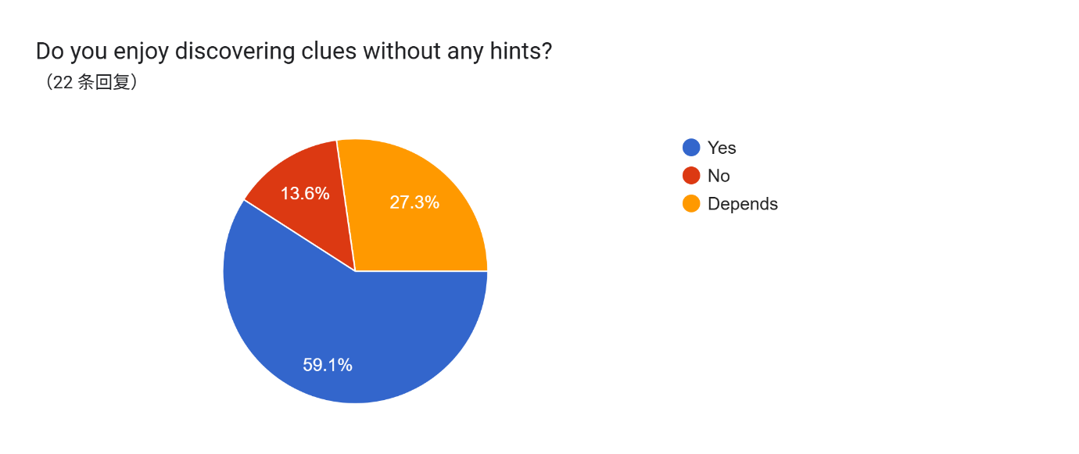  Figure 30 Survey Question 17
Analysis | 59.1% of participants enjoy discovering clues without hints, while 27.3% selected “Depends” and 13.6% do not.  This suggests that most players appreciate exploration-based gameplay, but some still prefer guidance depending on the situation.
18 | 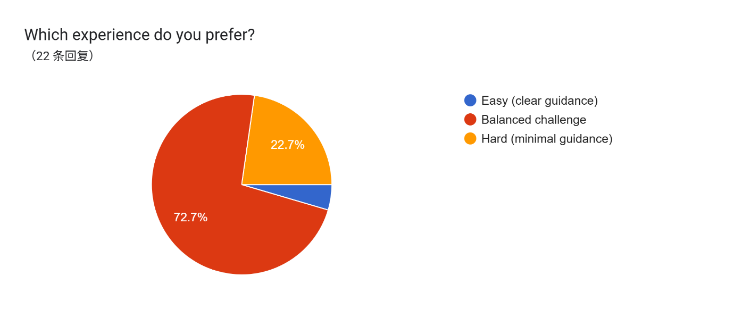  Figure 31 Survey Question 18
Analysis | The majority of participants (72.7%) prefer a balanced challenge, while fewer participants prefer easy or hard experiences.  This indicates that players prefer a balance between guidance and difficulty, aligning with previous findings.
19 | 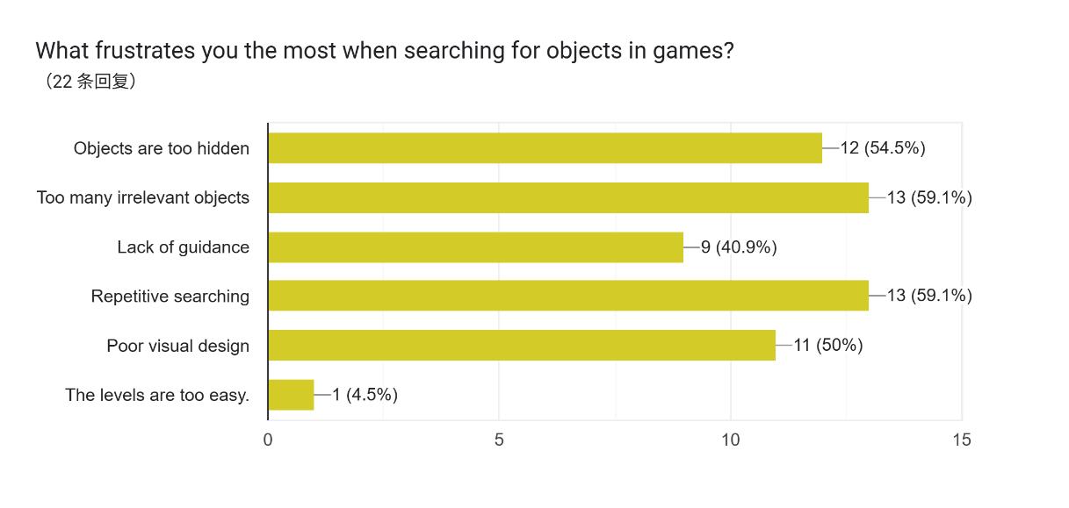  Figure 32 Survey Question 19
Analysis | The most common frustrations include too many irrelevant objects (59.1%) and repetitive searching (59.1%), followed by hidden objects (54.5%) and poor visual design (50%).  This highlights key design issues that negatively affect player experience, particularly related to clutter and lack of clarity.
20 | 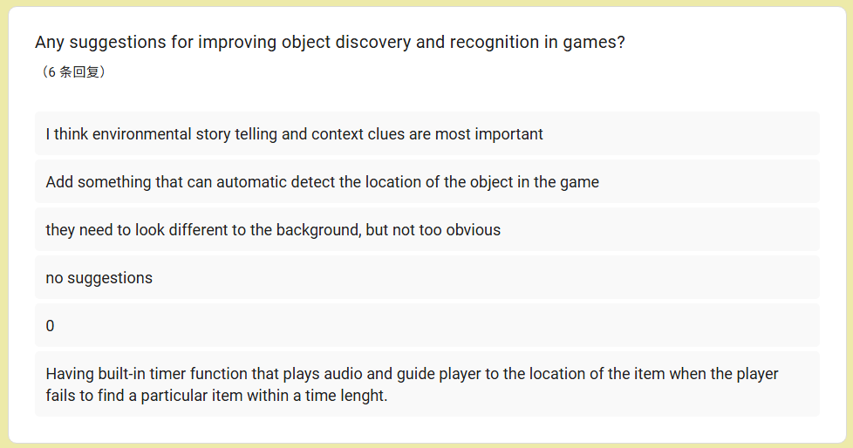  Figure 33 Survey Question 3
Analysis | Participants suggested improvements such as better environmental storytelling, clearer object distinction, and subtle guidance systems. Some also suggested adaptive systems such as hints or audio cues when players struggle.

3.3.6 Section 2B: Reasons for Not Playing Investigation Games
Table 15: Section 2B: Reasons for Not Playing Investigation Games
 | Question
21 | 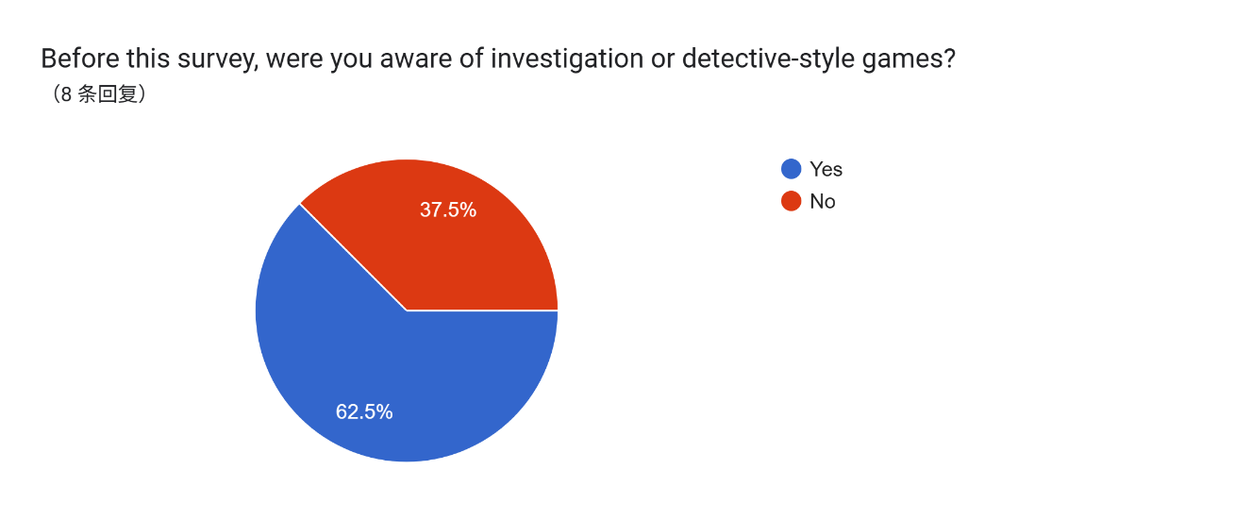  Figure 34 Survey Question 21
Analysis | The results show that 62.5% of participants are aware of investigation or detective-style games, while 37.5% are not.  This indicates that a portion of the target audience lacks awareness of the genre, which may contribute to their lack of engagement. This suggests that visibility and exposure are important factors in attracting new players.
22 | 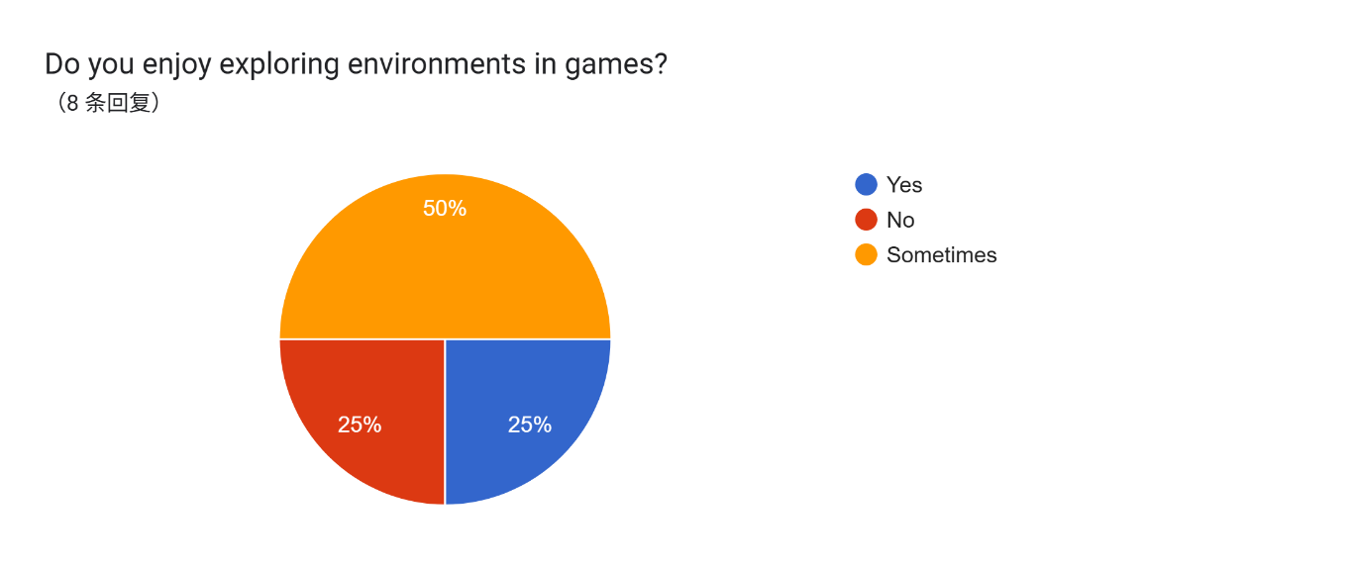  Figure 35 Survey Question 22
Analysis | 50% of participants reported that they sometimes enjoy exploring environments in games, while only 25% clearly enjoy it and 25% do not.  This suggests that although some participants are open to exploration-based gameplay, it is not consistently appealing to all players. This may indicate that current implementations of exploration mechanics are not engaging enough for non-players.
23 | 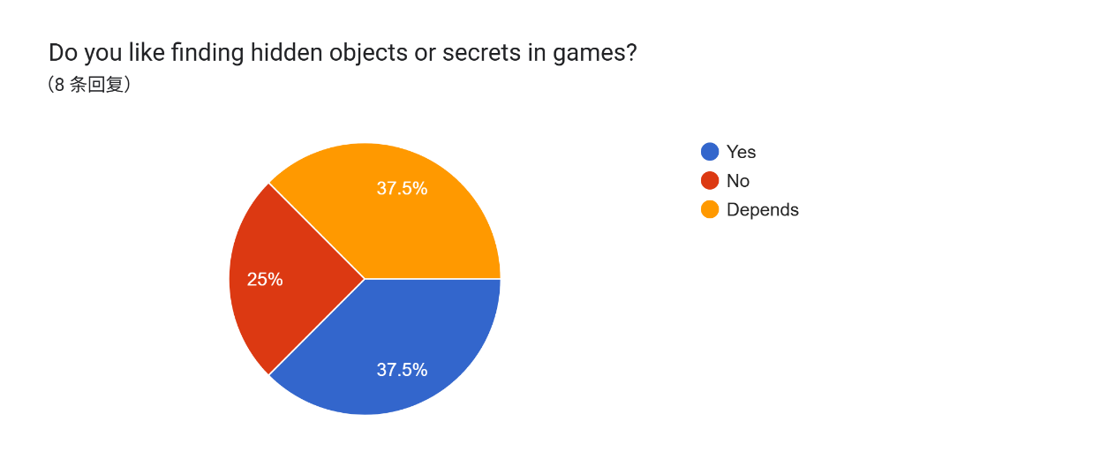  Figure 36 Survey Question 23
Analysis | The responses are relatively balanced, with 37.5% enjoying finding hidden objects, 37.5% selecting “Depends,” and 25% not enjoying it.  This indicates that object discovery mechanics are not universally appealing. Players may prefer these mechanics only when they are well-designed and not overly difficult or frustrating.
24 | 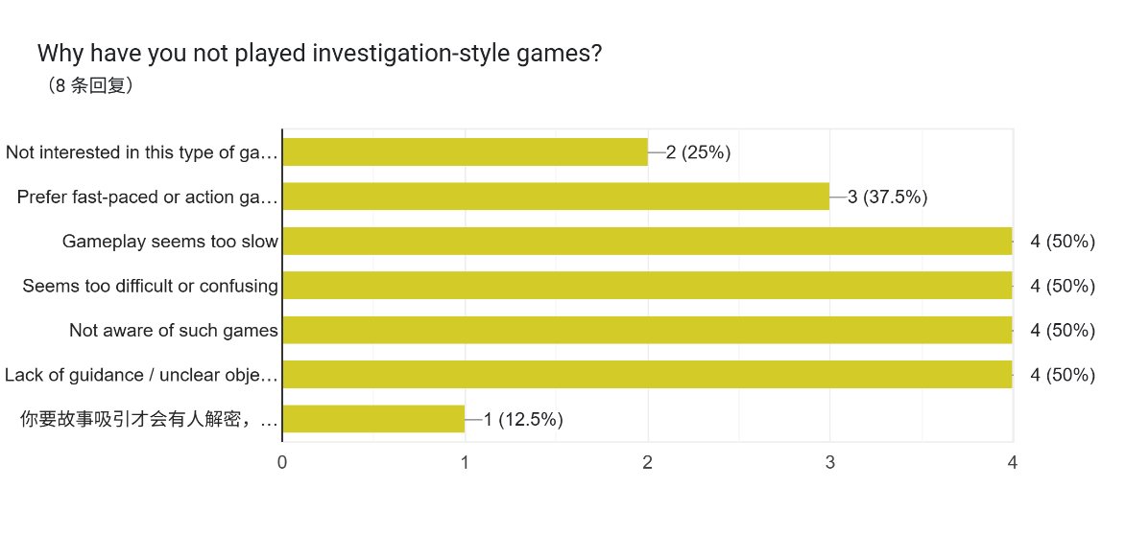  Figure 37 Survey Question 24
Analysis | The most common reasons for not playing investigation-based games include:  - Gameplay seems too slow (50%)  - Seems too difficult or confusing (50%)  - Not aware of such games (50%)  - Lack of guidance or unclear objectives (50%)  Other reasons include preference for fast-paced games (37.5%) and lack of interest (25%).  These findings suggest that non-players perceive investigation games as slow, complex, and unclear. This highlights key barriers that prevent players from engaging with the genre.
25 | 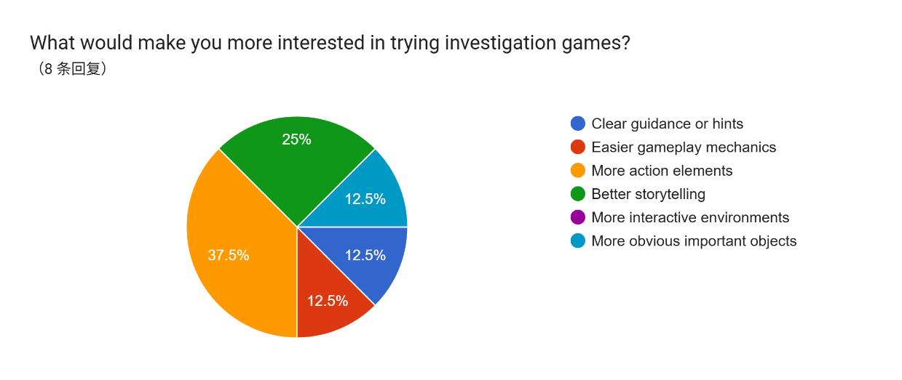  Figure 38 Survey Question 25
Analysis | The most selected factor is more action elements (37.5%), followed by better storytelling (25%). Other options such as clearer guidance, easier mechanics, and more obvious objects were selected by smaller percentages.  This suggests that non-players are more attracted to dynamic and engaging gameplay elements. Incorporating elements such as clearer progression, stronger narrative, or slight action components may help increase interest.
26 | 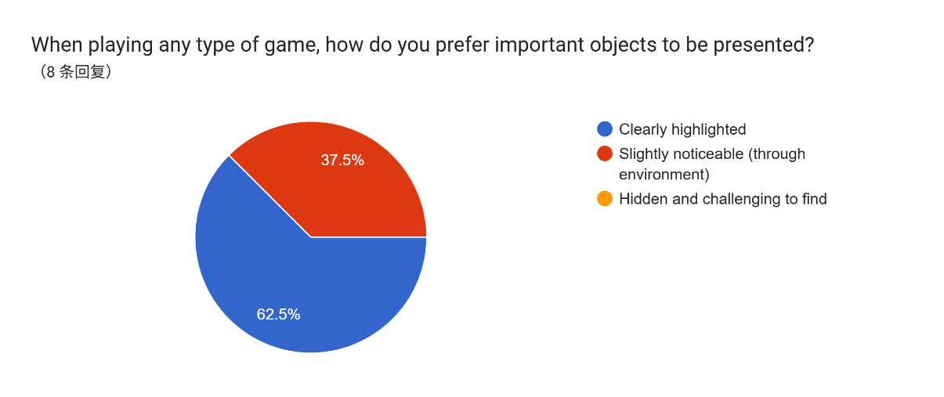  Figure 39 Survey Question 26
Analysis | 62.5% of participants prefer clearly highlighted objects, while 37.5% prefer objects that are slightly noticeable through environmental design.  This shows that non-players rely more on direct guidance compared to experienced players. This suggests that games targeting new players should include clearer visual indicators or guidance systems to reduce confusion.
27 | 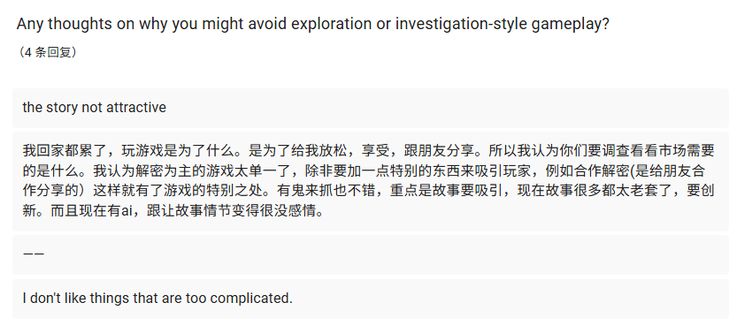  Figure 40 Survey Question 27
Analysis | From the open-ended responses, several key themes were identified:  - Lack of interest due to unengaging story  - Preference for simpler gameplay  - Dislike of overly complex mechanics  These responses indicate that narrative quality and gameplay simplicity play an important role in attracting new players.

These responses reinforce the importance of balancing clarity and challenge in level design.

3.3.6 User Requirements
Table 16: Table of User Requirements
No. | Requirement | Description
1 | Natural Exploration Support | The game must allow players to discover important objects through exploration rather than relying heavily on UI indicators. Level design elements such as layout, environmental cues, and visual guidance should be used to naturally direct player attention.
2 | Clear Visual Distinction of Objects | Important objects must be visually distinguishable from surrounding elements using contrast, colour, shape, or design, enabling players to easily recognize relevant items.
3 | Meaningful Object Placement | Objects must be placed in logical and contextually appropriate locations within the environment, allowing players to interpret their importance based on their position.
4 | Balanced Level Design | The game environment must maintain a balance between simplicity and detail, ensuring that players are not overwhelmed by excessive objects while still maintaining immersion.
5 | Controlled Environmental Clutter | The number of irrelevant or decorative objects must be minimized or structured carefully to prevent confusion and improve object recognition efficiency.
6 | Optional or Subtle Guidance System | The game should provide optional or subtle guidance, such as environmental hints or adaptive cues, rather than relying entirely on explicit UI indicators.
7 | Strong Environmental Storytelling | The environment must communicate meaning through visual storytelling, allowing players to understand object relevance through context rather than direct instruction.
8 | Moderate Challenge Level | The gameplay must maintain a balanced difficulty level, encouraging players to think and explore without causing frustration or excessive difficulty.

3.3.7 Summary
The analysis of the survey results provides a clear understanding of player behaviour, preferences, and challenges related to object discovery and recognition in investigation-based games. The findings show that players generally prefer exploration-based gameplay, where they actively search for and identify important objects rather than relying heavily on UI-based guidance systems.
From the results, it is evident that players rely on a combination of visual appearance, object placement, and environmental context when identifying important objects. Among these factors, visual distinction plays the most significant role, as players tend to recognize objects that stand out clearly within the environment. However, object placement and narrative context are also important, indicating that effective level design requires multiple elements working together.
In terms of exploration behaviour, most players prefer to carefully examine their surroundings and interact with the environment. This suggests that players are willing to engage in detailed exploration if the game provides meaningful feedback and clear environmental cues. At the same time, many participants reported that they sometimes miss important objects, highlighting the need for better design strategies to support object discovery.
The results also show that level design has a significant impact on player experience. Factors such as environmental storytelling, clear layout, and object placement were identified as key elements that help players explore more effectively. On the other hand, cluttered environments were found to negatively affect player performance by causing confusion and making it harder to identify relevant objects.
In addition, findings from participants who have not played investigation-based games reveal that lack of awareness, perceived difficulty, and unclear gameplay are key barriers to engagement. These participants tend to prefer clearer guidance systems and more accessible gameplay, highlighting the need for a balanced design approach that accommodates both experienced and new players.
Overall, player preferences indicate that a balanced approach is most effective. While experienced players prefer exploration and minimal guidance, non-players show a greater reliance on clear indicators and structured gameplay. This suggests that game design should balance challenge and accessibility to support a wider audience.
Based on these findings, a set of user requirements has been established to guide the design of the game prototype. These requirements focus on supporting natural exploration, improving visual clarity, optimizing object placement, and maintaining a balanced level of challenge.
In conclusion, the results of this analysis demonstrate that effective level design plays a crucial role in enhancing object discovery and recognition. By integrating both player and non-player perspectives, this study provides a strong foundation for developing a more engaging and accessible investigation-based gameplay experience.

CHAPTER 4: SYSTEM DESIGN AND IMPLEMENTATION

4.1 Introduction
This chapter describes the design and implementation of the investigation game prototype developed for this Final Year Project. The prototype was created to apply the findings from the literature review and questionnaire analysis into a playable Unity-based experience. The implementation focuses on supporting object discovery and recognition through spatial level design, strategic clue placement, environmental context, and controlled interaction feedback.
The purpose of the prototype is not to produce a full commercial investigation game, but to demonstrate how level layout, clue placement, interactable objects, and narrative interaction can guide players without relying entirely on direct UI-based guidance. The prototype therefore acts as a practical response to the research aim and user requirements identified in Chapter 3.

4.2 Overall Game Concept
The game prototype is designed as a narrative-driven investigation experience. The player explores several connected locations, interacts with objects and NPCs, reads contextual information, and uses an in-game computer interface to support investigation activities. The core experience encourages the player to observe the environment carefully and identify meaningful objects based on their placement, visual appearance, and relationship to the story.
The prototype uses a panel-based scene structure in Unity. Instead of loading many separate Unity scenes, the main gameplay is organised under a single main scene, with different locations represented as panels. This approach allows the project to switch between areas quickly while keeping shared systems such as dialogue, settings, audio, save/load, map navigation, and localisation active in one controlled environment.

4.3 Implemented Game Areas
The main playable environment includes the home area, orphanage area, orphanage entrance, staff room, and additional map destinations prepared for the investigation flow. Each area is represented using a separate panel containing background artwork, interactable objects, navigation buttons, and relevant NPCs. The home area introduces the player to the investigation flow and contains the computer interaction. The orphanage-related panels support progression through the case by requiring the player to move from the orphanage to the entrance and then to the staff room.
The level flow was designed to control the order in which information is encountered. For example, the player does not immediately access every location at once. Instead, movement is structured through navigation buttons and map panels so that the investigation can develop gradually. This supports the research requirement for meaningful object placement and environmental progression.

4.4 Object Interaction System
Interactable objects are used as the main method for discovery and recognition. Objects placed within the environment can respond to player interaction by showing dialogue text, object descriptions, or inspection images. This allows the player to examine clues and understand their relevance through interaction rather than through constant explicit instruction.
The cursor interaction system provides visual feedback when the player hovers over interactive elements. This improves usability while still allowing the environment itself to carry the main guidance role. Different interaction targets can use different cursor presets, making it easier for the player to recognise whether an object can be viewed, talked to, or used for another action.

4.5 Dialogue System
The dialogue system supports conversations with NPCs and descriptive text for objects. It includes functions such as dialogue progression, history viewing, automatic playback, skip functionality, and continued NPC conversation progress. These features allow narrative information to be delivered in a structured way while maintaining player control over reading speed.
The dialogue interface was improved during implementation by adding an inline continuation indicator. When a sentence has finished displaying and more dialogue remains, a small downward triangle appears at the end of the current sentence to show that the player can continue. This indicator does not appear on the final sentence, reducing confusion and improving readability.

4.6 Computer Interface System
The prototype includes an in-game computer interface that simulates opening a separate desktop environment. When the player interacts with the computer in the main game, the main gameplay canvas is hidden and the computer canvas is shown. This creates the impression that the player has entered the computer screen while still remaining inside the same Unity scene.
The computer interface contains desktop icons, browser-style pages, and a tutorial application. A return button is shown only on the computer desktop, allowing the player to return to the main gameplay canvas. When an application or browser page is opened, the desktop return button is hidden so that it does not interfere with the computer interface. Browser pages use their own close controls, separating desktop-level navigation from browser-level navigation.

4.7 Map and Location Navigation
The map and location navigation system controls movement between the different gameplay panels. The design was adjusted so that the orphanage flow follows a clear order: the player first reaches the orphanage, then moves to the entrance, then enters the staff room. From the staff room, the player returns to the entrance before returning to the orphanage. This prevents the player from skipping important spatial context and supports a more coherent investigation route.
This navigation structure reflects the research findings that clear layout and controlled progression can improve object discovery. By limiting available movement options based on the current location, the game reduces confusion while still allowing the player to feel that they are exploring connected spaces.

4.8 Localisation System
A localisation system was implemented to support both Chinese and English text. Dialogue lines, object descriptions, item text, and user interface labels can be displayed according to the selected language. The settings menu includes a language selection control, and the selected language is saved so that the game can remember the player's previous choice.
Localisation is important for accessibility because players may understand clues and story information more accurately in their preferred language. Since investigation games rely heavily on text interpretation, supporting multiple languages helps reduce misunderstanding and improves the clarity of object and clue information.

4.9 Audio and Settings System
The prototype includes a basic audio management system that separates master volume, background music volume, and sound effect volume. These values can be controlled from the settings interface. This allows players to adjust the audio experience based on preference and supports a more complete game prototype.
Button sound effects and dialogue sound effects were also considered as part of the interaction feedback. These small audio responses help make the interface feel more responsive and support player engagement during exploration and dialogue reading.

4.10 Save and Load Support
The project includes save and load support for selected gameplay data. The main menu was adjusted so that a new game and load game are separated into different buttons. The load game option is only intended to appear when save data exists, preventing the player from selecting a load option before any progress has been saved.
This system supports usability by making the menu state match the actual availability of saved progress. It also helps the game behave more like a complete prototype rather than a single-session demonstration.

4.11 Implementation Summary
Overall, the implementation translates the research findings into a functional investigation game prototype. The prototype includes spatial panel navigation, interactable objects, NPC dialogue, object inspection, a computer interface, map progression, localisation, audio settings, and basic save/load support. These systems work together to demonstrate how object discovery and recognition can be supported through design choices rather than relying only on direct visual highlighting.

CHAPTER 5: TESTING AND EVALUATION

5.1 Introduction
Testing was conducted to ensure that the prototype functions correctly and that the implemented features support the project objectives. Since the project focuses on object discovery and recognition in investigation games, the testing process considered both functional correctness and the relationship between the implemented systems and the user requirements identified in Chapter 3.

5.2 Functional Testing
Functional testing was carried out throughout development to check whether each major gameplay system behaved as intended. The test cases focused on menu flow, map navigation, dialogue progression, object interaction, computer interface switching, localisation, settings, audio control, and save/load behaviour.
Test Area | Expected Result | Outcome
New Game flow | Selecting New Game hides the main menu and opens the gameplay panel. | Passed
Computer interaction | Clicking the computer opens the computer canvas and disables the main gameplay canvas. | Passed
Computer return button | The return button appears on the desktop and hides when an application is opened. | Passed
Dialogue progression | NPC and object dialogue can progress line by line without breaking conversation continuity. | Passed
Dialogue history | Previously displayed dialogue can be viewed through the history panel. | Passed
Map navigation | The player can move between available location panels according to the intended route. | Passed
Orphanage route | The player moves from orphanage to entrance, then staff room, then back through the correct route. | Passed
Language switching | UI, dialogue, and object text change according to the selected language. | Passed
Audio settings | Master, BGM, and SFX volume sliders control the relevant audio categories. | Passed
Load Game visibility | Load Game is hidden when no save data exists and appears after saving. | Passed after adjustment

5.3 Requirement-Based Evaluation
The prototype was evaluated against the user requirements developed from the survey analysis. This evaluation helped determine whether the final implementation addressed the main needs identified from player responses.
User Requirement | Implementation Response
Natural Exploration Support | The game uses location panels, environmental objects, and map progression to encourage exploration.
Clear Visual Distinction of Objects | Important objects are represented as interactable elements with visual placement and cursor feedback.
Meaningful Object Placement | Objects and NPCs are placed in relevant locations such as the home area, orphanage entrance, and staff room.
Balanced Level Design | Panel-based navigation controls the amount of information shown to the player at one time.
Controlled Environmental Clutter | Non-essential elements can be hidden or limited during guided progression, especially in the video demonstration flow.
Optional or Subtle Guidance System | Cursor feedback and navigation buttons provide guidance without replacing environmental observation.
Strong Environmental Storytelling | Dialogue, object descriptions, and computer information support the story context.
Moderate Challenge Level | The prototype balances clue discovery with structured navigation so that players are guided but not fully directed.

5.4 Evaluation of Project Objectives
The first objective was to analyse how players discover important objects during exploration in investigation-based games. This was addressed through the questionnaire findings in Chapter 3 and applied in the prototype through interactable objects and controlled spatial layouts.
The second objective was to examine how players recognise and differentiate relevant objects from non-relevant ones. The prototype addresses this by using visual contrast, object placement, inspection images, and interaction feedback to help players identify objects that may be important to the investigation.
The third objective was to evaluate how level design elements influence player exploration and object recognition. The implementation uses panel-based level design, route control, location grouping, and environmental context to demonstrate how spatial structure can guide player behaviour.
The fourth objective was to assess player preferences and experiences regarding object discovery without heavy reliance on UI guidance. The survey results showed that players prefer a balance between exploration and clarity. The prototype responds to this by combining natural environmental design with limited feedback such as cursor changes, dialogue prompts, and map navigation.

5.5 Issues Encountered During Development
Several implementation issues were encountered during development. One issue was the management of multiple UI panels within a single Unity scene. Since the project uses panel-based scene switching, inactive panels, map panels, dialogue panels, settings panels, and computer panels needed to be carefully controlled to prevent overlapping interactions.
Another issue was the integration of localisation across different types of text. Dialogue, object descriptions, item text, and user interface labels required consistent handling so that language changes were reflected across the game. Font compatibility also needed to be considered because some fonts did not display Chinese characters correctly.
The computer interface also required adjustment because the desktop return button and browser-level close buttons had different purposes. The final implementation separates these responsibilities so that the player can exit the computer from the desktop while browser pages use their own close controls.

5.6 Testing Summary
The testing process shows that the major systems required for the prototype are functioning and support the intended investigation gameplay. While the prototype is not a full commercial game, it provides a working demonstration of the research concept. The implemented systems support object discovery, object recognition, narrative progression, and player guidance through level design and interaction feedback.

CHAPTER 6: CONCLUSION AND FUTURE WORK

6.1 Conclusion
This Final Year Project investigated how strategic clue placement and spatial level design can enhance object discovery and recognition in investigation-based games. The research began by identifying issues in existing investigation game design, including over-reliance on UI guidance, weak environmental guidance, and difficulty distinguishing relevant objects from non-relevant objects.
Through literature review and questionnaire analysis, the study found that players rely on visual appearance, object placement, environmental context, and interaction feedback when identifying important objects. The findings also showed that players prefer a balanced approach: experienced players often enjoy exploration and subtle guidance, while less experienced players benefit from clearer cues and structured progression.
Based on these findings, a Unity-based investigation game prototype was developed. The prototype includes connected location panels, interactable objects, NPC dialogue, object inspection, map navigation, a computer interface, localisation support, audio settings, and save/load functions. These features demonstrate how a game can guide players through environmental structure and meaningful interaction rather than relying only on direct object highlighting.
Overall, the project achieved its main aim by translating research findings into a functional prototype. The final implementation shows that strategic placement, clear spatial structure, and contextual feedback can support object discovery and recognition while preserving the player's sense of exploration.

6.2 Limitations
There are several limitations in this project. First, the prototype was developed within a limited timeframe, so the game content, number of locations, and amount of narrative content are limited. Some visual assets and interaction elements are functional placeholders rather than final production-quality assets.
Second, the evaluation relies mainly on survey findings and functional testing rather than a large-scale gameplay study. Although the survey provided useful insights into player preferences, further direct observation would be needed to measure how players actually behave while playing the prototype.
Third, because the project uses a single-scene, panel-based structure, the current implementation is suitable for a prototype but may require refactoring if expanded into a larger game with more levels, cases, and complex state management.

6.3 Future Work
Future work could include expanding the prototype with more investigation cases, additional environments, more complete artwork, and deeper NPC interactions. More advanced clue logic could also be implemented so that player decisions have stronger consequences on the investigation outcome.
A future version of the project could also include formal playtesting with observation, task completion timing, and post-play interviews. This would allow the researcher to compare intended player guidance with actual player behaviour and further evaluate the effectiveness of strategic clue placement and spatial level design.
Finally, the localisation, save/load, audio, and computer interface systems could be polished further to support a more complete game experience. These improvements would help transform the current research prototype into a more refined investigation game.

References
Adams, E. (2014). Fundamentals of game design (3rd ed.). New Riders.
Barlow., S. (2015). Her Story.
Björk, S. &. (2019). Patterns in game design (Updated ed.). CRC Press.
Brown, E. &. (2004). A grounded investigation of game immersion. CHI Conference Proceedings, 1297–1300.
Brown, E. &. (2004). A grounded investigation of game immersion.
Calleja, G. (2011). In-game: From immersion to incorporation. MIT Press.
draw.io. (2023). draw.io documentation.
Ermi, L. &. (2005). Fundamental components of the gameplay experience. Proceedings of DiGRA.
Fernández-Vara, C. (2015). Introduction to game analysis. Routledge.
Fullerton, T. (2018). Game design workshop: A playcentric approach to creating innovative games (4th ed.). CRC Press.
Games., C. G. (2022). The Case of the Golden Idol.
Hassenzahl, M. ((2018)). The thing and I: Understanding the relationship between user and product. Springer, 3–16.
Hunicke, R. L. (2004). MDA: A formal approach to game design and game research.
Inc., A. (2023). Adobe Photoshop documentation. Retrieved from https://helpx.adobe.com/photoshop
Isbister, K. (2019). How games move us: Emotion by design. MIT Press.
Jenkins, H. (2004). Game design as narrative architecture. Computer, 44(3), 118–130.
Jennett, C. e. (2008). Measuring and defining the experience of immersion in games. International Journal of Human-Computer Studies, 66(9), 641–661.
Juul, J. ((2010). A casual revolution: Reinventing video games and their players. MIT Press.
Keogh, B. (2018). A play of bodies: How we perceive videogames. MIT Press.
Koster, R. (2013). A theory of fun for game design (2nd ed.). O'Reilly Media.
Lidwell, W. H. (2010). Universal principles of design. Rockport Publishers.
Nacke, L. E. (2017). The maturing of gamification research. Computers in Human Behavior, 71, 450–454.
Norman, D. A. (2013). The design of everyday things (Revised ed.). Basic Books.
Norman, D. A. (2013/2018 ed.). The design of everyday things. Basic Books.
Passini, R. (1992). Wayfinding in architecture. MIT Press.
Pope., L. (2018). Return of the Obra Dinn.
Rogers, Y. S. (2019). Interaction design: Beyond human-computer interaction (5th ed.). Wiley.
Salen, K. &. (2004). Rules of play: Game design fundamentals. MIT Press.
Schell, J. (2019). The art of game design: A book of lenses (3rd ed.). CRC Press.
Sweller, J. (1988). Cognitive load during problem solving: Effects on learning. Cognitive Science, 12(2), 257–285.
Technologies., U. (2023). Unity User Manual. Retrieved from https://docs.unity3d.com
Totten, C. W. (2014)). An architectural approach to level design. CRC Press.
Tversky, B. (2005). In The Cambridge handbook of thinking and reasoning . Visuospatial reasoning, pp. 209–240.

APPENDICES

Appendix A: Proposal

Figure 41 Proposal

Appendix B: Ethics Form (Fast Track)
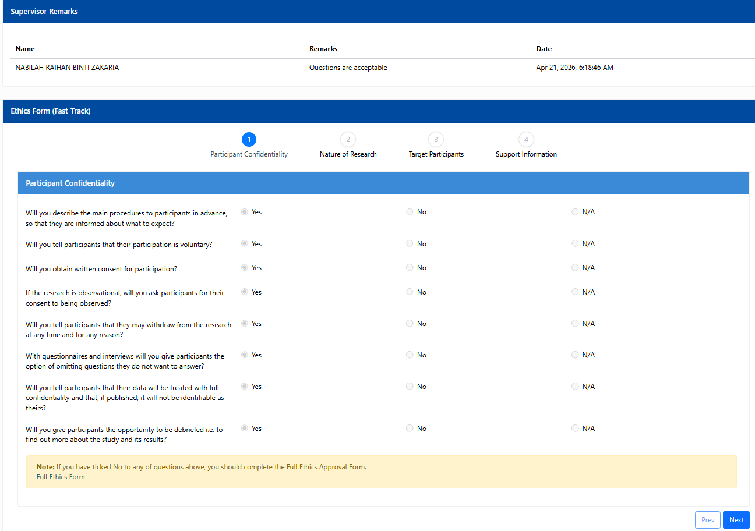
Figure 42 Ethics Form (Fast Track) Page 1

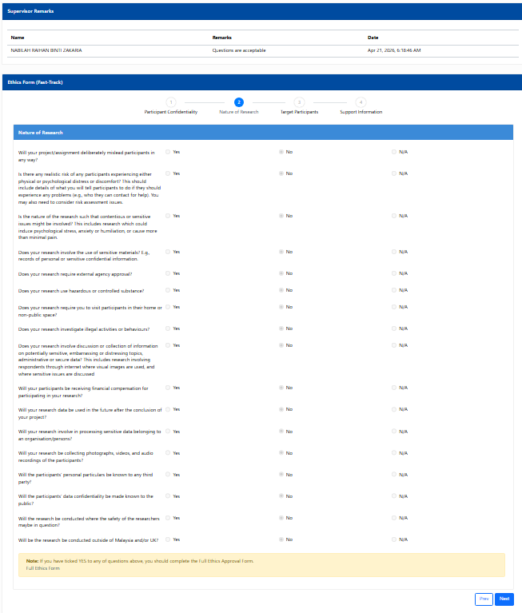
Figure 43 Ethics Form (Fast Track) Page 2

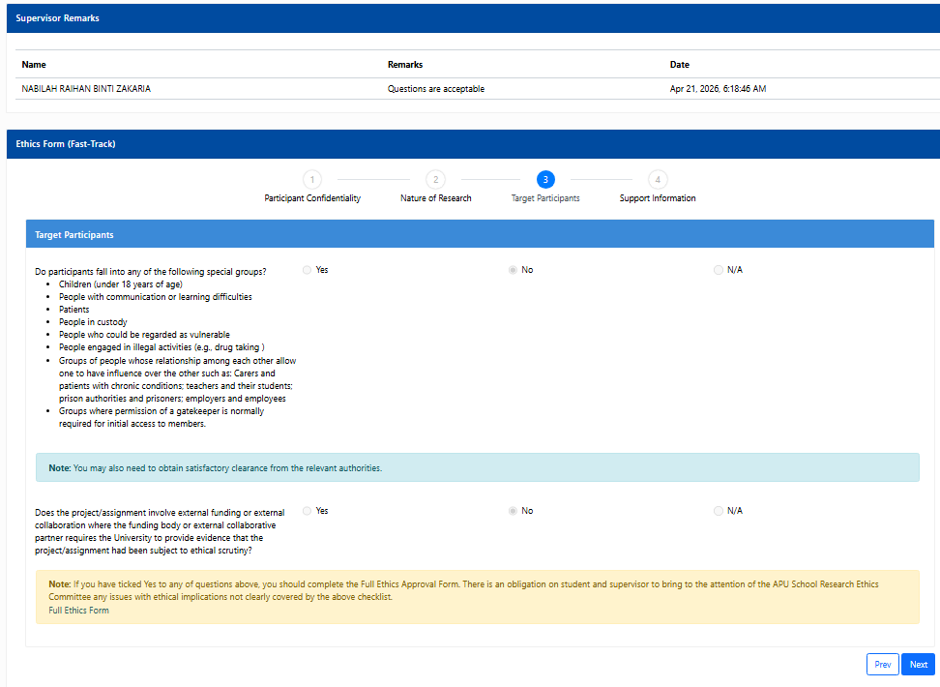
Figure 44 Ethics Form (Fast Track) Page 3

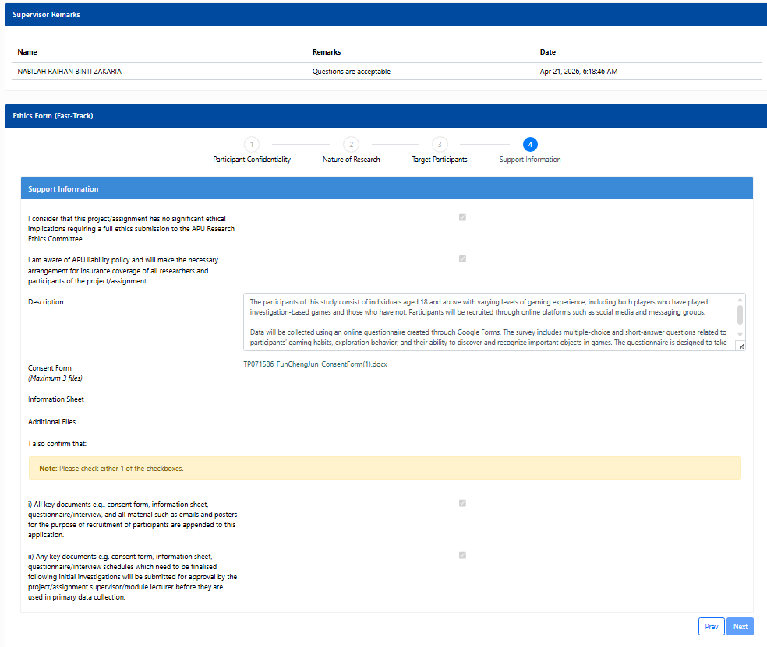
Figure 45 Ethics Form (Fast Track) Page 4

Appendix C: Log Sheet
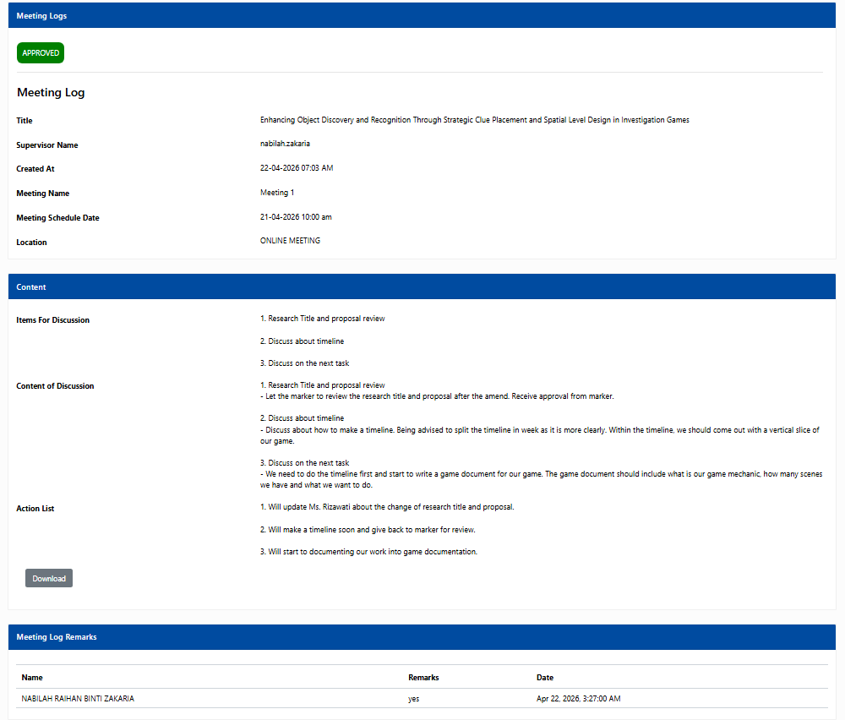
Figure 46 Meeting Log Sheet-1

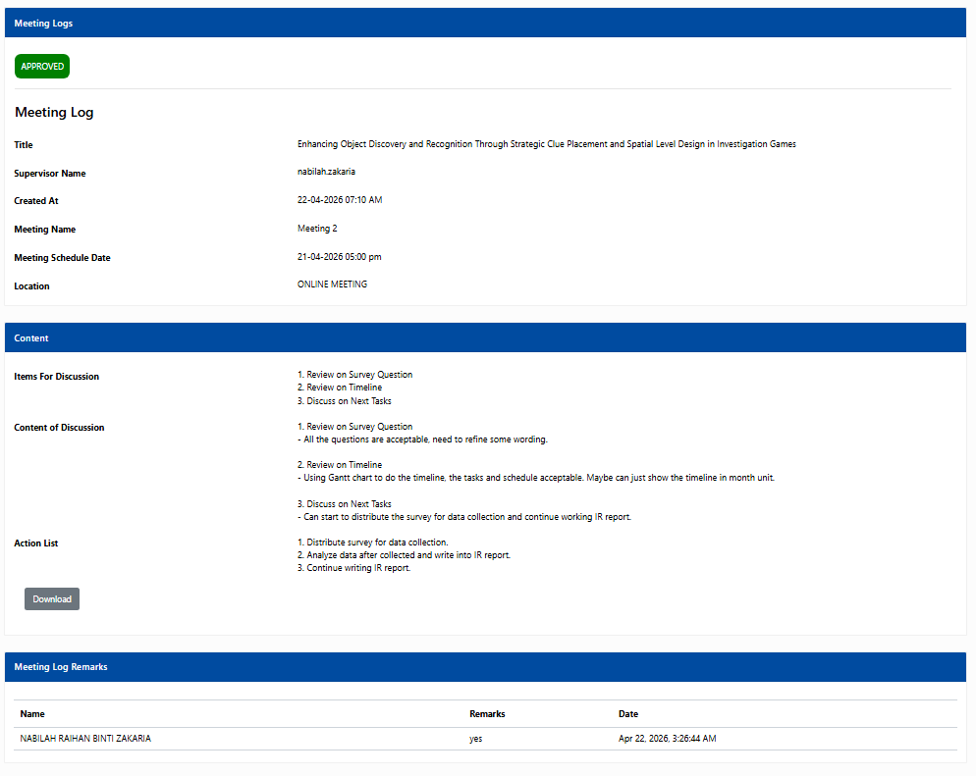
Figure 47 Meeting Log Sheet-2
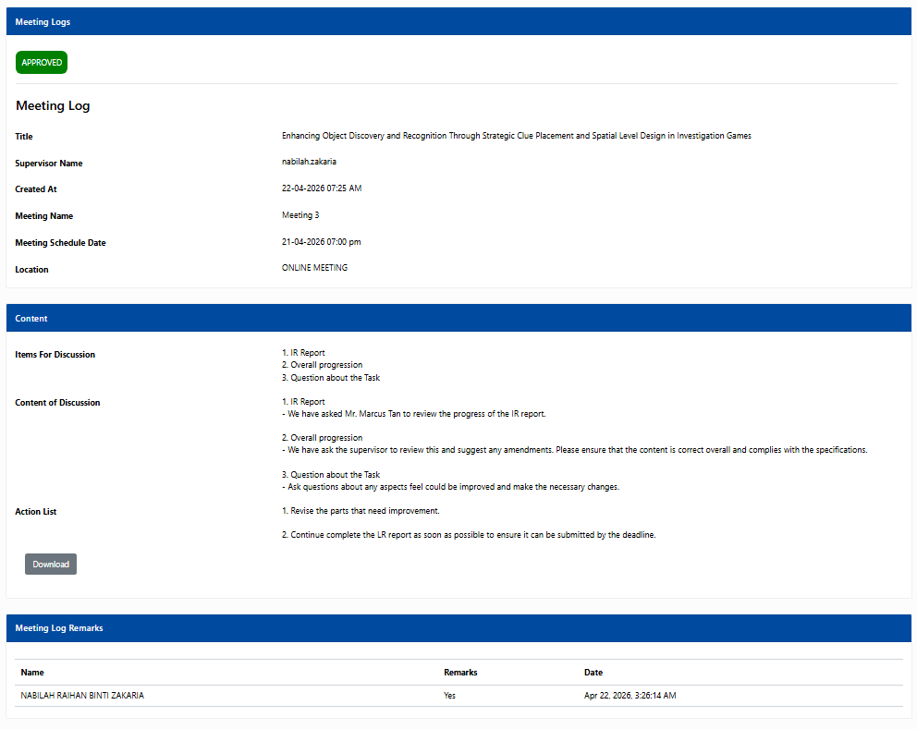
Figure 48 Meeting Log Sheet-3

Appendix D: Gantt Chart

Figure 49 Gantt Chart-1

Figure 50Gantt Chart-2

Figure 51 Gantt Chart-3

Figure 52 Gantt Chart-4

Figure 53 Gantt Chart-5

Appendix E: Respondence Demographic Profile
Table 17:Table of Respondence Demographic Profile
No. | Age Range | Gender | Gaming Frequency | Played Investigation Game
1 | 18–24 | Male | Daily | Yes
2 | 25–34 | Male | Daily | Yes
3 | 18–24 | Male | Daily | No
4 | 18–24 | Male | Daily | No
5 | 18–24 | Male | A few times a week | Yes
6 | 18–24 | Male | Several times a week | Yes
7 | 25–34 | Female | Several times a week | Yes
8 | 18–24 | Male | Daily | No
9 | 18–24 | Male | Daily | Yes
10 | 18–24 | Male | Daily | Yes
11 | 18–24 | Male | Daily | No
12 | 18–24 | Male | Daily | Yes
13 | 18–24 | Male | Daily | No
14 | 18–24 | Male | A few times a month | Yes
15 | 25–34 | Male | Daily | No
16 | 18–24 | Male | Several times a week | No
17 | 18–24 | Male | Daily | Yes
18 | 18–24 | Male | Daily | Yes
19 | 18–24 | Male | Daily | No
20 | 18–24 | Male | Daily | Yes
21 | 18–24 | Male | Daily | Yes
22 | 18–24 | Male | Daily | Yes
23 | 18–24 | Male | Daily | Yes
24 | 18–24 | Male | Daily | Yes
25 | 18–24 | Male | Daily | Yes
26 | 18–24 | Male | Daily | Yes
27 | 18–24 | Male | Daily | Yes
28 | 18–24 | Male | Daily | Yes
29 | 25–34 | Male | Daily | Yes
30 | 25–34 | Male | Daily | Yes

