**INTRODUCTION:**

A data warehouse project with IBM Cloud Db2 Warehouse is a strategic initiative that leverages IBM's cloud-based data warehousing solution. It involves integrating data from various sources, designing data models, loading historical and real-time data, and utilizing analytics and reporting tools. Scalability and performance are key features, with the flexibility to adjust resources as needed. Robust security and compliance measures are essential. Ongoing maintenance and monitoring ensure data quality and availability, and integration with other tools for advanced analytics and visualization is possible. The project's outcome is a powerful data warehousing environment that facilitates data-driven decision-making and business growth.

**ATTRIBUTES USED**

- `SELECT`: Specifies the data to retrieve.

- `*`: Selects all columns; you can specify specific columns.

- `FROM TableName`: Indicates the table to query.

- `WHERE Condition`: Filters the data based on specific conditions.

**TOOLS USED**

1. IBM Db2 Warehouse on Cloud: The core platform for data warehousing, offering scalability and high-performance analytics.

2. IBM Data Studio: A development environment for SQL, debugging, performance tuning, and database administration.

3. ETL (Extract, Transform, Load) Tools: Such as IBM InfoSphere DataStage, used for data integration, transformation, and loading from source systems to the data warehouse.

4. IBM Cognos Analytics: A business intelligence and analytics tool for creating reports, dashboards, and data visualizations to derive insights from the data warehouse.

**PURPOSE TO IMPLEMENT**

1. Data Analysis and Business Intelligence: Enable in-depth data analysis and business intelligence to make informed decisions and gain insights from historical and current data.

2. Data Integration: Consolidate data from various sources into a centralized repository to provide a unified view of the organization's information.

3. Historical Data Storage: Preserve historical data for long-term trend analysis, compliance, and auditing.

4. Performance Optimization: Optimize data retrieval and query performance for efficient access to data by users and applications.

5. Data-Driven Decision-Making: Empower organizations to make data-driven decisions, improving efficiency, competitiveness, and overall business performance.

**IMPLEMETATION PROCESS**

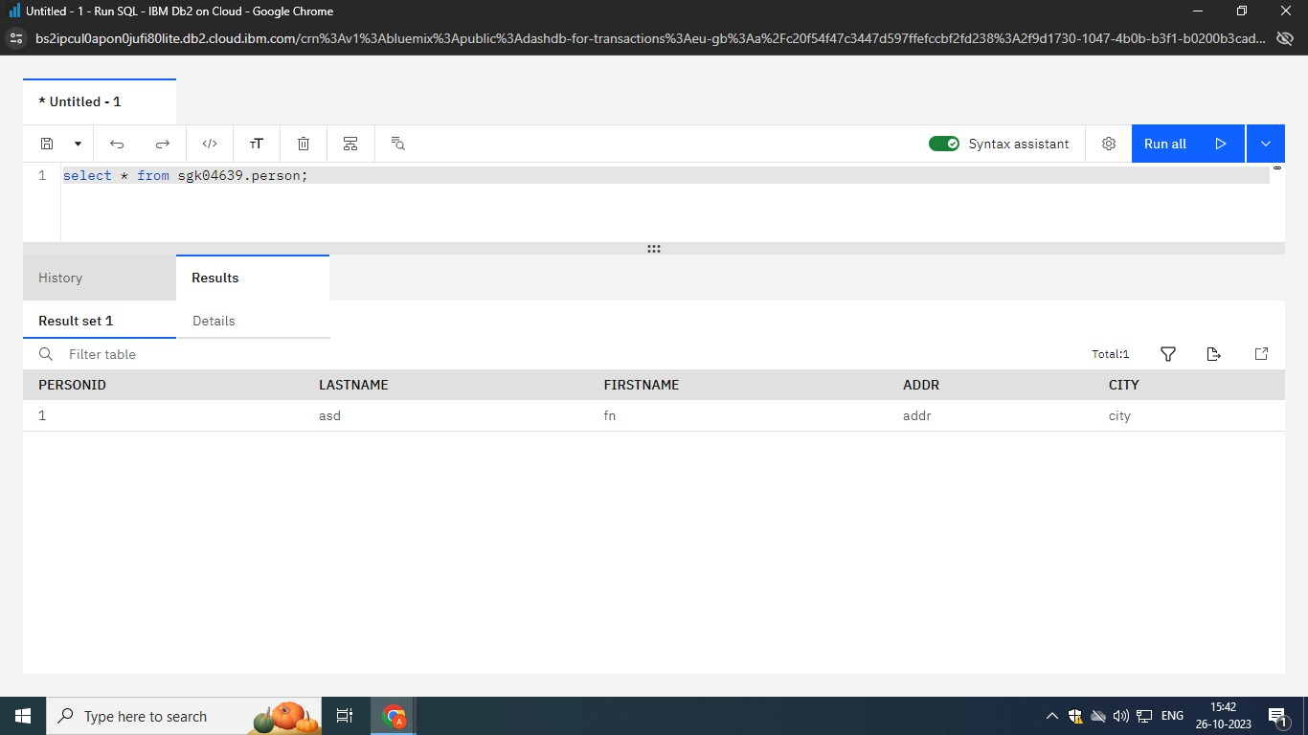

The implementation process of the provided SQL code and project encompasses several essential steps. It begins with setting up the database environment, selecting a suitable database management system (e.g., IBM Db2), and configuring the database server. The SQL code is then executed to create the database schema, defining the structure of tables such as Customers, Products, Orders, and OrderDetails. Data is populated into these tables through INSERT statements, and ETL (Extract, Transform, Load) processes may be implemented for data integration and transformation. Integration with applications and reporting tools, like IBM Cognos Analytics, is vital for data analysis and visualization. Performance tuning using tools such as IBM Db2 Performance Monitor is crucial. Data governance practices ensure data quality, security, and compliance. Backup and recovery procedures safeguard data integrity. Continuous monitoring and maintenance, along with scalability considerations, are key. Security measures protect sensitive data, and thorough documentation and training facilitate effective utilization. Regular assessments and improvements are performed to align the project with evolving business requirements, ultimately enabling data-driven decision-making and enhancing business operations.

**OUTCOMES**

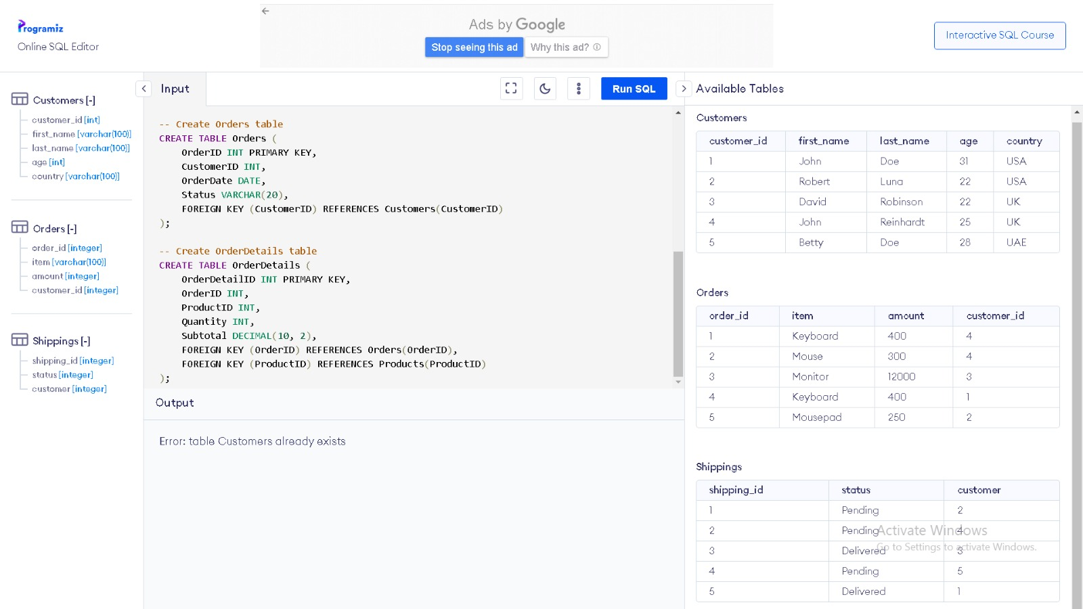

The provided SQL code creates a database schema with four tables: Customers, Products, Orders, and OrderDetails. It defines the structure of these tables with various attributes, such as customer names, product details, order information, and order details. Upon executing this code, no immediate output is generated. Instead, it establishes the framework for data storage. To see output, you'd need to execute SQL queries for tasks like inserting, querying, updating, or deleting data. The output from these queries would involve data results in rows and columns or messages indicating the success or failure of the operations. In summary, this code initializes the database structure, and actual output depends on subsequent interactions with the database using SQL commands.

**CONCLUSION**

In conclusion, the SQL code and associated data warehousing project establish a structured foundation for effective data management. The project enables data integration from various sources, promoting data consolidation and unification. It empowers data-driven decision-making by offering insights from historical and real-time data. Robust data governance and security measures ensure data quality, privacy, and regulatory compliance. The project optimizes query performance and resource utilization for efficient data access. Its ongoing nature, with monitoring and scalability, ensures adaptability to evolving data needs. In essence, this project supports informed decision-making, operational efficiency, and business success in a data-driven environment.