ComicCraft - AI Comic Story Creator using Gemini Models
Project Topic: The Dragon in Our School
Project Documentation

1. AIM
To create a creative digital comic titled “The Dragon in Our School” using ComicCraft by combining characters, backgrounds, dialogues, and different scenes to present an interesting and meaningful story.

2. ALGORITHM
- Start the ComicCraft application and create a new comic project.
- Select a suitable comic template or layout for presenting the story.
- Choose a suitable school background for the opening scene.
- Create the main characters required for the story, including students, teachers, and the dragon.
- Introduce the main characters and establish the school environment in the first scene.
- Develop the beginning of the story by showing an unusual event occurring in the school.
- Introduce the dragon into the school and show how the students notice its presence.
- Add appropriate dialogues and speech bubbles to communicate the characters’ thoughts, feelings, and conversations.
- Show the students’ reactions to the unexpected appearance of the dragon.
- Develop the main problem or conflict between the situation at the school and the presence of the dragon.
- Arrange the characters and backgrounds properly in each comic panel so that the story is easy to understand.
- Continue the storyline by showing the students trying to understand the dragon instead of immediately treating it as a threat.
- Add suitable actions, expressions, dialogues, and scenes to make the story interesting and meaningful.
- Develop the story towards the climax, where the main problem involving the dragon is addressed.
- Provide a suitable solution to the problem and show how the characters resolve the situation.
- Create the final scene with a positive and meaningful ending.
- Check the complete comic for proper scene order, character placement, dialogues, spelling, backgrounds, and visual consistency.
- Make necessary corrections and improvements to the comic.
- Save the completed project in ComicCraft.
- Export or present the final comic as the completed project.
- Stop.
FLOWCHART
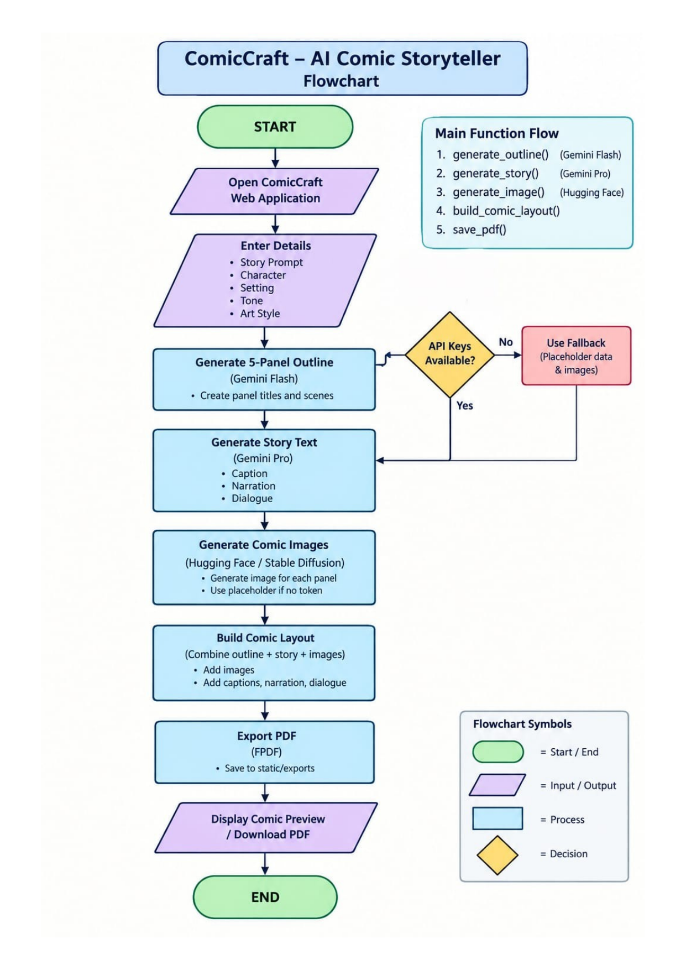
Figure: ComicCraft project flowchart.

3. PROJECT DESCRIPTION
ComicCraft is a web-based AI comic storytelling application developed in Python using FastAPI. The project converts a user's story idea into a structured five-panel comic. For the sample project, the selected story is “The Dragon in Our School”. The application combines AI-generated story planning, narration and dialogue, comic-style image generation, panel organization, web preview, and PDF export into one workflow.
The application is divided into small modules so that each stage of comic generation has a clear responsibility. The FastAPI backend receives the input and coordinates the modules. The Gemini Flash workflow creates the structured panel outline, the Gemini Pro workflow expands the outline into narration and dialogue, the image generation module creates panel illustrations, the layout builder combines the information, and the exporter creates the final PDF.

4. PROJECT OBJECTIVES
- Accept a story idea and related comic preferences through a web interface.
- Generate a structured five-panel comic outline.
- Generate panel narration, captions, and dialogue.
- Create comic-style illustrations for the panels using the configured Hugging Face image-generation workflow.
- Combine text and images into a consistent five-panel layout.
- Display the generated comic through a web preview.
- Export the completed comic as a PDF.

5. PROJECT WORKFLOW
- User enters the story prompt and comic details.
- FastAPI receives and validates the input.
- Gemini Flash generates the five-panel outline.
- Gemini Pro expands the outline into narration and dialogue.
- Image generation creates an illustration for each panel.
- layout_builder.py matches panel information with the generated images.
- exporters.py creates the PDF output.
- The preview page displays the completed comic and the user can download the PDF.
Input | Outline | Story | Images | Layout | PDF | Output
Story details
 | Gemini Flash
 |  | Gemini Pro
 |  |  | Hugging Face
 |  |  |  | Layout Builder
 |  |  |  |  | FPDF
 |  |  |  |  |  | Comic preview

6. SYSTEM ARCHITECTURE
The project follows a modular FastAPI architecture. The application entry point is app/main.py. Routing and orchestration are handled by app/routes.py. AI and processing functions are separated into individual Python modules, while HTML templates and CSS provide the web interface.
- Frontend: HTML templates with Jinja2 and static CSS/JavaScript.
- Backend: FastAPI with Uvicorn.
- Story outline: gemini_flash.py.
- Story narration and dialogue: gemini_pro.py.
- Image generation: image_generator.py.
- Panel mapping: layout_builder.py.
- PDF export: exporters.py.
- Static assets: static/panels and static/exports.
- Configuration/dependencies: .env and requirements.txt.

7. MODULE DESCRIPTION
main.py – Creates the FastAPI application, mounts the static directory, includes the router, and provides a health endpoint.
routes.py – Coordinates user input, comic generation, image generation, layout creation, PDF export, preview rendering, and related API routes.
gemini_flash.py – Generates the structured five-panel outline from the story prompt.
gemini_pro.py – Expands the panel outline into narration, captions, and character dialogue.
image_generator.py – Creates or retrieves the panel illustration according to the configured Hugging Face image-generation workflow and stores the image path.
layout_builder.py – Maps outline panels to story panels and image paths and builds the final five-panel layout.
exporters.py – Creates the downloadable PDF containing the comic images and associated text.
index.html / comic_preview.html / export_success.html – Provide the input, preview, and export-success web pages.
style.css – Controls the visual presentation of the ComicCraft web interface.
Coding files supplied for this project include main.py, routes.py, exporters.py, gemini_flash.py, gemini_pro.py, image_generator.py, layout_builder.py, and the frontend files. The complete source text included in this document is limited to the files actually supplied as editable code files; the remaining supplied implementations are represented by their original VS Code screenshots.

8. FASTAPI ROUTES AND PROCESSING
- / : loads the ComicCraft input page.
- /generate : accepts the form input and runs the complete comic-generation workflow.
- /generate-comic/json : accepts structured JSON input and returns comic layout information and the generated PDF path.
- /test-image : provides a direct image-generation test route.
- /export-success : displays the successful export/download page.
- /health : returns {'status': 'ok'} to confirm that the application is running.
The main generation route coordinates generate_outline(), generate_story(), generate_image(), build_comic_layout(), and save_pdf() in sequence. Error handling is performed around the generation workflow so that failures can be returned as appropriate HTTP responses.

9. DEVELOPMENT ENVIRONMENT
The project uses a Python virtual environment and the dependencies listed in requirements.txt.
Installation and run commands
python -m venv env
env\Scripts\activate
pip install -r requirements.txt
uvicorn app.main:app --reload
The requirements file used by the project includes FastAPI, Uvicorn, Jinja2, python-multipart, google-generativeai, huggingface-hub, Pillow, fpdf2, pydantic and python-dotenv.

10. PROJECT FOLDER STRUCTURE
Current project structure
ComicCraft/
├── app/
│ ├── __init__.py
│ ├── main.py
│ ├── routes.py
│ ├── gemini_flash.py
│ ├── gemini_pro.py
│ ├── image_generator.py
│ ├── layout_builder.py
│ └── exporters.py
├── static/
│ ├── panels/
│ └── exports/
├── templates/
│ ├── index.html
│ ├── comic_preview.html
│ └── export_success.html
├── .env
├── requirements.txt
└── env/

11. PROJECT IMPLEMENTATION / CODING
app/main.py
from fastapi import FastAPI
from fastapi.staticfiles import StaticFiles
from .routes import router

app = FastAPI(title="ComicCraft - AI Comic Storyteller", version="1.0.0")
app.mount("/static", StaticFiles(directory="static"), name="static")
app.include_router(router)

@app.get("/health")
def health():
return {"status": "ok"}
app/layout_builder.py
def build_comic_layout(outline, story, image_paths):
story_map = {p["panel"]: p for p in story.get("panels", [])}
layout = []

for p in outline.get("panels", [])[:5]:
s = story_map.get(p["panel"], {})
layout.append({
"panel": p["panel"],
"title": p["title"],
"scene": p["scene"],
"image": image_paths[p["panel"] - 1],
"caption": s.get("caption", p["title"]),
"narration": s.get("narration", p["scene"]),
"dialogue": s.get("dialogue", "")
})

return layout
The remaining modules follow the same modular design: routes.py coordinates the workflow, gemini_flash.py and gemini_pro.py handle the text-generation stages, image_generator.py handles illustration generation, and exporters.py creates the PDF.
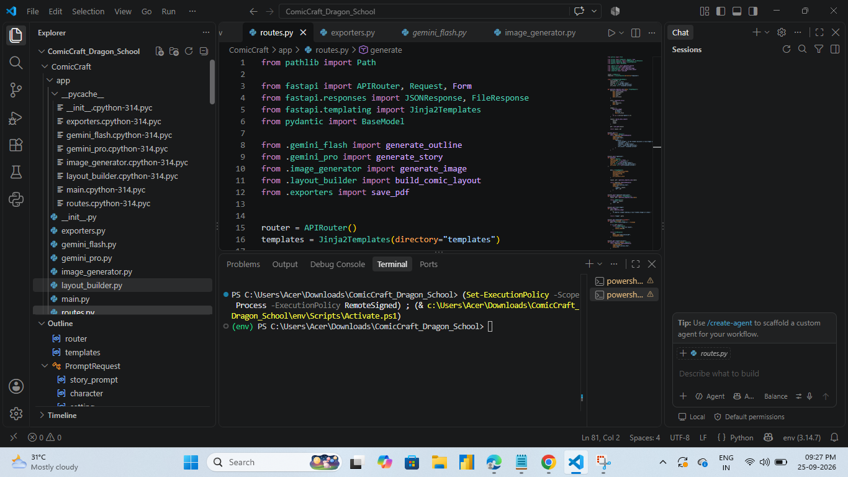
Figure: Current ComicCraft implementation and project execution in VS Code.
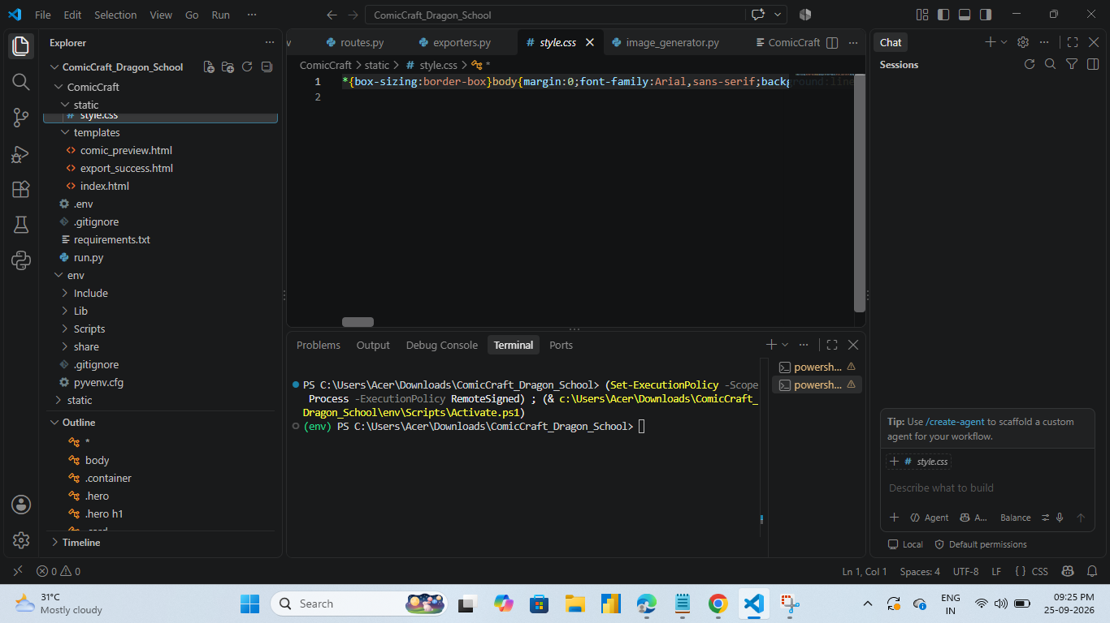
Figure: Current project files and code execution in VS Code.

11A. ACTUAL PROJECT CODING SUPPLIED
The following implementation material is taken from the project files supplied for this documentation. Only the code and screenshots actually provided for the current ComicCraft project are included here.
main.py
from fastapi import FastAPI
from fastapi.staticfiles import StaticFiles
from .routes import router

app = FastAPI(title="ComicCraft - AI Comic Storyteller", version="1.0.0")
app.mount("/static", StaticFiles(directory="static"), name="static")
app.include_router(router)

@app.get("/health")
def health():
return {"status": "ok"}
layout_builder.py
def build_comic_layout(outline, story, image_paths):
story_map = {p["panel"]: p for p in story.get("panels", [])}
layout = []
for p in outline.get("panels", [])[:5]:
s = story_map.get(p["panel"], {})
layout.append({"panel": p["panel"], "title": p["title"], "scene": p["scene"], "image": image_paths[p["panel"]-1], "caption": s.get("caption", p["title"]), "narration": s.get("narration", p["scene"]), "dialogue": s.get("dialogue", "")})
return layout
exporters.py
from pathlib import Path
from datetime import datetime
from fpdf import FPDF

OUT = Path("static/exports")
OUT.mkdir(parents=True, exist_ok=True)

def safe(text):
"""Convert text to PDF-safe Latin-1 text."""
text = str(text or "")

# Replace problematic Unicode characters
replacements = {
"\u2018": "'",
"\u2019": "'",
"\u201c": '"',
"\u201d": '"',
"\u2013": "-",
"\u2014": "-",
"\u2026": "...",
"\u00a0": " ",
"\u2022": "-",
}

for old, new in replacements.items():
text = text.replace(old, new)

return text.encode("latin-1", "replace").decode("latin-1")

def clean_text(text):
"""Prevent FPDF errors caused by extremely long words."""
text = safe(text)

words = text.split()
fixed_words = []

for word in words:
# Break extremely long words into smaller pieces
if len(word) > 40:
chunks = [
word[i:i + 35]
for i in range(0, len(word), 35)
]
fixed_words.append(" ".join(chunks))
else:
fixed_words.append(word)

return " ".join(fixed_words)

def write_text(pdf, text, font_style="", font_size=11, height=6):
"""Safely write wrapped text to the PDF."""
text = clean_text(text)

if not text.strip():
return

pdf.set_font("Helvetica", font_style, font_size)

# Explicit width prevents FPDF horizontal-space errors
pdf.multi_cell(
w=180,
h=height,
text=text,
align="L"
)

def save_pdf(layout):
filename = f"comic_{datetime.now().strftime('%Y%m%d_%H%M%S')}.pdf"
path = OUT / filename

pdf = FPDF(
orientation="P",
unit="mm",
format="A4"
)

pdf.set_auto_page_break(auto=True, margin=15)

for panel in layout:
pdf.add_page()

# Title
pdf.set_xy(15, 15)
write_text(
pdf,
panel.get("title", "Comic Panel"),
font_style="B",
font_size=18,
height=9
)

# Image
image_path = panel.get("image")

if image_path and Path(image_path).exists():
try:
pdf.image(
image_path,
x=15,
y=38,
w=180
)
except Exception:
pass

# Put text in a safe area near bottom
pdf.set_xy(15, 225)

write_text(
pdf,
panel.get("caption", ""),
font_style="B",
font_size=12,
height=7
)

write_text(
pdf,
panel.get("narration", ""),
font_style="",
font_size=10,
height=6
)

dialogue = panel.get("dialogue")

if dialogue:
pdf.ln(2)

write_text(
pdf,
dialogue,
font_style="I",
font_size=10,
height=6
)

pdf.output(str(path))

return filename
The routes.py, requirements.txt, exporters.py and style.css implementations are also documented with the original VS Code screenshots supplied with the project.
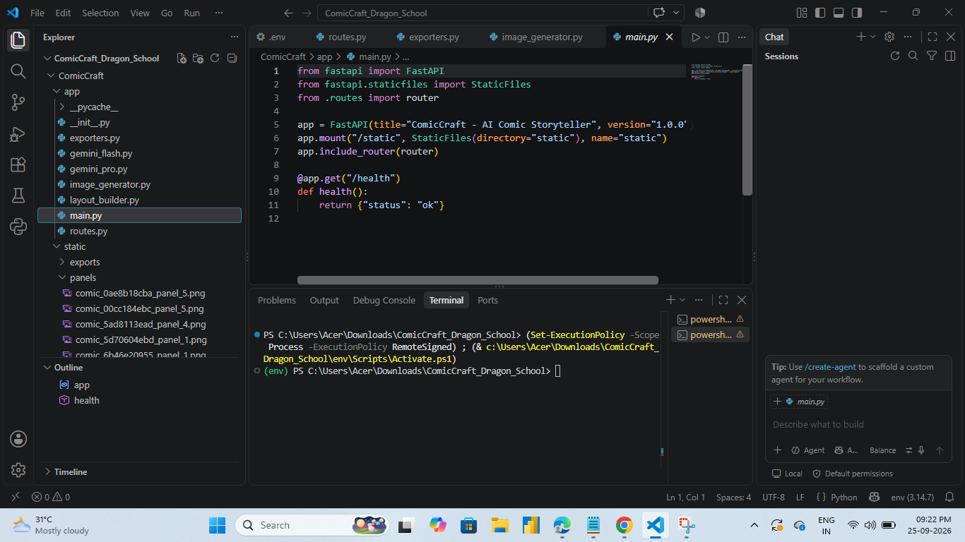
Figure: main.py - FastAPI application entry point
Figure: routes.py - comic generation route and module imports
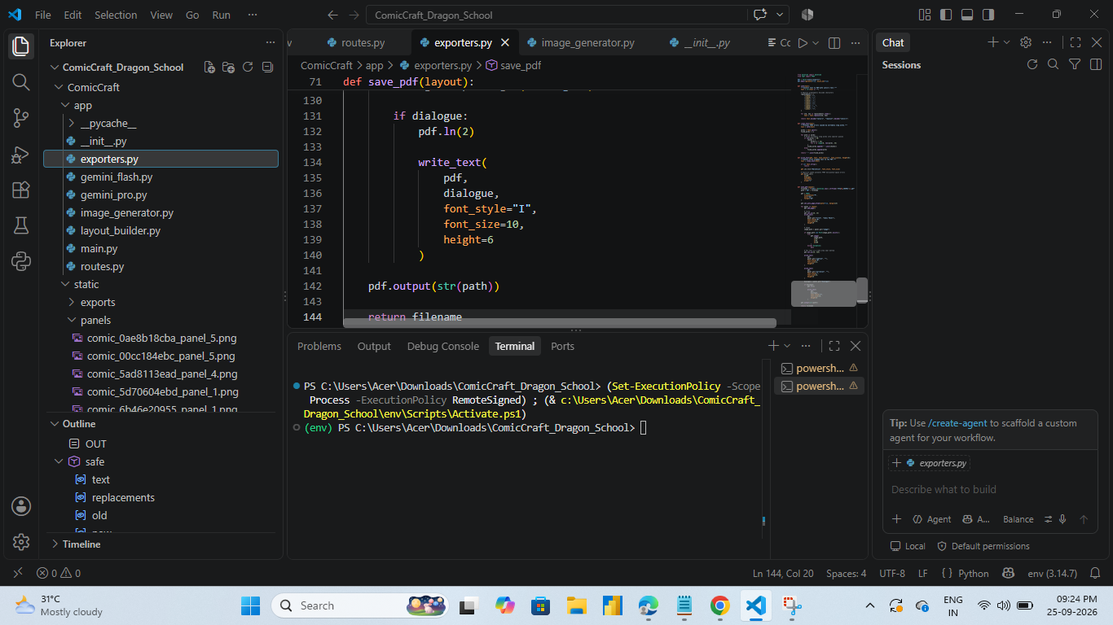
Figure: exporters.py - PDF export implementation
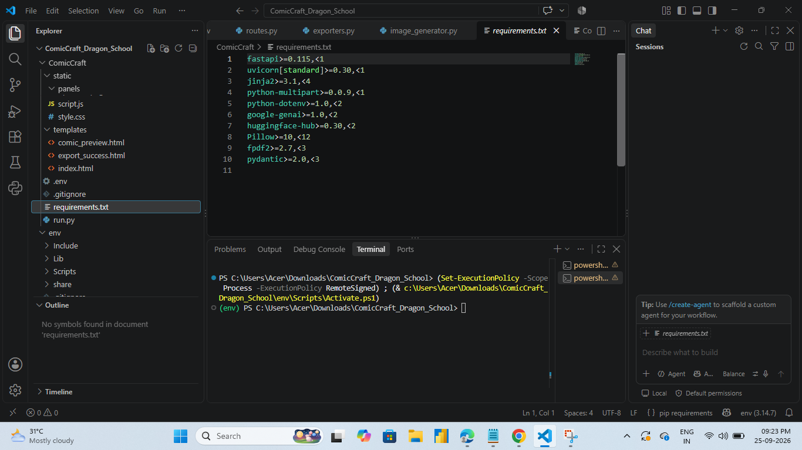
Figure: requirements.txt - project dependencies
Figure: style.css - frontend styling
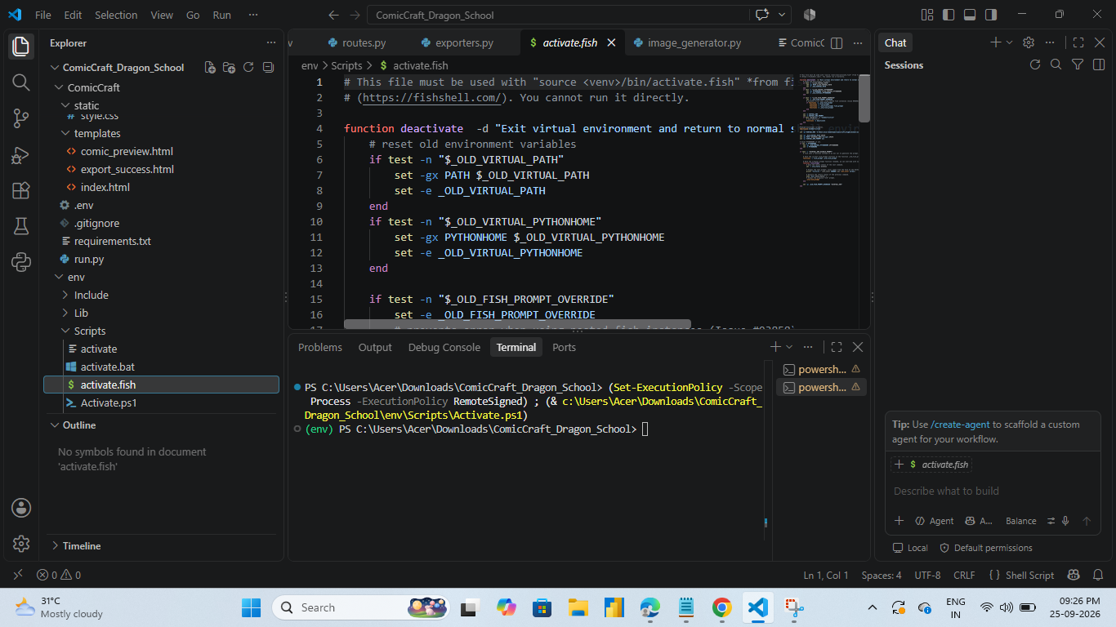
Figure: Virtual-environment execution in VS Code

12. USER INTERFACE
- index.html provides the comic-generation input form.
- comic_preview.html displays the generated panels and associated story text.
- export_success.html confirms successful comic export.
- style.css provides the visual styling for the web pages.
- Static panel images are stored under static/panels and generated PDF files under static/exports.

13. SAMPLE COMIC: THE DRAGON IN OUR SCHOOL
The project demonstrates the ComicCraft workflow using the sample story “The Dragon in Our School”. The story is organized as five panels so that the AI-generated outline, story text, illustrations, layout and PDF export can be demonstrated through a complete end-to-end run.
- Panel 1 – The Unexpected Bell: Ari arrives at Dragon School and a mysterious bell rings before class begins.
- Panel 2 – The Smallest Dragon: Ari meets a small dragon in the school environment.
- Panel 3 – The Teamwork Test: Ari and the dragon work together during a school activity.
- Panel 4 – A Different Kind of Friend: the story develops the friendship between the student and dragon.
- Panel 5 – The Dragon’s Special Power: the final panel presents the dragon and its special ability.

14. OUTPUT AND PDF EXPORT
Actual project output images supplied with the project are included below as Panels 1–5. No old fox-comic output is used in this output section.
After the five panels are generated, build_comic_layout() creates the final panel data structure. The exporter then places the comic content into a PDF. The generated PDF is stored in the project's static/exports directory and can be accessed from the web application's export flow.
The final output consists of a five-panel comic containing panel images together with the corresponding titles, scenes, captions, narration and dialogue.
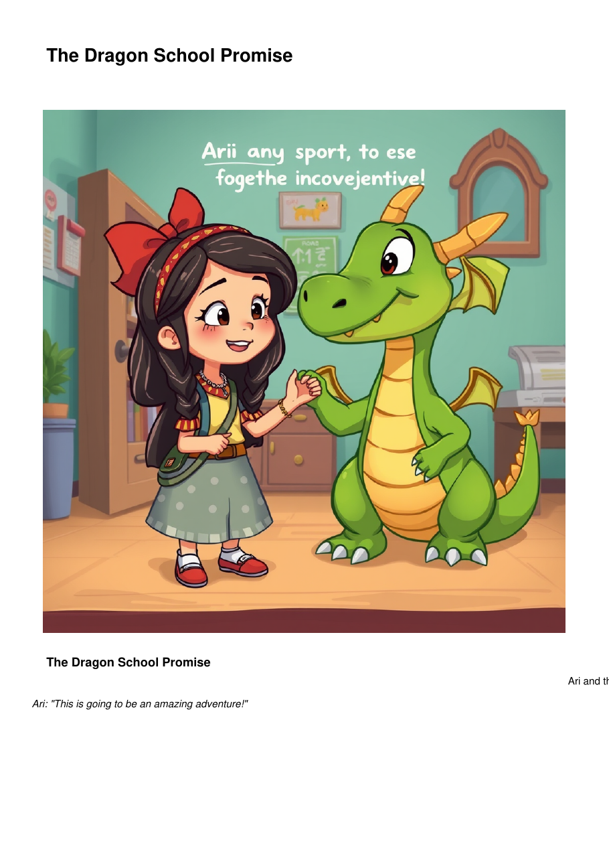
Panel 5 – The Dragon’s Special Power
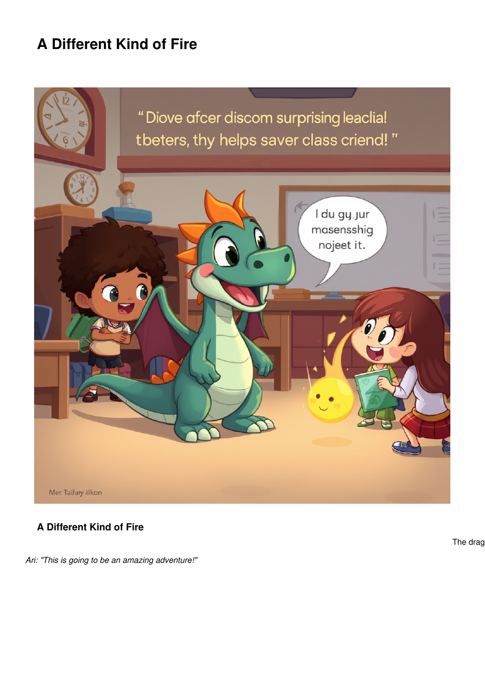
Panel 4 – A Different Kind of Friend
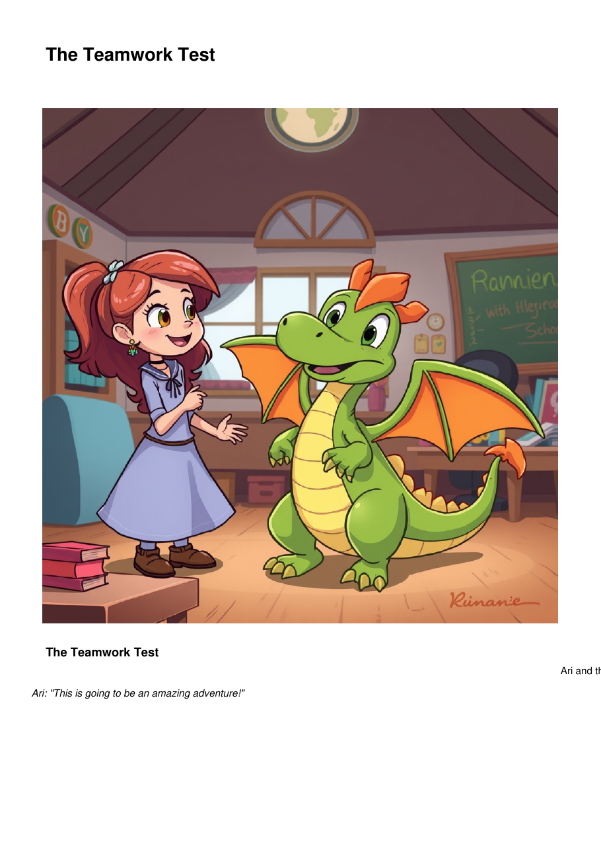
Panel 3 – The Teamwork Test: Ari and the dragon work together during a school activity.
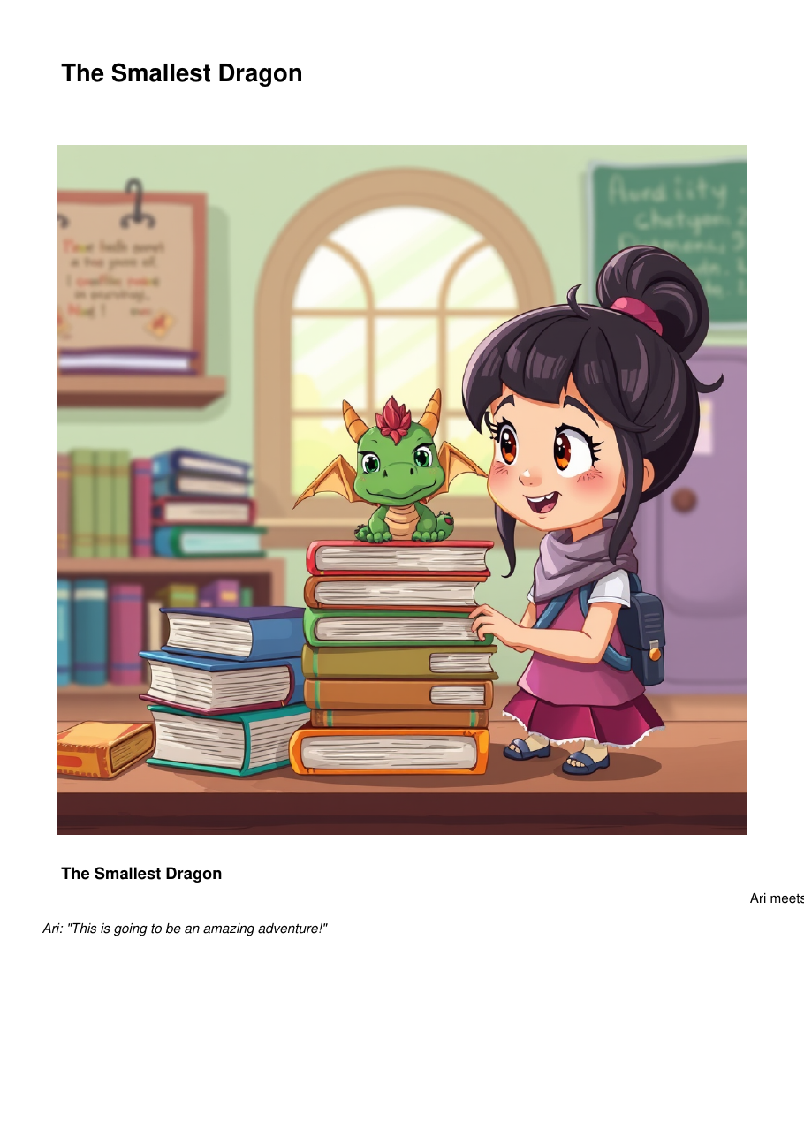
Panel 2 – The Smallest Dragon: Ari meets a small dragon in the school environment.
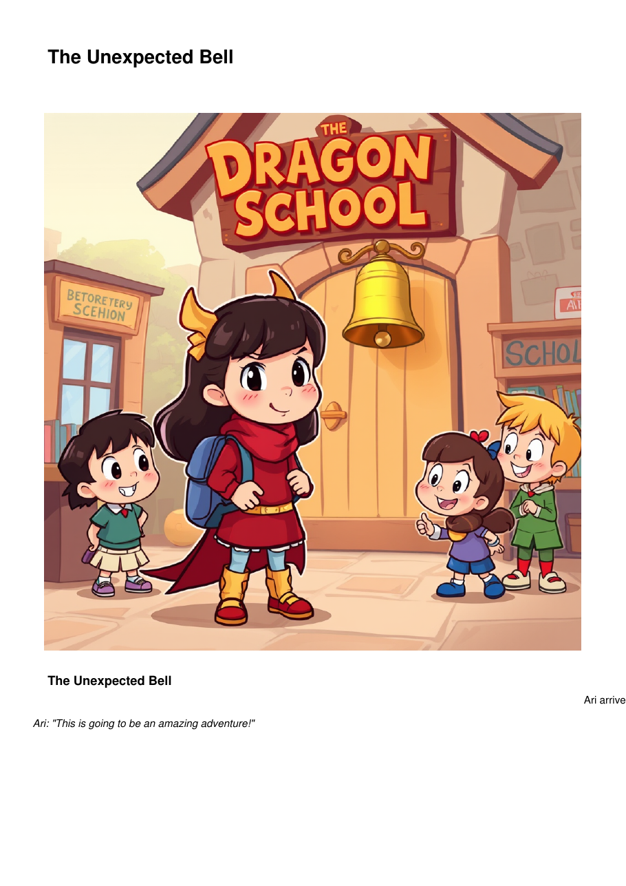
Panel 1 – The Unexpected Bell: Ari arrives at Dragon School and a mysterious bell rings before class begins.
These five images are the actual Dragon School comic output supplied with the project. They are included as the project's final visual output rather than the sample fox-comic images from the earlier documentation.

15. TESTING AND VERIFICATION
- Application startup: verified through the FastAPI application and /health endpoint.
- Input processing: story and comic preference fields are received by the backend.
- Outline generation: the workflow produces a maximum of five structured panels.
- Story generation: each panel is associated with narration/caption/dialogue data.
- Image generation: generated image paths are passed into the layout builder.
- Layout verification: panel numbers are matched between outline and story data.
- PDF export: the final layout is passed to save_pdf() and stored under static/exports.
- Frontend verification: the generated content is rendered through the comic preview template.

16. KEY FEATURES
- AI-assisted comic story generation.
- Five-panel structured storytelling.
- Separate story-outline and narration stages.
- AI-assisted comic illustration generation.
- Automatic panel-to-story mapping.
- Browser-based comic preview.
- PDF export for saving and sharing.
- Modular Python/FastAPI implementation.
- Fallback handling can support demonstration when configured AI services are unavailable.

17. CONCLUSION
ComicCraft demonstrates an end-to-end AI-assisted comic creation workflow in which a story idea is converted into structured panels, narration, dialogue, illustrations, and a downloadable PDF. The FastAPI backend coordinates the complete process while the individual modules keep story generation, image generation, layout building, and PDF export separate and manageable.
Using “The Dragon in Our School” as the project story, the application shows how a simple creative idea can be transformed into a five-panel digital comic through a web interface. The project provides a practical example of integrating generative AI with Python web development and document generation.

18. FUTURE ENHANCEMENTS
- Support longer multi-page comic stories.
- Allow users to regenerate an individual panel without recreating the whole comic.
- Add persistent comic libraries for saved projects.
- Provide more export formats and page-layout choices.
- Add stronger character-consistency controls across generated images.

