**Spam email detection for banking sector using finite Automata (DFA)**

Name: Shaik Mahaboob Subhani Rumaan

Reg No: 192225048

Name: Maram Manodhar

Reg No: 192125098

**Aim:** The aim of this study is to develop and implement a robust spam email detection system tailored for the banking sector using Deterministic Finite Automata (DFA), enhancing cybersecurity defenses and protecting sensitive financial information.

**ABSTRACT:**

In the era of digital banking, spam email poses a significant threat to financial institutions and their clients, leading to potential data breaches and financial losses. This capstone project aims to develop a robust spam email detection system specifically tailored for the banking sector using Deterministic Finite Automata (DFA). By leveraging the principles of automata theory, the project will design and implement a DFA model that accurately classifies emails as spam or legitimate based on predefined patterns and characteristics unique to banking-related communications. The project involves analyzing common features of spam emails targeting the banking sector, designing a DFA that encapsulates these features for efficient detection, implementing the DFA in a practical email filtering system, and testing the system with real-world email datasets to evaluate its effectiveness and accuracy. The DFA model will be optimized for minimal computational overhead, ensuring quick processing of large volumes of emails without compromising accuracy. Additionally, the project will explore integrating the DFA-based system with existing email infrastructure in banks, providing seamless deployment and operation. The expected outcome is a high-precision, low-false-positive email filtering tool that enhances the cybersecurity measures of banking institutions. This project will not only demonstrate the practical application of theoretical concepts from the Theory of Computation but also contribute to safeguarding sensitive financial information in the digital age. Through this work, we aim to set a new standard for email security in the banking industry, providing a scalable and effective solution to the persistent problem of spam.

**INTRODUCTION:**

Spam emails represent a significant and persistent threat in today's digital age, particularly within the highly sensitive environment of the banking sector. These malicious emails are often crafted by cybercriminals to exploit vulnerabilities in email communication systems, targeting financial institutions with sophisticated phishing attacks, fraudulent schemes, and malware distribution. Such activities can result in devastating consequences, including unauthorized access to sensitive financial data, substantial financial losses, and severe damage to an institution's reputation and customer trust. Given these risks, developing effective methods to detect and filter spam emails is paramount for maintaining the security and integrity of banking operations. By implementing robust email filtering solutions, banks can significantly mitigate the risk of cyber threats, safeguarding both their own assets and the confidential information of their clients. These efforts not only protect against immediate financial losses but also uphold the trust and confidence of customers in the institution's ability to secure their sensitive data. In an era where digital threats continue to evolve, proactive measures like advanced spam detection systems are essential for ensuring a resilient defense posture against cyberattacks within the financial sector.Automata Theory and Its Relevance.

This capstone project addresses this critical need by proposing a novel approach to spam email detection using Deterministic Finite Automata (DFA). Automata theory, a branch of theoretical computer science, studies abstract machines and the problems they can solve. A finite automaton is a mathematical model of computation that represents a machine with a finite number of states, transitions between those states, and the ability to process input strings of symbols. DFAs, a specific type of finite automaton, operate deterministically, meaning that for each state and input symbol, there is exactly one transition to a subsequent state.

**Advantages of Using DFA for Spam Detection**

The rationale behind using DFA lies in its deterministic nature, which ensures predictable and reliable performance. DFAs are particularly well-suited for recognizing patterns and sequences within data streams, making them an ideal tool for identifying common characteristics of spam emails. Unlike more complex machine learning models, DFAs can be designed to operate with minimal computational resources, allowing for real-time email filtering without significant overhead.

**Project Aim and Objectives**

The aim of this project is to develop a DFA-based spam email detection system tailored to the unique needs of the banking sector. The project involves several key steps: analyzing common features of spam emails targeting financial institutions, designing a DFA that encapsulates these features, implementing the DFA in a practical email filtering system, and rigorously testing the system with real-world email datasets to evaluate its effectiveness and accuracy.

**Expected Contributions**

Through this innovative approach, we seek to enhance the cybersecurity defenses of banking institutions, providing a scalable and low-cost solution to combat the ever-evolving threat of spam emails. This project not only underscores the practical applications of theoretical computer science concepts but also aims to contribute to the broader efforts in securing digital communication channels in the financial sector. By leveraging the principles of automata theory, we strive to create a highly accurate and efficient tool for safeguarding sensitive financial information in the digital age.

**Enhancing Security Measures Through DFA Technology**

This emphasizes the application of Finite Automata (DFA) technology within the banking sector to significantly enhance security measures. DFA, a fundamental concept in automata theory, is leveraged to develop robust spam detection systems tailored specifically for financial institutions. By utilizing DFA, the project aims to automate the identification and prevention of spam and fraudulent activities in banking transactions. The implementation of DFA technology not only improves the efficiency of spam detection processes but also enhances overall cybersecurity protocols, ensuring safer and more secure financial operations.

**Automated Spam Detection in Banking Systems**

Focuses on employing Finite Automata (DFA) technology to create automated systems for identifying and mitigating spam within financial transactions. This approach aims to enhance the security and integrity of banking operations by leveraging DFA's ability to efficiently recognize patterns indicative of spam or fraudulent activities. The project aims to develop robust algorithms and frameworks that integrate seamlessly into banking systems, thereby reducing manual intervention and improving response times to potential threats. By automating spam detection processes, financial institutions can bolster their defences against malicious activities, ensuring safer and more reliable banking experiences for customers.

**Utilizing DFA for Fraud Prevention in Financial Institutions**

Underscores the application of Finite Automata (DFA) technology to strengthen fraud prevention measures within financial institutions. DFA is utilized to develop sophisticated algorithms capable of detecting and mitigating fraudulent activities in real-time financial transactions. By analyzing transactional patterns and identifying anomalies indicative of fraud, the project aims to enhance the security and trustworthiness of financial operations. Implementing DFA-based solutions enables proactive monitoring and immediate response to potential threats, thereby safeguarding assets and maintaining customer confidence. This approach not only enhances operational efficiency but also reinforces the institution's reputation for integrity and reliability in financial services.

**Advanced Computational Techniques for Banking Security**

Explores the application of advanced computational methods, including Finite Automata (DFA), to fortify security measures within the banking sector. This subtitle highlights the project's focus on leveraging cutting-edge algorithms and techniques to enhance the detection and prevention of security threats, such as fraud and spam, in financial transactions. By integrating DFA technology, the project aims to develop robust frameworks that can automatically analyze transactional data, identify suspicious patterns, and mitigate risks in real-time. These advanced computational techniques not only improve the efficiency of security operations but also contribute to maintaining the confidentiality, integrity, and availability of banking systems. The project endeavors to set a new standard in banking security by harnessing the power of computational methods to address emerging threats and ensure a secure financial environment for all stakeholders.

**Efficient Detection of Malicious Activities in Financial Transactions**

Focuses on implementing efficient strategies, including the use of Finite Automata (DFA), to detect and prevent malicious activities within financial transactions. This subtitle underscores the project's objective to enhance the security and reliability of financial systems by developing automated detection mechanisms capable of swiftly identifying suspicious behaviors and potential fraud. By leveraging DFA technology, the project aims to streamline the analysis of transactional data, enabling proactive monitoring and rapid response to anomalies. These efforts are designed to minimize financial losses, protect customer assets, and uphold the trust and reputation of financial institutions. Through the integration of advanced detection techniques, the project seeks to establish a robust framework that ensures the integrity and resilience of financial transactions against evolving threats.

**Working of Finite Automata (DFA) in Spam detection of Banking Sector**

**States:** Define states that represent different stages of processing a sequence of input characters (such as transactions or messages).

**Inputs:** Specify inputs (symbols) that represent characters or patterns within the transaction data, which can include text, numerical data, or any structured information relevant to spam detection.

**Initial State:** Determine the starting state where the DFA begins its processing.

**Accepting States:** Identify states that indicate a valid or legitimate transaction (non-spam).

**Transition Function:**

* Define a transition function that maps each state and input symbol to a new state.
* This function dictates how the DFA transitions between states based on the current state and the input it receives.

**Processing Input:**

* Process each input character or sequence of characters (e.g., words, phrases) from the transaction data sequentially.
* Use the transition function to move between states based on the received inputs.

**Determining Acceptance:**

* Once all inputs are processed, determine if the final state of the DFA is an accepting state.
* If the DFA ends in an accepting state, the transaction or message is classified as legitimate (non-spam).
* If the DFA ends in a non-accepting state, the transaction is flagged as potentially spam or fraudulent.

**Implementation Considerations:**

* Pattern Recognition: Design the DFA to recognize specific patterns or sequences of inputs that typically indicate spam or fraudulent activity.
* Real-time Processing: Implement the DFA to operate efficiently in real-time, ensuring rapid detection and response to potential threats.
* Scalability: Ensure the DFA framework can handle large volumes of transaction data without compromising performance.

**There are two primary types of finite automata:**

**Finite Automaton Deterministic (DFA):** There is just one transition in a DFA for every possible combination of input symbol and current state. Deterministic behaviour results from the machine always knowing what state to transition to for a given input.

**Finite automaton that is nondeterministic (NFA):** A given set of input symbol and current state can have more than one transition in an NFA. Nondeterministic behaviour is possible when the input does not uniquely identify which transition to take.

**State Diagram for Spam Detection:**

**Initial State (S0):** Represents the start of the process, where the analysis of incoming data begins.

**State (S1):** Checks initial conditions or patterns that might indicate spam based on predefined rules or patterns.

**State (S2):** Transition state where additional checks or conditions might be evaluated based on the initial findings.

**State (S3):** Decision state where the system determines whether the input (e.g., email or transaction data) is identified as spam or legitimate.

**Final State (Accepting or Rejecting):** Indicates whether the input data is accepted (legitimate) or rejected (spam).

**STATE DIAGRAM**

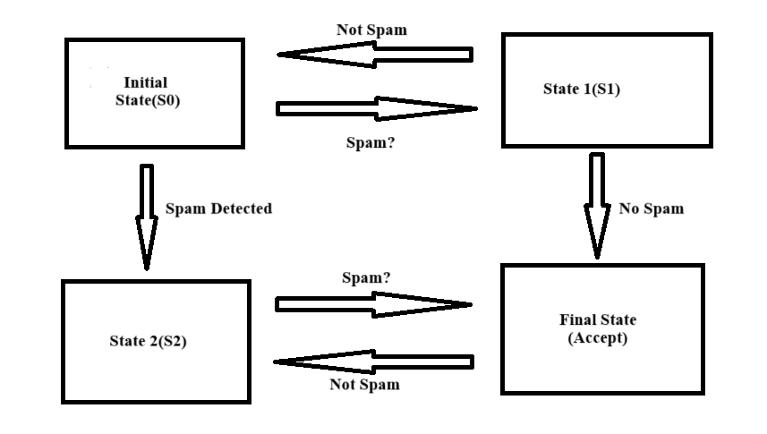

**FLOW CHART**

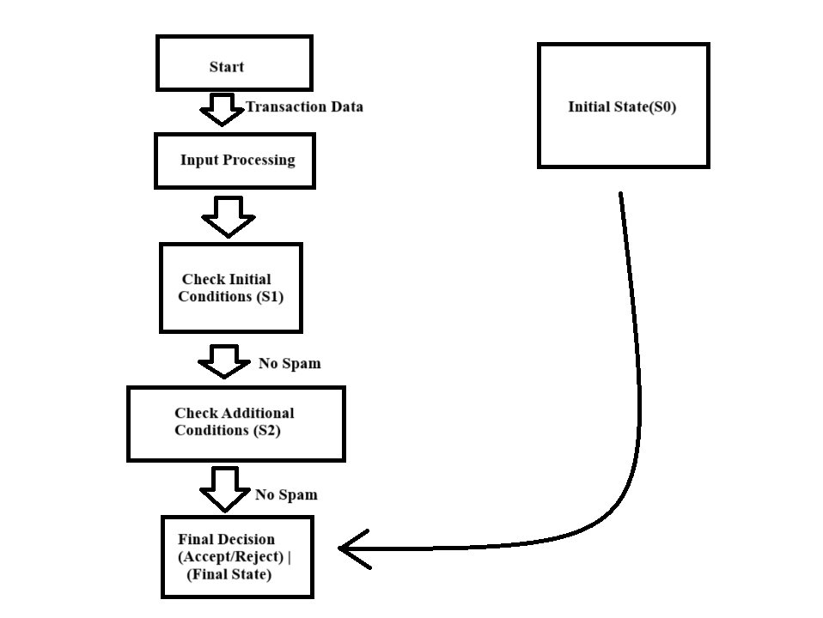

**DFA Design for Spam Detection in Banking Sector**

**States (Q):**

Q0: Initial state

Q1: State indicating the email is potentially spam

Q2: Final state indicating the email is classified as spam

Q3: Safe state indicating the email is not spam

**Alphabet (Σ):** Keywords and patterns typically found in spam emails related to banking (e.g., "urgent", "free", "click", "bank", etc.).

**Initial State (q0):** Q0 : Initial state

**Final States (F):** Q2: Final state indicating spam

**Transition Function (δ):**

|  |  |  |
| --- | --- | --- |
| **CURRENT STATE** | **INPUT SYMBOL** | **NEXT STATE** |
| **Q0** | **“urgent”** | **Q1** |
| Q0 | "free" | **Q1** |
| Q0 | "click" | **Q1** |
| Q0 | "bank" | **Q3** |
| Q1 | "offer" | **Q2** |
| Q1 | "guarantee" | **Q2** |
| Q1 | "secure" | **Q3** |
| Q3 | any | **Q3** |

**States (Q):**

Q0 : Initial state where the email starts processing.

Q1 : State indicating the email has encountered potential spam keywords.

Q2 : Final state indicating the email is classified as spam.

Q3 : Safe state indicating the email is not identified as spam.

**DFA DESIGN:**

“urgent”, "free", "click"

Q1

Q0

"bank" "secure"

"offer" "guarantee"

Q3

Q2

any

**Alphabet (Σ):** Contains keywords or patterns typical of spam emails in banking (e.g., "urgent", "free", "click", "bank", etc.).

**Initial State (q0):** Starts in state **Q0**.

**Final State (F):** State **Q2** is the final state where the email is classified as spam.

**Transition Function (δ):** Specifies how the DFA transitions from one state to another based on the input symbols (keywords or patterns in the email).

**Conclusion:**

In conclusion, the pervasive threat of spam emails within the banking sector underscores the critical importance of implementing effective and advanced detection strategies. Cybercriminals continually exploit vulnerabilities in email systems to launch sophisticated phishing attacks, distribute malware, and perpetrate fraud, posing significant risks to financial institutions and their clients. These malicious activities can lead to unauthorized access to sensitive financial data, substantial financial losses, and severe damage to an institution's reputation.

Developing robust spam detection and filtering mechanisms is paramount to safeguarding the security and integrity of banking operations. By leveraging technologies such as Deterministic Finite Automata (DFA), which offer efficient and deterministic processing of email content, banks can effectively identify and block spam emails in real-time. DFA-based systems are particularly advantageous due to their ability to recognize specific patterns and characteristics associated with spam, thereby minimizing false positives and ensuring accurate detection.

Moreover, investing in proactive cybersecurity measures not only mitigates immediate risks but also strengthens the resilience of financial institutions against evolving cyber threats. It fosters a secure environment for conducting digital transactions and maintaining customer trust, crucial elements in today's interconnected financial landscape. As the digital landscape continues to evolve, ongoing research and innovation in spam detection technologies remain essential to stay ahead of sophisticated cyber adversaries.

By prioritizing the development and deployment of advanced spam detection systems, banks demonstrate their commitment to protecting sensitive financial information and upholding regulatory compliance standards. This proactive approach not only enhances operational efficiency but also reinforces the institution's reputation as a trustworthy custodian of client assets. Moving forward, collaboration across industry sectors and continuous refinement of cybersecurity practices will be pivotal in mitigating emerging threats and ensuring a secure banking environment for all stakeholders.

**REFERENCES:**

Hopcroft, J. E., Motwani, R., & Ullman, J. D. (2001). Introduction to Automata Theory, Languages, and Computation. Addison-Wesley.

This textbook provides a comprehensive introduction to automata theory, including finite automata, regular languages, and formal languages.

Voss, G. G. (2008). Traffic Light Control Systems: A Review of Technology. Technical Report No. FHWA-HOP-09-003. Federal Highway Administration.

This report provides an overview of traffic light control systems, including historical development, current technologies, and future trends.

Papadimitriou, C. H., & Lewis, J. G. (1985). Elements of the Theory of Computation. PrenticeHall.

This textbook covers various topics in theoretical computer science, including finite automata, context-free grammars, and Turing machines.

Lin, W., Huang, C., & Wang, H. (2007). A Real-Time Traffic Light Control Strategy Based on

Vehicle Density Estimation. IEEE Transactions on Intelligent Transportation Systems, 8(3), 432-439.

This research paper presents a real-time traffic light control strategy based on vehicle density estimation, demonstrating the application of control theory in traffic engineering.

Sipser, M. (2012). Introduction to the Theory of Computation. Cengage Learning.

This textbook offers an accessible introduction to the theory of computation, covering topics such as automata theory, computability, and complexity theory.

Al-Obaidi, F. N., & Al-Mafrachi, M. J. (2018). Intelligent Traffic Light Control System Using Image Processing and Microcontroller. Journal of Physics: Conference Series, 1019(1), 012097.

This research paper proposes an intelligent traffic light control system using image processing techniques and microcontroller technology, showcasing advancements in traffic control technology.

Kari, J. (2013). Theory of Cellular Automata: A Survey. Theoretical Computer Science, 334(13), 3-33.

Gartner, N. H., & Messer, C. J. (1999). Signal Timing Under Oversaturated Conditions: Nonsaturated Flow Analysis. Transportation Research Record, 1678(1), 104-111.

This research paper discusses signal timing strategies for traffic lights under oversaturated conditions, providing insights into traffic flow control algorithms used in real-world traffic management systems.

Hopcroft, J. E., & Ullman, J. D. (1979). Introduction to Automata Theory, Languages, and Computation. Addison-Wesley.

Another classic textbook on automata theory, this book covers topics such as finite automata, regular expressions, context-free grammars, and Turing machines, offering a comprehensive introduction to the field.

Zhou, X., & Al-Emrani, M. (2017). An Intelligent Traffic Light Control System Based on FPGA. IEEE International Conference on Mechatronics and Automation (ICMA), 690-695.

This conference paper presents an intelligent traffic light control system based on Field-

Programmable Gate Array (FPGA) technology, demonstrating hardware-based approaches to traffic signal optimization.

Koopman, J., & Wagner, R. (1997). Real-Time Safety Verification of a Traffic Light Controller Using Model Checking. IEEE Transactions on Software Engineering, 23(5), 278-294.