FACEMOOD:

REQUIREMENTS MANAGEMENT PLAN

Contents

1 OVERVIEW 1
1.1 Purpose 1
1.2 Scope 1
1.3 Applicability 1
1.4 Document Organization 1
1.5 Applicable Documents 1
1.6 Changes and Revisions 1
1.7 Issues

Revision History:

DATE | Version | Description | Author
29/04/2019 | 1.0 | General modification on the RM document | Manoela Timossi Lubambo
14/05/2019 | 1.0.1 | Improvement of the RM document adding REAL FUCKING cases | Manoela Timossi Lubambo
15/05/2019 | 1.0.2 | Draft of the project architecture added using SOA | Manoela Timossi Lubambo
28/05/2019 | 1.0.3 | New SOA draft | Manoela Timossi Lubambo

OVERVIEW
FaceMood main goal is, through face recognition prevent airport terrorist attacks using mood detection that leads to any traces of suspicious behavior.
  - Purpose
FaceMood goal is to prevent terrorism acts to happen. The system will use face recognition and through that, spot any traces of suspicious behavior or any kind of behavior that could put the small percent of airport population’s life in danger. FaceMood aim to decrease the time wasted on airport lines and analyses if the pilot is able to make the flight.
  - Scope

- The project will have: Interface, face detection, an AI used to identify the emotions.
- It will be developed by the development team using SCRUM methodology.
- The team will weekly work on the project and the project manager will update the RM after their weekly meetings.
- The main goal is to at least identify precisely 3 different emotions on the beta version.
  - Applicability
FaceMood is going to be used to detect suspicious behaviors in airports. It will be used by an airport employee on passengers before they board on the flight.
  - Applicable Documents
The main document that will be used is the project plan.
  - Changes and Revisions
The revisions will be done by the project manager that will be updating the document weekly with the development team’s updates.
  - Issues
The main issue will be finding good tools that can help the face recognition since only few libraries are good to do this in python. Spotting the complex emotions of humans like anxiety will be another challenging issue since sometimes face expressions cannot be 100% precise on those cases.

FACEMOOD OPERATIONAL SEQUENCE:
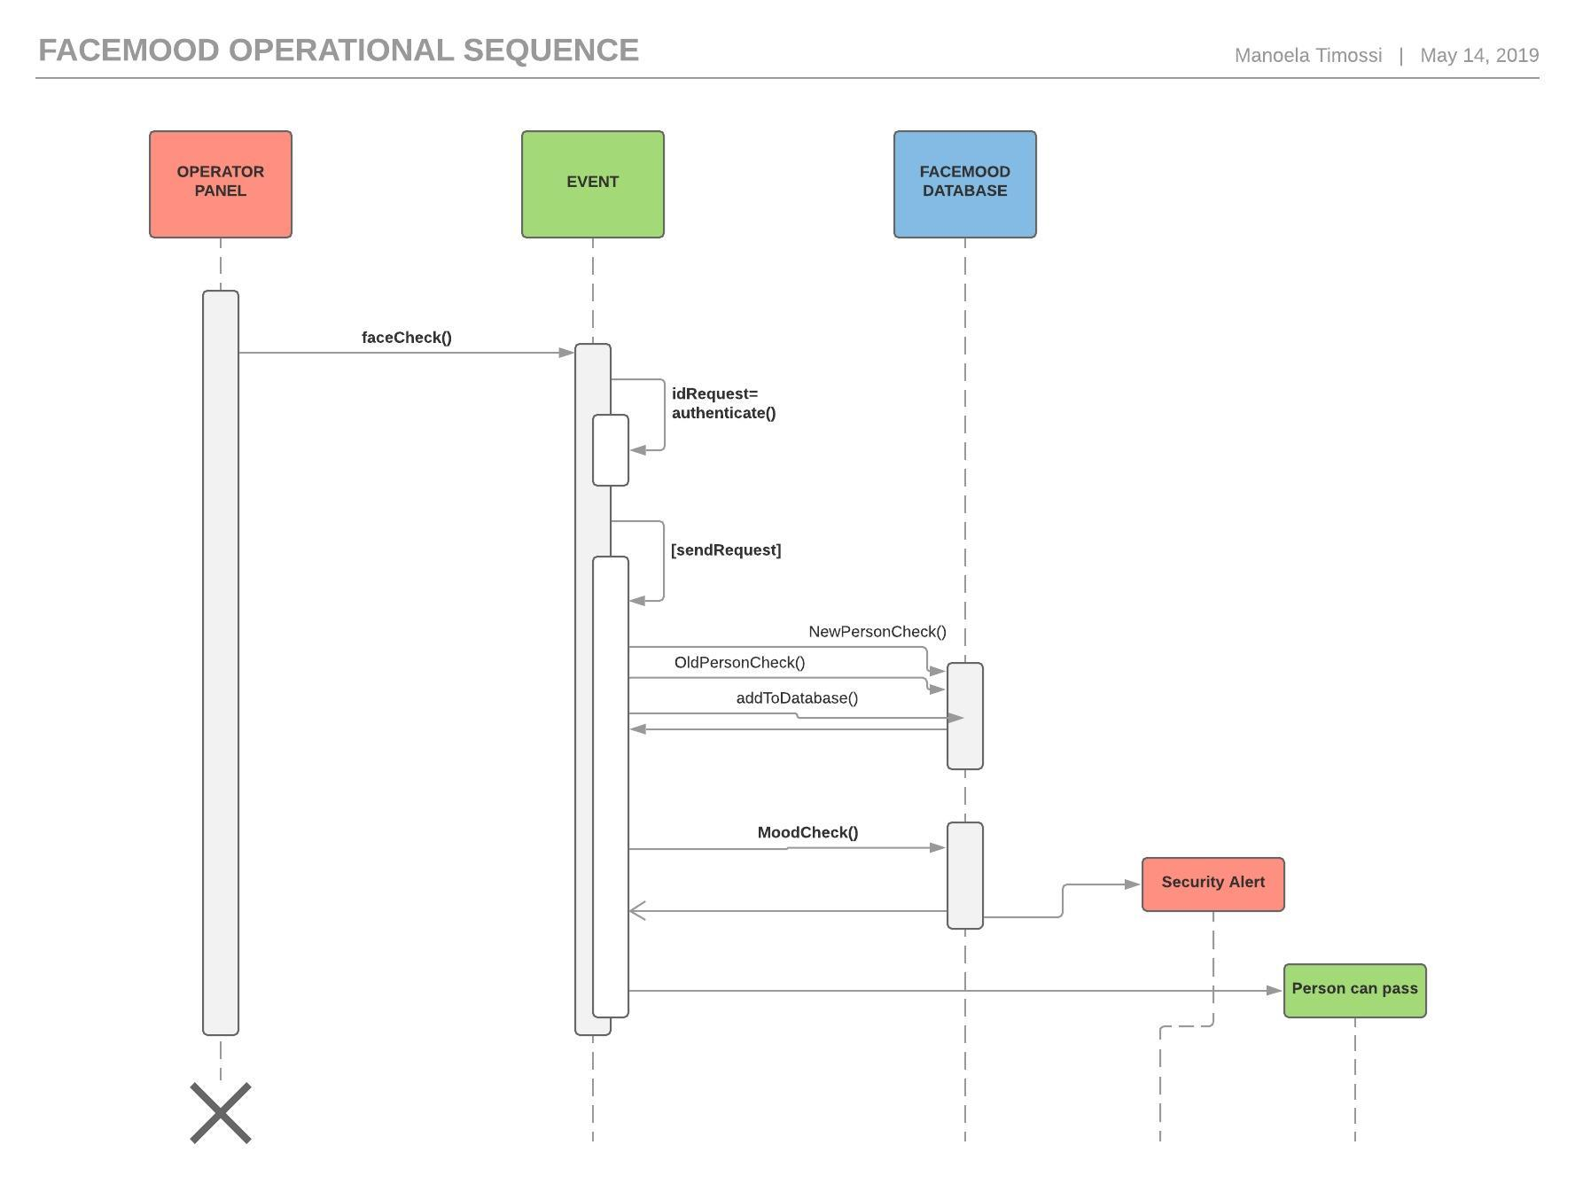
REAL FUCKING:
FU:
Facemood can easily be fixed because when there’s an error or bug, it will be displayed on the operator interface so they can report the bug and the company, that developed the project, can be called and this way it will be fixed faster. On the operator panel will be also displayed an update option which it will download the patch and install by itself.
CK:
Facemood will be able to recognize if it’s properly functioning or not. If there’s a problem on its execution. It will be reported on the operator panel.

IN:
Facemood will be able to operate without a network conection because every class and method will be able to operate by itself.
G:
In general, Facemood will be prioritize security since it will be used as a national security tool on airports.
R:
Facemood’s code will be able to me reused in other subjects like the detection of DISEASES THROUGH face recognition.
E:
The system will be able to receive updates that will allow and add new features to it.
A:
Facemood will have a history option that will allow the operator to see the past results of its last use. the result will contain the last statistics and the last people checked through the app.
L:
Facemood will have independent methods that makes it loosely coupled and this way it will reduce the independencies its modules and parts.

- How will facemood operate?

- FACEMOOD UML

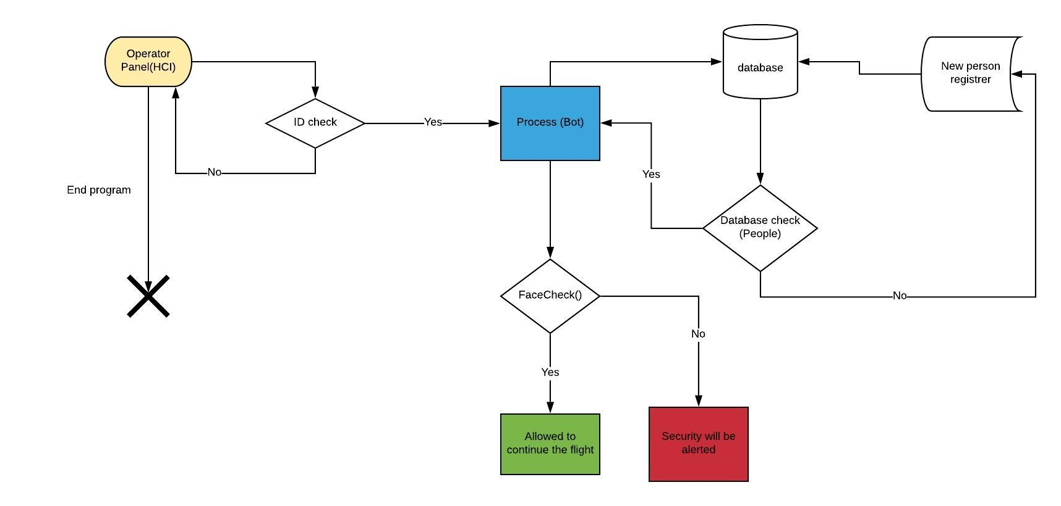

1. Operation Panel:
The operation panel will contain the user interface. when the operator choose to check the passenger it will ask for their id. if the id matches with the operator’s id it will continue to run the program. if not the operator will be brought back to the operator panel.
2. process:
The bot will ask the passengers some questions about how they feel and store it on the program’s database. The process will will check after the operator add the passenger’s information (ID, name, address, age, passport number, etc) on the system if it’s contained on the database. if it is, the program will proceed if not, the information will be added to the database. So, when the passengers comeback to another flight their information will be on the database, no needing to be registered again.
- FaceCheck():
The passenger face will be scanned, if they show no sign of any suspicious behavior, they will be allowed to fly. if they are show any sign of suspicious behavior security will be called and the passenger will be interviewed.
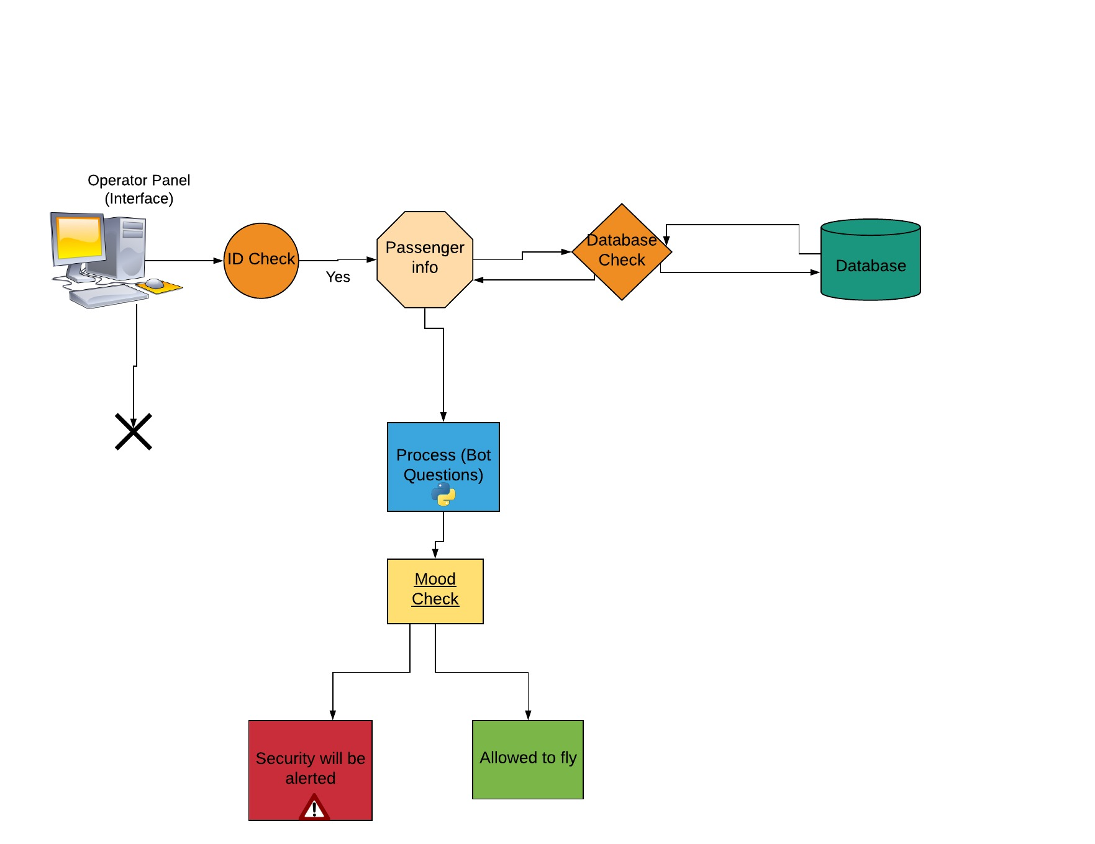
- Service-Oriented Architecture:

