Craig Soto, Ben Casey

Android App Proposal

Project 2 App: The Freegan Quest (Scavenger Hunt)

October 30, 2013

**Introduction**

The proposed Android Application is called the School Scheduler, which helps users keep track of homework while in school. This app will allow the user to view a list of courses and a list of homework assignments. The normal features the app will have are: 2 activities, edit text fields, and buttons. These will be implemented to allow the user to add/edit/delete courses and homework assignments within the app. The advanced features the app we will have are: database interactions and fragments. The database interactions will be implemented to store, retrieve, and update each course and homework assignments so that the app can store this information after the app has been closed, stopped or interrupted. The fragments will be implemented for inserting new courses and for easy viewing of the list of homework in a specific course.

**Add/Edit/Delete Courses**

When the program starts the first time, the Main Activity will display an empty list of courses and an “Add” button. When the user clicks “Add”, an input dialog will appear that will allow the user to type in the name of the course they want to add to the list. After typing in the name of the course and clicking “Ok” the app will add the course to the database, the dialog will disappear, and the Main Activity will be visible with the name(s) of the course(s) in the list. If the user performs a long press on the course name, the app will display a list of options. Among those options will be edit and delete, which will allow the app to interact with the database accordingly. If the user decides to edit the name of a course the activity will pass the key to the course name in the database to the dialog. This is so that the dialog will be able to retrieve and edit the information before updating it in the database. The user will be allowed to add as many courses as they need (in theory) but for our app we will make sure the app can handle at least 7 with no issues.

The Main Activity will look like this:

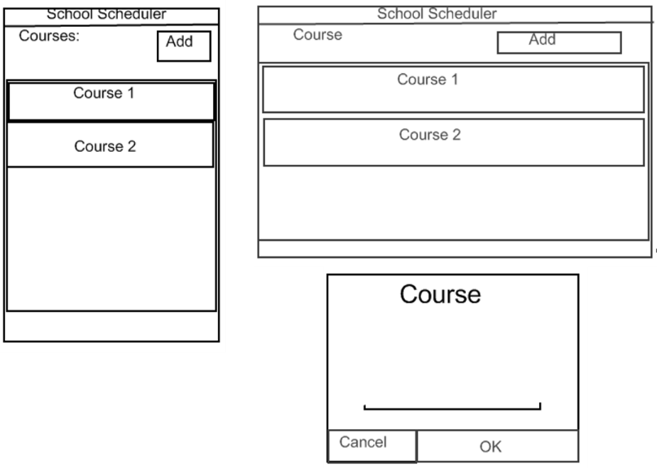

**Add/Edit/Delete Homework**

Once there is a least one course in the list of courses, the user has the ability to add homework to that course. To do that, the user will have to click on the course. This will pop up a fragment that displays an empty list of homework (initially) and an “Add” button. When the user clicks the “Add” button, the app will start the Homework Activity, which will be used to add homework and its information to the database. The Main Activity will pass the name of the course to this activity so that when the activity adds the homework to the database, it can associate that homework with the course.

The activity will display the name of the course, have edit text areas for the name of the homework and a description of the homework, a date selector field (to select when the homework is due), and a “Submit” button. The description will be limited to 140 characters so that when it appears in the list of homework for the course, the user can see a quick description of that homework. After the user has filled in all the criteria and click submit the activity will add this information to the database and return back to Main Activity with the fragment list of homework visible. If the user doesn’t enter in a name or a date the app will enter in generic input (“Untitled”, today’s date) and add this information to the database. If the description is empty it will remain empty when added to the database. If the user clicks the back button the app will return back to Main Activity with the fragment list of homework visible. No information will be passed from the Homework Activity to the Main Activity/fragment because the fragment will need to show the updated list of homework and will retrieve that from the database.

Similar to the list of courses, if the user performs a long press on the homework, the app will display a list of options. Among those options will be edit and delete, which will allow the app to interact with the database accordingly. If the user decides to edit homework information the Main Activity will pass the key to the homework information in the database to the Homework Activity. This is so that the activity will be able to retrieve and edit the information before updating it in the database. The user will be able to see all information needed for the homework (name, date, description). This will make it so that the user won’t have to navigate to a new activity to see the full information, because it is already visible. The user will be allowed to as many homework assignments as they need (in theory) but for our app we will make sure the app can add at least 10 with no issues.

The fragment containing a list of homework assignments will look like this:

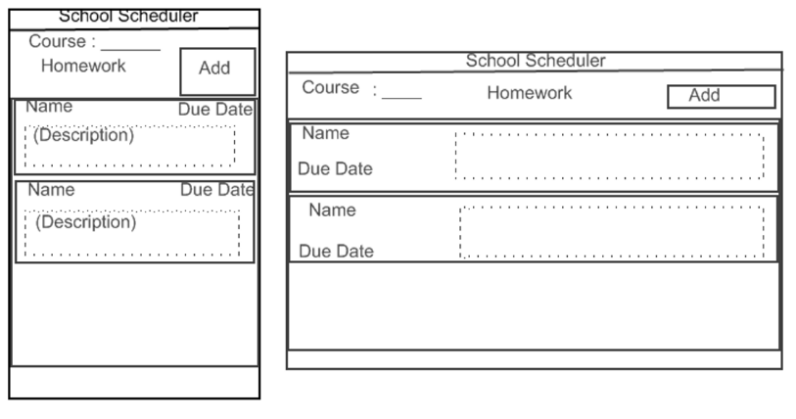

And the Homework Activity will look like this:

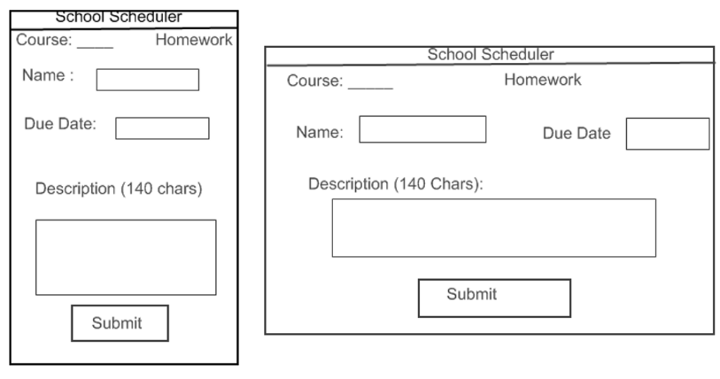

**Life Cycle**

Upon starting the Android app, the app will initialize the variables used throughout the app in the onCreate() method. These variables will be used in the onStart() and onResume() methods to set up the app layout. As the user interacts with the app, these variables will be updated and saved incase the app is paused, stopped, restarted and resumed. This will help the user resume activity with the app in the case a phone call occurs or the user needs to exit the app. The variables that will need to be saved will be any variable not yet saved to the database, such as: the name of a course in the open dialog, the name of a homework, due date, and description in the Homework Activity. When in the Homework Activity, if the user submits or cancels (click back button), it will use the onDestroy() method and clear all the variables that were saved for the homework information.

**Submissions**

For the intermediate submission, we will have activity and fragment navigation complete. A user will be able to click the “Add” button for courses and homework assignments. This means that the course dialog and homework fragment will appear but won’t be able to view any information added by the user because the database interaction with the app won’t be implemented. The app will be able to navigate to the Homework Activity, insert information in the editable areas, and navigate back to the Main Activity. Again, no information edited here will be visible in the fragments because it will not be inserted into the database. This will all be done for the portrait view only.

For the final submission, we will have all functionality complete for the app. In particular, the app will allow the user to properly add/edit/delete courses and homework assignments and have a working database that handles adding/editing/deleting courses and homework assignments. Limitations will be enforced and special homework cases will be handled (empty name or date). Functionality for the landscape view will also be completed, so that the user can rotate the device as needed.