W.R. Wilcox, Clarkson University
Last revised September 17, 2012

Definitions of descriptive statistics of a single variable
generated by the Descriptive Statistics tool in Excel’s Data Analysis

Background

Imagine that we want to know the distance from the front wall of this room to its back wall. We measure it. We measure it again and obtain a slightly different result. We might guess that the average of these two measurements would be closer to the true (unknown) value, and that the more measurements we make the closer the average will be to the true value. In principle, the number of possible measurements is unlimited.

We might also measure the diameter of pistons being produced in an automotive plant. Each of these will be somewhat different, reflecting not only errors in our method of measuring but also real variations in the actual diameter. Again, in principle, there is no limit to the number of pistons that could be produced and measured.

In both our examples, we define the “population” as the number of measurements that could be made and “samples” as the actual measurements made. The challenge of statistics is to use the samples to estimate characteristics of the population. Often, we use different symbols for these characteristics, depending on whether they are for the population or for the samples. For example, the population mean (average) is generally given the Greek letter mu, μ, and the sample mean is written. The square root of the average square of the deviation of individual values of the population from μ is the population standard deviation, and is given the Greek letter sigma, σ. The sample standard deviation, s, is defined below and is an estimate of σ. As the sample size n is increased, becomes closer to μ and s closer to σ.

In the following, we denote the individual value of the sample or measurement as x_{i}, where i goes from 1 to n. The terms below appear in the order they are produced by Excel’s Descriptive Statistics. Each term is followed in capital letters by the Excel function that produces the same value, a definition or explanation of the statistic, and then the relevant equation.

Note that the mean, standard error, median, mode, standard deviation, range, minimum, maximum, sum and confidence level all have the same units as the sample values x_{i}.
Mean (AVERAGE): The sum of all samples divided by the number of values: 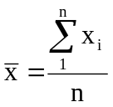
Standard Error: The population standard deviation of many measurements of a mean of n samples. It is estimated by the standard deviation of one measurement of the mean divided by the square root of n: 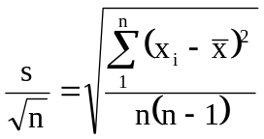

Median (MEDIAN): If n is odd, the value of x_{i} for which half of the remaining values are larger and half are smaller. If n is even, the average of the two values in the middle.

Mode (MODE): The most frequently occurring value, if any.

Standard Deviation (STDEV): From Excel’s Help on this function, “The standard deviation is a measure of how widely values are dispersed from the average value (the mean).” 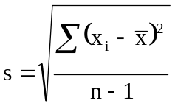

Sample variance (VAR): Square of the standard deviation: 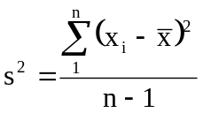

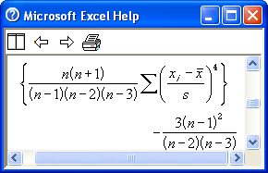
Kurtosis (KURT): From Excel’s Help on this function, “Kurtosis characterizes the relative peakedness or flatness of a distribution compared with the normal distribution. Positive kurtosis indicates a relatively peaked distribution. Negative kurtosis indicates a relatively flat distribution.” The kurtosis of a sample is consistent with a normal distribution for a population if it is small, e.g. less than 0.3.

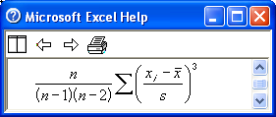
Skewness (SKEW): “Skewness characterizes the degree of asymmetry of a distribution around its mean. Positive skewness indicates a distribution with an asymmetric tail extending toward more positive values. Negative skewness indicates a distribution with an asymmetric tail extending toward more negative values.” The skewness of a sample is consistent with a normal distribution for a population if it’s absolute value is small, e.g. less than 0.3.

Range: Maximum value minus minimum value. (Usually increases as n increases, making it a poor
measure of the dispersion or spread of the population values.)

Mimimum (MIN): Minimum value.

Maximum (MAX): Maximum value.
Sum (SUM): Sum of all values, 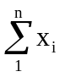
Count (COUNT): Number of values, n

Confidence Level (chosen %):
If the population is normally distributed and you choose the default of 95% (α = 0.05), then the probability is 95% that 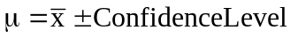. The Confidence Level = 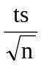, where t is Student’s t (or, often, just t). Thus the probability is 1 – α that 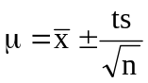 , or α that the true value of μ lies outside these confidence limits. The value of t can be calculated by Excel’s TINV function, in which ν = n-1 is the degrees of freedom and α is the probability (chance that the confidence limits do not include the true μ). There are several important things to note:
- The Excel function CONFIDENCE does not give the same results unless n is greater than about 100. The reason is that the Descriptive Statistics tool correctly uses the Student’s t distribution for a finite sized sample, while CONFIDENCE uses the normal distribution, which is for an infinite population. See normally distributed for a more detailed explanation and for MATLAB programs to calculate Student’s t and descriptive statistics.
- The more the absolute values of skewness or kurtosis exceed 1, the greater is the probability that the population is not normally distributed, and the less chance that the confidence level calculated by Excel is correct.
- Exercise 4a shows how Excel can provide a graphical test of normalcy.
- The probability α that 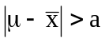can be found using Excel as follows. Calculate 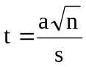. Then
α = TDIST(t,n,2). This is called a two-tailed test.

The probability that 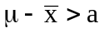is ½ of
TDIST(t,n,2), or TDIST(t,n,1). This is called a one-tailed test.

Outliers

Outliers are values x_{i} which differ significantly from the mean. The most modern criterion seems to be Grubbs’ Test (the t discussed on that page is Student’s t). If an outlier is so identified, you should look at the source of the data to see if there is any reason why this value might be invalid. If so, it is permissible to throw it out and recalculate all of the statistics. But it should not be thrown out simply because it is an outlier.

Return to the Excel tutorial home.

Comments and suggestions always welcome. Email to wilcox@clarkson.edu.

