**SR UNIVERSITY**

**AI CODING**

**ASSIGNMENT NO:01**

**NAME : Gobbilla Manoghna**

**ENROLLMENT NO: 2403A54078**

**BATCH NO : 03**

**TASK:00**

**Install and configure GitHub Copilot in VS Code. Take screenshots of each step.**

**OUTPUT:**

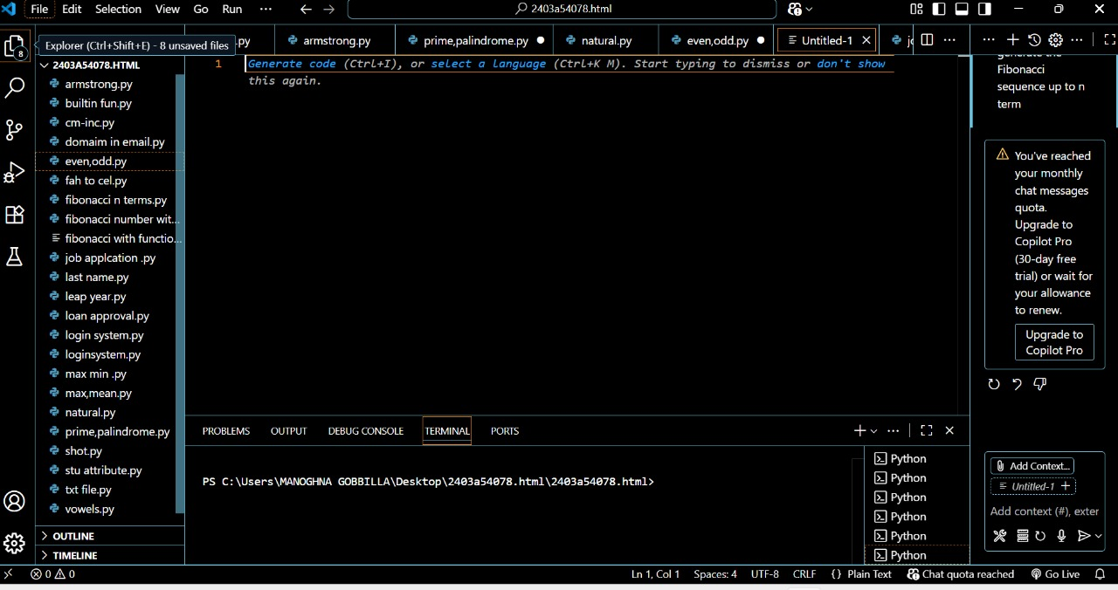

**TASK:01**

**Use GitHub Copilot to generate a Python program that calculates the factorial of a number without defining any functions (using loops directly in the main code).**

**CODE:**

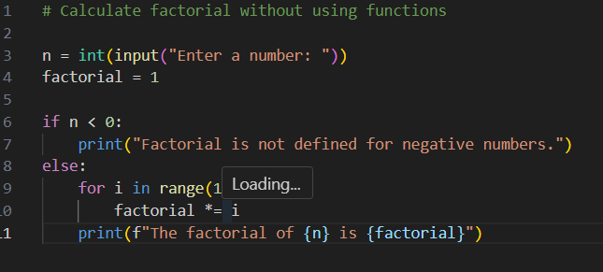

**OUTPUT:**



**TASK:02**

**Examine the Copilot-generated code from Task 1 and demonstrate how its efficiency can be improved (e.g., removing unnecessary variables, optimizing loops).**

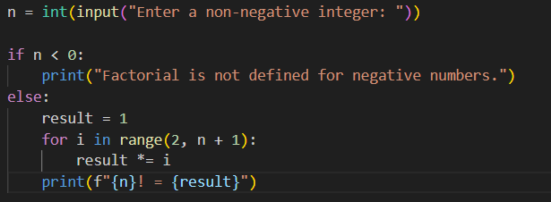

**OUTPUT:**



**TASK:03**

**Use GitHub Copilot to generate a Python program that calculates the factorial of a number using a user-defined function.**

**CODE:**

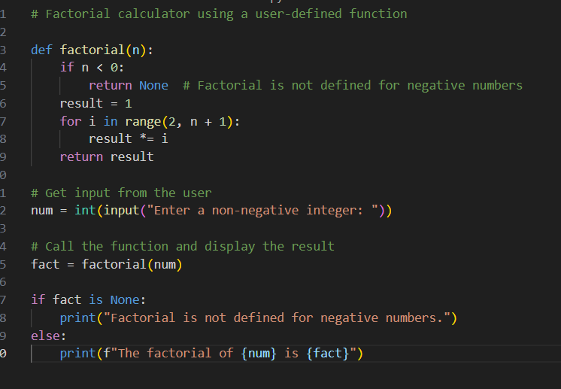

**OUTPUT:**



**TASK:04**

**Differentiate between the Copilot-generated factorial program with functions and without functions in terms of logic, reusability, and execution.**

**EXPLANATION:**

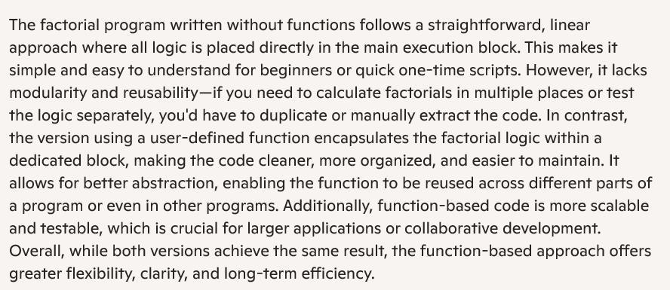

**TASK:05**

**Prompt GitHub Copilot to generate both iterative and recursive versions of the factorial function.**

**CODE:**

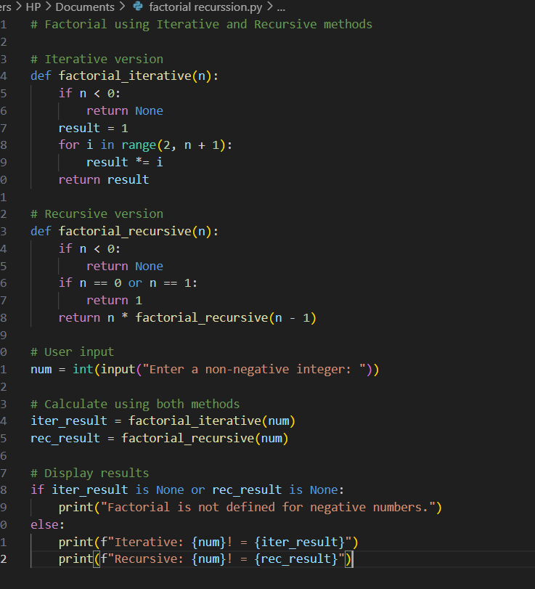

**OUTPUT:**

