**SR UNIVERSITY**

**AI CODING**

**ASSIGNMENT NO:02**

**NAME : Gobbilla Manoghna**

**ENROLLMENT NO: 2403A54078**

**BATCH NO : 03**

TASK:01

Write a function in python to display mean,minimum,maximum from the given list

CODE:

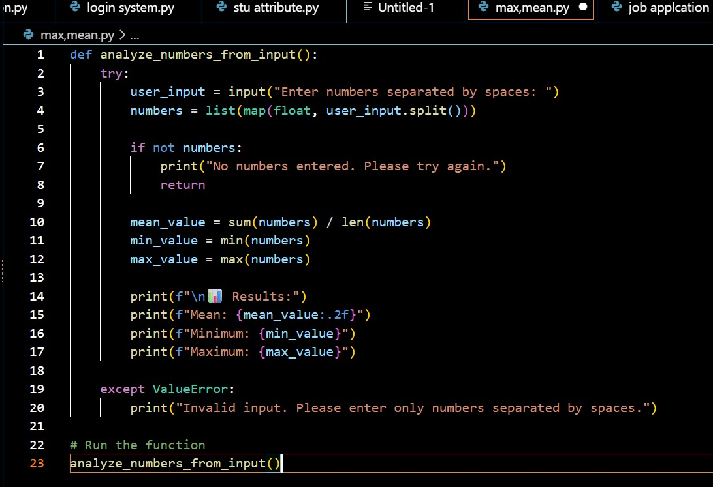

OUTPUT:

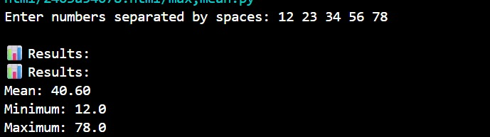

EXPLANATION:

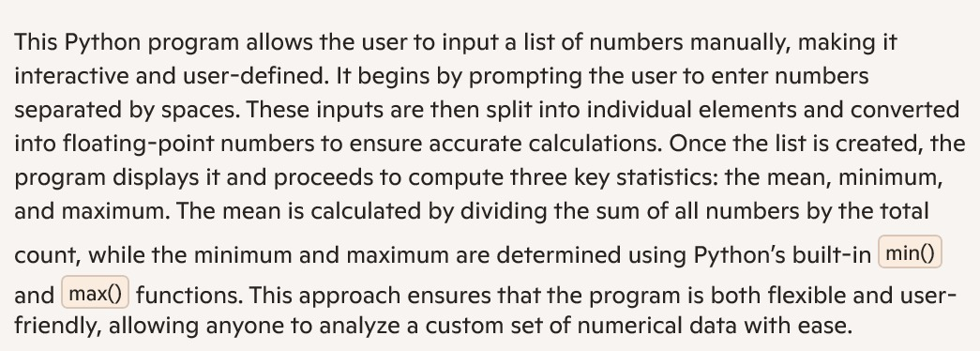

TASK:02

write a function in python which checks whether a number is an Armstrong number

CODE:

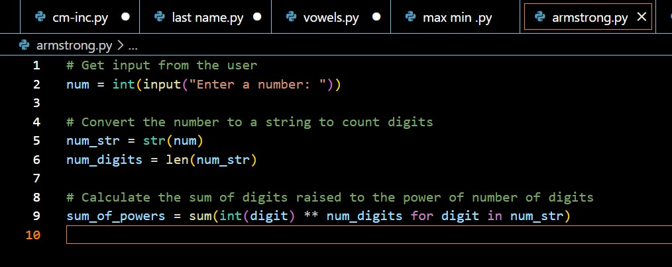

OUTPUT:

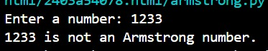

EXPLANATION:

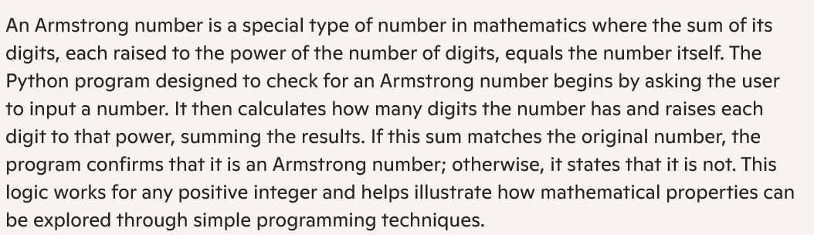

TASK:03

write a function in python which checks the number is prime or not using is_prime() and also checks if the number is palindrome or not using is_palindrome() and display the output

CODE:

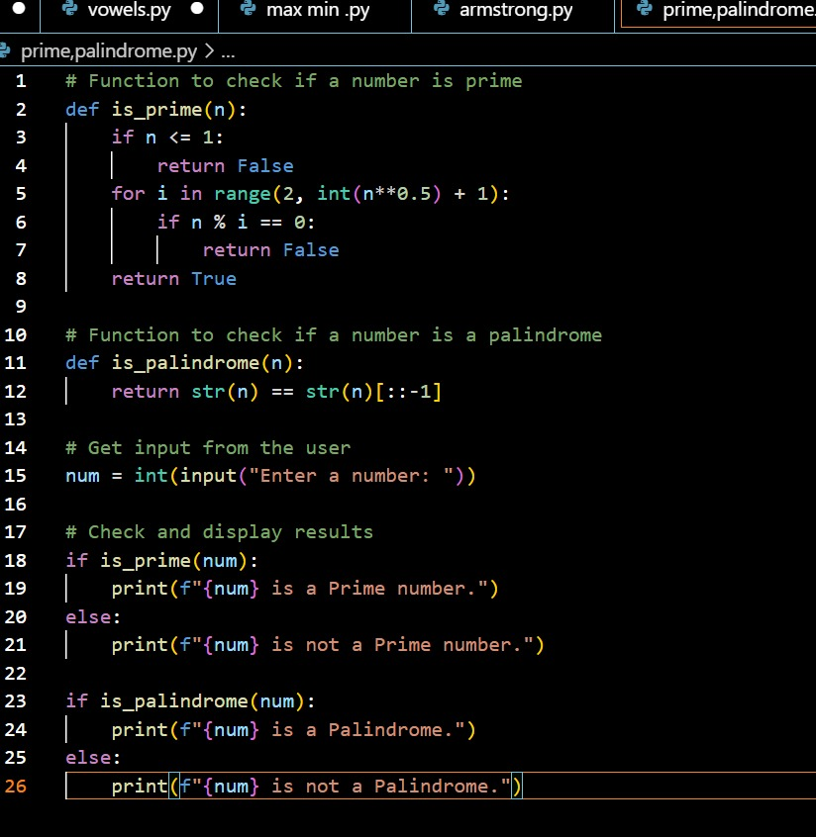

OUTPUT:

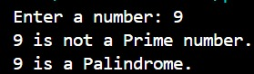

EXPLANATION:

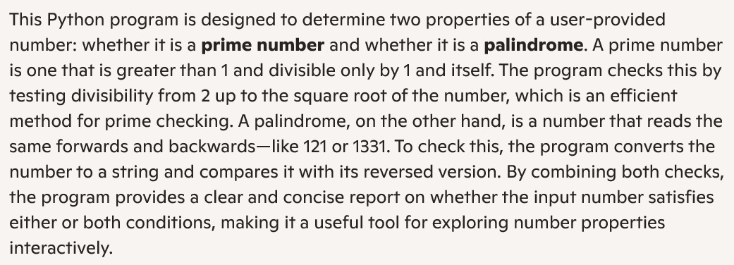

TASK:04

write a function python which takes input and prints the sum of first n natural numbers

CODE:

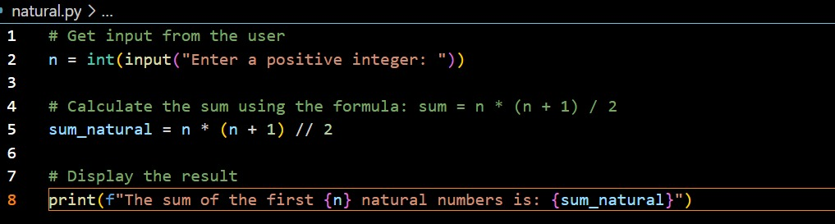

OUTPUT:



EXPLANATION:

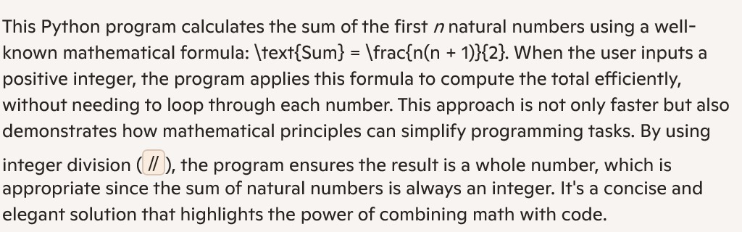

TASK:05

write a python program to calculate sum of odd and even numbers separated and display it

CODE:

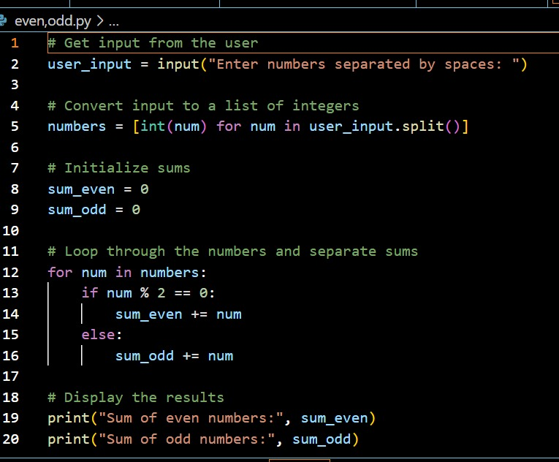

OUTPUT:

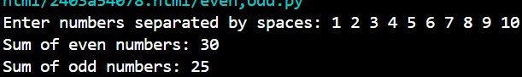

EXPLANATION:

